Abstract
Background/Objective: This study compared individuals with Restrictive Anorexia Nervosa (R-AN; n = 40) to Healthy Controls (HCs; n = 45) and healthy controls at RIsk of eating disorders (RI; n = 38) in a Probabilistic Reversal Learning (PRL) task. The aim was to investigate whether R-AN individuals perform similarly to HCs and RIs in neutral contexts but show significant impairments in food-related contexts. Method: Participants completed a PRL task, making choices related to their disorder or unrelated to it. Results: R-AN individuals showed lower learning rates for food-related decisions, but their performance on neutral decisions was similar to the HC and RI groups. Additionally, only the R-AN patients exhibited reduced learning rates for food-related decisions compared to food-unrelated decisions. Conclusions: These findings suggest that contextual cues, like food images, negatively impact Reinforcement Learning (RL) processes in individuals with R-AN. This raises questions about whether the impaired RL performance should be solely attributed to compromised learning mechanisms, especially when RL abilities appear intact in neutral contexts. The study’s insights may have implications for developing interventions that target decision-making processes in individuals with R-AN.
Keywords: anorexia nervosa, reinforcement learning, contextual learning, probabilistic reversal learning
Word count:
References: 1955

Decision-Making and Learning in Anorexia Nervosa: Slower Learning and Greater Caution with Food Stimuli

Introduction
Anorexia Nervosa (AN), specifically its restricting subtype (R-AN), is a pervasive eating disorder characterized by a skewed body image and extreme weight loss (American Psychiatric Association, 2022). The challenge of effectively treating AN is accentuated by its significant lifetime prevalence rates—1.4% in women and 0.2% in men—and a mortality rate ranging between 5-20% (Qian et al., 2022; Linardon et al., 2017). This amplifies the urgency to elucidate its underlying mechanisms, which are still unknown (Chang et al., 2021).
Recent research emphasizes the role of executive functions in the onset and maintenance of AN, particularly cognitive inflexibility and decision-making challenges (Bartholdy et al., 2016). In individuals with AN, this rigidity typically manifests as resistance to new information, perpetuating a cycle of maladaptive behaviors. Building upon this understanding, a largely unexplored area within this domain is examining how cognitive inflexibility impacts reinforcement learning (RL) – the brain's adaptive mechanism for refining decision-making based on feedback from prior experiences (Schaefer & Steinglass, 2021).
In AN, the cognitive processes governing food choices differ significantly from those of average eaters. Individuals with AN inherently assign lower values to food, particularly high-calorie options, compared to typical eaters (Rouhani, Grossman, & Tusche, 2023), leading to the adoption of dysfunctional eating behaviors. Initial control strategies may be necessary to begin restrictive eating, but the positive psychological effects that individuals with AN experience after restricting their eating—such as a sense of control or satisfaction from weight loss—activate dopaminergic systems in the brain. This activation is associated with reward and pleasure, reinforcing the rigid eating habits and making them more ingrained and difficult to alter (O’Hara et al., 2015; Steinglass & Foerde, 2016). Specific brain regions associated with habit formation have been implicated in this skewed food decision-making process (Foerde et al., 2015, 2020, 2022). This suggests that reward and punishment processing might be altered in individuals with AN. For example, dietary restriction, despite its extreme and dangerous nature, is perceived as rewarding, while palatable food is perceived as punishing (O’Hara et al., 2015). This mechanism of altered RL may underpin the fundamental decision-making processes that sustain the disorder, especially in the context of eating decisions.
However, the literature on aberrant reinforcement learning (RL) in AN has been fragmented and inconclusive. Studies have reported a wide range of findings: some have found impaired RL in response to negative feedback (Ritschel et al., 2017), others noted elevated learning rates following punishment (Bernardoni et al., 2018), and yet others observed no significant differences at all (Sarrar et al., 2016; Geisler et al., 2017). This inconsistency highlights the complexity of AN's reward processing system, often marked by overactivation of neural reward circuits due to severe dietary restrictions (Keating et al., 2012). Paradoxically, despite this hyperactivation, there is evidence of a dampened neural and subjective response to typically rewarding stimuli, especially food-related (Wierenga et al., 2014; Keating et al., 2012). Neuroimaging studies consistently show individuals with AN tend to proactively avoid negative outcomes (Matton et al., 2013; Bischoff-Grethe et al., 2013), further elucidating their unusual reward and punishment processing mechanisms. Overall, current neurobiological insights reveal significant deviations in reward and punishment processing in AN, with an increased sensitivity to negative stimuli and a decreased response to rewards (Haynos et al., 2020).
We propose that to better capture the decision-making challenges in AN, it is crucial to consider the differential processing of food vs. non-food stimuli. Traditional RL studies often use neutral stimuli, which may not fully engage the cognitive and emotional mechanisms involved in food-related decision-making. Therefore, our study incorporates both food-related and neutral stimuli into RL tasks to better understand value assignment and decision-making in AN, considering the long-term goals and prior experiences of patients. This conceptual reorientation provides a way to re-evaluate the inconsistent RL findings in AN (Hildebrandt et al., 2015; Hildebrandt et al., 2018). The disparities in results may not solely be attributed to the nature of stimuli used—whether generic or disorder-specific—but also to the manner in which they are integrated within the experimental design (Schaefer & Steinglass, 2021). For instance, even studies that attempt to incorporate disorder-relevant feedback (Foerde et al., 2021) often revert to generic stimuli during pivotal decision-making phases, inadvertently sidelining the potential contextual influences on RL.
To investigate learning processes in AN, we developed a reward learning paradigm with two contexts: decisions between a disorder-relevant stimulus (food) and a neutral counterpart, and choices exclusively between neutral stimuli. Building on prior work showing disrupted reward processing in AN (Haynos et al., 2020), we hypothesize that individuals with AN exhibit a more conservative learning rate when making decisions involving disorder-relevant stimuli, compared to healthy controls (HCs). This conservative learning rate may reflect a reduced tendency to update beliefs or strategies related to food based on new information, indicating cognitive rigidity. Instead, we expect no differences in learning rates for decisions unrelated to the disorder. This innovative methodology aims to enrich our understanding of RL mechanisms in AN and uncover novel cognitive avenues for therapeutic interventions (refer to Discussion for further elaboration).

Methods
The study, which adhered to the Declaration of Helsinki, was approved by the University of Florence’s Ethical Committee (Prot. n. 0178082). All eligible participants provided informed consent and willingly agreed to participate in the study.

Participants
The study involved 40 individuals with Restricting-Type Anorexia Nervosa (R-AN) as per DSM-5 criteria and 45 healthy volunteers. R-AN participants were recruited from Italian outpatient facilities for the treatment of eating disorders (Specchidacqua Institute, Montecatini, Pistoia; Gruber Center, Outpatient Clinic, Bologna). Patients underwent a treatment program that included individual psychotherapy, nutritional intervention, and medication when needed. Diagnosis was made by specialized psychiatrists and psychologists using the Structured Clinical Interview for DSM-5 Clinical Version (SCID-5-CV; First, Williams, Karg, & Spitzer, 2015).
An additional 310 young females were recruited through social media and university ads, completing the Eating Attitudes Test-26 (EAT-26). Thirty-eight individuals scoring above 20 on EAT-26 and not currently in treatment were classified as "at-risk" (RI). From the remaining, 45 were randomly selected as healthy controls (HC). Both RI and HC groups, which had normal BMI, were age-, sex-, and education-matched with the R-AN group (see Table 1). Further details are available in the Supplementary Information (SI).
Including the at-risk group allows us to investigate whether food-related RL impairment is present solely in the clinical group (state marker) or also in the premorbid phase of the disorder (permanent marker). This group is appropriate because, even without a formal diagnosis, they exhibit features common to the AN group, as indicated by self-reported measures (see Table 1). If the at-risk group shows RL alterations, it suggests RL is a permanent marker of the disorder. Conversely, the absence of RL alterations in the at-risk group would indicate that RL is a state marker, only present when the disorder is active.

Procedure

In the initial session, participants' eligibility was assessed via a clinical interview. Eligible participants underwent anthropometric measurements and completed psychometric scales including the Eating Attitude Test-26 (EAT-26; Garner, 1991; Italian version by Dotti & Lazzari, 1998), the Body Shape Questionnaire-14 (BSQ-14; Dowson and Henderson, 2001; Italian version by Matera et al., 2013), the Social Interaction Anxiety Scale (SIAS; Mattick and Clarke, 1998; Italian version by Sica et al., 2007), the Depression Anxiety Stress Scale-21 (DASS-21; Lovibond and Lovibond, 1995; Italian version by Bottesi et al., 2015), the Rosenberg Self-Esteem Scale (RSES; Rosenberg, 1965; Italian version by Salerno et al., 2017), and the Multidimensional Perfectionism Scale (MPS; Frost, Marten, Lahart, and Rosenblate, 1990; Italian version by Lombardo, 2008) – see SI.
In a subsequent session, participants engaged in a Probabilistic Reversal Learning (PRL) task. The objective was to maximize "virtual euro" accumulation (Figure 1, top) by selecting the more advantageous image between two options. The task involved a 2.5-second decision period between two images, guided by trial-and-error feedback. Correct choices were indicated by an image of a euro coin, while incorrect choices were signaled by an image of a crossed-out euro coin. The stimuli, randomly selected from sets of food-related and unrelated images from the International Affective Picture System (IAPS) database (Lang, Bradley, & Cuthbert, 1997), varied with each trial.
The food-related category included images of French fries, cake, pancake, cheeseburger, and cupcake (IAPS #7461, 7260, 7470, 7451, 7405). The food-unrelated category featured images of a lamp, book, umbrella, basket, and clothespin (IAPS #7175, 7090, 7150, 7041, 7052). For the control task, five images were used for each of the two food-unrelated categories: flowers (IAPS #5000, 5001, 5020, 5030, 5202) and objects (IAPS #7010, 7020, 7034, 7056, 7170).
The task consisted of two 160-trial blocks: one mixed and one exclusively food-unrelated. Initially, reward rates were at chance level but improved over time, enhancing performance (Figure 1, bottom). A contingency switch caused a temporary performance drop, followed by recovery, eventually stabilizing at a 0.7 success rate due to the 70% reward probability, with three such switches occurring per session.
Sample size was determined through simulation studies (see SI).
Data analysis
Data analysis comprised two steps. First, we calculated standard PRL behavioral indices, including win-stay, lose-shift strategies, and reaction times. Subsequently, we applied a computational model to accurately analyze the underlying mechanisms guiding learning strategies (Caudek et al., 2020).
Behavioral measures
We analyzed win-stay and lose-shift strategies to understand decision-making patterns in different groups. Win-stay, the proportion of trials where the same stimulus is selected after a win, had rates of 0.845 (SE = 0.014) for controls, 0.780 (SE = 0.0228) for the at-risk group, and 0.754 (SE = 0.0179) for the R-AN group. Lose-shift, the proportion of trials where the opposite stimulus is selected after a loss, had rates of 0.591 (SE = 0.0166) for controls, 0.563 (SE = 0.0177) for the at-risk group, and 0.569 (SE = 0.0173) for the R-AN group.
To assess the effects of stimulus type (food vs. neutral), group, and their interaction on these strategies, we employed Bayesian multilevel models with random effects for subjects and random slopes for stimulus. Model comparisons using the Expected Log Predictive Density (ELPD) statistic indicated that including these fixed effects did not improve predictions for win-stay (elpd_diff = -11.1, SE = 8.0) or lose-shift (elpd_diff = -17.7, SE = 6.2), favoring the null models.
Average reaction times (RT) were recorded as 0.45 seconds (SE = 0.012) for controls, 0.45 seconds (SE = 0.017) for at-risk participants, and 0.56 seconds (SE = 0.018) for R-AN participants. A robust Bayesian model revealed a credible median RT difference between controls and R-AN participants (ΔRT = 0.10 seconds, 89% CI [0.06, 0.14]), but not between controls and at-risk participants (89% CI [-0.04, 0.05]). Furthermore, Bayesian regression identified a credible increase in RT for R-AN participants when choosing between a food image and a neutral image compared to two neutral images (β = 0.05, 89% CI [0.00, 0.09]). No credible difference in this increase was found between controls and at-risk participants (89% CI [-0.04, 0.06]).
Computational Modeling
Descriptive statistics like win-stay and lose-shift offer insights but do not fully capture reinforcement learning processes (Caudek et al., 2020; 2021). Therefore, we used computational models, particularly the Rescorla-Wagner model, which updates value expectations based on reward feedback (Rescorla & Wagner, 1972). This model includes the learning rate (α) and the temperature parameter (β), typically estimated with the SoftMax function. However, the SoftMax function's descriptive adequacy has been questioned (Pedersen & Frank, 2021). To better understand choice mechanisms, we employed the Reinforcement Learning Drift Diffusion Model (RLDDM; Pedersen & Frank, 2021), which integrates the Drift Diffusion Model (DDM) with the Reinforcement Learning framework, replacing the SoftMax function.

The RLDDM integrates value updates with a drift-diffusion process for decision-making (Ratcliff & McKoon, 2008). This model captures both the evolution of choice proportions and decision times, providing a richer interpretation of RL mechanisms (Pedersen, Frank, & Biele, 2017; Pedersen & Frank, 2020). The Drift Diffusion Model (DDM), a sequential-sampling model, assumes decisions are made by sampling noisy evidence until reaching a decision boundary, fitting reaction time (RT) distributions and accuracy data simultaneously. This approach is particularly relevant for understanding decision-making in R-AN participants, who exhibit increased RT when choosing between a food image and a neutral image compared to two neutral images. By combining RL's dynamic learning processes with sequential-sampling models' decision processes, we can better describe instrumental learning mechanisms in populations with specific cognitive and behavioral profiles, such as R-AN.

Results

Models selection
To test our hypotheses regarding the differential processing of food vs. non-food stimuli in R-AN, we compared various RLDDM models, each differing in their conditioning on group (R-AN, HC, RI) and stimulus type (food vs. neutral). We used the Deviance Information Criterion (DIC) to balance model fit and complexity, selecting the model with the lowest DIC as the best trade-off. Among the evaluated models, Model M7 had the lowest DIC, indicating the best trade-off between goodness of fit and model complexity (see SI for details). In Model M7, the parameters $α^{+}$ (learning rate for rewards), $α^{-}$ (learning rate for punishments), a (decision threshold), v (drift rate), and t (non-decision time) were conditioned on both group and stimulus type (food vs. neutral).
Model Estimation and Hypothesis Testing
Within-Group Comparisons. Within-group comparisons (Figure 2, panel B) revealed that individuals with R-AN exhibited a reduced learning rate from rewards for food-related choices compared to neutral choices (Cohen’s d = -1.206, p = 0.0098). No credible difference in learning rate was observed between related and neutral choices in HC (p = 0.5544) or RI (p = 0.2247) groups. Similarly, no credible difference was found in the learning rate from punishments across all groups (R-AN: p = 0.2349, HC: p = 0.6993, RI: p = 0.5101). R-AN individuals showed a higher decision threshold for food-related choices compared to neutral choices (Cohen’s d = 0.802, p = 0.0013), a result also found in HCs (Cohen’s d = 0.474, p = 0.0256) – Figure 3, panel B.
Between-Group Comparisons. Between-group comparisons provided additional evidence of differential processing of food stimuli. For food-related choices, R-AN individuals showed a decreased learning rate from rewards compared to HC (p = 0.0009, Cohen’s d = 1.498) and RI (p = 0.0085, Cohen’s d = 1.209) – Figure 2, panel A. Conversely, no credible difference in reward learning rate was observed between R-AN and HC (p = 0.4325), or R-AN and RI (p = 0.3232), for food-unrelated choices. Furthermore, R-AN individuals exhibited a decreased learning rate from punishment in food-related choices compared to HCs (p = 0.0274, Cohen’s d = 1.144), but not in food-unrelated ones (Figure 4, panel A). However, this effect only emerged in comparisons between R-AN individuals and HCs, not in the within-group comparisons of food-related and unrelated choices among the R-AN participant (Figure 4, panel B).
R-AN individuals exhibited a higher decision threshold for food-related choices compared to HC (Cohen’s d = -0.622, p = 0.0068) and RI (Cohen’s d = -0.454, p = 0.0118), with no credible group differences for food-unrelated choices (Figure 3, panel A). Lastly, no credible differences were noted in both within-group and between-group comparisons for the drift rate (v) and non-decision time parameters (t).
The results reported here cannot be attributed to the impact of comorbidities or medication status. The correlation between comorbidity and medication was 0.78, indicating a high overlap. We compared R-AN participants with diagnosed comorbidities (45% of the sample) to those without comorbidities using Model M7 and found no credible differences in any parameters between the two groups (see Table 3).
Preferential choices
To examine potential biases against food choices in R-AN individuals during the PRL task, we analyzed the frequency of food choices in blocks where a food image was paired with a neutral image. The R-AN group showed no significant bias against choosing the food image, with a food choice proportion of 0.49, 95% CI [0.46, 0.51]. No credible differences in food choices were found between the R-AN and HC groups (contrast R-AN - HC = -0.007, 95% CI [-0.037, 0.024]), or between the R-AN and RI groups (contrast R-AN - RI = 0.013, 95% CI [-0.019, 0.046]).

Discussion

Our study investigated the differential processing of food-related versus neutral stimuli in RL tasks. Elevated decision thresholds (parameter a) for food-related choices were observed in both R-AN and HCs, indicating increased attentional bias and cognitive control. However, R-AN individuals exhibited a notable asymmetry in learning rates, with a reduced positive learning rate (α^+) for food-related choices, unlike HCs and recovered individuals (RIs). Between-group comparisons revealed lower learning rates (α^+ and α^-) for food-related choices in R-AN. DDM parameters indicated higher decision thresholds for food-related choices in R-AN, suggesting cautious decision-making. No credible biases or comorbidity influences were found.

General discussion
In this study, we explored the differential processing of food-related versus neutral stimuli in reinforcement learning among individuals with R-AN, HCs, and those at risk for eating disorders using a novel PRL paradigm that included both food-related and neutral choices. Our findings support the hypotheses formulated in the Introduction, revealing notable differences in learning rates and decision-making processes specifically related to food stimuli in individuals with R-AN.
We observed that individuals with R-AN exhibited lower learning rates for food-related choices, while learning rates among HCs remained consistent across both food-related and neutral contexts. This finding aligns with previous research indicating altered responses to reward and punishment in individuals with AN (Haynos et al., 2020). Our study extends this understanding by illustrating that the presence of food-related stimuli impacts the RL process itself, particularly in those with R-AN.
Our results indicate that individuals with R-AN exhibit greater boundary separation in the DDM, requiring more evidence before making decisions, which suggests increased caution or uncertainty (Haynos et al., 2020). Additionally, a lower learning rate in the RW model implies that R-AN participants update their expectations less frequently in response to feedback, reflecting lower confidence in the feedback. These findings reveal that in the food-related context, individuals with R-AN give less weight to information, leading to more cautious decision-making and infrequent updates to their expectations. This suggests that feedback in the food-related context is perceived as less reliable or relevant.
More generally, eating behavior engages both goal-directed (model-based) and habit-based (model-free) learning systems. Previous studies have linked maladaptive eating to an increased reliance on habit learning (Foerde et al., 2015; Koban et al., 2023). Our results suggest that the slower learning rate observed in the food-related context among R-AN individuals reflects a habit-like avoidance of high-calorie food, which interferes with goal-directed decision-making.
In PRL tasks, performance may be affected by learning impairment, where participants struggle to update stimulus value accurately, and decision impairment, where incorrect stimuli are chosen despite intact learning. Our findings indicate that individuals with R-AN face difficulties in both domains but only with food-related stimuli. This supports the notion of differential RL deficits in R-AN and challenges the hypothesis of a generalized RL impairment in this group (Foerde et al., 2021).
Our results also show that individuals with R-AN exhibit a conservative learning rate in food-related contexts when engaging with rewards, a caution not seen with punishments. This aligns with neurobiological models suggesting that AN symptoms are maintained by diminished reward responses and amplified aversive responses, potentially due to an overreliance on cognitive control circuits (Wierenga et al., 2014). Supporting this, Bernardoni et al. (2018) noted that in PRL tasks with neutral stimuli, AN individuals adjusted beliefs more rapidly to negative feedback compared to healthy controls. We speculate that the lack of contextual effect on negative learning rates may result from a balance between cautious learning from food-related cues and accelerated learning following punitive feedback.
A critical question is whether the food-related alterations observed are state or permanent markers of AN (Holliday et al., 2005). Using an at-risk group with some clinical features of AN but not the full disorder allows for inferences about RL's role in AN. If this group shows RL alterations in the premorbid phase, RL impairment may be a permanent marker of AN. If not, RL could be a state marker, appearing only when the disorder is active and improving upon remission. Our results support the latter: the at-risk group behaved like the HC group, suggesting RL impairment is specific to active AN. An ongoing study from our lab includes remitted AN patients to determine if clinical remission restores typical RL function, potentially providing deeper insights into whether RL deficits are state-dependent or enduring traits.
These findings have treatment implications. Cognitive Remediation Therapy (CRT) is used to address cognitive inflexibility in AN by employing cognitive exercises and behavioral interventions to improve central coherence, reduce inflexibility, and enhance understanding of thinking styles (Tchanturia et al., 2010). CRT typically avoids symptom-related themes, using neutral stimuli to foster therapeutic alliance and minimize dropout rates. However, recent studies suggest CRT may not consistently improve central coherence, cognitive flexibility, or eating disorder symptoms (Hagan et al., 2020; Tchanturia et al., 2017). Trapp et al. (2022) propose modifying CRT to incorporate food-relevant stimuli, aligning with our study's hypothesis. If future research confirms the context-sensitivity of maladaptive RL in AN, a reevaluation of current intervention approaches may be warranted.
Our study has several limitations and suggests directions for future research. Firstly, the use of symbolic rewards and punishments, depicted as euro coin images, prompts further investigation with tangible incentives. Secondly, the exclusion of hospitalized R-AN patients calls for research on how illness severity impacts food-related biases in RL. Thirdly, while no discernible choice biases between food-related and neutral stimuli were observed, exploring alternative metrics like fixation duration might be insightful. Fourthly, omitting women under 18, a critical age group for AN onset, underscores the need for including this demographic in future studies to better understand learning processes in R-AN. Lastly, the results' generalizability may be limited to individuals from different cultural and ethnic backgrounds. Despite these limitations, our study introduces a novel PRL paradigm for examining RL in R-AN, isolates learning asymmetry from comorbid conditions, and provides comparative insights with an HC group, shedding light on the role of food-related stimuli in RL for R-AN.
Conclusions
Our findings reveal that food-related stimuli interfere with reward learning in individuals with R-AN, highlighting potential cognitive targets for treatment.
Data availability
Additional statistical analyses, detailed information about measurement scales, and further information regarding sample properties, along with an in-depth explanation of the RLDDM model, can be accessed at the Open Science Framework: https://anonymous.4open.science/r/naturalistic_rl/sup_mat.pdf

References
American Psychiatric Association. (2022). Diagnostic and Statistical Manual of Mental Disorders (5th ed., Text Revision). Arlington, VA: American Psychiatric Publishing.
Bartholdy, S., Dalton, B., O’Daly, O. G., Campbell, I. C., & Schmidt, U. (2016). A systematic review of the relationship between eating, weight and inhibitory control using the stop signal task. Neuroscience & Biobehavioral Reviews, 64, 35–62.
Beck, A. T., & Alford, B. A. (2009). Depression: Causes and treatment. University of Pennsylvania Press.
Bernardoni, F., Geisler, D., King, J. A., Javadi, A.-H., Ritschel, F., Murr, J., … Ehrlich, S. (2018). Altered medial frontal feedback learning signals in Anorexia Nervosa. Biological Psychiatry, 83(3), 235–243.
Bernardoni, F., King, J. A., Geisler, D., Ritschel, F., Schwoebel, S., Reiter, A. M., … Ehrlich, S. (2021). More by stick than by carrot: A reinforcement learning style rooted in the medial frontal cortex in anorexia nervosa. Journal of Abnormal Psychology, 130(7), 736–747.
Bischoff-Grethe, A., McCurdy, D., Grenesko-Stevens, E., Irvine, L. E. Z., Wagner, A., Yau, W.-Y. W., et al.others. (2013). Altered brain response to reward and punishment in adolescents with anorexia nervosa. Psychiatry Research: Neuroimaging, 214(3), 331–340.
Bottesi, G., Ghisi, M., Altoè, G., Conforti, E., Melli, G., & Sica, C. (2015). The Italian version of the Depression Anxiety Stress Scales-21: Factor structure and psychometric properties on community and clinical samples. Comprehensive Psychiatry, 60, 170–181.

Caudek, C., Sica, C., Marchetti, I., Colpizzi, I., & Stendardi, D. (2020). Cognitive inflexibility specificity for individuals with high levels of obsessive-compulsive symptoms. Journal of Behavioral and Cognitive Therapy, 30(2), 103-113.
Caudek, C., Sica, C., Cerea, S., Colpizzi, I., & Stendardi, D. (2021). Susceptibility to eating disorders is associated with cognitive inflexibility in female university students. Journal of Behavioral and Cognitive Therapy, 31(4), 317–328.
Chang, P. G., Delgadillo, J., & Waller, G. (2021). Early response to psychological treatment for eating disorders: A systematic review and meta-analysis. Clinical Psychology Review, 86, 102032.
Dasgupta, I., & Gershman, S. J. (2021). Memory as a computational resource. Trends in Cognitive Sciences, 25(3), 240-251.
Dotti, A., & Lazzari, R. (1998). Validation and reliability of the italian EAT-26. Eating and Weight Disorders-Studies on Anorexia, Bulimia and Obesity, 3(4), 188–194.
Dowson, J., & Henderson, L. (2001). The validity of a short version of the Body Shape Questionnaire. Psychiatry Research, 102(3), 263–271.
Feher da Silva, C., & Hare, T. A. (2020). Humans primarily use model-based inference in the two-stage task. Nature Human Behaviour, 4(10), 1053-1066.
First, M. B., Williams, J. B., Karg, R. S., & Spitzer, R. L. (2015). Structured clinical interview for DSM-5-research version (SCID-5 for DSM-5, research version; SCID-5-RV, version 1.0.0). Arlington, VA, US: American Psychiatric Association.
Foerde, K., Daw, N. D., Rufin, T., Walsh, B. T., Shohamy, D., & Steinglass, J. E. (2021). Deficient goal-directed control in a population characterized by extreme goal pursuit. Journal of Cognitive Neuroscience, 33(3), 463–481.
Foerde, K., Schebendach, J. E., Davis, L., Daw, N., Walsh, B. T., Shohamy, D., & Steinglass, J. E. (2022). Restrictive eating across a spectrum from healthy to unhealthy: behavioral and neural mechanisms. Psychological Medicine, 52(9), 1755-1764.
Foerde, K., Steinglass, J. E., Shohamy, D., & Walsh, B. T. (2015). Neural mechanisms supporting maladaptive food choices in anorexia nervosa. Nature Neuroscience, 18(11), 1571-1573.
Frost, R. O., Marten, P., Lahart, C., & Rosenblate, R. (1990). The dimensions of perfectionism. Cognitive Therapy and Research, 14(5), 449–468.
Garner, D. M. (1991). Eating Drjorder Inventory-2 Manual. Odessa, Fla.: Psychological Assessment Resources.
Geisler, D., Ritschel, F., King, J. A., Bernardoni, F., Seidel, M., Boehm, I., et al.others. (2017). Increased anterior cingulate cortex response precedes behavioural adaptation in anorexia nervosa. Scientific Reports, 7(1), 42066.
Guillaume, S., Gorwood, P., Jollant, F., Van den Eynde, F., Courtet, P., & Richard-Devantoy, S. (2015). Impaired decision-making in symptomatic anorexia and bulimia nervosa patients: A meta-analysis. Psychological Medicine, 45(16), 3377–3391.
Hagan, K. E., Christensen, K. A., & Forbush, K. T. (2020). A preliminary systematic review and meta-analysis of randomized-controlled trials of cognitive remediation therapy for anorexia nervosa. Eating Behaviors, 37, 101391.
Haynos, A. F., Lavender, J. M., Nelson, J., Crow, S. J., & Peterson, C. B. (2020). Moving towards specificity: A systematic review of cue features associated with reward and punishment in anorexia nervosa. Clinical Psychology Review, 79, 101872.
Haynos, A. F., Widge, A. S., Anderson, L. M., & Redish, A. D. (2022). Beyond description and deficits: How computational psychiatry can enhance an understanding of decision-making in anorexia nervosa. Current Psychiatry Reports, 1–11.
Heald, J. B., Lengyel, M., & Wolpert, D. M. (2023). Contextual inference in learning and memory. Trends in Cognitive Sciences.
Hildebrandt, T., Grotzinger, A., Reddan, M., Greif, R., Levy, I., Goodman, W., & Schiller, D. (2015). Testing the disgust conditioning theory of food-avoidance in adolescents with recent onset anorexia nervosa. Behaviour Research and Therapy, 71, 131–138.
Hildebrandt, T., Schulz, K., Schiller, D., Heywood, A., Goodman, W., & Sysko, R. (2018). Evidence of prefrontal hyperactivation to food-cue reversal learning in adolescents with anorexia nervosa. Behaviour Research and Therapy, 111, 36–43.
Holliday, J., Tchanturia, K., Landau, S., Collier, D., & Treasure, J. (2005). Is impaired set-shifting an endophenotype of anorexia nervosa?. American Journal of Psychiatry, 162(12), 2269-2275.
Keating, C., Tilbrook, A. J., Rossell, S. L., Enticott, P. G., & Fitzgerald, P. B. (2012). Reward processing in anorexia nervosa. Neuropsychologia, 50(5), 567–575.
Koban, L., Wager, T. D., & Kober, H. (2023). A neuromarker for drug and food craving distinguishes drug users from non-users. Nature Neuroscience, 26(2), 316-325.
Kruschke, J. K., & Liddell, T. M. (2018). Bayesian data analysis for newcomers. Psychonomic Bulletin & Review, 25(1), 155–177.
Lang, P. J., Bradley, M. M., Cuthbert, B. N., et al. (1997). International affective picture system (IAPS): Technical manual and affective ratings. NIMH Center for the Study of Emotion and Attention, 1(39-58), 3.
Lee, D. G., Daunizeau, J., & Pezzulo, G. (2023). Evidence or Confidence: What is really monitored during a decision?. Psychonomic Bulletin & Review, 30, 1360–1379.
Linardon, J., Fairburn, C. G., Fitzsimmons-Craft, E. E., Wilfley, D. E., & Brennan, L. (2017). The empirical status of the third-wave behaviour therapies for the treatment of eating disorders: A systematic review. Clinical Psychology Review, 58, 125–140.
Lombardo, C. (2008). Adattamento italiano della multidimensional perfectionism scale (MPS). Psicoterapia Cognitiva e Comportamentale, 14 (3), 31–46.
Lovibond, P. F., & Lovibond, S. H. (1995). The structure of negative emotional states: Comparison of the Depression Anxiety Stress Scales (DASS) with the Beck Depression and Anxiety Inventories. Behaviour Research and Therapy, 33(3), 335–343.
Matera, C., Nerini, A., & Stefanile, C. (2013). The role of peer influence on girls’ body dissatisfaction and dieting. Revue Européenne De Psychologie Appliquée/European Review of Applied Psychology, 63(2), 67–74.
Mattick, R. P., & Clarke, J. C. (1998). Development and validation of measures of social phobia scrutiny fear and social interaction anxiety. Behaviour Research and Therapy, 36(4), 455–470.
Matton, A., Goossens, L., Braet, C., & Vervaet, M. (2013). Punishment and reward sensitivity: Are naturally occurring clusters in these traits related to eating and weight problems in adolescents? European Eating Disorders Review, 21(3), 184–194.
O’Hara, C. B., Campbell, I. C., & Schmidt, U. (2015). A reward-centred model of anorexia nervosa: A focussed narrative review of the neurological and psychophysiological literature. Neuroscience & Biobehavioral Reviews, 52, 131-152.
Onysk, J., & Seriès, P. (2022). The effect of body image dissatisfaction on goal-directed decision making in a population marked by negative appearance beliefs and disordered eating. Plos One, 17(11), e0276750.
Palminteri, S., Khamassi, M., Joffily, M., & Coricelli, G. (2015). Contextual modulation of value signals in reward and punishment learning. Nature communications, 6(1), 8096.
Palminteri, S., & Lebreton, M. (2021). Context-dependent outcome encoding in human reinforcement learning. Current Opinion in Behavioral Sciences, 41, 144-151.
Pedersen, M. L., & Frank, M. J. (2020). Simultaneous hierarchical bayesian parameter estimation for reinforcement learning and drift diffusion models: A tutorial and links to neural data. Computational Brain & Behavior, 3, 458–471.
Pedersen, M. L., Frank, M. J., & Biele, G. (2017). The drift diffusion model as the choice rule in reinforcement learning. Psychonomic Bulletin & Review, 24, 1234–1251.
Qian, J., Wu, Y., Liu, F., Zhu, Y., Jin, H., Zhang, H., … Yu, D. (2022). An update on the prevalence of eating disorders in the general population: A systematic review and meta-analysis. Eating and Weight Disorders-Studies on Anorexia, Bulimia and Obesity, 27(2), 415–428.
Ratcliff, R., & McKoon, G. (2008). The diffusion decision model: Theory and data for two-choice decision tasks. Neural Computation, 20(4), 873–922.
Rescorla, R. A., & Wagner, A. R. (1972). A theory of pavlovian conditioning: Variations in the effectiveness of reinforcement and nonreinforcement. In A. H. Black & W. F. Prokasy (Eds.), Classical conditioning II: Current research and theory (pp. 64–69). New York, NY: Appleton-Century Crofts.
Ritschel, F., Geisler, D., King, J. A., Bernardoni, F., Seidel, M., Boehm, I., … Ehrlich, S. (2017). Neural correlates of altered feedback learning in women recovered from anorexia nervosa. Scientific Reports, 7(1), 1–10.
Rosas, J. M., Todd, T. P., & Bouton, M. E. (2013). Context change and associative learning. Wiley Interdisciplinary Reviews: Cognitive Science, 4(3), 237–244.
Rosenberg, M. (1965). Society and the adolescent self-image. Princeton, NJ: Princeton University Press.
Rouhani, N., Grossman, C. D., & Tusche, A. (2023, September 4). Decisions on a platter: Food biases and arousal alter reward learning. PsyArXiv. https://doi.org/10.31234/osf.io/uz9xc
Salerno, L., Ingoglia, S., & Coco, G. L. (2017). Competing factor structures of the Rosenberg Self-Esteem Scale (RSES) and its measurement invariance across clinical and non-clinical samples. Personality and Individual Differences, 113, 13-19.
Sänger, J. (2019). Can’t take my eyes off you – how task irrelevant pictures of food influence attentional selection. Appetite, 133, 313–323.
Sarrar, L., Holzhausen, M., Warschburger, P., Pfeiffer, E., Lehmkuhl, U., & Schneider, N. (2016). Cognitive function in adolescent patients with anorexia nervosa and unipolar affective disorders. European Eating Disorders Review, 24(3), 232–240.
Schaefer, L. M., & Steinglass, J. E. (2021). Reward learning through the lens of RDoC: A review of theory, assessment, and empirical findings in the eating disorders. Current Psychiatry Reports, 23, 1–11.
Sica, C., Musoni, I., Bisi, B., Lolli, V., & Sighinolfi, C. (2007). Social phobia scale e social interaction anxiety scale: Traduzione e adattamento italiano. Bollettino Di Psicologia Applicata, 252, 59–71.
Steinglass, J. E., & Foerde, K. (2016). How does anorexia nervosa become resistant to change?. In Managing severe and enduring anorexia nervosa (pp. 64-75). Routledge.
Stockburger, J., Schmälzle, R., Flaisch, T., Bublatzky, F., and Schupp, H. T. (2009). The impact of hunger on food cue processing: an event-related brain potential study. Neuroimage, 47, 1819–1829.
Tchanturia, K., Davies, H., Reeder, C., & Wykes, T. (2010). Cognitive remediation therapy for anorexia nervosa. London: King’s College London.
Tchanturia, K., Giombini, L., Leppanen, J., & Kinnaird, E. (2017). Evidence for cognitive remediation therapy in young people with anorexia nervosa: Systematic review and meta-analysis of the literature. European Eating Disorders Review, 25(4), 227–236.
Trapp, W., Heid, A., Röder, S., Wimmer, F., & Hajak, G. (2022). Cognitive remediation in psychiatric disorders: State of the evidence, future perspectives, and some bold ideas. Brain Sciences, 12(6), 683.
Weider, S., Indredavik, M. S., Lydersen, S., & Hestad, K. (2015). Neuropsychological function in patients with anorexia nervosa or bulimia nervosa. International Journal of Eating Disorders, 48(4), 397-405.
Wierenga, C. E., Ely, A., Bischoff-Grethe, A., Bailer, U. F., Simmons, A. N., & Kaye, W. H. (2014). Are extremes of consumption in eating disorders related to an altered balance between reward and inhibition? Frontiers in Behavioral Neuroscience, 8, 410.
Wise, T., Emery, K., & Radulescu, A. (2023). Naturalistic reinforcement learning. Trends in Cognitive Sciences. In press.
Wu, M., Brockmeyer, T., Hartmann, M., Skunde, M., Herzog, W., & Friederich, H.-C. (2014). Set-shifting ability across the spectrum of eating disorders and in overweight and obesity: A systematic review and meta-analysis. Psychological Medicine, 44(16), 3365–3385.
Zhang, Z., Manson, K. F., Schiller, D., & Levy, I. (2014). Impaired associative learning with food rewards in obese women. Current Biology, 24(15), 1731–1736.

Table 1.
Summary of Sample’s Demographic and Clinical Characteristics.
 | R-AN (n = 40) Mean (SD) | HC (n = 45) Mean (SD) | RI (n = 38) Mean (SD) | AN - HC PE (95% CI) | AN - RI PE (95% CI) | AN - HC Cohen’s d | AN - RI Cohen’s d
Age (years) | 21.11 (4.33) | 19.49 (2.32) | 21.31 (4.82) | -0.00 (-0.22, 0.18) | 0.01 (-0.21, 0.25) | 0.09 | -0.18
Education (years) | 14.53 (1.11) | 14.11 (0.98) | 13.89 (0.78) | 0.08 (-0.14, 0.33) | 0.13 (-0.11, 0.41) | -0.08 | -0.13
BMI (kg/m²) | 17.79 (2.85) | 21.78 (3.53) | 21.64 (4.11) | -2.74 (-3.67, -1.79) | -3.22 (-4.32, -2.07) | 2.67 | 3.15
EAT-26 Total score | 35.89 (19.46) | 5.09 (5.10) | 25.86 (12.44) | 1.76 (1.32, 2.20) | 0.18 (-0.25, 0.62) | -1.84 | -0.18
EAT-26 Dieting | 19.11 (11.24) | 3.27 (3.96) | 16.06 (8.00) | 53.96 (32.78, 80.9) | 4.38 (-2.46, 12.10) | -4.54 | -0.36
EAT-26 Bulimia | 7.17 (3.95) | 0.76 (1.48) | 5.78 (3.86) | 1.36 (0.99, 1.72) | 0.11 (-0.17, 0.41) | -2.33 | -0.18
EAT-26 Oral control | 9.61 (6.23) | 1.07 (1.67) | 4.03 (4.05) | 1.53 (1.12, 1.96) | 0.81 (0.42, 1.20) | -1.95 | -1.03
BSQ-14 Total score | 139.78 (35.26) | 97.47 (32.37) | 147.94 (37.13) | 17.50 (11.30, 23.91) | -3.40 (-10.10, 3.15) | -1.21 | 0.24
RSES Total score | 22.69 (5.29) | 28.33 (5.76) | 22.53 (5.76) | -5.601 (-8.12, -3.15) | 0.192 (-2.31, 2.90) | -1.22 | 0.23
DASS-21 Stress | 12.86 (4.67) | 9.13 (3.55) | 12.17 (3.74) | 3.73 (1.89, 5.38) | 0.69 (-1.12, 2.59) | -0.94 | -0.18
DASS-21 Depression | 10.61 (5.49) | 6.82 (4.33) | 11.22 (4.99) | 3.78 (1.76, 6.14) | -0.62 (-2.91, 1.77) | -0.77 | 0.12
DASS-21 Anxiety | 8.25 (4.51) | 5.76 (4.26) | 7.56 (4.47) | 2.48 (0.50, 4.33) | 0.70 (-1.39, 2.64) | -0.56 | -0.16
SIAS Total score | 37.31 (15.45) | 27.69 (13.01) | 39.03 (14.87) | 9.63 (3.12, 15.84) | -1.68 (-8.28, 5.07) | -0.66 | 0.12
MPS Cmd | 45.47 (8.21) | 40.02 (7.24) | 49.25 (8.17) | 5.46 (2.05, 9.02) | -3.73 (-7.47, -0.15) | -0.69 | 0.48
MPS Ps | 25.33 (5.74) | 22.00 (4.86) | 25.67 (6.33) | 3.33 (0.89, 5.86) | -0.32 (-3.07, 2.19) | -0.60 | 0.06
MPS Pepc | 20.78 (6.64) | 21.02 (5.84) | 25.22 (7.92) | -0.63 (-3.49, 2.42) | -3.88 (-7.09, -0.90) | 0.09 | 0.57
MPS Or | 23.94 (5.11) | 23.07 (5.16) | 22.17 (5.55) | 0.84 (-1.49, 3.17) | 1.77 (-0.66, 4.26) | -0.17 | -0.34
Note. BMI: Body Mass Index, which is lower than that of HC and RI, consistent with findings from studies on eating disorders (CITAZIONI); PE: Posterior Estimate; EAT-26: Eating Attitude Test-26 (Garner, 1991); BSQ-14: Body Shape Questionnaire-14 (Dowson and Henderson, 2001); SIAS: Social Interaction Anxiety Scale (Mattick and Clarke, 1998); DASS-21: Depression Anxiety Stress Scale-21 (Lovibond and Lovibond, 1995); RSES: Rosenberg Self-Esteem Scale (Rosenberg, 1965); MPS: Multidimensional Perfectionism Scale (Frost et al., 1990).

Table 2.
Posterior Parameter Estimates of RLDDM Model M7 by Group (R-AN, HC, RI) and Context of PRL Choice (disorder-related vs. disorder-unrelated information).
Group | Par. | Neutral choice | Food choice | $$p$$ | Cohen’s $d$
R-AN | a | 1.273 (0.039) | 1.442 (0.040) | 0.0013 | 0.802
R-AN | v | 1.403 (0.320) | 1.776 (0.342) | 0.7907 | 0.190
R-AN | t | 0.188 (0.011) | 0.174 (0.011) | 0.8311 | -0.253
R-AN | $$α^{-}$$ | 1.815 (1.081) | 0.738 (1.096) | 0.2349 | -0.432
R-AN | $$α^{+}$$ | 1.006 (0.899) | -1.786 (0.756) | 0.0098 | -1.206
HC | a | 1.222 (0.033) | 1.314 (0.034) | 0.0256 | 0.474
HC | v | 2.157 (0.265) | 1.790 (0.263) | 0.1606 | -0.358
HC | t | 0.183 (0.009) | 0.172 (0.009) | 0.8228 | -0.280
HC | $$α^{-}$$ | 2.780 (0.874) | 3.442 (0.980) | 0.6993 | 0.298
HC | $$α^{+}$$ | 1.198 (0.680) | 1.326 (0.700) | 0.5544 | 0.071
RI | a | 1.245 (0.041) | 1.316 (0.039) | 0.1026 | 0.403
RI | v | 2.197 (0.322) | 1.849 (0.307) | 0.2133 | -0.381
RI | t | 0.188 (0.011) | 0.186 (0.011) | 0.5462 | 0.166
RI | $$α^{-}$$ | 2.857 (1.067) | 2.904 (1.062) | 0.5101 | 0.015
RI | $$α^{+}$$ | 1.573 (0.847) | 0.739 (0.752) | 0.2247 | -0.438
Note. The learning rates (α) are presented on a logit scale, which means the range of values extends from -∞ to +∞. The learning rates ($α$) are shown on a logit scale. The probability ($p$) describes the Bayesian test that the posterior estimate of the parameter in the disorder-related context is greater than the posterior estimate of the parameter in the disorder-unrelated context. Standard deviations are provided in parentheses.

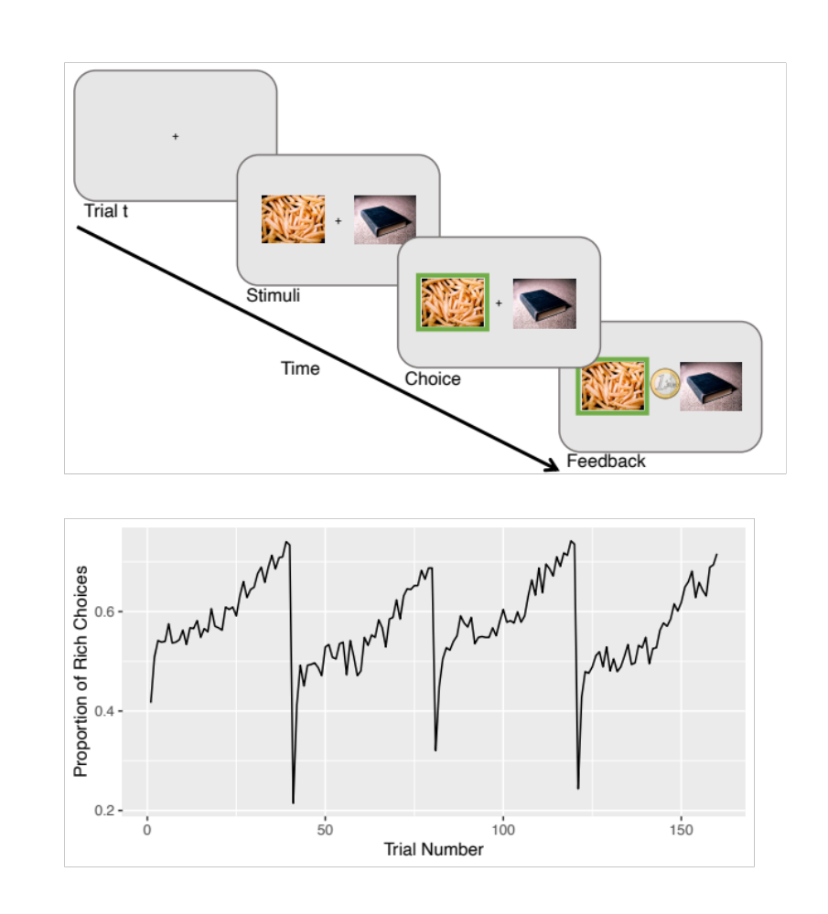

Figure 1: Top. The figure illustrates a single trial of the PRL task. Bottom. The trial-by-trial proportion of choosing the image with the highest probability of reward in the first epoch is shown for all participants.

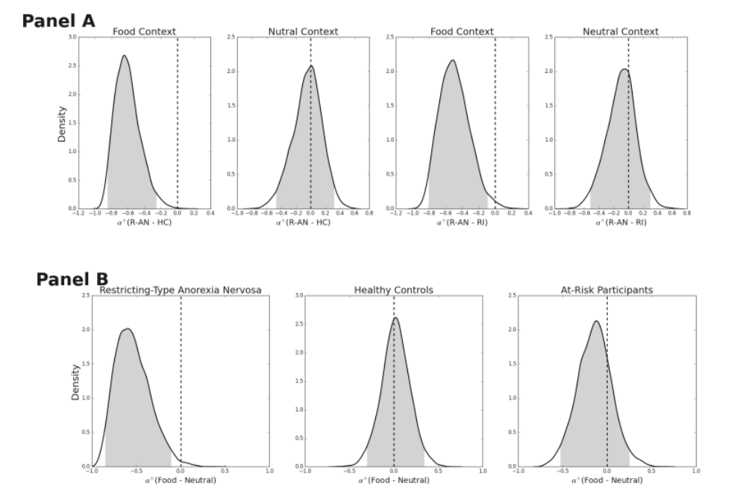
Figure 2: Panel A. Plots of the posterior distribution of the group effects (AN - HC; AN - RI) for parameter $α^{+}$ of the RLDDM, for disorder-related choices (Food context) and disorder-unrelated (Neutral context) choices. Panel B. Plots of the posterior distribution of the within-group effects ($α_{food}^{+}-α_{neutral}^{+}$) across the three groups of participants.

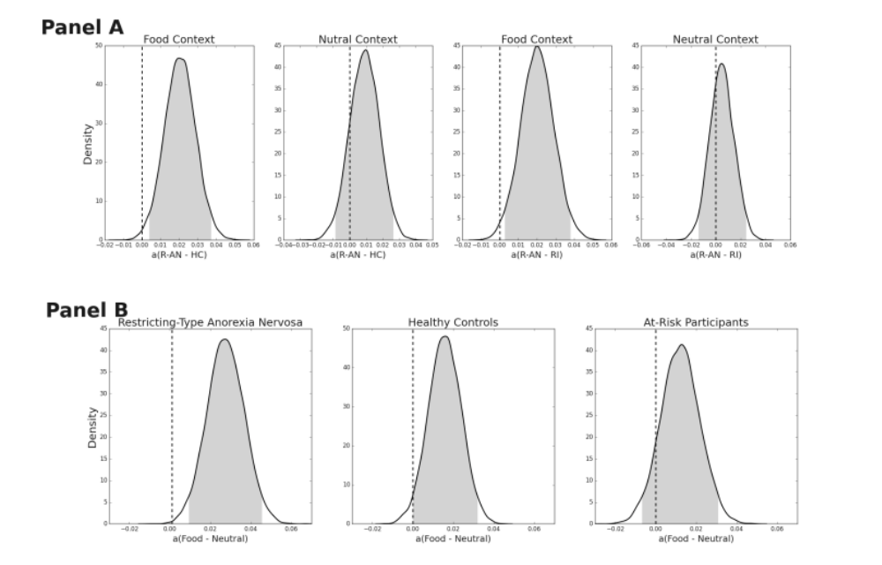
Figure 3: Panel A. Plots of the posterior distribution of the group effects (AN - HC; AN - RI) for parameter $a$ of the RLDDM, for disorder-related choices (Food context) and disorder-unrelated (Neutral context) choices. Panel B. Plots of the posterior distribution of the within-group effects ($a_{food}-a_{neutral}$) across the three groups of participants.

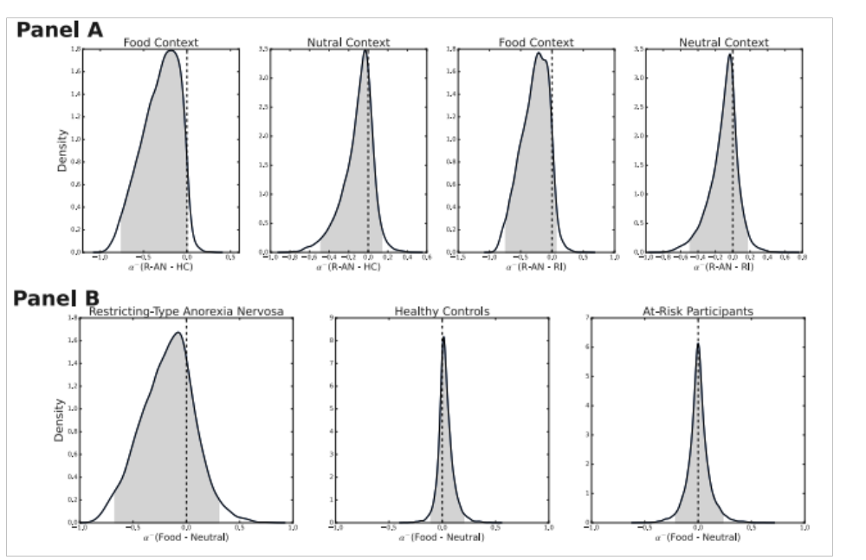
Figure 4: Panel A. Plots of the posterior distribution of the group effects (AN - HC; AN - RI) for parameter $α^{-}$of the RLDDM, for disorder-related choices (Food context) and disorder-unrelated (Neutral context) choices. Panel B. Plots of the posterior distribution of the within-group effects ($α_{food}^{-}-α_{neutral}^{-}$) across the three groups of participants.

