Supplementary Analysis of Daily Conductivity Data

Curtis C. Bohlen, Casco Bay Estuary Partnership

9/12/2021

# Introduction

This analysis is being conducted to help design a stormwater structure to store (high conductivity) snow melt and release it at the optimal time to minimize the conductivity observed in the downstream receiving waters. If this proves feasible, it may provide a way to reduce the ecological impact of high conductivity events on the stream biota. To guide design decisions, we want to understand patterns of specific conductance in Long Creek in and around winter “high conductivity” events.

While we have looked at statistical approaches, we fall back on a predominately graphical approach to understanding what affects conductivity in Long Creek.

## Data Limitations

This analysis is based on the data selected data from the Long Creek Watershed Management District (LCWMD). In particular, it is based on data shared with the Casco Bay Estuary Partnership (CBEP) in preparation for our 2020 “State of Casco Bay” report. Those data do not include discharge data, although it is my understanding that discharge data is available. We use water depth as a weak surrogate for discharge here, but mass-balance calculations (estimating mass of chloride flowing past monitoring locations per unit time) are not possible with these data alone.

In addition, we downloaded weather data directly from an on-line NOAA archive. Daily summary data on weather is readily available. We have not found a convenient way to access historical hourly weather data. As a result, **most** graphics are based on daily summary statistics. The values we use for specific conductance and water depth are based on daily median. Weather data are daily totals (for precipitation and snowfall) or minimums and maximums (for temperature).

# Import Libraries

We used several R “Packages” in preparing these analyses, We show which ones we used here, for transparency purposes. The most important packages are part of the well-known “Tidyverse”. The Tidyverse is set of r packages that function almost as extensions to base R. They are widely used for data manipulation, graphics development, and programming in R.

The CBEPgraphics Package is a small package built by CBEP staff that facilitates making graphics with consistent design defaults. It is not strictly necessary for any of the following analyses.

library(gridExtra) # Facilitates assembling graphics from multiple plots  
  
library(tidyverse) # Used for data manipulation (dplyr) and graphics (ggplot2)  
library(rlang) # Used to allow "tidy evaluation" in our graphics function  
  
library(CBEPgraphics) # Allows Consistent CBEP graphics design  
load_cbep_fonts() # Including the 'Montserrat' font family  
theme_set(theme_cbep())

# Data Preparation

We omit most data preparation code, as of littler interest to readers. We include ## Load Weather Data Weather data was downloaded from a NOAA “Climate Data Online” API using a custom Python script. The data included daily information on precipitation, snowfall, and (minimum and maximum) air temperatures.

## Load Daily Data

We developed daily summaries of the LCWMD datafor our "State of Casco Bay data analysis. Here we loaded only the daily medians for conductivity, water depth, and (estimated) chloride concentrations.in daily summaries and retain only the median values.

# Combine Daily and Weather Data

We merged the two source datasets by date.

## Data Corrections

During our "State of Casco BAy data review, we noted several inconsistencies in the LCWMD data. her we walk through the corrections we chose to maketo the data as originally provided to us by LCWMD.

(Most of these corrections have no effect on our analyses, since they relate to data from the summer months; we include them here for completeness.)

## Anomolous Depth Values

Several depth observations in the record are impossible or highly unlikely. In particular, several observations show daily median water depths over 15 meters. And those observations were recorded in May or June, at site S05, with no associated record of significant precipitation, and no elevated depths at other sites on the stream.

A few more observations show daily median depths over 4 meters, which also looks unlikely in a stream of this size. All these events also occurred in May or June of 2015 at site S05. Some sort of malfunction of the pressure transducer appears likely.

We can trace these observations back to the raw QA/QC’d pressure and sonde data submitted to LCWMD by GZA, so they are not an artifact of data preparation.

We removed extreme values (anything over 4 meters). The other daily medians in May and June of 2015 appear reasonable, and we leave them in place, although given possible instability of the pressure sensors, it could make sense to remove them all.

### Single S06B Chloride Observation from 2017

The data includes just a single chloride observation from site S06B from any year other than 2013. While we do not know if the data point is legitimate or not, it has very high leverage in statistical models, and we suspect a transcription error of some sort. We removed related Conductivity and Chloride values from the data. Since we chose not to look at Site S06B because of a lack of winter data, this does not affect our analyses.

### Site S03, End of 2016

We noted some extreme dissolved oxygen data at the end of 2016. Values were both extreme and highly variable. We concluded that the data was suspect, perhaps because of damage to, burying of the sensors. We decided to remove chloride and oxygen observations after October 15th that year.

# Data Review

## Limited Data from Winter Months

We have limited data from most winter months. We have January data from only one year, February data from only three, and December data from four.

xtabs(~ Yearf + Month, data = daily_data)  
#> Month  
#> Yearf Jan Feb Mar Apr May Jun Jul Aug Sep Oct Nov Dec  
#> 2010 0 0 0 0 0 69 97 103 120 124 120 35  
#> 2011 0 15 101 120 124 120 124 124 120 124 120 112  
#> 2012 0 39 93 90 93 113 124 124 120 39 96 124  
#> 2013 9 0 46 128 155 140 124 124 120 138 150 15  
#> 2014 0 0 53 102 155 150 155 155 150 155 120 0  
#> 2015 0 0 8 141 186 180 186 186 180 160 30 0  
#> 2016 0 0 10 170 186 180 186 186 180 186 168 0  
#> 2017 0 0 186 180 186 180 186 186 180 186 102 0  
#> 2018 0 0 16 180 186 180 186 186 180 186 126 0  
#> 2019 0 0 18 180 186 60 0 0 0 0 0 0

We restrict our attention to February, and March. (Preliminary review showed that there are few high conductivity events in the December data. We have too little January data to make much difference.).

winter_data <- daily_data %>%  
 filter(Month %in% month.abb[c(2,3)]) %>%   
 filter(! is.na(SpCond_Median))

## Uneven Winter Sampling By Site

#> Number of Days with Data by Site and Year  
#> Year  
#> Site 2011 2012 2013 2014 2015 2016 2017 2018 2019  
#> S01 36 44 19 11 0 0 31 3 3  
#> S03 36 44 4 21 0 1 31 3 3  
#> S05 0 0 4 0 8 1 31 2 3  
#> S06B 0 0 19 0 0 0 0 0 0  
#> S07 36 44 0 21 0 1 31 2 3  
#> S17 0 0 0 0 0 0 0 3 3

# Drop Data from Sites with Little Winter Data

We retain data from four sites:

* Site S07 is at the bottom of Blanchard Brook.
* Site S05 is mid-watershed, upstream of the Turnpike.
* S03 is just above the confluence of the the North Branch with the Main Stem.
* S01 is near the bottom of the South Branch.

winter_data <- winter_data %>%  
 filter(Site != 'S06B' & Site != 'S17')

# Exploratory Graphic

We take a quick look at all the winter data 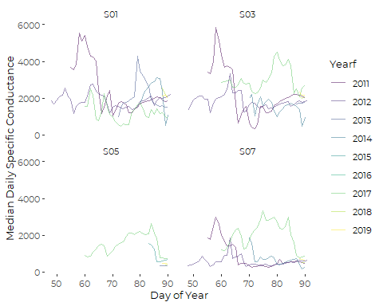 We see a two (or perhaps three) clear conductivity spikes, in 2011 and 2017, that show up at all sites (when we have data). We will focus on these events, each of which is associated with a major winter storm. We choose not to examine several other conductivity spikes, because they are smaller, or less consistent across sites. For example, another sizeable spike appears (around DOY == 78) in 2013, but only at Site S01.

# Event-based Graphics

We designed a graphic that shows specific conductance at the top of a multi-panel layout, with likely environmental drivers shown below. We wrote a function to produce the graphic based on selected data, so we could focus on what is going on at specific sites around specific high conductivity events.

# 2011 Conductivity Peak

## 2011 Storm at Site S07

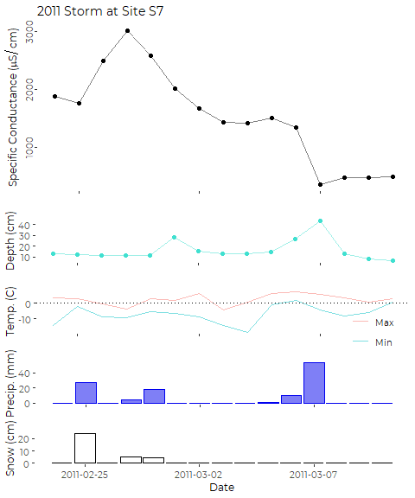

Conductivity starts out high, but climbs further for several days **after** a major winter storm that dumped more than 9 inches of snow at the Jetport. What appears to be a warmer winter storm occurs on the 27th and 28th. The storm appears to shift from mostly snow on 2/27 to mostly rain on 2/28. Water levels in Blanchette Brook climb on the 29th, and conductivity in the stream drops quickly for a few days, but then levels off again. A major rainstorm in early March drops more than 2 inches of rain, which leads to another increase in water depth, and a rapid drop in conductivity.

## 2011 Storm at Site S03

Depth data is unavailable from Site S03 for the period of these storms.

#> Warning: Removed 15 row(s) containing missing values (geom_path).  
#> Warning: Removed 15 rows containing missing values (geom_point).

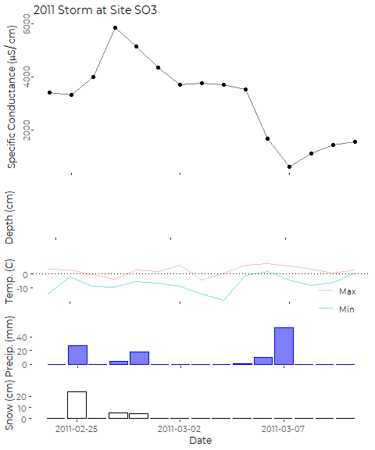 While specific conductance at S03 is nearly double what we saw at S07, the temporal pattern is similar. Without local depth data, we can not interpret these data with much authority, but it is likely that similar processes are at work.

## 2011 Storm at Site S01

Depth data is unavailable from Site S03 for the period of these storms.

#> Warning: Removed 15 row(s) containing missing values (geom_path).  
#> Warning: Removed 15 rows containing missing values (geom_point).

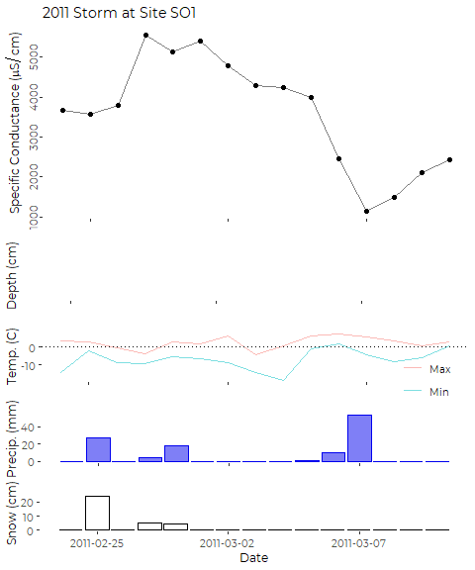

Again, we lack water depth data from this site, but the overall pattern is similar.

# 2017 Conductivity Peak

## 2017 Storms at Site S07

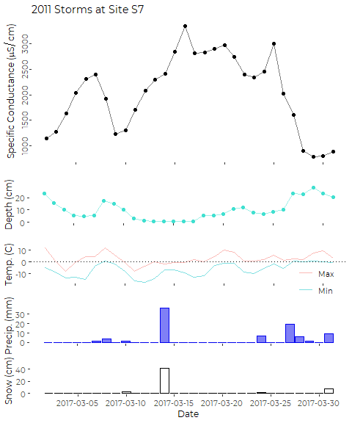

The record starts with specific conductance rising rapidly, while water depth in Blanchette Brook is dropping, perhaps following a relatively small rain event a few days prior to the beginning of the record shown here. A light rain event that persisted for several days under relatively warm conditions causes stream flow to jump, and conductivity to fall. Colder weather,a minor snowfall on 3/10 and a large snow event on 3/14 preceded a rapid climb in conductivity. Conductivity stayed relatively high for over a week. A second spike in conductivity follows a (very) minor snow event around 03/24. A large (about 3/4 inch) rain event on 3/27 leads to a jump in water depth in the stream, and a rapid decline in conductivity.

## 2017 Storms at Site S05

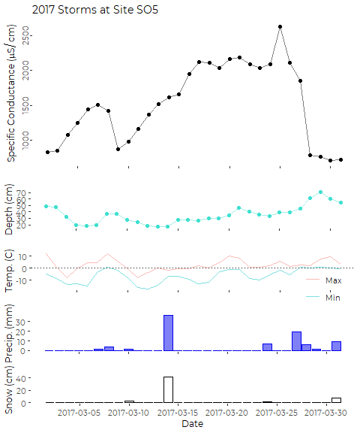

The overall pattern at site S05 looks similar to what we observed at Site S07. That is not too surprising, as Blanchette Brook enters Long Creek above Site S05. Conductivity in Long Creek climbs after snow events, and drops after rain events that are significant enough to cause an increase in water depth in the stream.

## 2017 Storms at Site S03

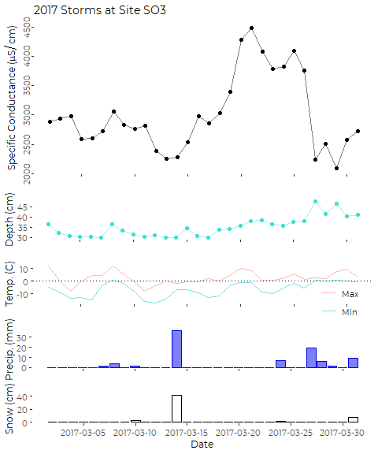

The pattern is a bit less clear at Site S03, especially following smaller storm events. The rainfall on 3/06 and 3/07 leads to an increase in water depth, but also an increase in conductivity. Conductivity then gradually declines over a period of days, until the major storm on 3/14, which appears to lead to increasing conductivity for a period of days. There is a one-day increase immediately after the small snow storm on 3/24, and then the rainfall on 3/27 and 3/28 increases stream flow, and lowers conductivity.

## 2017 Storms at Site S01

#> Warning: Removed 30 row(s) containing missing values (geom_path).  
#> Warning: Removed 30 rows containing missing values (geom_point).

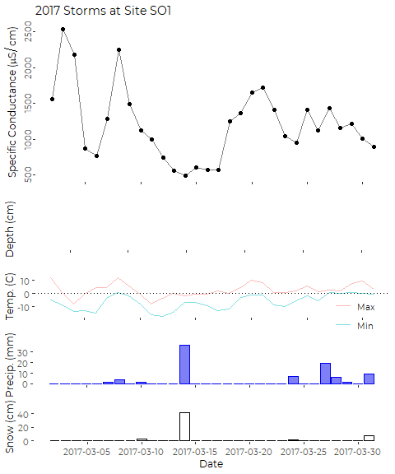

We lack water depth data for this site in 2017.

Rapidly climbing conductivity at the start of this period may be following a minor rain event on 3/01 or warm daytime temperatures. The drop in Conductivity on 3/05 and 3/06 does not correspond to any storm event. The (warm) precipitation on 3/07 and 3/08 occurs simultaneously with a spike in conductivity, followed by a rapid drop. Recovery to lower conductivity 3/10 to 3/17 appears to mirror temperatures, and occurs despite a snowstorm on 3/14.

The snow storm on 3/14 precedes a climb in specific conductance (moderate compared to what was observed at the other sites) by several days. The subsequent increase corresponds to warmer daytime temperatures. Later rain events appear to have little effect on specific conductance in the stream.

Site S01 drains a sizeable portion of the parking area of the Maine Mall. It’s watershed has a very high level of imperviousness, including many acres of parking and roadway. I hypothesize that the primary driver of high specific conductance at this site is wash-off of chlorides from the parking area by liquid water during rain events and via snow melt on warm days.