Monthly Frequencies of “Big Rain” and Snow Events

Curtis C. Bohlen, Casco Bay Estuary Partnership

9/14/2021

# Introduction

This analysis is being conducted to help design a stormwater structure to store (high conductivity) snow melt and release it at the optimal time to minimize the conductivity observed in the downstream receiving waters. If this proves feasible, it may provide a way to reduce the ecological impact of high conductivity events on the stream biota. To guide design decisions, we want to understand patterns of specific conductance in Long Creek in and around winter “high conductivity” events.

While we have looked at statistical approaches, we fall back on a predominately graphical approach to understanding what affects conductivity in Long Creek.

## Data Limitations

We downloaded weather data directly from an on-line NOAA archive. Daily summary data on weather is readily available. We have not found a convenient way to access historical hourly weather data. As a result, **most** graphics are based on daily summary statistics. The values we use for specific conductance and water depth are based on daily median. Weather data are daily totals (for precipitation and snowfall) or minimums and maximums (for temperature).

# Import Libraries

We used several R “Packages” in preparing the analyses, We show which ones we used here, for transparency purposes. The most important packages are part of the well-known “Tidyverse”. The Tidyverse is set of r packages that function almost as extensions to base R. They are widely used for data manipulation, graphics development, and programming in R.

The CBEPgraphics Package is a small package built by CBEP staff that facilitates making graphics with consistent design defaults. It is not strictly necessary for any of the following analyses.

library(gridExtra) # Facilitates assembling graphics from multiple plots  
  
library(tidyverse) # Used for data manipulation (dplyr) and graphics (ggplot2)  
#library(rlang) # Used to allow "tidy evaluation" in our graphics function  
  
library(CBEPgraphics) # Allows Consistent CBEP graphics design  
load_cbep_fonts() # Including the 'Montserrat' font family  
theme_set(theme_cbep())

# Data Preparation

We omit most data preparation code, as of little interest to readers, and simply summarize the steps and decisions made.

## Load Weather Data

Weather data was downloaded from a NOAA “Climate Data Online” API using a custom Python script. The data included daily information on precipitation, snowfall, and (minimum and maximum) air temperatures.

## Load Water Depth Data

We developed daily summaries of the LCWMD data for our “State of Casco Bay” data analysis. Here we load only the daily medians for water depth.

We have some screwy summer water levels from May or June of 2015 at site S05. We filter out any observation over 3 meters. Since w eare interested in winter conditions, this does not matter much.

ggplot(depth_data, aes(sdate, D_Median, color = Site)) + geom_point()  
#> Warning: Removed 1968 rows containing missing values (geom_point).

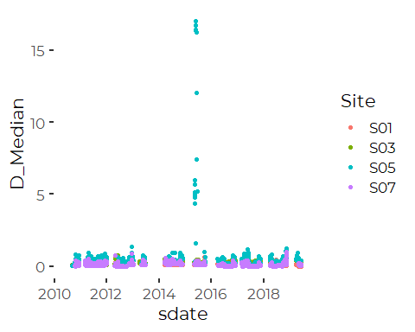

depth_data <- depth_data %>%  
 mutate(D_Median = if_else(D_Median > 3, NA_real_, D_Median)) %>%  
 pivot_wider(sdate, names_from = Site, values_from = D_Median) %>%  
 filter(if_all(c('S01', 'S03', 'S05', 'S07'), ~ ! is.na(.)))

# Combine Daily and Weather Data

We merged the two source datasets by date.

# Winter Months

We restrict our attention to February, and March. (Preliminary review showed that there are few high conductivity events in the December data. We have too little January data to make much difference.).

winter_data <- the_data %>%  
 filter(Month %in% month.abb[c(1, 2, 3, 4, 12)]) %>%  
 mutate(Month = factor(Month, levels = c('Dec', 'Jan', 'Feb', 'Mar', 'Apr')))

# Exploratory Graphic

We take a quick look at the winter data 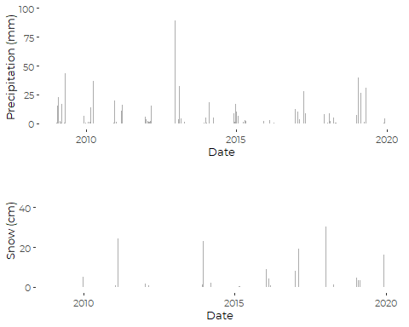 That’s not very helpful, except that is showns many precip events that don’t line up with snow events.

# “Big Rain”

We really want to identify “rain events”, say over 10 mm = 1 cm precipitation with snow under five times the precip. As a rule of thumb, fresh snow is about ten times the depth of equivalent rain, so this suggests most of the precip fell as rain during those events.

winter_data <- winter_data %>%  
 mutate(bigrain = PRCP > 8 & SNOW < 5*PRCP,  
 snowevent = SNOW > 0)

plt3 <- ggplot(winter_data, aes(DOY, PRCP, fill = bigrain)) +  
 geom_col(alpha = 0.5) +  
 scale_color_viridis_d() +  
 theme(legend.position = "bottom") +  
 xlab('Date') +  
 ylab('Precipitation (mm)') +  
 theme_cbep(base_size = 10) +  
 facet_wrap(~Year)  
  
  
plt4 <- ggplot(winter_data, aes(DOY, SNOW/10, fill = bigrain)) +  
 geom_col(alpha = 0.5) +  
 scale_color_viridis_d() +  
 theme(legend.position = "bottom") +  
 xlab('Date') +  
 ylab('Snow (cm)') +  
 theme_cbep(base_size = 10) +  
 facet_wrap(~Year)  
  
plt <- grid.arrange(plt3, plt4, nrow = 2, heights = c(1,1))

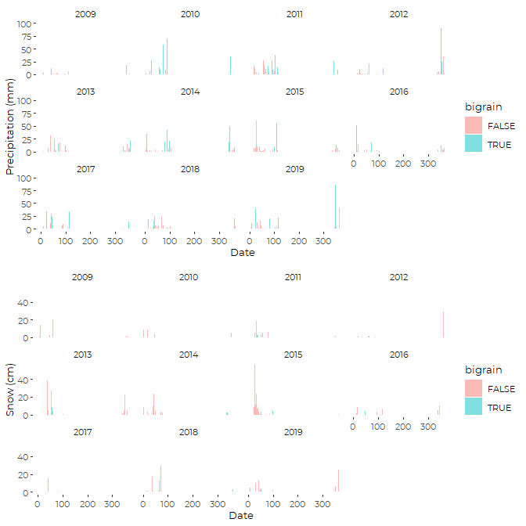

With that in hand, we can make a frequency table.

(freq_table <- xtabs(~Year + Month, data = winter_data, subset = bigrain))  
#> Month  
#> Year Dec Jan Feb Mar Apr  
#> 2009 4 0 2 3 3  
#> 2010 3 1 4 8 2  
#> 2011 5 0 2 4 6  
#> 2012 5 2 1 1 3  
#> 2013 2 0 3 1 3  
#> 2014 8 3 2 4 2  
#> 2015 5 1 0 2 4  
#> 2016 3 1 4 4 1  
#> 2017 3 2 1 1 5  
#> 2018 3 3 4 0 4  
#> 2019 4 5 2 2 5

mn <- apply(freq_table, 2, mean)  
stnd_dev <- apply(freq_table, 2, sd)  
tbl <- cbind(round(mn,1), round(stnd_dev,3))  
colnames(tbl) <- c('Mean', 'Std. Dev.')  
tbl  
#> Mean Std. Dev.  
#> Dec 4.1 1.640  
#> Jan 1.6 1.567  
#> Feb 2.3 1.348  
#> Mar 2.7 2.240  
#> Apr 3.5 1.508

# Snow Events

freq_table <- xtabs(~Year + Month, data = winter_data, subset = snowevent)  
mn <- apply(freq_table, 2, mean)  
stnd_dev <- apply(freq_table, 2, sd)  
tbl <- cbind(round(mn,1), round(stnd_dev,3))  
colnames(tbl) <- c('Mean', 'Std. Dev.')  
tbl  
#> Mean Std. Dev.  
#> Dec 6.7 2.611  
#> Jan 7.2 1.662  
#> Feb 8.0 2.720  
#> Mar 5.0 2.049  
#> Apr 1.4 1.286