Supplementary Analysis of High Frequency Conductivity Data

Curtis C. Bohlen, Casco Bay Estuary Partnership

9/12/2021

# Introduction

This analysis is being conducted to help design a stormwater structure to store (high conductivity) snow melt and release it at the optimal time to minimize the conductivity observed in the downstream receiving waters. If this proves feasible, it may provide a way to reduce the ecological impact of high conductivity events on the stream biota. To guide design decisions, we want to understand patterns of specific conductance in Long Creek in and around winter “high conductivity” events.

While we have looked at statistical approaches, we fall back on a predominately graphical approach to understanding what affects conductivity in Long Creek.

## Data Limitations

This analysis is based on the data selected data from the Long Creek Watershed Management District (LCWMD). In particular, it is based on data shared with the Casco Bay Estuary Partnership (CBEP) in preparation for our 2020 “State of Casco Bay” report. Those data do not include discharge data, although it is my understanding that discharge data is available. We use water depth as a weak surrogate for discharge here, but mass-balance calculations (estimating mass of chloride flowing past monitoring locations per unit time) are not possible with these data alone.

In addition, we downloaded weather data directly from an on-line NOAA archive. Daily summary data on weather is readily available. We have not found a convenient way to access historical hourly weather data. As a result, **most** graphics are based on daily summary statistics. The values we use for specific conductance and water depth are based on daily median. Weather data are daily totals (for precipitation and snowfall) or minimums and maximums (for temperature).

# Import Libraries

We used several R “Packages” in preparing these analyses, We show which ones we used here, for transparency purposes. The most important packages are part of the well-known “Tidyverse”. The Tidyverse is set of r packages that function almost as extensions to base R. They are widely used for data manipulation, graphics development, and programming in R.

The CBEPgraphics Package is a small package built by CBEP staff that facilitates making graphics with consistent design defaults. It is not strictly necessary for any of the following analyses.

library(gridExtra) # Facilitates assembling graphics from multiple plots  
  
library(tidyverse) # Used for data manipulation (dplyr) and graphics (ggplot2)  
library(rlang) # Used to allow "tidy evaluation" in our graphics function  
  
library(CBEPgraphics) # Allows Consistent CBEP graphics design  
load_cbep_fonts() # Including the 'Montserrat' font family  
theme_set(theme_cbep())

# Data Preparation

We omit most data preparation code, as of littler interest to readers.

## Load Weather Data

Weather data was downloaded from a NOAA “Climate Data Online” API using a custom Python script. The data included daily information on precipitation, snowfall, and (minimum and maximum) air temperatures.

## Load High Frequency Data

We developed daily summaries of the LCWMD datafor our "State of Casco Bay data analysis. Here we loaded only the daily medians for conductivity, water depth, and (estimated) chloride concentrations.in daily summaries and retain only the median values.

#> Warning: Missing column names filled in: 'X1' [1]

# Data Correction

## Site S03, End of 2016

We noted some extreme dissolved oxygen data at the end of 2016. Values were both extreme and highly variable. We concluded that the data was suspect, perhaps because of damage to, burying of the sensors. We decided to remove chloride and oxygen observations after October 15th that year.

# Data Review

## Limited Data from Winter Months

We have limited data from most winter months. We have January data from only one year, February data from only three, and December data from four.

xtabs(~ Yearf + Month, data = sonde_data)  
#> Month  
#> Yearf Jan Feb Mar Apr May Jun Jul Aug Sep Oct Nov Dec  
#> 2010 0 0 0 0 0 6256 9051 9720 11504 11897 11520 3199  
#> 2011 0 1268 9492 11520 11904 11427 11904 11743 11518 11904 11520 10553  
#> 2012 0 3579 8913 8629 8928 10786 11904 11904 11520 3486 8944 11904  
#> 2013 664 0 2092 6109 7438 6676 5714 5710 5760 6425 7200 598  
#> 2014 0 0 2443 4835 7440 7197 7440 7440 7194 7440 5683 0  
#> 2015 0 0 724 8056 10381 10080 10410 10415 10073 9094 1599 0  
#> 2016 0 0 314 8124 8925 8639 8928 8928 8640 8927 7929 0  
#> 2017 0 0 8746 8640 8926 8639 8928 8928 8639 8927 4763 0  
#> 2018 0 0 595 8640 8928 8640 8924 8928 8639 8928 5911 0  
#> 2019 0 0 747 8640 8924 2729 0 0 0 0 0 0

We restrict our attention to February, and March. (Preliminary review showed that there are few high conductivity events in the December data. We have too little January data to make much difference.).

winter_data <- sonde_data %>%  
 filter(Month %in% month.abb[c(2,3)]) %>%   
 filter(! is.na(SpCond))

## Uneven Winter Sampling By Site

#> Number of Days with Data by Site and Year  
#> Year  
#> Site 2011 2012 2013 2014 2015 2016 2017 2018 2019  
#> S01 3314 4176 886 496 0 0 1462 111 127  
#> S03 3311 4160 160 974 0 17 1458 111 62  
#> S05 0 0 160 0 724 13 1457 77 124  
#> S06B 0 0 886 0 0 0 0 0 0  
#> S07 3309 4155 0 972 0 14 1452 74 122  
#> S17 0 0 0 0 0 0 0 112 126

# Drop Data from Sites with Little Winter Data

We retain data from four sites:

* Site S07 is at the bottom of Blanchard Brook.
* Site S05 is mid-watershed, upstream of the Turnpike.
* S03 is just above the confluence of the the North Branch with the Main Stem.
* S01 is near the bottom of the South Branch.

winter_data <- winter_data %>%  
 filter(Site != 'S06B' & Site != 'S17')

# Exploratory Graphic

We take a quick look at all the winter data 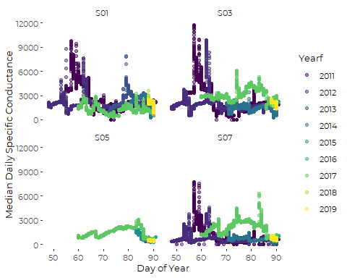 We see a two (or perhaps three) clear conductivity spikes, in 2011 and 2017, that show up at all sites (when we have data). We will focus on these events, each of which is associated with a major winter storm. We choose not to examine several other conductivity spikes, because they are smaller, or less consistent across sites. For example, another sizeable spike appears (around DOY == 78) in 2013, but only at Site S01.

rm(sonde_data)

# Event-based Graphics

We designed a graphic that shows specific conductance at the top of a multi-panel layout, with likely environmental drivers shown below. We wrote a function to produce the graphic based on selected data, so we could focus on what is going on at specific sites around specific high conductivity events.

# 2011 Conductivity Peak

## 2011 Storm at Site S07

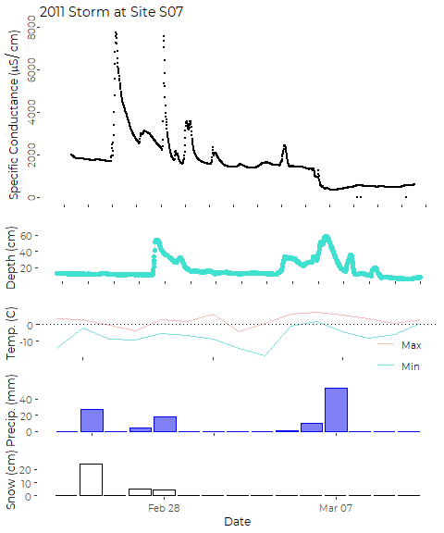

Conductivity starts out high, but climbs rapidly on the day **after** a major winter storm that dumped more than 9 inches of snow at the Jetport. What appears to be a warmer winter storm occurs on the 27th and 28th. The storm appears to shift from mostly snow on 2/27 to mostly rain on 2/28. Water levels in Blanchette Brook climb on the 28th, and conductivity in the stream skyockets, but also drops quickly, then tapers gradually for a few days. A major rain on 3/05 through 3/07 drops more than 2 inches of rain, which leads to another increase in water depth, and a rapid drop in conductivity.

The major spikes in conductivity (two, three, or five spikes) all last less than 24 hours. Spikes develop rapidly, and then exhibit something like an exponential fall-off in conductivity.

## 2011 Storm at Site S03

Depth data is unavailable from Site S03 for the period of these storms.

#> Warning: Removed 1370 row(s) containing missing values (geom_path).  
#> Warning: Removed 1370 rows containing missing values (geom_point).

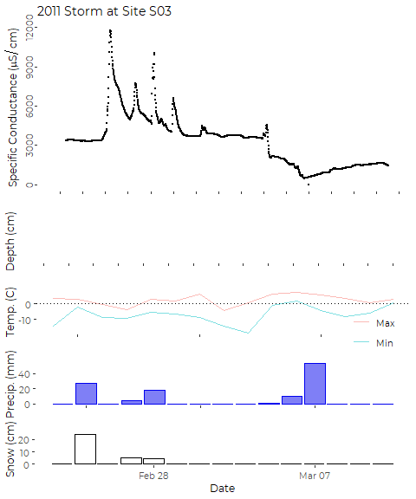 While specific conductance at S03 is several times what we saw at S07, the temporal pattern is similar, but with more short-term spikes in conductivity. The spikes in conductivity appear to be diurnal, occurring over night or in the early morning. Perhaps that corresponds to overnight salt applications?

WE again see a dilution effect after the major rains on March 6 and 7.

## 2011 Storm at Site S01

Depth data is unavailable from Site S03 for the period of these storms.

#> Warning: Removed 1375 row(s) containing missing values (geom_path).  
#> Warning: Removed 1375 rows containing missing values (geom_point).

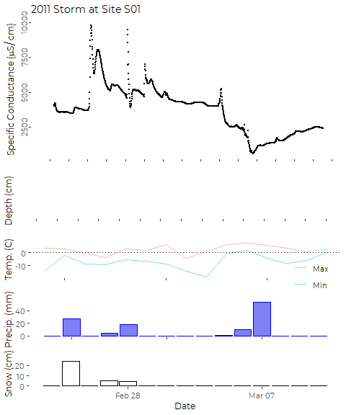

Again, we lack water depth data from this site, but the overall pattern is similar. We see only a small jump in conductivity associated with the storm on 2/25, but a much larger jump on 2/26 in the early morning, and another spike on 2/18, which appears to lead to gradual systemic increase in conductivity for several days.

My interpretation is that we are seeing rapid runoff to the stream immediately following night-time application of salt on the Maine Mall parking lots, followed by a more gradual increase that reflects recent cummulative applications and dilution by rainfall.

# 2017 Conductivity Peak

## 2017 Storms at Site S07

#> Warning: Removed 10 rows containing missing values (geom_point).  
#> Warning: Removed 31 rows containing missing values (geom_point).

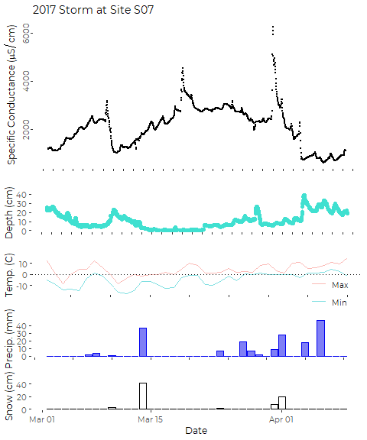

The record starts with specific conductance rising rapidly, while water depth in Blanchette Brook is dropping, perhaps following a relatively small rain event a few days prior to the beginning of the record shown here. A light rain event that persisted for several days under relatively warm conditions causes stream flow to jump, and conductivity to fall. A short-term spike in conductivity occurs just before a minor snowfall on 3/10, but not before the major snowfall on 3/14. After that large storm, however, conductivity climbs steadily for about a week. The peak in conductivity occurs as air temperatures rise above freezing on 3/20. Values hold steady then decline after rain, but spike again before a snow storm on April 1.

## 2017 Storms at Site S05

#> Warning: Removed 10 rows containing missing values (geom_point).  
#> Warning: Removed 1 rows containing missing values (geom_point).

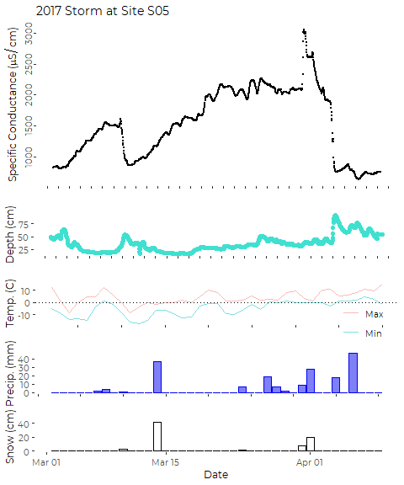

The overall pattern at site S05 looks similar to what we observed at Site S07. That is not too surprising, as Blanchette Brook enters Long Creek above Site S05. Conductivity in Long Creek climbs after snow events, and drops after rain events that are significant enough to cause an increase in water depth in the stream.

Here we do not see the marked spikes in conductivity that may indicate local sources of salt preceeding storms.

## 2017 Storms at Site S03

#> Warning: Removed 10 rows containing missing values (geom_point).

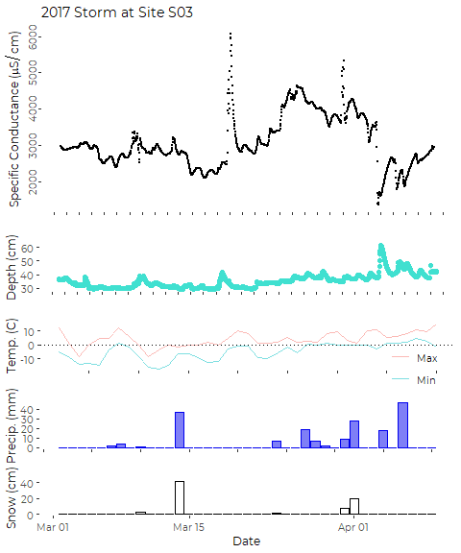

The pattern is a bit less clear at Site S03, especially following smaller storm events. COnductivity climbs for over a week after the large storm on 3/14. The sharpest spikes appear to coincide with warmer days, perhaps indicating snow melt events. Deeper water is associated with lower condcctivity.

## 2017 Storms at Site S01

#> Warning: Removed 10 rows containing missing values (geom_point).  
#> Warning: Removed 1437 row(s) containing missing values (geom_path).  
#> Warning: Removed 1437 rows containing missing values (geom_point).

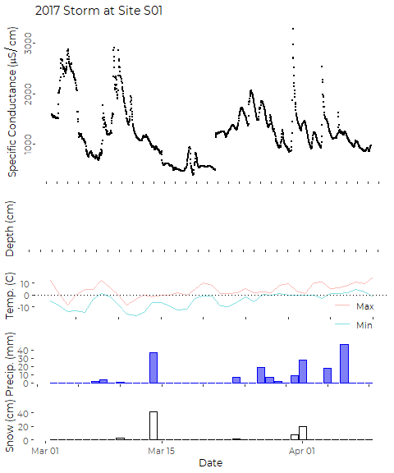

We lack water depth data for this site in 2017.

Rapidly climbing conductivity at the start of this period may be following a minor rain event on 3/01 or warm daytime temperatures. The drop in Conductivity on 3/05 and 3/06 does not correspond to any storm event. The (warm) precipitation on 3/07 and 3/08 occurs simultaneously with a spike in conductivity, followed by a rapid drop.

The snow storm on 3/14 precedes a climb in specific conductance (moderate compared to what was observed at the other sites) by several days. The subsequent increase corresponds to warmer daytime temperatures. Later rain events appear to have little effect on specific conductance in the stream.

Site S01 drains a sizeable portion of the parking area of the Maine Mall. It’s watershed has a very high level of imperviousness, including many acres of parking and roadway. I hypothesize that the primary driver of high specific conductance at this site is wash-off of chlorides from the parking area by liquid water during rain events and via snow melt on warm days.