MV_2025-09-06
# plot of species counts for hibernacula substrate based on most recent .csv, hibernacula_camera_trapping_sp_list.csv
hibernacula$`Common Name` <- factor(hibernacula$`Common Name`,
levels = hibernacula$`Common Name`)
hibernacula <- hibernacula %>% arrange(Detections)
cthibernacula2021 <- hibernacula %>%
ggplot(aes(x = `Common Name`,y = Detections,fill = `Common Name`))+
geom_col(alpha = 0.9)+
ggtitle("2021 Hibernacula Substrate Species Observations")+
theme_light()+
theme(axis.ticks.x = element_blank(),axis.text.x = element_blank(),
legend.title = element_blank(),legend.text = element_text(size = 8),
plot.title = element_text(hjust = 0.5))
# top 5 species utilizing hibernacula:
# 1. Western Meadowlark
# 2. American Crow
# 3. Killdeer
# 4. Burrowing Owl
# 5. Canada Goose
#ggsave(filename = paste0("Camera_Trapping_Hibernacula_Composition_2021_",
# format(Sys.Date(),"%Y-%m-%d"),".pdf"),
# cthibernacula2021,width = 200,height = 140,units = "mm")
plot(cthibernacula2021)
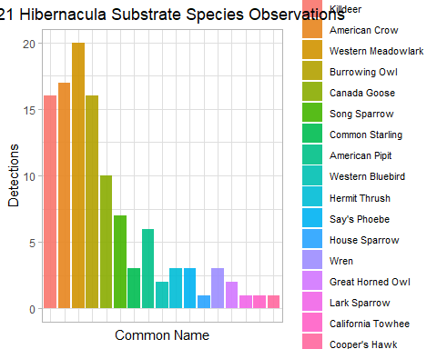
mbshibernacula <- joined %>% filter(Substrate == "Habitat Feature - Hibernacula") %>%
ggplot(aes(x = Species,y = Count,fill = Species)) +
geom_col(alpha = 0.9) +
ggtitle("Species Composition for Hibernacula by Survey Year") +
theme_light() +
theme(axis.ticks.x = element_blank(),axis.text.x = element_blank(),
axis.title.x = element_blank(),legend.title = element_text(face = "bold"),
legend.text = element_text(size = 10),plot.title = element_text(hjust = 0.5)) +
facet_wrap(~ survey_year)
# surprised that there were so few detections for hibernacula, so manually verifying by restricting dataframe below - verified correct
# joined_hibernacula <- joined %>% filter(survey_year == "2020-2021" & Substrate == "Habitat Feature - Hibernacula")
# bshibernacula <- birdsurveys %>% filter(Year == 2020 & Substrate == "Habitat Feature - Hibernacula")
#ggsave(filename = paste0("Monthly_Bird_Survey_Hibernacula_Composition_",
# format(Sys.Date(),"%Y-%m-%d"),".pdf"),
# mbshibernacula,width = 200,height = 140,units = "mm")
plot(mbshibernacula)
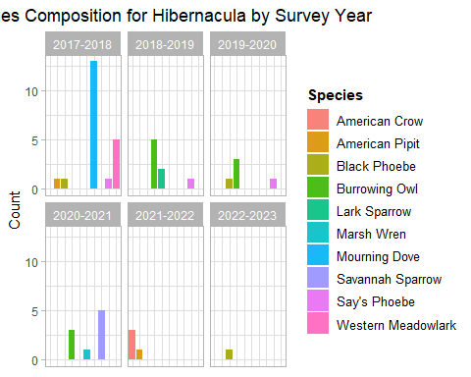
totals <- joined %>% group_by(survey_year,General.Type) %>% summarise(total_count = sum(Count))
## `summarise()` has grouped output by 'survey_year'. You can override using the
## `.groups` argument.
totals %>% ggplot(aes(x = survey_year,y = total_count,fill = General.Type)) +
geom_col(show.legend = F) +
labs(x = "Survey Year",y = "Count",
title = "Observation of General Types per Survey Year Across All Substrates") +
facet_wrap(~ General.Type) +
theme_light() +
theme(axis.text.x = element_text(angle = 90,hjust = 1,vjust = 0.5),
plot.title = element_text(hjust = 0.5))
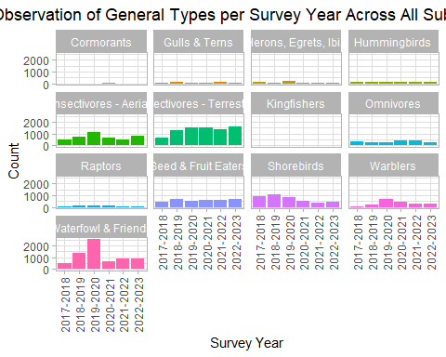
# number of observed species per survey year
total_species <- joined %>% group_by(survey_year,Species) %>% summarise(total_count = sum(Count))
## `summarise()` has grouped output by 'survey_year'. You can override using the
## `.groups` argument.
# dataframe for count of unique species per survey year
richness <- data.frame(survey_year = unique(joined$survey_year),num_species = NA*6)
richness <- richness %>% arrange(survey_year)
for(i in 1:length(unique(total_species$survey_year))){
temp <- total_species %>% filter(survey_year == unique(total_species$survey_year)[i])
richness$num_species[i] <- length(unique(temp$Species))
}
richness %>% ggplot(aes(x = survey_year,y = num_species)) +
geom_col(alpha = 0.9,fill = "seagreen3") +
labs(x = "Survey Year",y = "Number of Species",
title = "Total Number of Observed Species per Survey Year") +
theme_light() +
theme(plot.title = element_text(hjust = 0.45))
