MV_2025-11-18
Matt Vinh

Main Figures
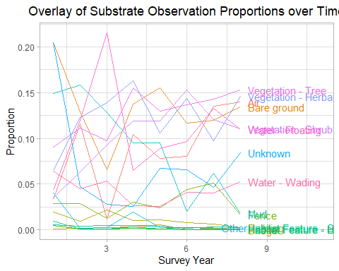
Figure 1: Relative proportions of observations per substrate per survey year with all substrates layered on top of each other. Due to the difficulty of differentiating the 16 included substrates I added a text label at the end of each line, allowing the substrates with nonzero relative proportion during survey year 8 to be better distinguished. This solution feels imperfect but I cannot think of another way to label the substrates to improve readability.
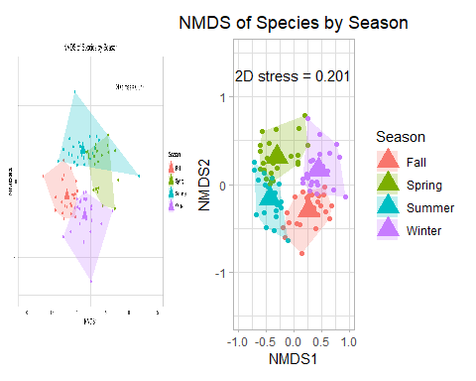
Figure 2, left: Previous species per season NMDS. This figure was incorporated as a saved .pdf, so formatting was limited, hence it looks a little weird. Next time I will just go through the process of recreating the figure. Figure 3, right: Updated Species per Season NMDS utilizing improved data aggregation, namely implementation of “unknown” substrate. Compared to Figure 2, Figure 3 has reduced ordination overlap and increased stress.
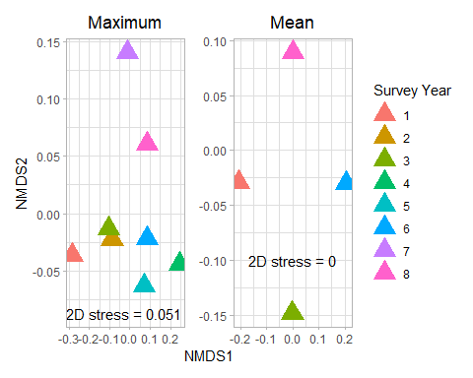
Figure 4, left: Maximum species abundance per survey year NMDS. Figure 5, right: Mean species abundance per survey year NMDS. Note that for the centroids in Figure 5, survey years 4, 5, 7 and 8 are all stacked in the “north” and survey years 2 and 3 are stacked in the “south”. Refer to Figure 6 for more details.
Figure 6: Table of mean species abundance per survey year NMDS centroid axes coordinates. Note the overlap of survey years 4, 5, 7 and 8 and survey years 2 and 3.
Survey_Year | axis1 | axis2
1 | -0.2062745 | -0.0288749
2 | -0.0006724 | -0.1487503
3 | -0.0006163 | -0.1487587
4 | 0.0004113 | 0.0893055
5 | 0.0004170 | 0.0891858
6 | 0.2060368 | -0.0304995
7 | 0.0003399 | 0.0891623
8 | 0.0003581 | 0.0892298

Developmental Figures
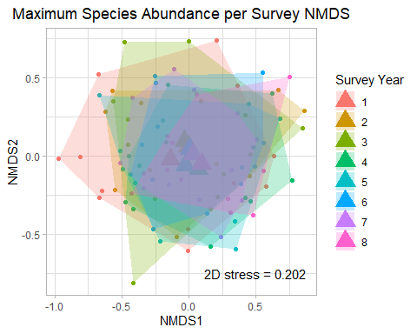
Figure 7: Maximum species abundance per survey NMDS. This NMDS visualization was produced to uderstand how changing from annual to indivdual survey would affect the ordination.
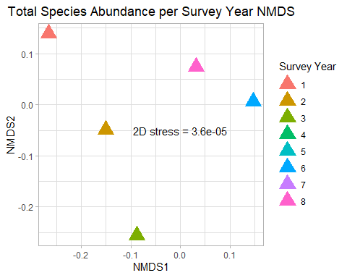
Figure 8: Total species abundance per survey year NMDS. This figure was the first produced, initially seeming “poor” to me due to the lack of encompassing hull such as that which is visible per survey year in Figure 7. The ordination result is similar to that of Figure 5, with survey years 4, 5, 6, 7 and 8 all stacked in the “north”. Although the plot is interesting, I am not sure if it is as informative as maximum abundance or mean abundance. Refer to Figure 9 for more details.
Figure 9: Table of total species abundance per survey year NMDS centroid axes coordinates. Note the overlap of survey years 4, 5, 6, 7 and 8.
Survey_Year | axis1 | axis2
1 | -0.2654753 | 0.1391542
2 | -0.1509122 | -0.0487933
3 | -0.0875021 | -0.2561942
4 | 0.1470055 | 0.0056063
5 | 0.1469957 | 0.0055942
6 | 0.1469805 | 0.0056323
7 | 0.0314749 | 0.0744964
8 | 0.0314331 | 0.0745042
Special thanks to Francis for helping me understand NMDS results as I worked.

