Campus Lagoon eBird data summary
Francis H. Joyce
Francis H. Joyce
13 February 2026

Background
This is a quick analysis of eBird data available for the Campus Lagoon eBird hotspot (“UCSB–Campus Lagoon” as of December 2025.
The hotspot details page reports that 256 species have been recorded here (across all years), in 2,884 checklists, by 822 eBirders.
Here I look at the number of species reported per year, the number of checklists submitted per year, and the relationship between those two variables.
Notes:
- The code to generate this summary is in this GitHub repository. Because of the large file sizes, the repository does not contain the data, which can be downloaded from eBird after submitting a data download request.
- This includes monthly CCBER surveys at Campus Lagoon if they were submitted to eBird

Preliminary figures
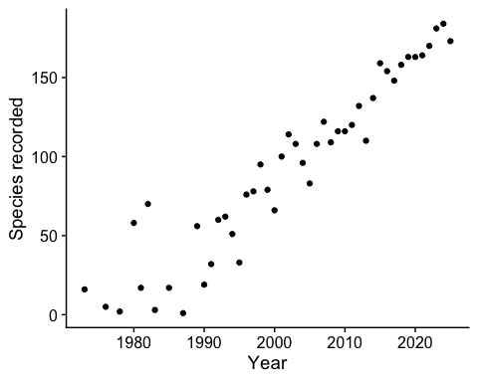
Figure 1: Number of species recorded at the UCSB Campus Lagoon eBird hotspot per calendar year.
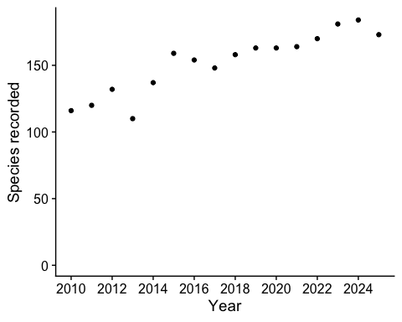
Figure 2: Number of species recorded per year between 2010 and 2025.
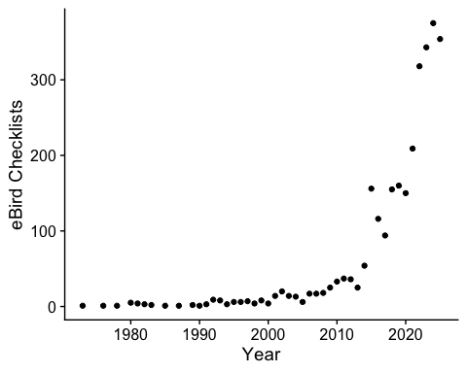
Figure 3: Number of checklists submitted at the UCSB Campus Lagoon eBird hotspot per calendar year.
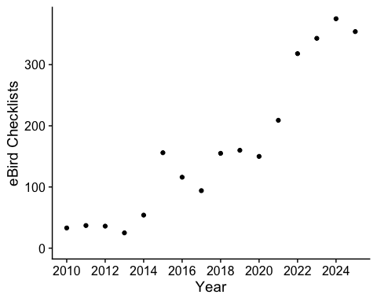
Figure 4: Number of checklists submitted at Campus Lagoon between 2010-2025.
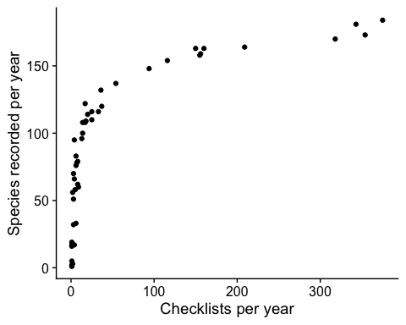
Figure 5: Number of species recorded per year in relation to the number of checklists submitted per year.

