NCOS ebird summary
Francis H. Joyce
30 January 2026

Background
This is a quick analysis of eBird data available for the North Campus Open Space eBird hotspot (“UCSB North Campus Open Space (formerly Ocean Meadows Golf Course)” as of December 2025.
The hotspot details page reports that 259 species have been recorded here, in 5,769 checklists, by 712 eBirders.
Here I look at the number of species reported per year, the number of checklists submitted per year, and the relationship between those two variables.
The code to generate this summary is in this GitHub repository. Because of the large file sizes, the repository does not contain the data, which can be downloaded from eBird after submitting a data download request.

Preliminary figures
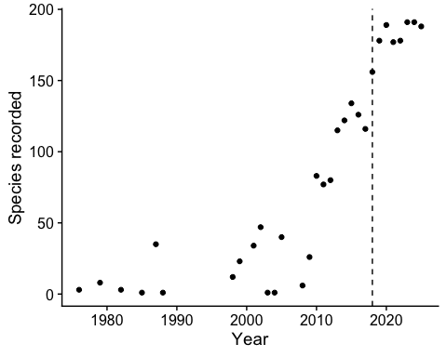
Figure 1. Number of species recorded at the NCOS eBird hotspot per calendar year. The vertical dashed line indicates 2018, when NCOS was opened to the public.
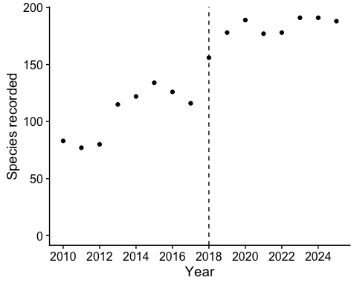
Figure 2. Number of species recorded per year between 2010 and 2025.
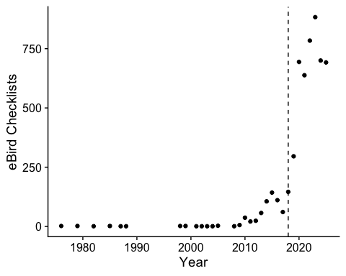
Figure 3. Number of checklists submitted at the NCOS eBird hotspot per calendar year. The vertical dashed line indicates 2018, when NCOS was opened to the public.
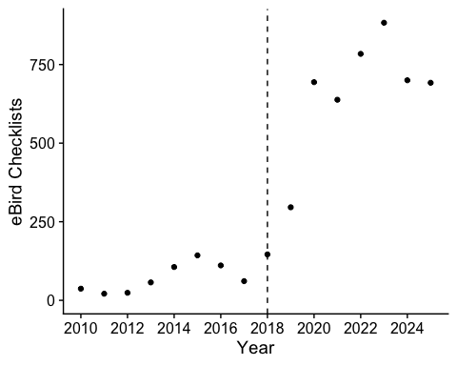
Figure 4. Number of checklists submitted at NCOS between 2010-2025. The vertical dashed line indicates 2018, when NCOS was opened to the public.
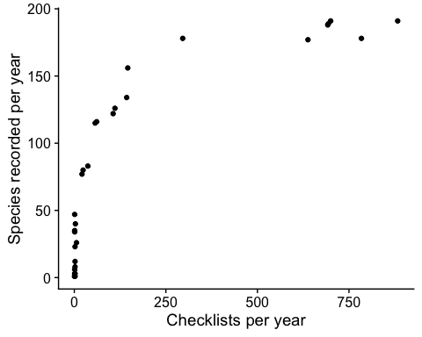
Figure 5. Number of species recorded per year in relation to the number of checklists submitted per year.

