Programme Walkthrough

The user is first prompted for their PIN. The date is also displayed above.

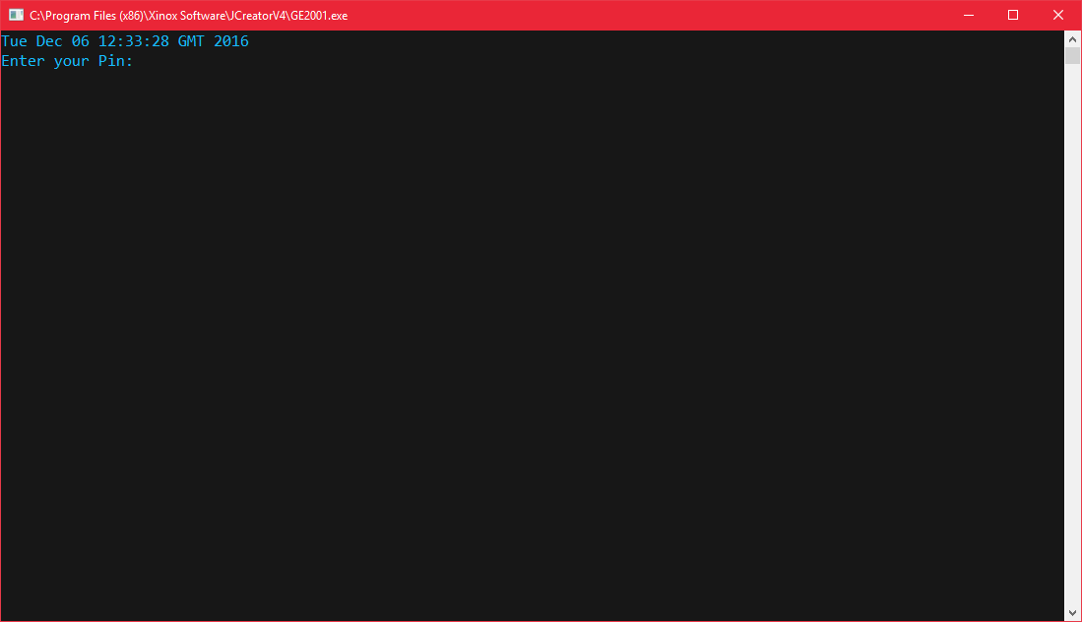

If the pin is incorrect , the incorrect pin will be displayed and then the user will be prompted to enter in a new pin.

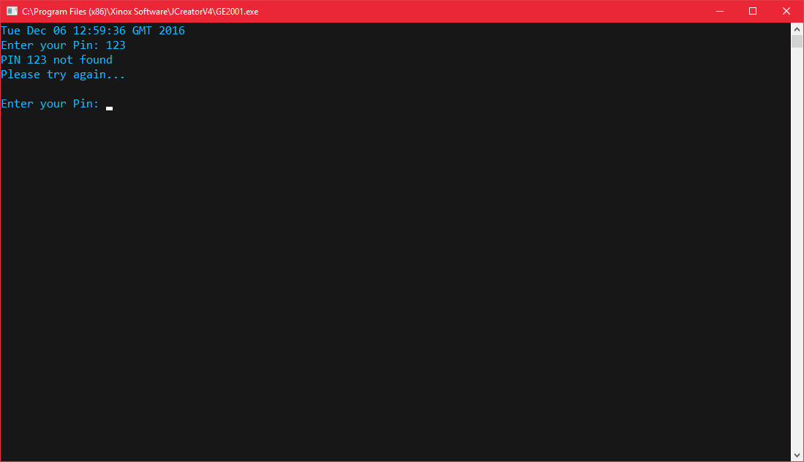

If pin is correct the User is welcomed and given a menu with options to select from, asking for their input.

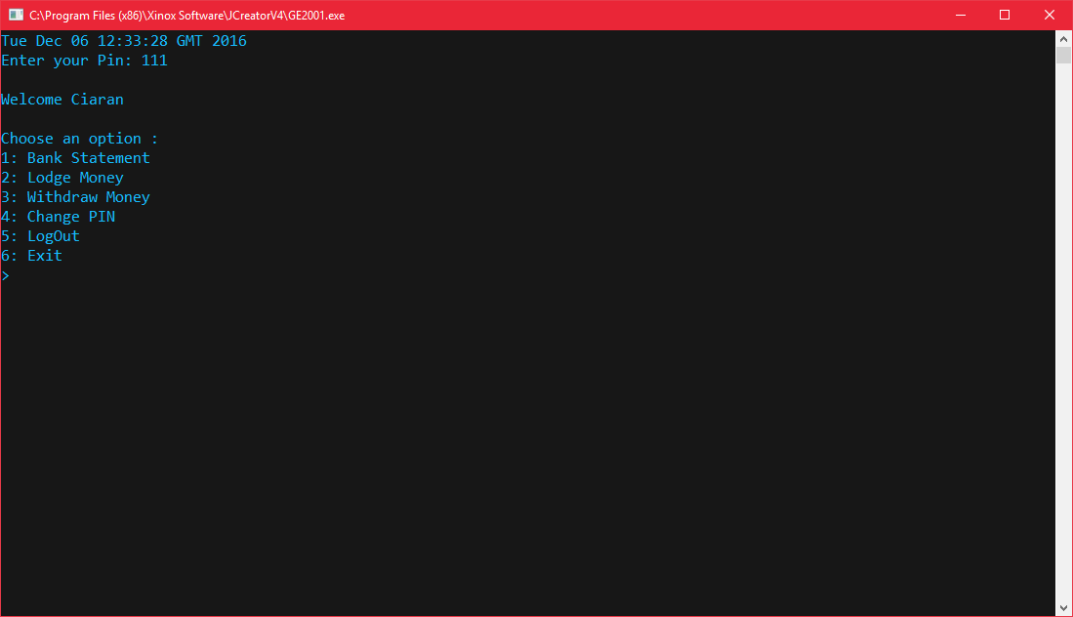

If the user selects an incorrect option an error will be displayed. The user is then again prompted with the menu.  
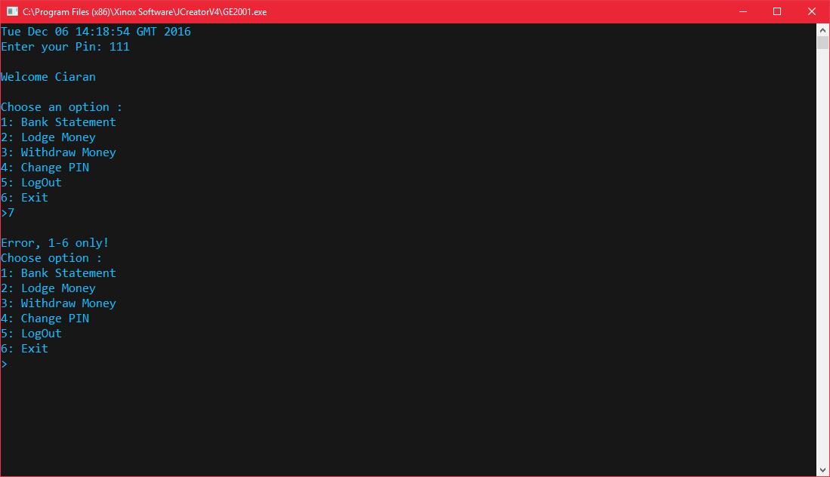

Option 1: will show your bank statement , This includes the users PIN,Name,Balance and whether overdraft facility is available.

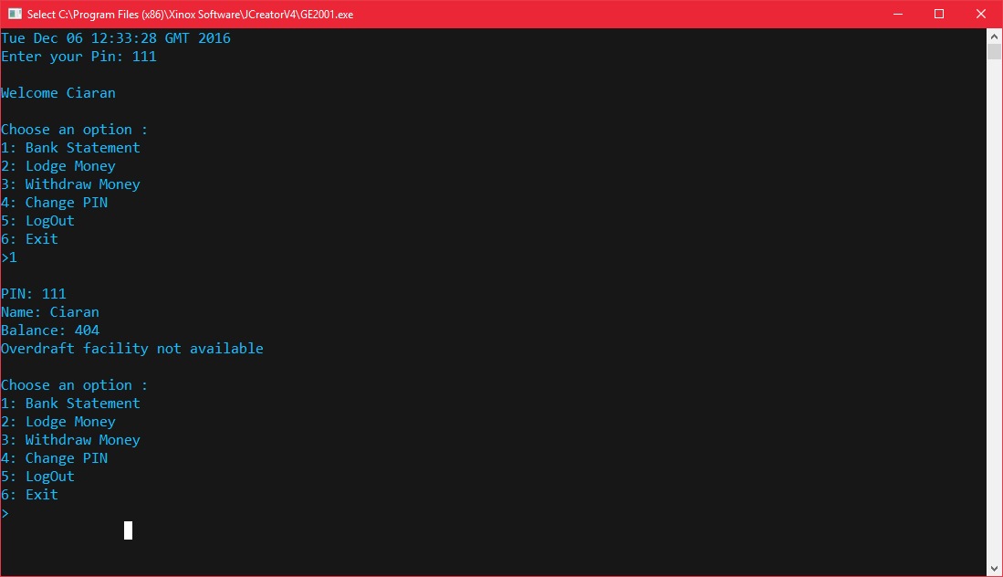

Selecting option 2: allows you to lodge money into your account.

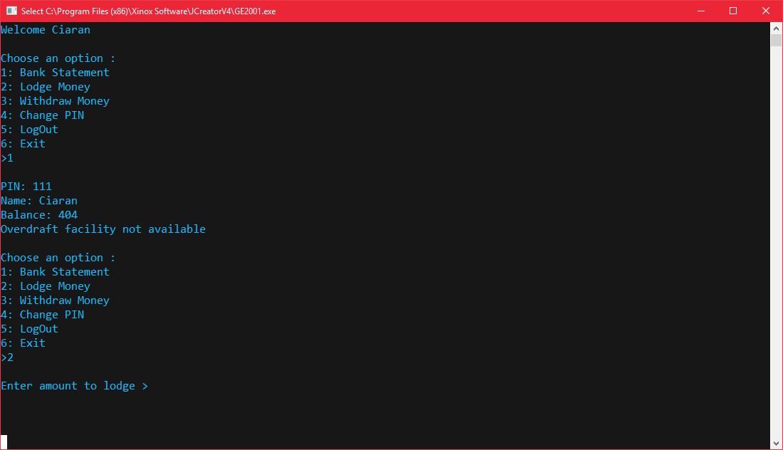

If the user enters a minus number or if letters are entered an error and will be displayed and the user is prompted to enter lodgement amount again until a correct amount is entered.

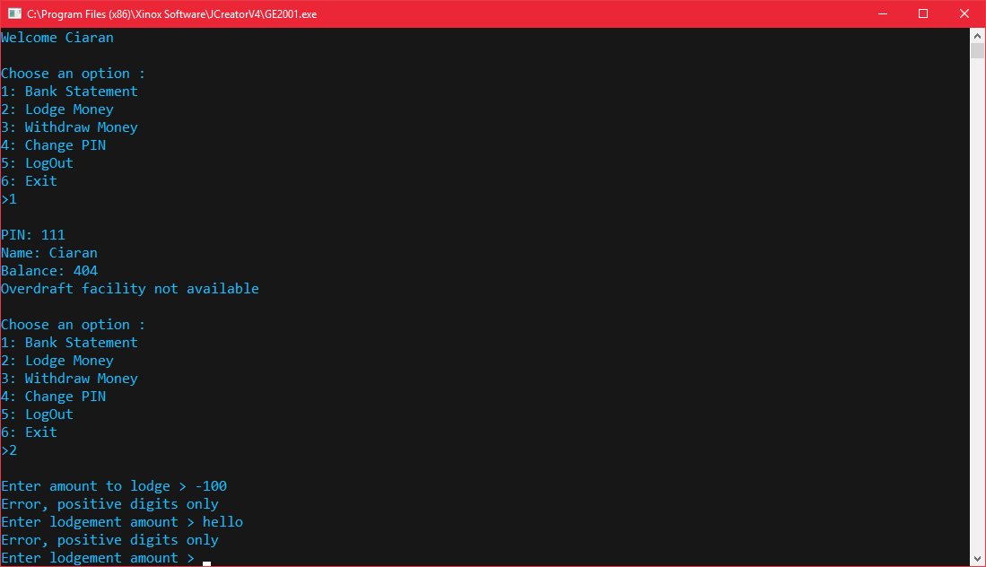

After the user enters an amount to lodge, the users new balance with be displayed. The user is then returned to the menu.

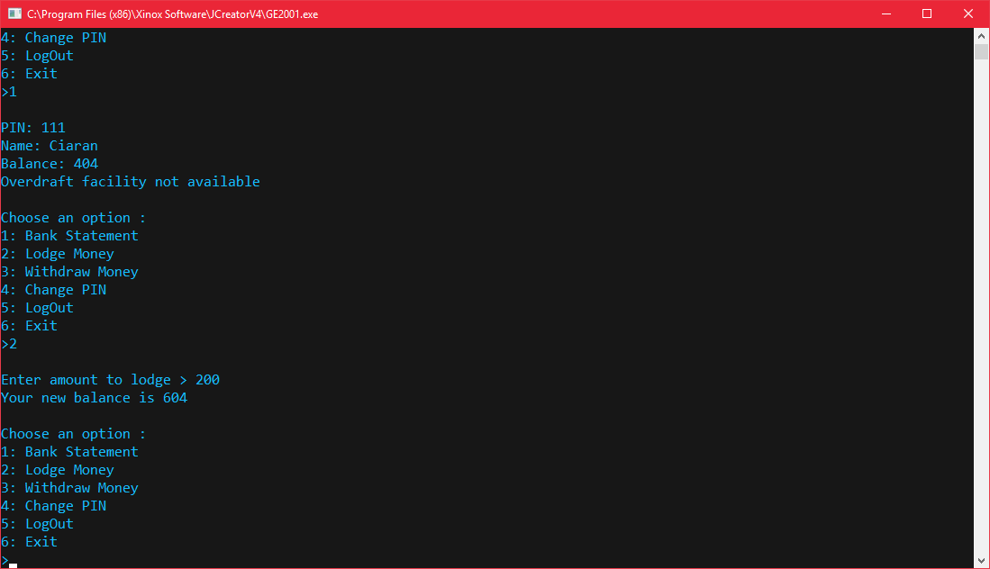

Selecting option 3: allows the user to withdraw money from their account.

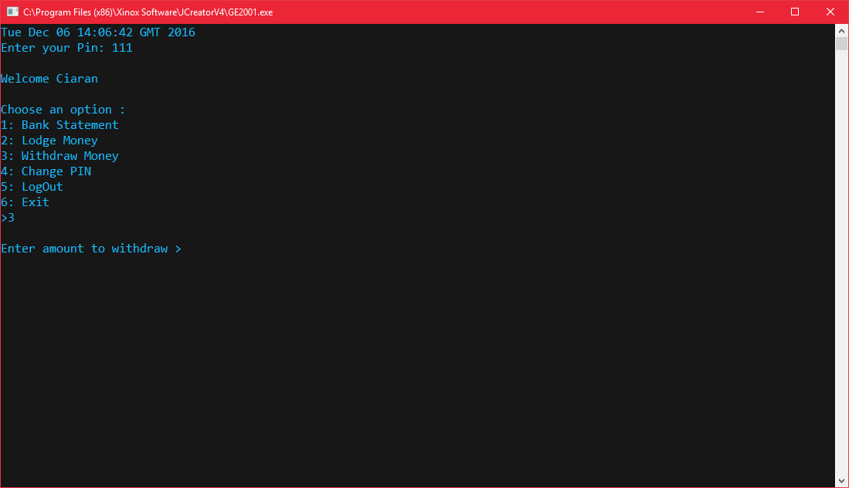

If the user enters a minus number or if letters are entered an error and will be displayed and the user is prompted to enter withdrawal amount again until a correct amount is entered.

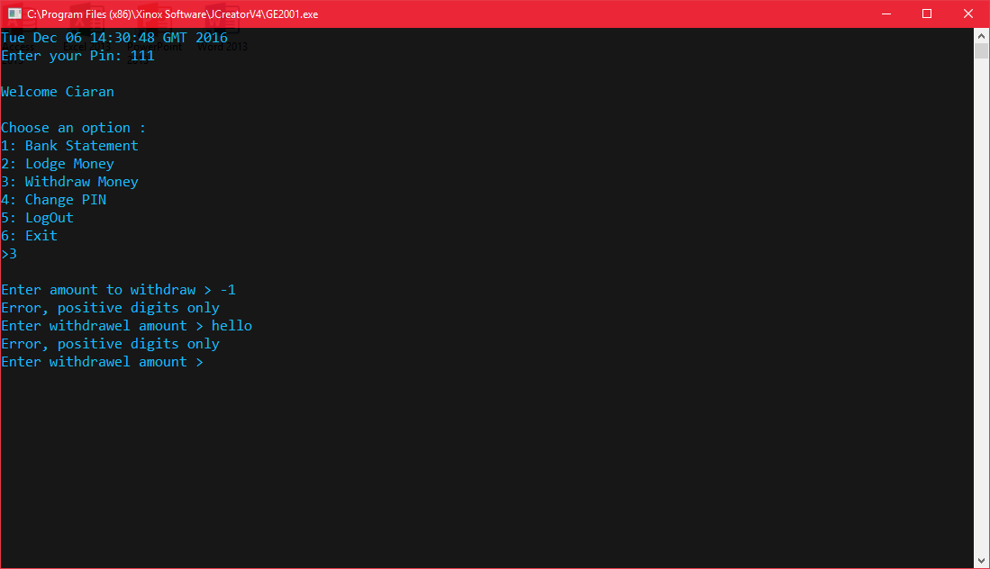

After the user enters the amount they wish to withdraw the new balance will be displayed and the user is returned to the menu.

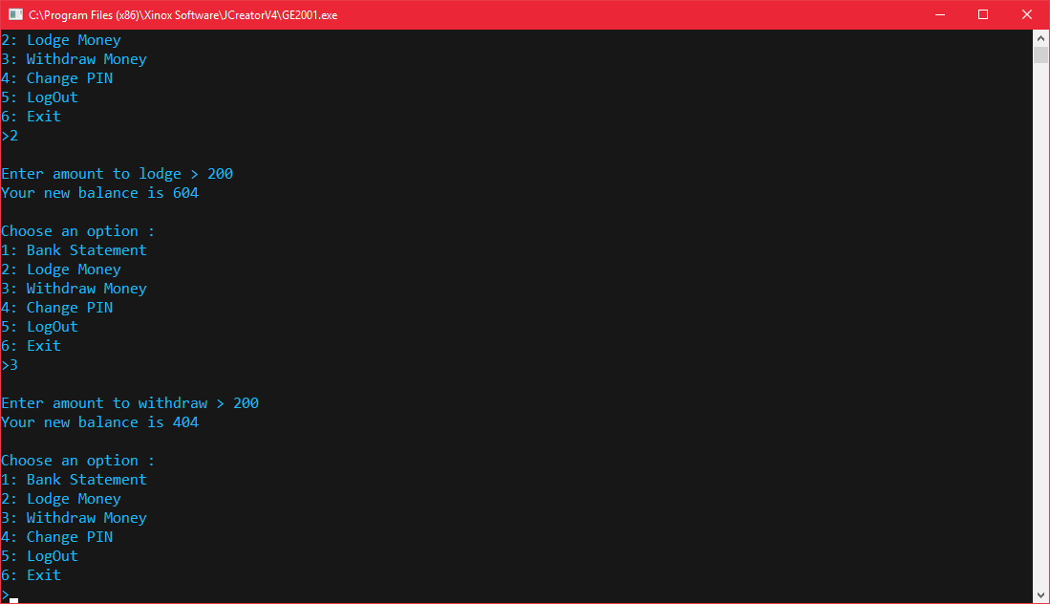

Option 4: allows the user to change their pin. Once entered the user will be prompted if they are sure they want to change their pin.

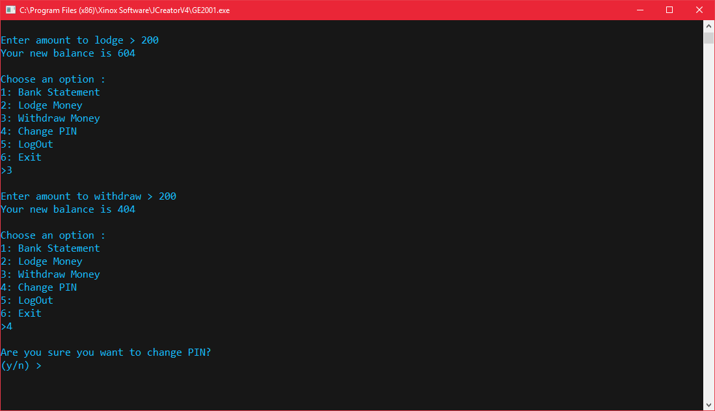

If the user has an error in their input for confirmation of changing the PIN  
i.e does not select ‘n’ or ‘y’. An error will be displayed.

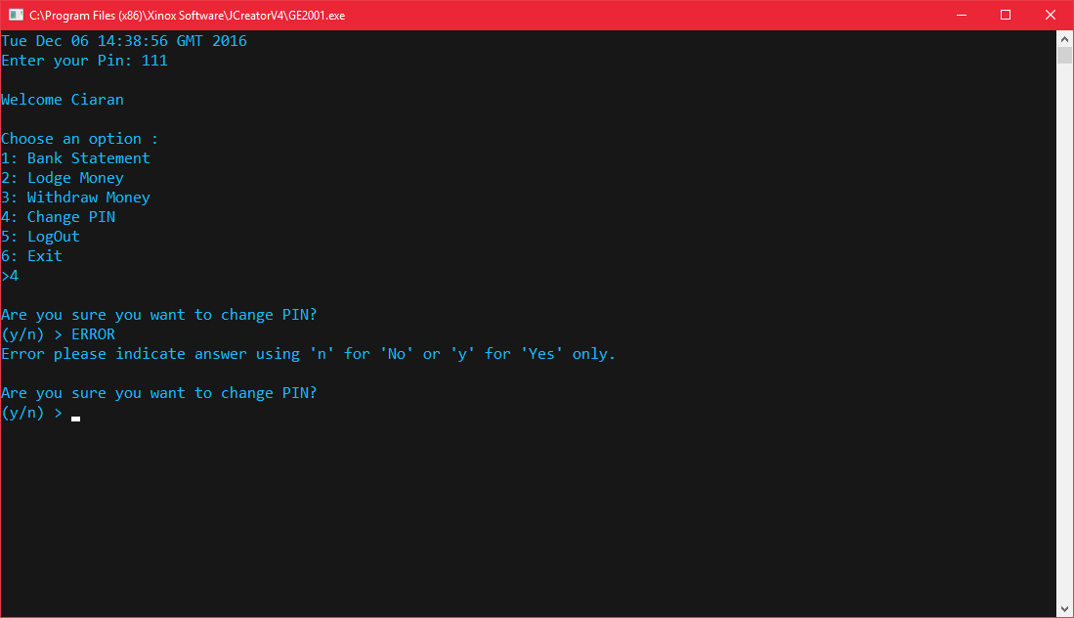

If the user declines to change their PIN by selecting ‘n’ a message will be displayed and they will be returned to the menu.

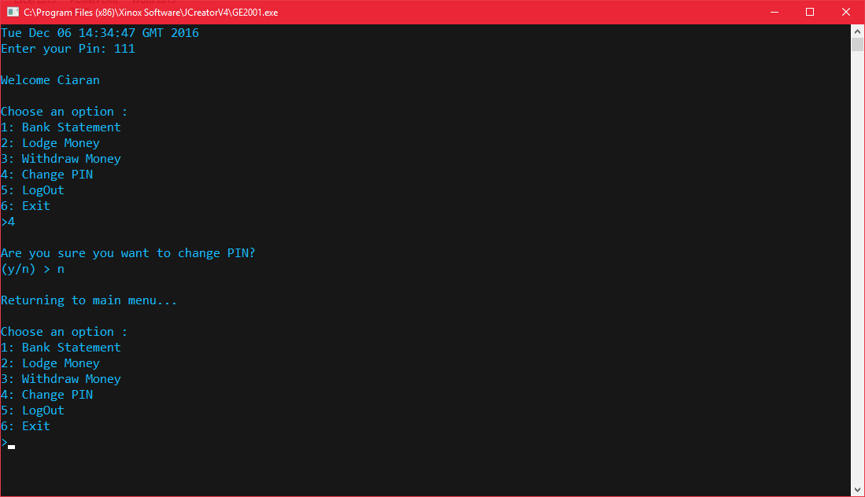

If the user confirms they want to change their pin they will be prompted to enter their new one.

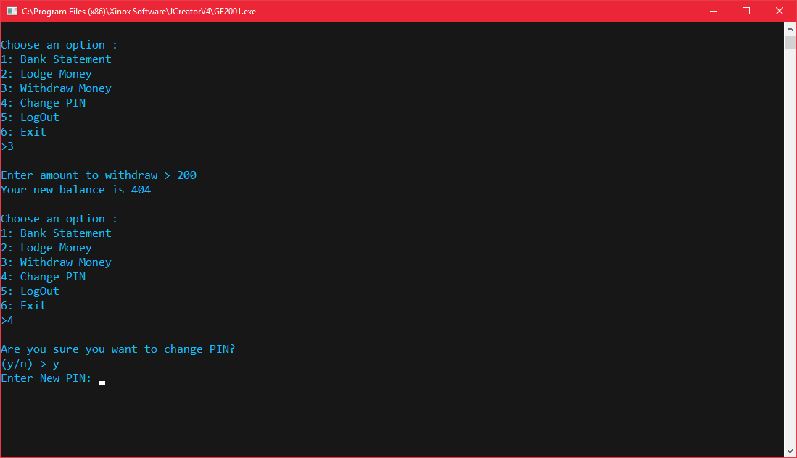

Option 5 allows the user to log out and sign in as a new user, asking for their pin.  
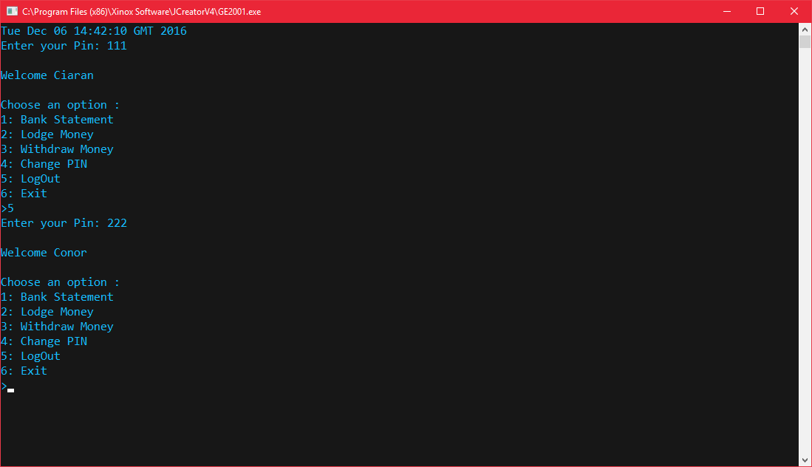

Option 6 exits the client and says goodbye to the user.

