Multi-physical metasurface NN
Configurations:
Suggested Environment: Python 3.8.18, tensorflow 2.13.0, deepxde 1.10.2
Dataset: All datasets for training and testing are contained in the subdirectory.

EM response by multi-fidelity DeepOnet:
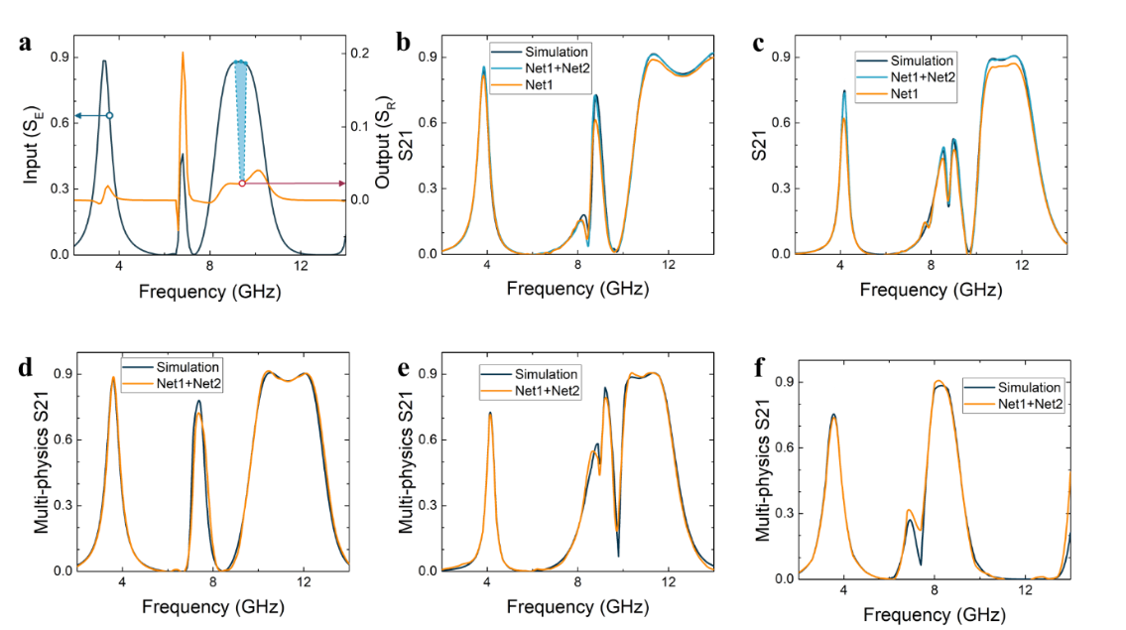
There are 3 steps in total in this shared code：
Step 1. Test the EM predictor with forward_code /electro_predictor.py. Validate the model; The average relative error in validation set (l1) is printed.
Step 2. Test the Multiphysics predictor with forward_code/ electro_thermal_predictor.py. Validate the model; The average relative error in validation set (l2) is printed.
Average temperature by latent dynamics networks:
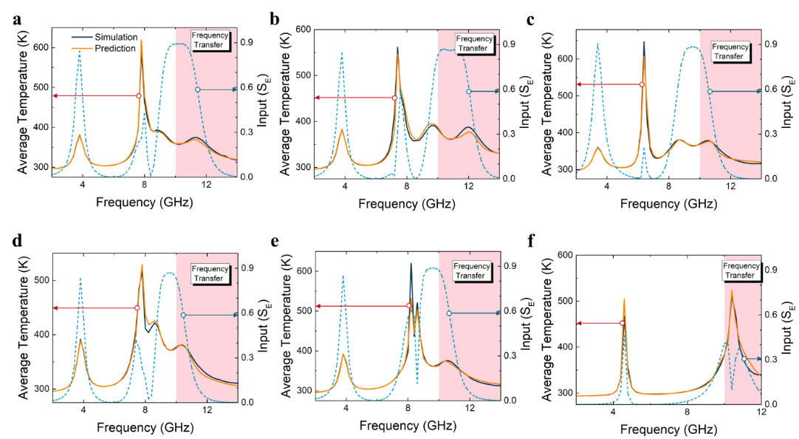
There are 2 steps in total in this shared code：
Step 1. Train/test the Multiphysics predictor with
forward_code /temperature_predictor.py.
Step 2. Validate the model with forward_code/temperature_predictor.py: he results are in variable yy and the ground truth are in variable y1. The average relative error in training frequency range is e1, and that of frequency transfer is e2.

Inverse design by data-analytical driven networks:
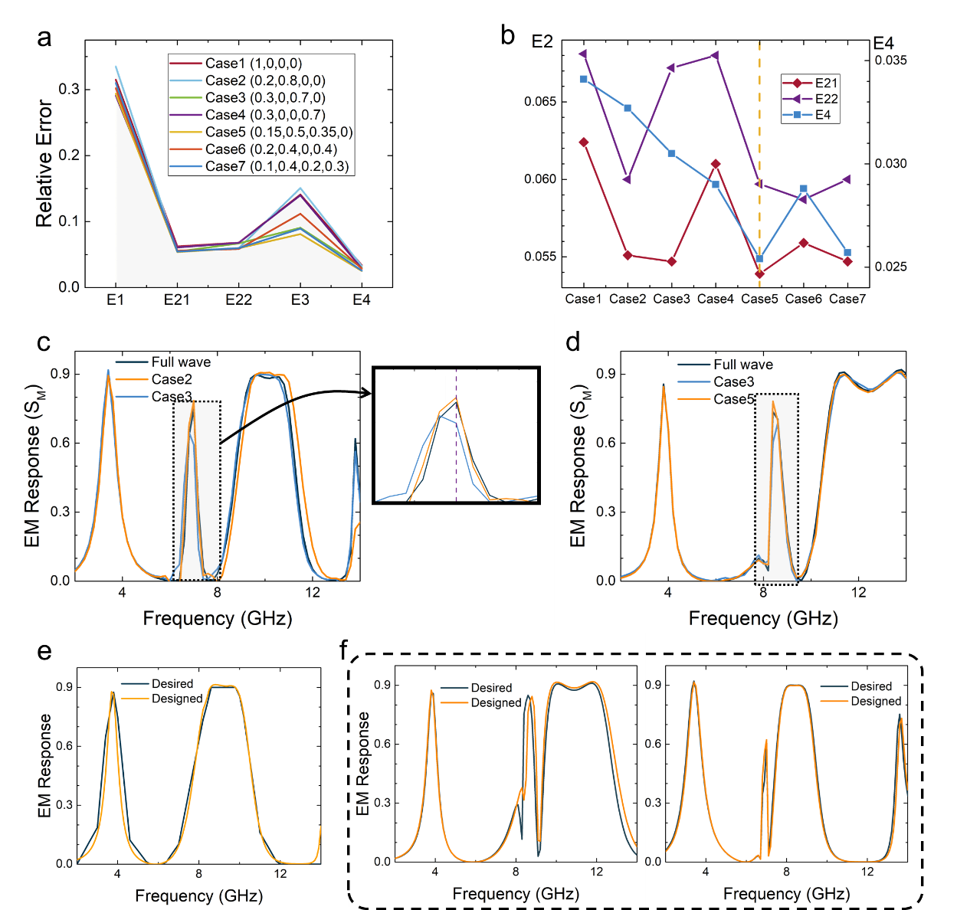
In the development of inverse design network, the weights in (4) are important to direct the training. To test the model, run inverse_design_code/inverse_design.py with the trained model, the average relative error in validation set (from E1 to E4) are printed. Model without input_T is tested in
inverse_design_code/ inverse_design_without_input_T.py

