**Supplemental Materials**

**Data Preprocessing**

Preprocessing of B0 inhomogeneity mappings

A total of 2 fieldmaps for the resting state scans were collected for each subject. A B0-nonuniformity map (or fieldmap) was estimated based on two (or more) echo-planar imaging (EPI) references with topup (Andersson et al., 2003; FSL 6.0.5.1:57b01774).

Anatomical data preprocessing

A T1-weighted (T1w) images was collected for each session. All of them were corrected for intensity non-uniformity (INU) with N4BiasFieldCorrection (Tustison et al., 2010), distributed with ANTs 2.3.3 (Avants et al., 2008, RRID:SCR_004757). The T1w-reference was then skull-stripped with a Nipype implementation of the antsBrainExtraction.sh workflow (from ANTs), using OASIS30ANTs as target template. Brain tissue segmentation of cerebrospinal fluid (CSF), white-matter (WM) and gray-matter (GM) was performed on the brain-extracted T1w using fast (FSL 6.0.5.1:57b01774, RRID:SCR_002823, Zhang et al., 2001). A T1w-reference map for each subject was computed after registration of all of the T1w images (after INU-correction) using mri_robust_template (FreeSurfer 6.0.1, Reuter et al., 2010). Brain surfaces were reconstructed using recon-all (FreeSurfer 6.0.1, RRID:SCR_001847, Dale et al., 1999), and the brain mask estimated previously was refined with a custom variation of the method to reconcile ANTs-derived and FreeSurfer-derived segmentations of the cortical gray-matter of Mindboggle (RRID:SCR_002438, Klein et al., 2017). Volume-based spatial normalization to MNI152NLin2009cAsym was performed through nonlinear registration with antsRegistration (ANTs 2.3.3), using brain-extracted versions of both T1w reference and the T1w template. The following templates were selected for spatial normalization: ICBM 152 Nonlinear Asymmetrical template version 2009c [Fonov et al., (2009), RRID:SCR_008796; TemplateFlow ID: MNI152NLin2009cAsym], FSL’s MNI ICBM 152 non-linear 6th Generation Asymmetric Average Brain Stereotaxic Registration Model [Evans et al., (2012), RRID:SCR_002823; TemplateFlow ID: MNI152NLin6Asym].

Functional data preprocessing

For each of the resting-state runs found per subject (across all tasks and sessions), the following preprocessing was performed. First, a reference volume and its skull-stripped version were generated from the shortest echo of the BOLD run using a custom methodology of fMRIPrep. Head-motion parameters with respect to the BOLD reference (transformation matrices, and six corresponding rotation and translation parameters) are estimated before any spatiotemporal filtering using mcflirt (FSL 6.0.5.1:57b01774, Jenkinson et al., 2002). The estimated fieldmap was then aligned with rigid-registration to the target EPI (echo-planar imaging) reference run. The field coefficients were mapped on to the reference EPI using the transform. BOLD runs were slice-time corrected to 1.21s (0.5 of slice acquisition range 0s-2.42s) using 3dTshift from AFNI (Cox & Hyde, 1997, RRID:SCR_005927). A T2★ map was estimated from the preprocessed EPI echoes, by voxel-wise fitting the maximal number of echoes with reliable signal in that voxel to a monoexponential signal decay model with nonlinear regression. The T2★/S0 estimates from a log-linear regression fit were used for initial values. The calculated T2★ map was then used to optimally combine preprocessed BOLD across echoes following the method described in (Posse et al., 1999). The optimally combined time series was carried forward as the preprocessed BOLD. The BOLD reference was then co-registered to the T1w reference using bbregister (FreeSurfer) which implements boundary-based registration (Greve & Fischl, 2009). Co-registration was configured with six degrees of freedom. First, a reference volume and its skull-stripped version were generated using a custom methodology of fMRIPrep. Several confounding time-series were calculated based on the preprocessed BOLD: framewise displacement (FD), DVARS and three region-wise global signals. FD was computed using two formulations following Power (absolute sum of relative motions, Power et al. (2014)) and Jenkinson (relative root mean square displacement between affines (Jenkinson et al., 2002). FD and DVARS are calculated for each functional run, both using their implementations in Nipype (following the definitions by Power et al., 2014). Frames that exceeded a threshold of 0.5 mm FD as well as following frames were annotated as motion outliers and censored in all analyses. Additionally, frames in which more than 10% of voxels were temporal outliers were censored in all analyses. The BOLD time-series were resampled into standard space, generating a preprocessed BOLD run in MNI152NLin2009cAsym space. First, a reference volume and its skull-stripped version were generated using a custom methodology of fMRIPrep. All resamplings can be performed with a single interpolation step by composing all the pertinent transformations (i.e. head-motion transform matrices, susceptibility distortion correction when available, and co-registrations to anatomical and output spaces). Gridded (volumetric) resamplings were performed using antsApplyTransforms (ANTs), configured with Lanczos interpolation to minimize the smoothing effects of other kernels (Lanczos, 1964).

Many internal operations of fMRIPrep use Nilearn 0.8.1 (Abraham et al., 2014, RRID:SCR_001362), mostly within the functional processing workflow. For more details of the pipeline, see the section corresponding to workflows in fMRIPrep’s documentation.

Copyright Waiver

The above boilerplate text was automatically generated by fMRIPrep with the express intention that users should copy and paste this text into their manuscripts unchanged. It is released under the CC0 license.

Supplemental Table 1: Study Participants

|  |  |  |  |
| --- | --- | --- | --- |
| *Scan Interval* | *12 Months* | | *4 Months* |
| *Condition* | ***Depressed*** | ***Healthy*** | ***Depressed*** |
| *Sample size* | 57 | 31 | 80 |
| *% Female (natal sex)* | 77 | 65 | 63 |
| *% White* | 68 | 52 | 74 |
| *Age at baseline (years)* | 15.72 | 15.47 | 15.73 |
| *Time between scans (months)* | 12.54 | 12.48 | 4.31 |
| *MFQ at baseline* | 12.28 | 1.29 | 12.65 |
| *ARI at baseline* | 3.04 | 0.55 | 3.45 |
| *SHAPS at baseline* | 15.94 | 3.11 | 15.94 |
| *SCARED at baseline* | 33.68 | 7.01 | 36.00 |
| *Mean ICC* | 0.34 | 0.24 | 0.31 |
| *Fingerprinting index* | 0.45 | 0.53 | 0.47 |
| *Discriminability* | 0.76 | 0.75 | 0.76 |
| *Discriminability-equivalent ICC* | 0.84 | 0.82 | 0.84 |

Supplemental Table 2: Effect Size Correlations

|  |  |  |  |  |
| --- | --- | --- | --- | --- |
|  | *Between-Group Cohen's d* | *ICC* | *Group Consistency* | *Differential Power* |
| *ICC* | -0.084*** |  |  |  |
| *Group Consistency* | 0.176*** | 0.106*** |  |  |
| *Differential Power* | 0.067*** | -0.494*** | 0.264*** |  |
| *Edge Discriminability* | 0.091*** | -0.137*** | -0.062*** | 0.138*** |
| *Computed correlation used Pearson-method with listwise-deletion.* | | | | |

|  |  |  |  |  |
| --- | --- | --- | --- | --- |
|  | *Between-Group Cohen's d* | *ICC* | *Group Consistency* | *Differential Power* |
| *ICC* | -0.089*** |  |  |  |
| *Group Consistency* | 0.120*** | 0.211*** |  |  |
| *Differential Power* | 0.067*** | -0.472*** | 0.129*** |  |
| *Edge Discriminability* | 0.092*** | -0.132*** | -0.104*** | 0.119*** |
| *Computed correlation used Spearman-method with listwise-deletion.* | | | | |

Supplemental Table 3: Behavioral Correlations

|  |  |  |  |
| --- | --- | --- | --- |
|  | *Within-Subject Variance* | *Fingerprinting* | *Participant Discriminability* |
| *MFQ (mean)* | -0.022 | -0.016 | -0.032 |
| *SHAPS (mean)* | -0.134 | 0.106 | -0.161 |
| *ARI (mean)* | -0.058 | 0.027 | -0.059 |
| *SCARED (mean)* | 0.084 | -0.055 | 0.074 |
| *Motion* | 0.099 | -0.185 | 0.091 |
| *Max Framewise Displacement* | 0.013 | -0.121 | 0.038 |
| *Age* | -0.053 | -0.066 | -0.038 |
| *Meds-Psychoactive (mean)* | -0.018 | -0.078 | -0.007 |
| *Meds-Other (mean)* | 0.003 | 0.013 | 0.042 |
| *MFQ (change)* | 0.051 | -0.025 | -0.032 |
| *SHAPS (change)* | -0.082 | -0.090 | -0.142 |
| *ARI (change)* | 0.096 | 0.086 | 0.041 |
| *SCARED (change)* | -0.078 | 0.115 | -0.145 |
| *Meds-Psychoactive (change)* | 0.004 | 0.090 | 0.003 |
| *Meds-Other (change)* | 0.223 | -0.162 | 0.166 |
| *Computed correlation used Pearson-method with listwise-deletion.* | | | |

|  |  |  |  |
| --- | --- | --- | --- |
|  | *Within-Subject Variance* | *Fingerprinting* | *Participant Discriminability* |
| *MFQ (mean)* | 0.038 | -0.048 | 0.015 |
| *SHAPS (mean)* | -0.086 | 0.146 | -0.127 |
| *ARI (mean)* | -0.014 | -0.017 | -0.042 |
| *SCARED (mean)* | 0.159 | -0.071 | 0.122 |
| *Motion* | -0.016 | -0.074 | -0.026 |
| *Max Framewise Displacement* | 0.010 | -0.146 | 0.010 |
| *Age* | -0.073 | -0.105 | -0.086 |
| *Meds-Psychoactive (mean)* | 0.112 | -0.189 | 0.096 |
| *Meds-Other (mean)* | 0.023 | 0.093 | 0.002 |
| *MFQ (change)* | -0.054 | 0.090 | -0.050 |
| *SHAPS (change)* | -0.192 | -0.046 | -0.178 |
| *ARI (change)* | 0.059 | 0.221 | 0.081 |
| *SCARED (change)* | -0.059 | 0.148 | -0.050 |
| *Meds-Psychoactive (change)* | 0.045 | 0.092 | 0.030 |
| *Meds-Other (change)* | 0.062 | -0.064 | 0.057 |

|  |
| --- |
| *Computed correlation used Spearman-method with listwise-deletion.* |

Supplemental Figure 1: Intraclass correlation coefficients across groups

Mean intraclass correlation coefficients across 1000-fold bootstrap with replacement. Upper and lower hinges of boxes are first and third quartiles; horizontal black lines are medians; whiskers are 1.5x interquartile range.

Supplemental Figure 2: Matrices of intraclass correlation coefficients

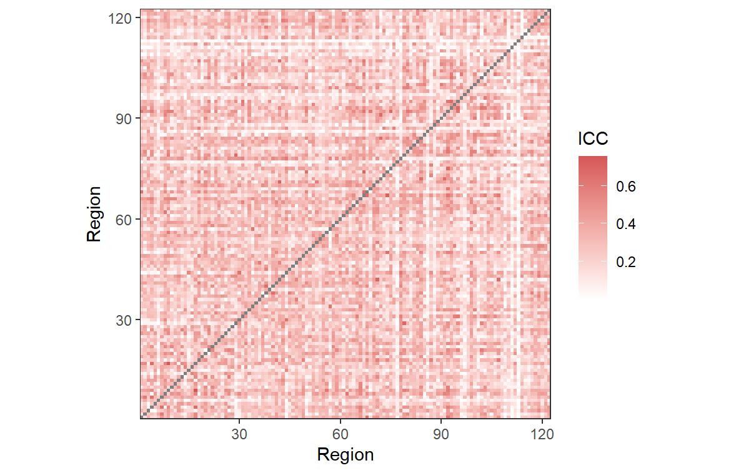

All Participants



HV Participants – 1 Year

Depressed Participants – 4 Months

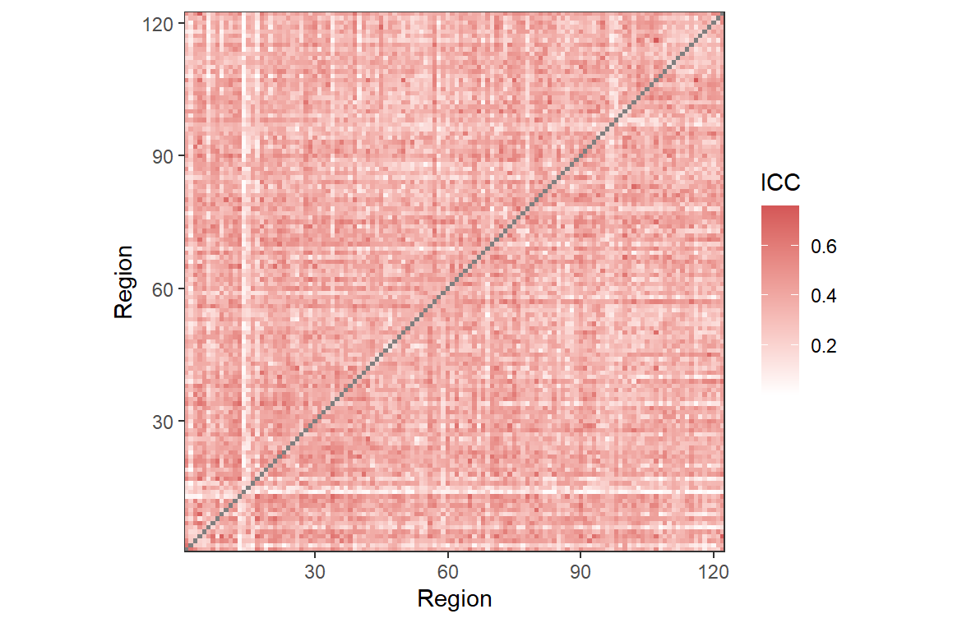

Depressed Participants – 1 Year

Supplemental Figure 3: Correlations between individual measures

MFQ: Child Self-Report – Short Version Mood and Feelings Questionnaire; SHAPS: Snaith-Hamilton Pleasure Scale; ARI1W: Affective Reactivity Index – 1 week; SCARED: Screen for Child Anxiety Related Disorders; MAX_FD – Maximum framewise displacement