# RESULTS

## Univariate Reliability

* 1. Edgewise reliability of functional connectivity was poor for both depressed individuals and healthy volunteers [Fig. 1]. However, the depressed participants had higher mean ICC, indicating improved reliability (0.35 > 0.24; Wilcoxon rank-sum: *p* < .001). The largest groupwise differences occurred in these connections XXX.

**Figure 1**: Mean edge-level ICC values for MDD (A) and HV (B), and mean contrast MDD - HV (C).

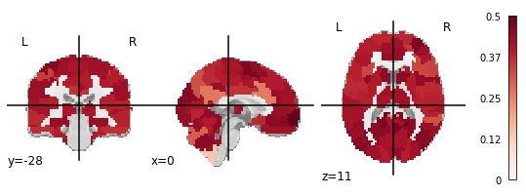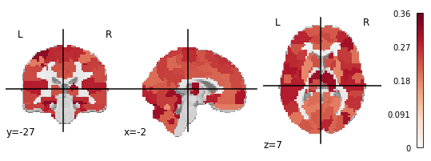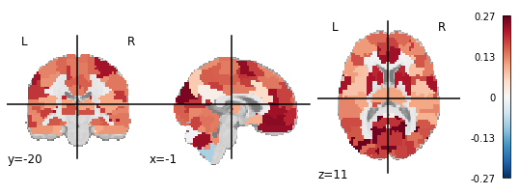

## Multivariate Reliability

* 1. Multivariate metrics reflected improved reliability compared to univariate [Fig. 2]. Fingerprinting values were moderate (FIHV = 0.53; FIMDD = 0.45) but greater than chance as estimated by a Poisson (1) distribution (*p* < .001) (Wang et al., 2021). Fingerprinting accuracy did not differ between groups, *X2* (1, *N* = 88) = 0.68, *p* > .05. Connections to a region in the prefrontal cortex had the highest group consistency, indicating that they reduced identifiability in all subjects [Fig. 3].
  2. Both groups were highly discriminable (*Discr*HV = 0.75; *Discr*MDD = 0.76; permutation test *p* < .01).

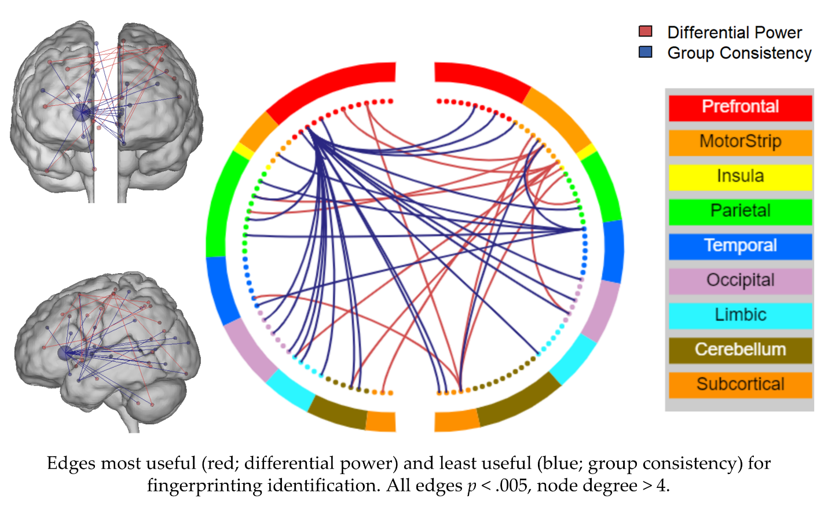

**Figure 3**: Edges that most improved (red; differential power) and least improved (blue; group consistency) fingerprinting identification. All edges p < .005, node degree > 4.

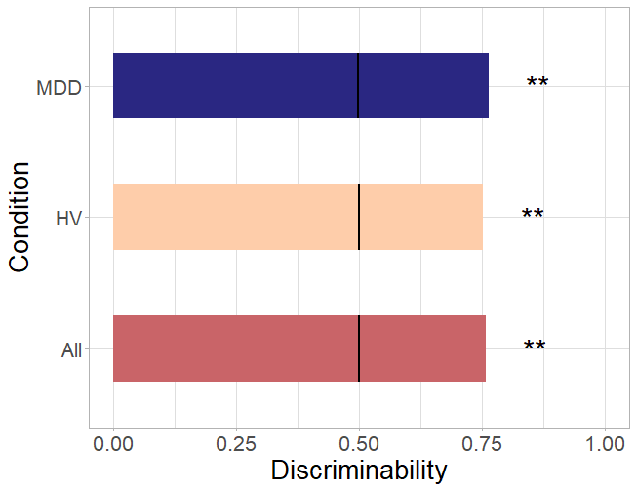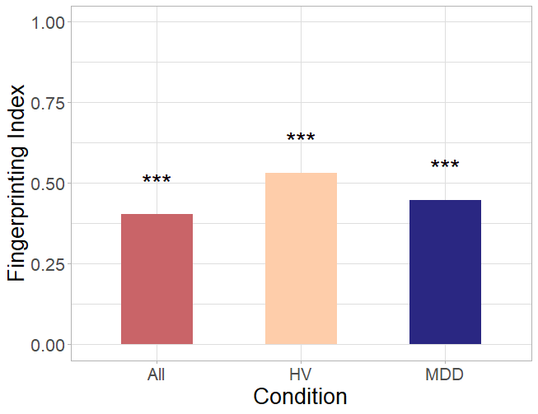

**Figure 2**: Fingerprinting (A) and Discriminability (B) across groups. Black lines indicate chance discriminability. **: p < .01, ***: p < .001.

## Effect size analysis

## The edge-level effect size of group differences between MDD and HV connectomes was not correlated with edge-level ICC, group consistency, differential power, or distance rank [Fig. 4].

## Correlation with clinical measures

## Continuous measures of reliability were not correlated with the change or between-session mean of the MFQ, SHAPS, ARI 1 week, or SCARED, nor did they correlate with age or medication status. The continuous measure of fingerprinting was correlated with maximum framewise displacement (*r* = -.38, *p* < .05) and between-session mean motion (*r* = -.63, *p* < .05) after correction for multiple comparisons [Fig. 5].

**Figure 4:** Edge-level ICC (A), Differential Power (B), Group Consistency (C), and Distance Rank (D) correlated with MDD-HV Cohen’s d effect size.

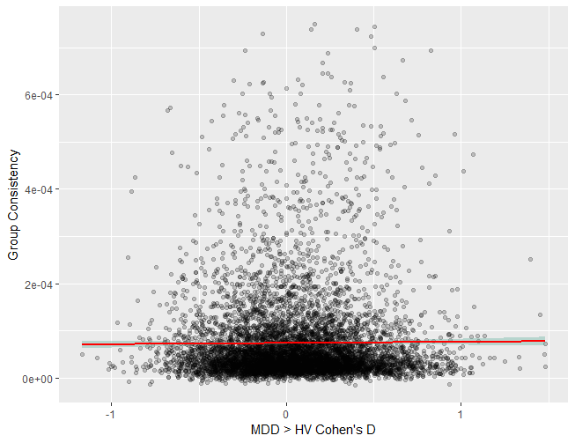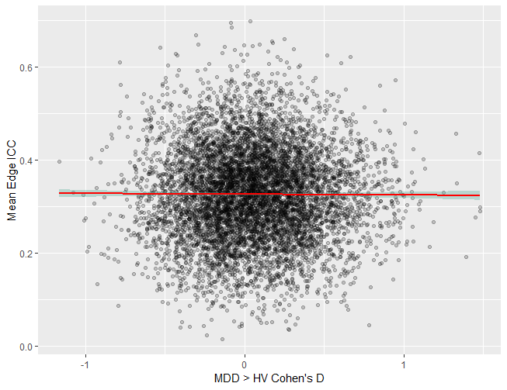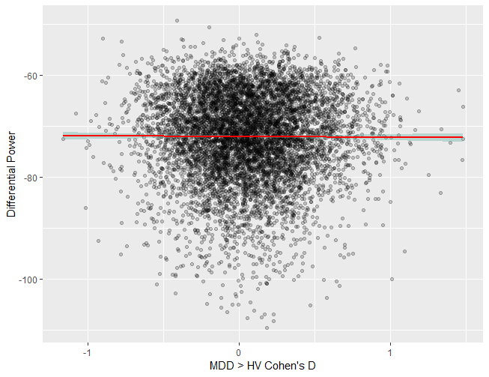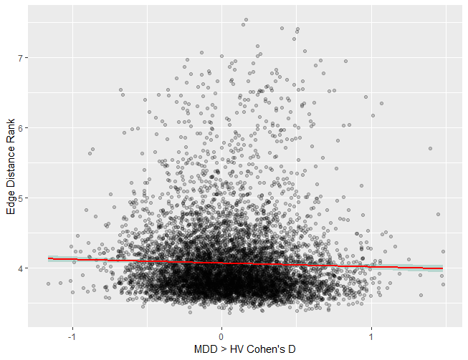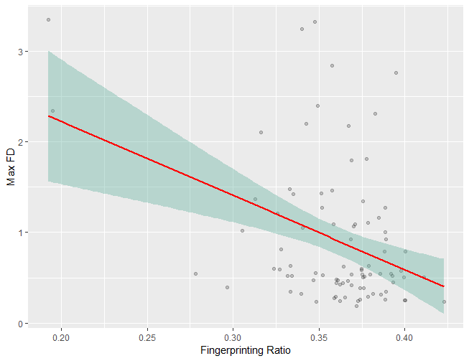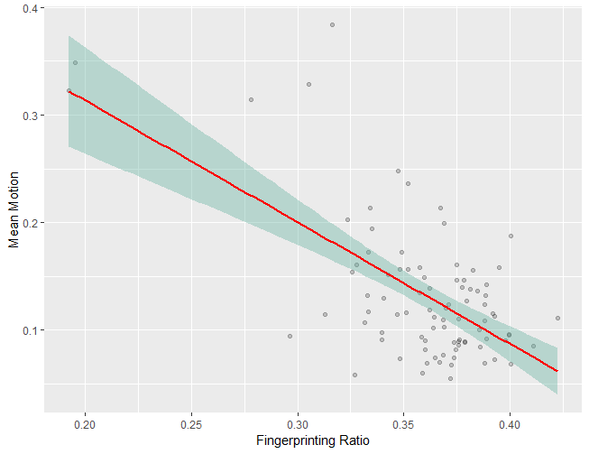

**Figure 5:** Spearman correlation between continuous measure of fingerprinting and max framewise displacement (A) and between-session mean motion (B)