Extreme Weather Service Website: User, Visual, and Technical Solutions
1. Website Name: ClimaXtreme
2. Background: Reason for choosing this topic
As global climate change gets worse, the frequency and intensity of extreme weather events have increased a lot. Most of the weather services focus on accurate data reporting and lack the shift from data to practical action guides. Our website includes both daily prevention and emergency response situations, meets the needs of different kinds of users, and hopes to provide ordinary people with quick and easy emergency plans for extreme weather and also real-time information for professionals.

3. Usage scenarios and audience analysis
3.1 Usage scenarios
3.1.1 Daily prevention
Users could get future extreme weather forecasts, learn about potentially affected areas and times in advance, and study science knowledge and protection measures for different types of extreme weather.
3.1.2 Emergency response
(1) After the government issues extreme weather warnings, users can quickly check targeted response measures and view real-time disaster situation updates. They can also use the AI assistant to find response measures quickly and get targeted risk avoidance tips.
(2) Users can search for relevant disaster news, reduce information gaps, and learn about the latest updates of affected areas.

3.2 Audience analysis
(1) General Public: The audience of our website needs intuitive and easy-to-use pages, and the AI assistant can help them solve problems.
(2) Researchers & Analysts：Our website uses various aspects of chart data and disaster distribution to help users understand disaster response measures.
(3)Policy Makers：We may need an overall disaster statistical panel to assess risk trends and develop disaster prevention strategies.

4. Webpage Functions and Technologies
4.1 Website color and style preferences
4.1.1 Color preference
Main color scheme: tends to choose blue (representing "professional and reliable", in line with the attributes of meteorological products), green (symbolizing "safety and hope", relieving user anxiety).
Auxiliary color: High contrast colors should be used for warning messages (such as red for emergency and yellow for attention), but excessive stimulation should be avoided.
4.1.2 Style preference
Overall style: The overall style should balance professionalism and affinity, reflecting both authority and familiarity. Concise and intuitive, with clear information hierarchy (avoiding redundant decorations, highlighting core data and measures).
Interactive experience: Easy to operate (such as seeing local weather), fast response (especially when warning information needs to be loaded instantly).
Content presentation: Combining graphics and text (with complex measures and schematic diagrams), using plain language (avoiding technical jargon and adding annotations if necessary).
Responsive Design: CSS media queries and Flexbox layout ensure smooth display across different devices, improving the mobile user experience. Page elements automatically adjust their layout and size according to screen size.

4.2 Query of emergency prevention measures for extreme weather
The artistic background of "embroidery/texture style" is used to display the countermeasures for rainstorm, high temperature and other disasters in combination with intangible culture, so as to provide a good reading experience.

4.3 News acquisition
The system supports disaster-oriented search, allowing users to obtain social dynamics while focusing on macro data.

4.4 Data analysis
Disaster Map: We display disaster distribution and severity based on a China map, intuitively showing disaster frequencies across different provinces.
Statistical Charts: We provide analysis of annual trend charts, pie charts for type proportions, and line charts of death tolls and economic losses to offer multidimensional data analysis.
Smart Filter: Users can customize the year range (2000-2025), disaster types and regions to achieve dynamic data cleaning and display.

4.5 Database Query
Spring Boot-based backend implementation for disaster data query: Configure SQLite database connection, define GET endpoints to receive frontend parameters; validate year compliance in the business layer, execute SQL queries via the data access layer after validation, and return results to the frontend through the endpoints.

4.6 AI access website
We introduce an AI Chatbot, so users don’t need to search through menus. They can directly ask questions in natural language, and the system will give immediate and accurate suggestions. This greatly lowers the threshold for users to obtain emergency information.

5. Web Work Flow Chart
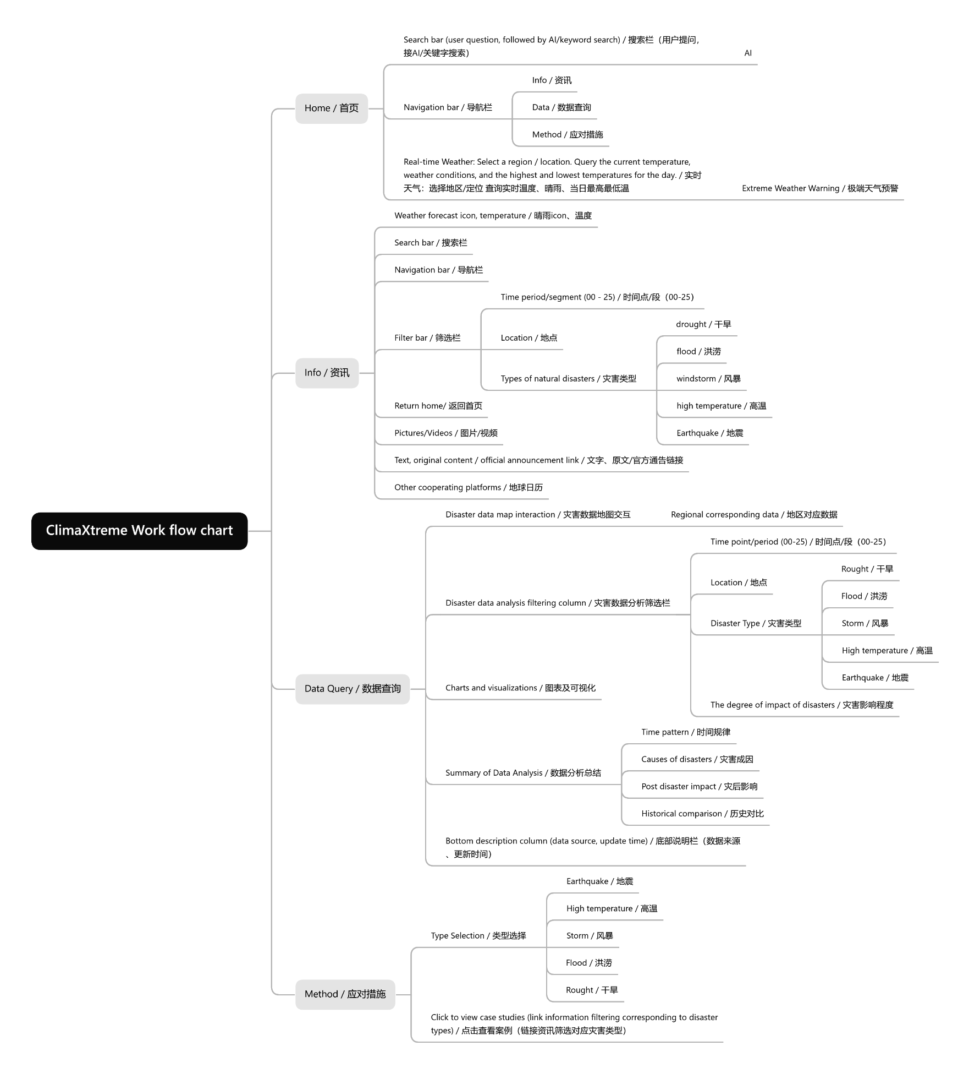
Based on our visual and technology design, we can get this web workflow chart, to code our website deeply.
Reference
[1] Ministry of Emergency Management of the People’s Republic of China: https://www.mem.gov.cn/
[2] MOJI Weather: https://www.moji.com/
[3] Iconfont: https://www.iconfont.cn/
[4] Webpage size specification: https://www.xiaohongshu.com/discovery/item/68255f350000000022026ed6?source=webshare&xhsshare=pc_web&xsec_token=ABomQVVhBG_TdUVrZym3loOahNnETHUevcioSG64PCWFI=&xsec_source=pc_share
[5] OpenWeather Ltd. (2025). OpenWeatherMap API [Software]. Retrieved from https://openweathermap.org/api
[6] Google. (2025). Gemini API [Large Language Model]. Retrieved from https://ai.google.dev/
[7] ECharts Map Data. (n.d.). Map of China (china.js) [Geospatial Data]. Retrieved from https://cdn.jsdelivr.net/npm/echarts/map/js/china.js
[8] Chart.js Contributors. (2025). Chart.js [JavaScript Library]. Retrieved from https://www.chartjs.org/
[9] SheetJS LLC. (2025). SheetJS Community Edition (xlsx) [JavaScript Library]. Retrieved from https://sheetjs.com/
[10] Fonticons, Inc. (2025). Font Awesome Free [Icon Toolkit]. Retrieved from https://fontawesome.com/

