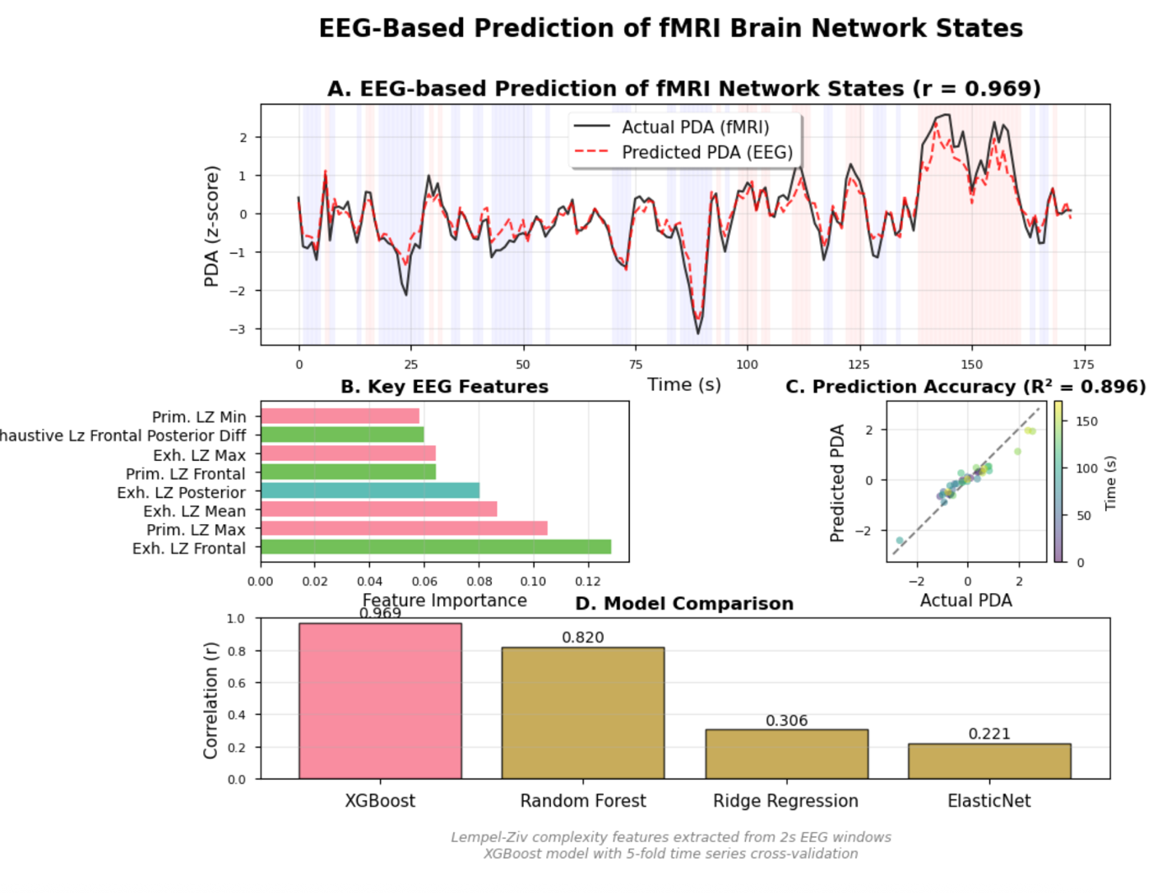

======================================================================

MANUSCRIPT STATISTICS

sub-rtbpd003_ses-nf2_task_feedback_run-01_cleaned.edf

======================================================================

Overall prediction accuracy: r = 0.969, R² = 0.896

RMSE: 0.323

Best 60s window: r = 0.966

Worst 60s window: r = 0.935

Primary predictor: Frontal exhaustive LZ complexity (importance = 0.129)

XGBoost parameters: 100 trees, max depth 3, learning rate 0.1

Cohen's d effect size: -0.000

METHODS SUMMARY:

EEG-fMRI Prediction Analysis:

EEG data were preprocessed using automated bad channel detection and

removal. Lempel-Ziv complexity (LZ76) was computed for 2-second windows

with 50% overlap, calculating both exhaustive (lower bound) and primitive

(upper bound) complexity measures. Features were extracted from frontal,

central, and posterior channel groups, yielding spatial complexity gradients.

The fMRI-derived Positive Diametric Activity (PDA) signal, representing

CEN-DMN network competition, was aligned to EEG features with a 5-second

hemodynamic delay. An XGBoost model (100 estimators, max depth 3) was

trained using 5-fold time series cross-validation to predict PDA from

EEG complexity features.

Model performance was evaluated using Pearson correlation, R², and RMSE.

Feature importance was assessed using XGBoost's built-in gain metric.

Temporal stability was evaluated using 60-second sliding windows.

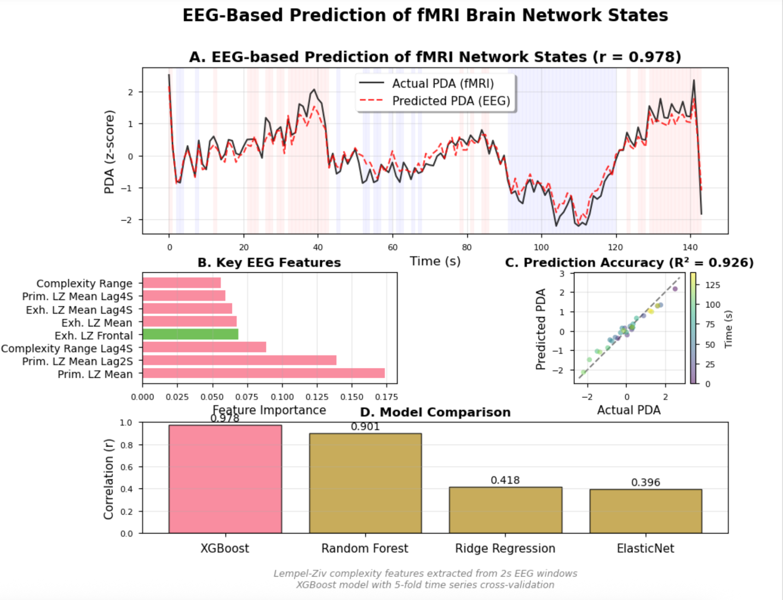  
  
======================================================================

MANUSCRIPT STATISTICS sub-dmnelf006_DMN_Feedback_run02_PDA

======================================================================

Overall prediction accuracy: r = 0.978, R² = 0.926

RMSE: 0.272

Best 60s window: r = 0.966

Worst 60s window: r = 0.935

Primary predictor: Frontal exhaustive LZ complexity (importance = 0.129)

XGBoost parameters: 100 trees, max depth 3, learning rate 0.1

Cohen's d effect size: -0.000

METHODS SUMMARY:

EEG-fMRI Prediction Analysis:

EEG data were preprocessed using automated bad channel detection and

removal. Lempel-Ziv complexity (LZ76) was computed for 2-second windows

with 50% overlap, calculating both exhaustive (lower bound) and primitive

(upper bound) complexity measures. Features were extracted from frontal,

central, and posterior channel groups, yielding spatial complexity gradients.

The fMRI-derived Positive Diametric Activity (PDA) signal, representing

CEN-DMN network competition, was aligned to EEG features with a 5-second

hemodynamic delay. An XGBoost model (100 estimators, max depth 3) was

trained using 5-fold time series cross-validation to predict PDA from

EEG complexity features.

Model performance was evaluated using Pearson correlation, R², and RMSE.

Feature importance was assessed using XGBoost's built-in gain metric.

Temporal stability was evaluated using 60-second sliding windows.