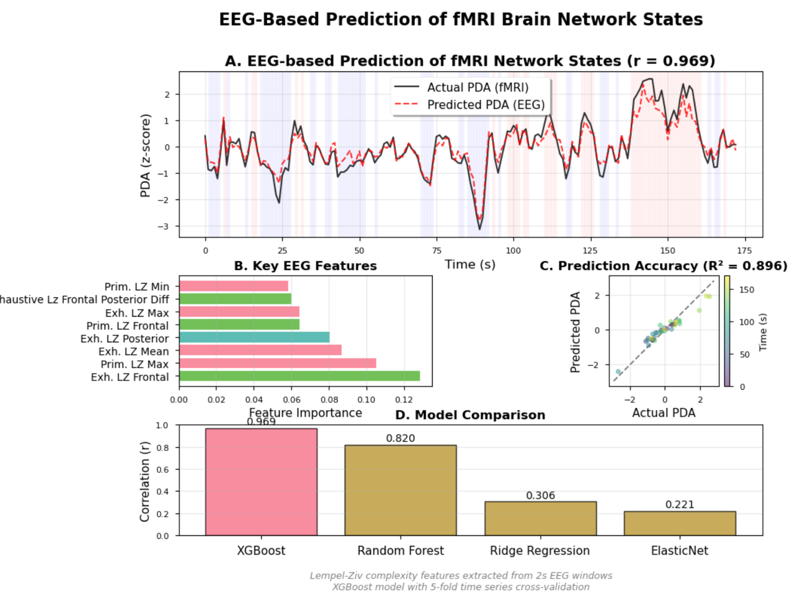
======================================================================
MANUSCRIPT STATISTICS
sub-rtbpd003_ses-nf2_task_feedback_run-01_cleaned.edf
======================================================================
Overall prediction accuracy: r = 0.969, R² = 0.896
RMSE: 0.323
Best 60s window: r = 0.966
Worst 60s window: r = 0.935
Primary predictor: Frontal exhaustive LZ complexity (importance = 0.129)
XGBoost parameters: 100 trees, max depth 3, learning rate 0.1
Cohen's d effect size: -0.000

METHODS SUMMARY:

EEG-fMRI Prediction Analysis:

EEG data were preprocessed using automated bad channel detection and
removal. Lempel-Ziv complexity (LZ76) was computed for 2-second windows
with 50% overlap, calculating both exhaustive (lower bound) and primitive
(upper bound) complexity measures. Features were extracted from frontal,
central, and posterior channel groups, yielding spatial complexity gradients.

The fMRI-derived Positive Diametric Activity (PDA) signal, representing
CEN-DMN network competition, was aligned to EEG features with a 5-second
hemodynamic delay. An XGBoost model (100 estimators, max depth 3) was
trained using 5-fold time series cross-validation to predict PDA from
EEG complexity features.

Model performance was evaluated using Pearson correlation, R², and RMSE.
Feature importance was assessed using XGBoost's built-in gain metric.
Temporal stability was evaluated using 60-second sliding windows.

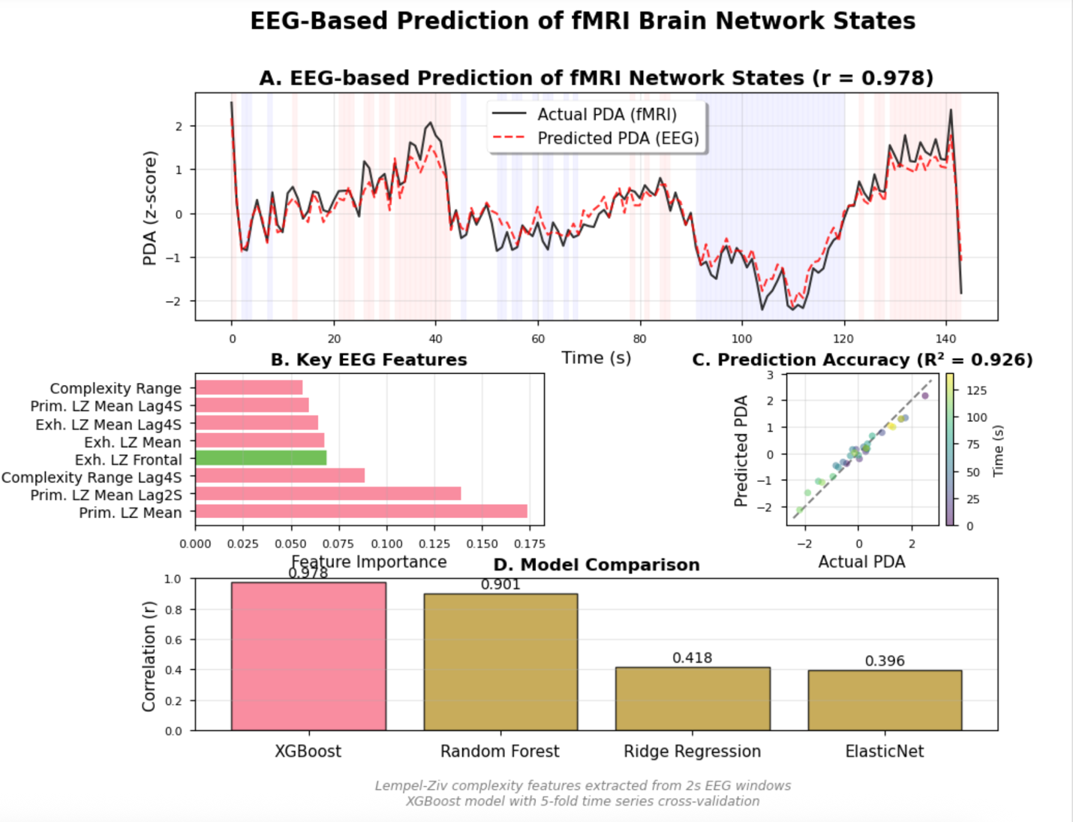
======================================================================
MANUSCRIPT STATISTICS sub-dmnelf006_DMN_Feedback_run02_PDA
======================================================================
Overall prediction accuracy: r = 0.978, R² = 0.926
RMSE: 0.272
Best 60s window: r = 0.966
Worst 60s window: r = 0.935
Primary predictor: Frontal exhaustive LZ complexity (importance = 0.129)
XGBoost parameters: 100 trees, max depth 3, learning rate 0.1
Cohen's d effect size: -0.000

METHODS SUMMARY:

EEG-fMRI Prediction Analysis:

EEG data were preprocessed using automated bad channel detection and
removal. Lempel-Ziv complexity (LZ76) was computed for 2-second windows
with 50% overlap, calculating both exhaustive (lower bound) and primitive
(upper bound) complexity measures. Features were extracted from frontal,
central, and posterior channel groups, yielding spatial complexity gradients.

The fMRI-derived Positive Diametric Activity (PDA) signal, representing
CEN-DMN network competition, was aligned to EEG features with a 5-second
hemodynamic delay. An XGBoost model (100 estimators, max depth 3) was
trained using 5-fold time series cross-validation to predict PDA from
EEG complexity features.

Model performance was evaluated using Pearson correlation, R², and RMSE.
Feature importance was assessed using XGBoost's built-in gain metric.
Temporal stability was evaluated using 60-second sliding windows.

