Pizza - A Carbohydrate Based Substrate For Tomato Delivery
Maxwell Ogden, Pizza Enthusiasts Institute
May 2017

Abstract
Pizza (Pizza et al. (2000)) is an understudied yet widely utilized implement for delivering in-vivo Solanum lycopersicum based liquid mediums in a variety of next-generation mastications studies. Here we describe a de novo approach for large scale T. aestivum assemblies based on protein folding that drastically reduces the generation time of the mutation rate.

Diagram
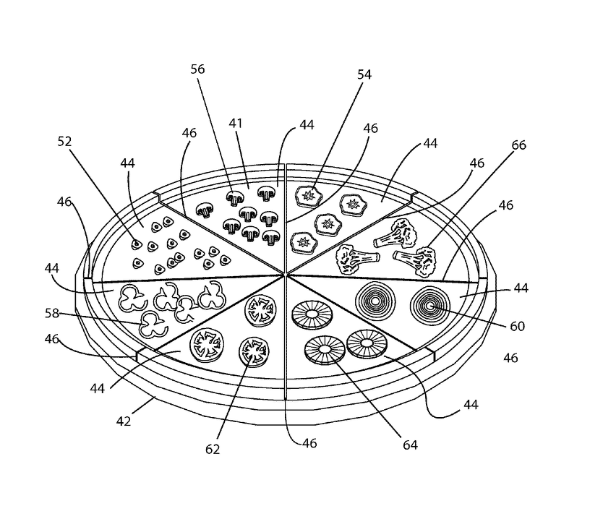
Figure 1: It’s Pizza

Algorithm

References
Pizza, Mariagrazia, Vincenzo Scarlato, Vega Masignani, Marzia Monica Giuliani, Beatrice Arico, Maurizio Comanducci, Gary T Jennings, et al. 2000. “Identification of Vaccine Candidates Against Serogroup B Meningococcus by Whole-Genome Sequencing.” Science 287 (5459): 1816–20.

