Pizza - A Carbohydrate Based Substrate For Tomato Delivery

Maxwell Ogden, Pizza Enthusiasts Institute

May 2017

# Abstract

中文測試！

Pizza (Pizza et al. (2000)) is an understudied yet widely utilized implement for delivering in-vivo *Solanum lycopersicum* based liquid mediums in a variety of next-generation mastications studies. Here we describe a de novo approach for large scale *T. aestivum* assemblies based on protein folding that drastically reduces the generation time of the mutation rate.

# Diagram

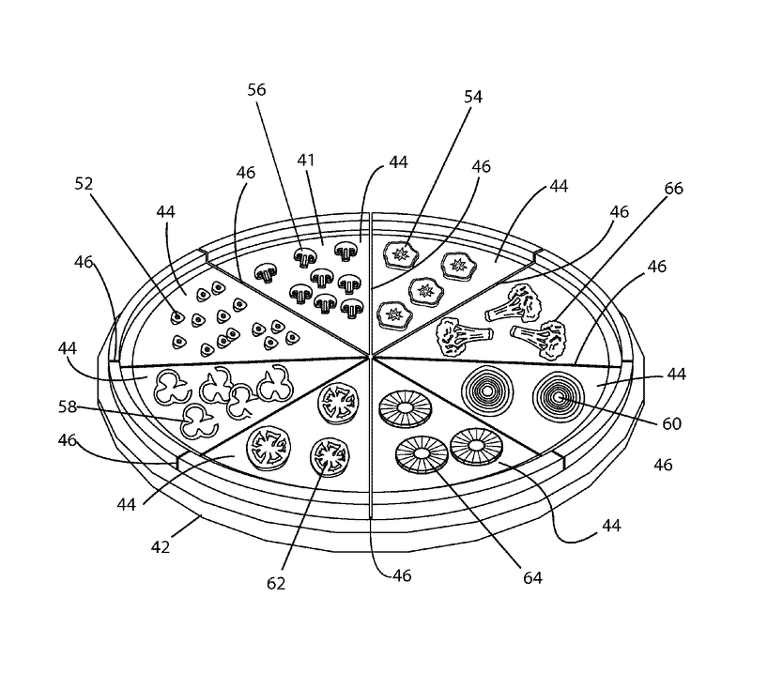

It’s Pizza

# Algorithm

$$f(x)=pizza^{2}$$

# References

Pizza, Mariagrazia, Vincenzo Scarlato, Vega Masignani, Marzia Monica Giuliani, Beatrice Arico, Maurizio Comanducci, Gary T Jennings, et al. 2000. “Identification of Vaccine Candidates Against Serogroup B Meningococcus by Whole-Genome Sequencing.” *Science* 287 (5459): 1816–20.