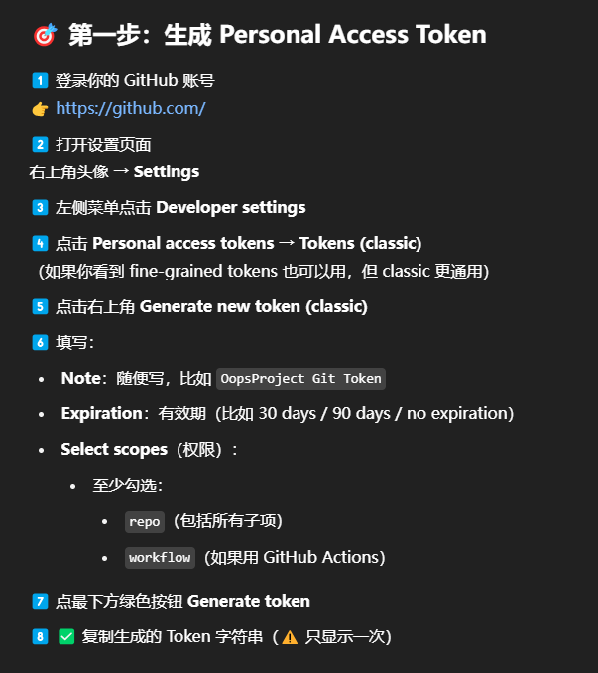
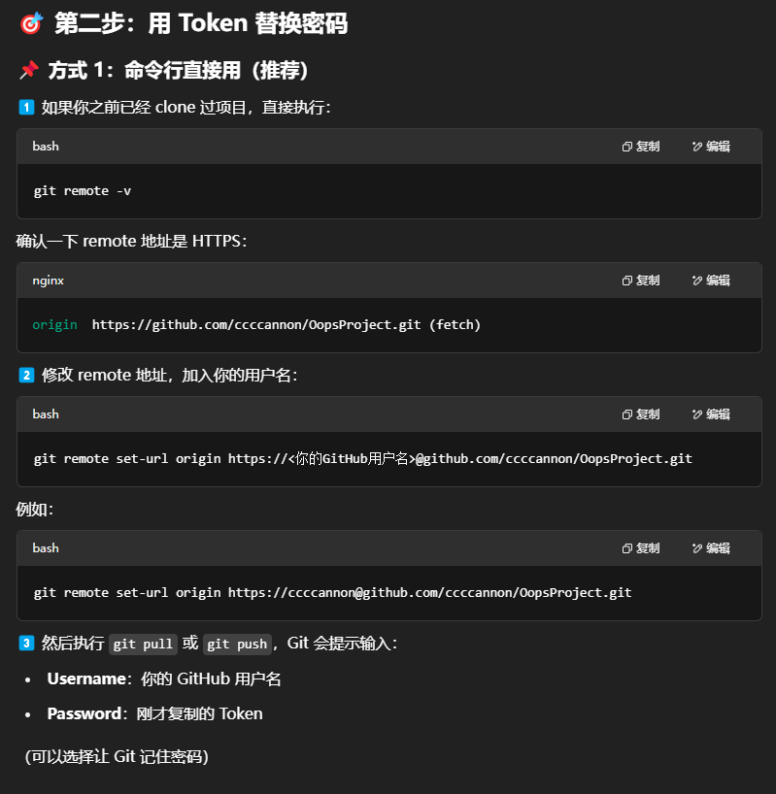
- git remote -v
- git remote set-url origin https://ccccannon@github.com/ccccannon/OopsProject.git



