Socket编程-----tcp通信工具

软件界面

2.功能实现

3.工作流程
服务器端
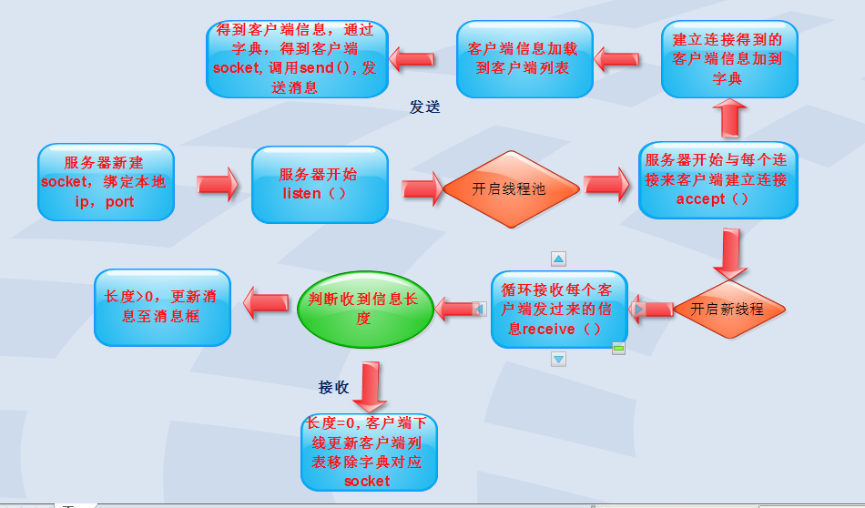

客户端
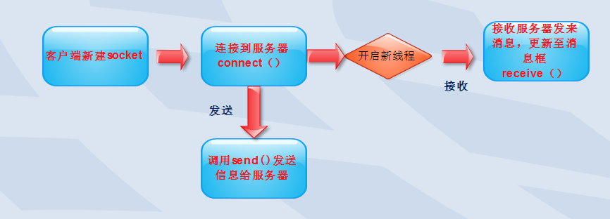

4主要代码实现
服务器端
namespace server
{
Dictionary<string, Socket> dic = new Dictionary<string, Socket>();
Socket skcon = null;
private void listen_Click(object sender, EventArgs e)
{
if (skcon ==null)
{
skcon = new Socket(AddressFamily.InterNetwork,SocketType.Stream ,ProtocolType.Tcp );//创建服务端socket
skcon.Bind(new IPEndPoint(IPAddress .Parse ( txtip .Text .Trim ()),int.Parse (txtport .Text .Trim ())));//绑定本地ip，port
skcon.Listen(100);//开始监听
label4 .Text = "开始监听。。";
label4.ForeColor = Color.Green;
ThreadPool.QueueUserWorkItem(new WaitCallback((skObj) => {
Socket skconnp = skObj as Socket;
while (true)
{
Socket skcommunication= skconnp.Accept();//开启另一现成连接每个过来的客户端
string userinfo=skcommunication .RemoteEndPoint .ToString ();
if (!dic.ContainsKey (userinfo ))
{
dic.Add(userinfo , skcommunication);//把炼联入的客户端加到字典中
}//跨线程修改消息框控件
txtmessage.Invoke(new Action<string>((m) => {
txtmessage.AppendText("客户端"+m+"上线了"+Environment .NewLine );
}), userinfo);
//跨线程修改客户端列表
listcontents.Invoke(new Action<string>((m) => {
listcontents.Items.Add(m);
}), userinfo);
//开启新线程接收客户端发来的消息
ThreadPool.QueueUserWorkItem(new WaitCallback((skObjc) => {
Socket skcomm = skObjc as Socket;
while (true)
{
byte[] buffer = new byte[1024 * 1024 * 2];
//接收消息
int r = skcomm.Receive(buffer);

if (r==0)
{
txtmessage.Invoke(new Action<string>(new Action<string>((x) => {

txtmessage.AppendText("主机"+x+"下线"+Environment .NewLine );
})),skcomm .RemoteEndPoint .ToString ());
listcontents.Invoke(new Action<string>((x) => {
listcontents.Items.Remove(x);//移除下线客户端
}), skcomm.RemoteEndPoint.ToString());
dic.Remove(skcomm .RemoteEndPoint .ToString ());//移除下线客户端对应的socket
break;
}
else
{
string message = Encoding.UTF8.GetString(buffer, 0, r);
//跨线程修改消息框内容
txtmessage.Invoke(new Action<string>((x) => {
txtmessage.AppendText("客户端"+skcomm .RemoteEndPoint .ToString ()+"发来信息"+x+Environment .NewLine );
}), message);
}
}
}), skcommunication);
}
}), skcon);
}
}

private void button2_Click(object sender, EventArgs e)
{
if (listcontents .SelectedItem !=null)
{//从字典中得到对与应客户端建立的socket
Socket client = dic[listcontents.SelectedItem.ToString()];
string message = txtsend.Text.Trim();
byte[] buffer = Encoding.UTF8.GetBytes(message );
//向客户端发送信息
client.Send(buffer );
txtmessage.AppendText("服务器向客户端"+client .RemoteEndPoint .ToString ()+"信息"+message +Environment .NewLine );
txtsend.Clear();
}
else
{
MessageBox.Show("请选择一个客户端");
}
}

客户端：

namespace client
{
public partial class Form1 : Form
{
Socket client;
private void button1_Click(object sender, EventArgs e)
{
if (client ==null)
{//新建客户端socket
client = new Socket(AddressFamily.InterNetwork ,SocketType.Stream ,ProtocolType.Tcp );
//连接服务器
client.Connect( IPAddress.Parse (txtip .Text .Trim ()),int.Parse (txtport .Text .Trim ()));
label3.Text = "连接成功";
label3.ForeColor = Color.Green;
//开启新线程接受服务器发来的消息
ThreadPool.QueueUserWorkItem(new WaitCallback((cliobj) => {
Socket clientcom = cliobj as Socket;
while (true)
{ byte[] buffer=new byte [1024*1024*1];
//接收消息
int r = clientcom.Receive(buffer);
string m = Encoding.UTF8.GetString(buffer ,0,r);
//跨线程修改textbox的值
textBox3.Invoke(new Action<string>(x => {
textBox3.AppendText("服务器发来信息"+x+Environment .NewLine );

}), m);
}
}), client);

}
}

private void button2_Click(object sender, EventArgs e)
{
if (client !=null)
{
byte[] buffer = Encoding.UTF8.GetBytes(textBox1 .Text.Trim ());
//发送消息到服务器
client.Send(buffer);
textBox1.Clear();
}
}

