## 1、接口位置

通过DC3-24P（弯针）接插件将ADC采集板“竖插”在FPGA_DEMO板（FMX7AR3B）的YOC6插座上，如下图1所示：

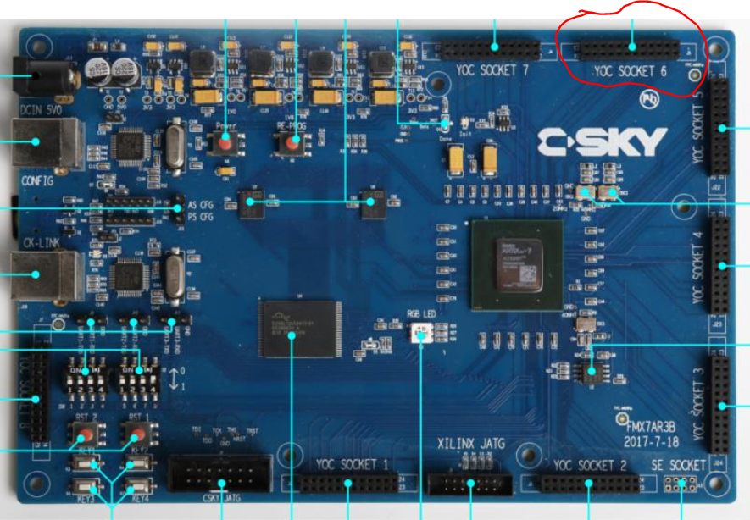

图1 ADC采集板插座位置示意图

## 2、接口定义

|  |  |  |  |  |
| --- | --- | --- | --- | --- |
| **序号** | **A端（YOC-SOCKET6）** | **B端（ADC采集板DC3-24P）** | **引脚定义** | **备注** |
| 1 | YOC4-1 | DC3_24P-1 | adc_dat[0] |  |
| 2 | YOC4-2 | DC3_24P-2 | **GND** |  |
| 3 | YOC4-3 | DC3_24P-3 | adc_dat[1] |  |
| 4 | YOC4-4 | DC3_24P-4 | adc_dat[2] |  |
| 5 | YOC4-5 | DC3_24P-5 | adc_dat[3] |  |
| 6 | YOC4-6 | DC3_24P-6 | adc_dat[4] |  |
| 7 | YOC4-7 | DC3_24P-7 | adc_dat[5] |  |
| 8 | YOC4-8 | DC3_24P-8 | adc_dat[6] |  |
| 9 | YOC4-9 | DC3_24P-9 | adc_dat[7] |  |
| 10 | YOC4-10 | DC3_24P-10 | **GND** |  |
| 11 | YOC4-11 | DC3_24P-11 | adc_dat[8] |  |
| 12 | YOC4-12 | DC3_24P-12 | adc_dat[9] |  |
| 13 | YOC4-13 | DC3_24P-13 | adc_dat[10] |  |
| 14 | YOC4-14 | DC3_24P-14 | adc_dat[11] |  |
| 15 | YOC4-15 | DC3_24P-15 |  | NC |
| 16 | YOC4-16 | DC3_24P-16 | int_adc_o | adc中断 |
| 17 | YOC4-17 | DC3_24P-17 | pin_res[0] | 备用管脚1 |
| 18 | YOC4-18 | DC3_24P-18 | pin_res[1] | 备用管脚2 |
| 19 | YOC4-19 | DC3_24P-19 | **GND** |  |
| 20 | YOC4-20 | DC3_24P-20 | **VDD3.3V** |  |
| 21 | YOC4-21 | DC3_24P-21 |  | NC |
| 22 | YOC4-22 | DC3_24P-22 | **VDD5.0V** |  |
| 23 | YOC4-23 | DC3_24P-23（ |  | NC |
| 24 | YOC4-24 | DC3_24P-24 |  | NC |

## 3、安装示意图



图2 ADC采集板安装示意图

## 4、注意事项

1. 如上图2所示视角，ADC采集板左侧为A面，右侧为B面，DC3-24P的安装确保ADC采集板的B面为元件焊接面；
2. 上图2视角中，DC3-24P的1脚在右下侧；