Maddy Zimmerman & Matthew Coetzee

Social Enterprises in Developing Economies II

Bo Hopkins

Case Study

**Get It**

“Oxfam’s [an organization working to end global poverty] existence relies on telling a tragic story about Africa and its development; I see Africa as one of the fastest growing regions in the world and a future exporter of innovation.”

* Lauren Russell, CEO of Get It

*Adelaine from Tally Bakery Cafe, a locally owned restaurant in Kigali, needs to buy ingredients for the next few days of business. Normally, Adelaine would have an employee drive to the local market to purchase fresh produce before the cafe opened its doors several days a week because the restaurant does not have sufficient cold storage facilities to store fresh produce for long periods of time. However, at the market, the price, the availability, and the quality of the produce varies considerably by day and farming season. Recently, Tally Bakery Cafe signed up with Get It, a fast moving consumer goods delivery company that specializes in fresh produce, to supply the cafe’s ingredients. One item on Adelaine’s lengthy supply list is 10 kilograms of open field tomatoes. Without Get It, 10 kg of tomatoes would cost Tally Bakery Cafe RWF 7,000 in the wet season and up to RWF 21,000 in the dry season, depending on the availability of tomatoes. Since signing up, Get It consistently supplies Adelaine’s 10 kg order of tomatoes for RWF 6,000. In addition to being RWF 1,000 cheaper, Get It saves Tally Bakery Cafe the cost and hassle of sourcing their own supplies for fresh produce purchases.*

**Supply Chain Systems in Rwanda:**

Rwanda is a small landlocked country in East Africa. About the size of Vermont and New Hampshire combined. Home to 13 million people, Rwanda has Africa’s highest population density. The vast majority of the population live in rural areas making service delivery and infrastructure delivery difficult to implement. The high density of people living in rural areas means that the land area available for farming is sparse, furthermore the agricultural sector is primarily subsistence based. Small, dense farming systems that are not commercially developed result has led to food insecurity in Rwanda[1]. In 2015, 39% of the Rwandan population lived below the poverty line, and approximately 35% of the population subsists on subsistence agriculture[2]. However, the country needs to import many of its food products given the underdeveloped and inefficient nature of Rwandan farm and food systems.

As a landlocked country, Rwanda has no ports, with the closest being in Mombasa, Kenya or Dar Es Salaam, Tanzania. Therefore, goods need to be moved by land, meaning that they travel slowly—often over unpaved roads—to reach their destination. Goods can be transported by air, which is faster but is decidedly more expensive and often subject to customs delays. Import taxes start at 25%, however, imports are often subject to additional taxes and transport charges. The price for goods can over triple in some cases after taxes and shipping. With 39% of the population living below the poverty line, food can become inaccessible and too expensive for many Rwandans[3] (Appendix 1). The high costs associated with importing basic food products means that there is significant potential for businesses that produce and transport food within Rwanda.

Further adding to the challenges facing Rwanda’s food system is the geography of the land. Rwanda is affectionately known as “The Land of 1,000 Hills,” however, these hills make land difficult for farming and the possibility of erosion and landslides higher. Roads have to be built within the limitations of hill and mountain contours, meaning infrastructure developments are expensive and travel is often indirect[4]**.** The infrastructure challenges in addition to the lack of advanced farming technologies mean that farmers often cannot gain the highest yield that their land, the soil, and its nutrients can provide.

Rwanda’s largest agricultural products are coffee, tea, pyrethrum, bananas, beans, sorghum, and potatoes[5]. A significant portion of their agricultural focus is based on cash crops in order to promote exports of highly valued goods. But there is significant potential for horticulture investment and a domestic market for it. Because importing into Rwanda faces significant challenges and high import tariffs, there is great need to harness domestic horticulture for its citizens. Given the high poverty rate, and the low level of purchasing power of Rwandan citizens, improving the food supply chain to reduce the cost of food is a national priority. Business that are able to increase the efficiencies of these systems can have a significant social impact by improving the stability of the food supply system.

As Rwanda aims at developing its agribusiness, it faces challenges as its horticulture supply chain is currently unreliable and operates inefficiently. During the dry seasons that fall between June - September and December - February, product availability is especially inconsistent[6]. Due to limitations of transport and asymmetric information, farmers will sell their produce to a middleman at a low price because they do not have direct access to the market and are dependent on these middlemen to transport their produce. In turn the produce is sold to another middle man at a higher price, who can sell to additional middleman, and the chain repeats. Eventually produce reaches the market, where the final seller still needs to make a profit, and further increases prices. The lack of reliable transport infrastructure increases the number of middlemen in the food supply chain, because there is a limited range in which most crops can be transported without major access to refrigerated transport systems or even trucks, motorcycles and tuk-tuks. The lack of transport means that middlemen are often the only buyers available to some farmers, allowing them to take advantage and purchase agricultural goods at incredibly low prices. Periodically, these inconsistencies and limitations in the supply chain can lead to a tripling in the price from the farmer to the market, especially in the dry season when prices are volatile[7] (Appendix 2).

At the market, vendors with the same products will be lined in rows trying to sell their products, competing without any product differentiation[8]. If vendors do not sell their items by the end of the day the produce will spoil due to the lack of refrigeration, and they will have to start the whole process of buying from middlemen again the next day. Not only do farmers get paid low prices, and consumers pay high prices, but the way the supply chain system functions means there can be an oversupply of food that will go bad within a few days. This system leads to variable prices, lack of access and paradoxically food shortages in the long run.

Throughout the supply chain from farmer to consumer, most produce should be kept cold to increase its store life. To illustrate the need for refrigeration, the impact of refrigeration on tomatoes has been analyzed; without any refrigeration, tomatoes can only keep for three days. However, when stored at 15 degrees Celsius, the same tomatoes can last up to fourteen days[9]. Throughout the supply chain in Rwanda, cold storage is rarely an option. Cold storage facilities are limited, and refrigeration for transport is even more unlikely. Produce is often kept in open air and in crates in storage at the farm, transport, and at the market. With an annual average temperature of 20.5 degrees Celsius and monthly average temperature variations of only 1.5 degrees Celsius, produce is kept in too warm of conditions, leading to more losses within the supply chain[10]. Therefore cold storage facilities are vital to the development of any horticultural-based business.

Quality does not only deteriorate from the lack of cold storage, but through poor transportation and packing. Tomatoes tend to get transported in baskets that are too large and placed in overfilled trucks, leading to bruising and thus decaying. While already overpriced, produce is additionally of low quality, providing consumers with poor nutritional output from their purchases. Additionally, when traveling from middleman to middleman, produce gets unpackaged and repackaged, which leads to bruising, and further decreases nutritional value and quality of the product[11]. With a more streamlined supply chain, not only will prices drop, but the value of the produce will increase. While we use the example of tomatoes, these inefficiencies impact all fresh produce deliveries in Rwanda.

It is clear that cold storage facilities and efficiently organized transport systems are needed to develop to maximize the horticultural potential of Rwanda. The focus on developing these food supply systems can help ensure Rwanda has increased food security and develop its potential to become a future exporter and important regional player. Increasing the efficiency of the supply chain, while increasing the total quantity moved through the system, will provide benefits to the consumer and producers. Businesses that help address these needs, that focus on the development of the Rwandan agricultural sector, can have a significant social impact on the country while operating as for-profit companies.

Despite the many challenges facing Rwanda and its food supply systems the economy of the country has been growing at an average rate of 7.6% between 2007 and 2016[12]. Rwanda is developing at one of the fastest rates on the African continent, and therefore provides a massive opportunity for business, investment and entrepreneurship. Economic and food supply chain development need to happen concurrently, which indicates a substantial need for improved supply chain systems in Rwanda.

*The supply chain in Rwanda is inefficient due to:*

* Small, underdeveloped farming systems
* Poor infrastructure
* Many middlemen involved in transportation, decreasing the quality because they are repackaged and handled more often
* Lack of refrigeration means there is a limited shelf life for horticultural products

*How Get It tackles the inefficient supply chain:*

* Improve farming systems to increase yields and supply
* Developing cold storage refrigeration
* Purchases directly from farmers
* Sells directly to businesses
* Ensures good quality and decreases damage done during transportation

**Get It:**

**The Business Model**

In October of 2014, Get It officially became a Rwandan business. Today, Get It provides fast moving consumer goods, such as fresh fruits and vegetables and dry goods, to hotels and restaurants in Rwanda. However, Get It started as a very different enterprise. Noticing that access to food is not easy in Kigali, let alone the rest of the country, Get It’s CEO, Lauren Russell, decided that she would start a business that simplified food shopping. She originally targeted rural villages to provide them with their everyday food needs as well as foods that were only accessible in Kigali. However, this business model did not work as the villagers often did not know that these products existed, and therefore had no need for them. Get It changed its business model to shift its focus to Kigali and businesses that rely on staple products. Selling to expats, she decided to introduce fruits and vegetables at the end of May 2015, and the business started to take off. But retail delivery was not the best market either due to an underdeveloped mobile payment system and a business model that relied on large numbers of small scale deliveries. By May of 2017, Lauren had transitioned from retail to business to business, providing fresh produce from Rwandan farms in large quantities and importing any necessary dry goods. Get It maintained a retail option by selling monthly subscriptions to farm boxes—preselected boxes of standard fruit and vegetable products. However, farm boxes are a marginal focus for the moment with the primary focus being on the company’s business to business relations. The shift toward a business to business model allows Get It to make bulk deliveries to clients that require vast produce supplies, and decreases the number of deliveries needed to make a viable business model (Appendix 3).

Get It is a company built to address the inefficiencies of the supply chain system in Rwanda. The operations start with the company’s relationship with farmers and the procurement of fresh horticultural goods. These goods are sourced from over 20 farms near Kigali, and are stored in Get It’s cold storage units. After the produce has been bought it is sorted and packaged as per each delivery request. As mentioned, Rwanda does not have many efficient food supply systems, meaning sourcing food is often unreliable and seasonal. While Get It aims to change that, the company’s baseline infrastructure needed to be built from nothing. This first meant building a warehouse for storage, building a cold storage facility, establishing an order and payment system, and establishing contracts with local farmers to provide the produce. This has all been done to create an efficient system in which produce is brought to the warehouse, inspected, sorted, washed, and stored. The produce is then packaged and shipped via truck, tuk-tuk, or moto to the customer. Although it seems like a relatively simple process, it takes the attention of many workers for an effective and efficient flow (Appendix 4).

Every delivery starts with an order. Orders are made through Facebook, SMS, Whatsapp Messenger or email and are processed fast enough to ensure a next day delivery. Orders need to be made the next day as businesses do not have access to expensive cold storage facilities and therefore rely on Get It to supply fresh produce. The ordering business specifies the quantity of the product requested, that is based on a catalog of produce and dry goods Get It releases every month. The orders are processed using TradeGecko inventory software. At 5:30 am, orders start being prepared for delivery with the goal of final orders for the first half of the day to leave the facility by 8 am. The inventory software runs on a cloud based system and allows the company to monitor the amount of produce in stock. However, there can and often was a delay in the cataloging and procurement of inventory, which meant that produce had to be bought from the local market at considerably higher costs to the business. Customers are able to specify a specific delivery time by the hour, or let Get It decide on a delivery window for them. Orders are, then, delivered throughout the day in a refrigerated truck, tuk-tuk and moto. While deliveries are being made, orders for the next day are continuously taken and are being prepared for throughout the business day.

Get It’s goal is to secure enough produce from contracts with farmers based near Kigali and to ensure sufficient quantity for delivery, but if there is a shortfall the processing team will supplement Get It’s supplies with produce from the market. However, this produce is expensive to procure on the day and cuts into Get It’s profits. Having a constant and large supply of horticultural goods is important for the business, but having too much produce may result in spoiling. The inventory of Get It is therefore in constant flux and needs to be delicately balanced in order to ensure a sufficient quality of the produce and minimize waste. Get It currently supplies to businesses in the greater Kigali area and started supplying Musanze, the Northern region of Rwanda that is a popular tourist destination for gorilla tracking, in June 2017.

Get It has greatly benefited from its transition to a business to business centered approach in which it has been able to play a significant impact in the development of the food supply value chain. Get It hires and employs agronomists that work at the base of the value chain, with farmers, in an attempt to better farming techniques and ensure quality produce. Paul Imulia is the Chief Agronomist at Get It, and his primary responsibility is working with farmers to ensure quality horticultural produce, in sufficient quantities, is secured quickly. Paul has a Bachelor of Science in Agribusiness. Paul identifies the relationships with the local farms in Rwanda as the backbone of the business, and Get It needs to invest in these farms and its relationships with them, even if it means giving them credit. Get It currently works with 18-20 farmers on extended contracts. These farms are chosen based on their ability and potential to deliver produce that is of: a sufficient quality, large quantities, abides by food safety regulations, and are price competitive. The majority of the farmers are local and medium sized - at roughly 2 acres. Currently Get It only has the transport infrastructure to work with farms that are relatively close to Kigali, and this puts a strain on the quantity that can be consistently purchased. Paul trains farmers in their use of spray chemicals and efficient harvest systems, and he envisions a more active role with farmers in which they are included in company meetings and vision.

Working with farmers has its own obstacles as well. Joseph, who is in charge of connecting with farmers and establishing contracts, cites two main reasons: farmers are not ready for Get It’s demand because they are used to smaller quantities and suppliers, and the farms tend to be of small scale. Ideally, there should be at least two farmers per product in order to prevent losses from stochasticity, but because farmers that use proper techniques and are of large enough scale are difficult to find, the agronomist is necessary component of Get It’s business strategy as farms need help scaling. Paul’s work should not only increase the volume and quality of products through his farm visits and advising, but also he helps find more farmers to keep up with Get It’s increasing demand. Additionally, by communicating Get It’s vision with farmers, Joseph sees the farmers being more incentivized to provide more produce with high levels of quality. Because Lauren’s business is new to Rwanda, and new farmers are being brought on often, there is a steep learning curve for the farmers who need to supply Get It with goods at a sufficient standard. With time, education, and communication, the farmers will be able to supply the right quantity and quality, and therefore, get better contracts to make more and steadier money. The interplay of farmer relations and Get It’s company values are an integral part of the partnership and common understanding within the agricultural supply chain. Get It relies on farmers adopting a collaborative view toward increasing agricultural yields. To incentivize this transition Get It offers consistent, year-long contracts at competitive prices that provide increased income and job security for farmers and their workers.

Additionally, Get It faces some financial challenges that are unique to operating within Rwanda. Lauren has expressed difficulties in getting credit based loans from banks as they generally require significant collateral. She has found getting equity investment easier than expected and notes that there are a great number of finance first investors willing to support businesses operating in Africa. Get It currently has over $1 million in equity investments, and continues to grow at its revenue streams at 20-50% month-over-month[13]. However, with every equity investment, Lauren loses a stake in her own business. Get It needs to find ways to finance its own expansion without relying too heavily on equity investments. Get It has had to invest in land in order to secure the collateral needed to take out loans within Rwanda, which puts a significant strain on the cash flow of the business.

**What Makes Get It Unique?**

Get It stands apart from any other company in Rwanda because it acquired the ISO (International Organization for Standardization) 22000: 2005 food safety certification in October of 2017. This certificate is the first in Rwanda and gives Get It an advantage over the competition. International hotels, the United Nations, and other international chains are required to provide food that has been certified as safe to eat at internationally recognized standards such as the ISO certification. As Rwanda’s only company that can officially say that they can provide safe food, at an ISO standard, Get It has a strong market-position within the food supply sector for international chains. However, not every business is aware, or follows, these safety standards. Part of Get It’s challenge is showing these organizations and companies why they should care and buy from a certified supplier. It is important to ensure that Get It secures local business in addition to the larger international chains, as popular local restaurants provide a lucrative clientele.

Food safety is fundamentally important and something that is often taken for granted in the developed world. Eating is a necessity, having food that you know will not make you sick is the first step to living a long and healthy life. Food safety begins at the farm. Farmers must apply fertilizers and pesticides correctly, plant and harvest at the right time, use proper planting techniques, and use ISO approved transport systems to bring the produce to Get It. When arriving at Get It, they are checked for quality and produce that does not reach minimum quality standards is thrown out. Next, they are washed in chlorinated water to remove any chemicals, bacteria, and dirt. Finally, they are stored in clean crates with a spacer crate between it and the ground to prevent further contamination in the cold storage unit. When packaging for clients, produce is put into new crates, still with spacer crates, and loaded into either the tuk-tuk or the truck to be delivered to the customer. Throughout the whole process, workers are required to scrub their hands, remove excess jewelry, and cover their hair to prevent further contamination. All steps within this process must be done inside a standing structure. By creating a sterile environment, the process tries to remove all possible pathogens within the food chain, to prevent further contamination, and to ensure that the food eaten will provide customers with nutritional benefits rather than making them sick.

**Lauren Russell and a Finance First Approach to Development:**

**The Force Behind Get It**

While working for the Nike Foundation, Lauren Russell was assigned to work in Rwanda for their project Girl Hub. After moving to Rwanda, she quickly noticed that food was not easily accessible. In order to make a single meal, she might have to go to travel to multiple stores. Realizing that there was a need for accessible food, she decided to start her own business that could supply any type of food that the average consumer needed. In December of 2013, she decided to start this business; by September, she left the Nike Foundation; and by October, Get It opened its (car) doors.

Lauren started Get It from her home and did the first 500 deliveries from the back of her car. Constantly changing her business model, Lauren has experimented with rural markets, retail markets, and many different types of food. Her tenacity and passion to create a consistent food supply has allowed Get It to remain operational. Additionally, she made some crucial decisions when first starting the company that made Get It the company it is today. A formative aspect of her business identity stems from turning down money from impact investors. Having originally targeted a rural customer base, impact investors saw that she could supply food to food deserts within Rwanda. However, she could not find a need for her company within this customer base. Because she refused impact investing money, she was able to shift her focus to the capital, Kigali. Accepting money from impact investors would have limited the ingenuity of Get It’s team and would have made the company answerable to donors that required impact metrics, potentially making decisions affecting the profitability of the start-up difficult to navigate.

In addition to believing social enterprises limit creativity, Lauren does not fully support the idea behind social enterprises because she believes that they tend to act too similarly to NGOs, while having the capacity to skew the market. The natural forces of the market are the means through which Lauren wants to improve the lives of Rwandans, rather than relying on donor money. Increased income results in an increased quality of life, and impact should not be the focus of any business. Rather businesses need to be sustainable and efficient to generate real change. She knows that if she is paying the farmers more than they would get in years past, that their lives will be positively impacted. With a finance-first mission, Lauren sees Get It as a “rock star business with ethics.” She aims to prove that fiscally responsible businesses can create a bigger impact than NGOs and social enterprises because they are empowering people through market systems that are not skewed and reliant on donor requirements.

Get It is a finance first operation. Profit is the key objective of the business. Lauren has made it clear that she believes solutions to social problems can be addressed through a American approach to business and the market-based system. Get It helps develop farming systems by consistently ordering large quantities of food at an agreed upon price. This helps farmers improve their yields, increases their income, and creates a less volatile pricing system.Furthermore, as Get It grows so do the number of jobs the business provides to Rwandan citizens, with opportunity for training and upward mobility. Lauren does not believe this should be measured with impact metrics; it can be extrapolated from the basic fact that farmers are being paid more consistently and able to supply more produce that impact is being achieved. Both parties are protected by consistent contracts that are agreed upon between Get It and farmers—a new system that was not part of the supply chain before Get It. Contracts ensure that both parties can be held accountable to deliver or purchase produce, and provide a proxy metric for impact (assuming quantities are stipulated on the contracts).

Lauren thinks big. She has ambitious goals for Get It, and her vision and tenacity make them tangible. Since earning their food safety certification, she sees the company supplying large hotels, restaurants, international chains, the United Nations, and even exporting Rwanda’s produce to nearby East African countries. She even hopes to open headquarters in many other East African nations, including Uganda and the Democratic Republic of the Congo. The infrastructure may be lacking currently for these visions, but she built a cold storage unit and a processing facility within a month. If there is a need and demand, she will find a way to have her business be the first to supply. She has a positive outlook on the future of Get It and the continent of Africa in general. Rather than seeing Africans as people deserving sympathy and aid, she sees them as innovators with their own agency. Lauren believes that soon Africa will be exporting innovation. Lauren’s forward looking focus is imperative for building a company, like Get It, the first of its kind in Rwanda. It allows her to build a company that can look beyond current restraints, such as a lack of cold storage facilities, and see a future where her company can reach a more consumers and rely on more and more small-holder farmers. Without this outlook, Get It would not have been able scale to its magnitude today, let alone survive.

**The Role of Government:**

Despite the challenges facing agricultural systems in Rwanda, it is a significant driver of the country’s economy. Agriculture employs more than 70% of the country’s population and accounts for roughly 32% of Rwanda’s GDP[14]. In 2012, as part of the government’s Special Economic Zone (SEZ) initiative in Kigali, a specific focus was placed on improving Rwanda’s agribusinesses. This government focused initiative was further emphasized in 2016, when the government launched an online platform to give investors information on public land and its suitability for agricultural development[15]. The government’s focus on food systems helped facilitate an environment in which Get It could operate and highlights the importance of private company and government collaboration. Rwanda’s initiative culminates in its “Vision 2020” development plan in which President Paul Kagame has placed a significant priority on land tenure reforms, rural development and agricultural investment[16]. The Rwandan Development Board illustrates their commitment though implementing a “food-basket approach” in which smallholder farmers are specifically identified as vital sources of accelerated growth and opportunity in the country[17]. The government is increasingly focused on encouraging private sector participation through reducing barriers to doing business and attempting to gain foreign investors[18].

The active role of the Rwandan government calls into question the efficacy of a “social enterprise” or “impact first” approach to agricultural development. The government subsidizes seed and fertilizers for priority crops in addition to taking strong initiatives that promote improved irrigation, land use improvement and social and water conservation. The government is making a concerted effort to move away from being a donor dependent country toward private sector participation and the subsequent empowerment of its citizens through their incorporation into the market system. This transition counters small subsistence based initiatives that are primarily focused on smallholder farmers that are not producing products traded in the formal economy. The Rwandan vision is develop the country’s land into a food basket that is capable of generating income and development through agribusiness. The Rwandan approach to business indicates that a partnership between the public and private sectors is important for social impact and development. However, the government has taken the lead on social issues, while businesses are encouraged to promote development.

Along with governmental support, Get It has a significant advantage over its competition. As mentioned, Get It is the first company to garner the ISO 22000:2005 food safety certification in Rwanda. All international chains are required, by government regulation, to serve certified and safe food. This, in theory, should give Get It a significant advantage over any competition, especially as this is Get It’s target demographic. But, not all businesses are abiding by these standards, meaning that they will get their produce from anywhere regardless of their sourcing and safety standards or lack thereof. The government regulation of the food industry indicates the growing partnership between the public and private sectors in Rwanda.

**Tourism, Economic Growth and Food Supplies**

Tourism has been earmarked by the Rwandan Development Board as a key sector for growth and jobs, with the Rwandan government being central to the development of the tourism industry. In 2013, the country boasted earnings of roughly $290 million, which has increased to more than $400 million in 2016[19]. The industry is still expected to grow and is providing vast potential for business growth. The Rwandan Development Board recognizes the presence of 200 hotels and over 4,500 hotel rooms in the country, a number that is constantly expanding as the tourism sector develops[20]. Get It is uniquely situated to cater to the produce supply needs of this sector, given its international safety certification. As the higher end tourism sector develops, businesses will need to ensure they are abiding by minimum safety standards. Supplying to hotels that are located near Rwanda’s national parks could provide a challenge for Get It as they are located at least two and a half hours away from Kigali, and the delivery of goods will place a considerable strain on Get It’s fleet of transportation vehicles that already needs to be expanded.

Lauren has ambitious plans for Get It. She wants to be able to export Get It’s produce to other East African nations and Europe. She also hopes to open offices in other East African nations. Abroad, Get It faces more competition. For example, in Kenya there is a company, Twiga, with a similar business model that exclusively sells bananas. In order to successfully open offices in other countries, Lauren must ensure that she tailors each office’s business model to its respective country. Throughout East Africa, there is plethora of diversity in development, technological usage, and culture. A system that works in Rwanda does not necessarily mean that it will work in Kenya or Uganda. Kenya, Uganda, and Tanzania all have substantially larger tourism industries than Rwanda ($7 billion, $1.88 billion, $4.5 billion in 2013 respectively compared to Rwanda’s $304.9 million)[21]. With international hotel chains, Get It’s target demographic, there is potential for high demand in these countries. However, before Get It expands internationally, the business needs to make sure that its operations are efficient in Rwanda.

**Challenges moving forward:**

* Increasing the scale of farming in Rwanda
* Increasing production lines
* Increasing the transport fleet
* Expanding into new markets
* Developing human capital
* Ensuring businesses abide by safety regulations

Get It has approached developing Rwandan food supply chains through a finance first operation. The business illustrates an innovative, Rwandan-based solution that utilizes market forces to address a need. There are many variables that lend to the success of Get It. While Get It continues to grow within Rwanda, Lauren needs to assess the plausibility of Get It’s business model being replicated in surrounding countries. Should Get It focus on expanding into neighboring countries, or should the company focus on its domestic operations within Rwanda?

**Acknowledgments:**

We would like to thank Bo Hopkins for his mentorship throughout these past two semesters. Additionally, thanks to Lauren and the team at Get It for welcoming us and providing us with insights on the company. Finally, thank you to our fellowship funders, particularly the MacMillan Center for making this experience possible.

**Appendices:**

**Appendix 1:**

Example of Taxes and Shipping Costs in Rwanda:

|  |  |  |  |  |  |  |  |  |  |  |  |  |  |
| --- | --- | --- | --- | --- | --- | --- | --- | --- | --- | --- | --- | --- | --- |
| Cost Per Case: | Import Taxes | VAT | Withholding | QIF | IDL | **Total Taxes** | Shipping Weight | Shipping Costs | Fees per Kg | Kountable | **Get It Margin** | **Total Cost w/VAT** | RWF Conversion |
|  | 25% | 18% | 6% | 0.2% | 2% |  | 100% | $4.00 | $1.50 | 11% | **20%** | **$1.23** | 860 |
| $100.00 | $25.00 | $22.50 | $5.50 | $0.20 | $1.50 | **$54.70** | 5.00 | $20.00 | $7.50 | $18.34 | **$40.89** | **$242.62** | 208,652 |

Get It has a margin of 15% on their imports but because of the costs involved with importing goods, local produce is the focus of Get It’s business

Import Tax: The tariffs the Rwandan government imposes on imports of products

VAT: The Value Added Tax of all products in Rwanda

Withholding Tax: The taxes collected from allowing companies to transfer money across borders

QIF: Qualifying Investor Fund * Check this  
IDL: Infrastructure Development Levy, that the government uses to finance African Union Activities

Kountable: fees for a multi-national online trading platform

Margin: Get It adds a margin of 15% to imports

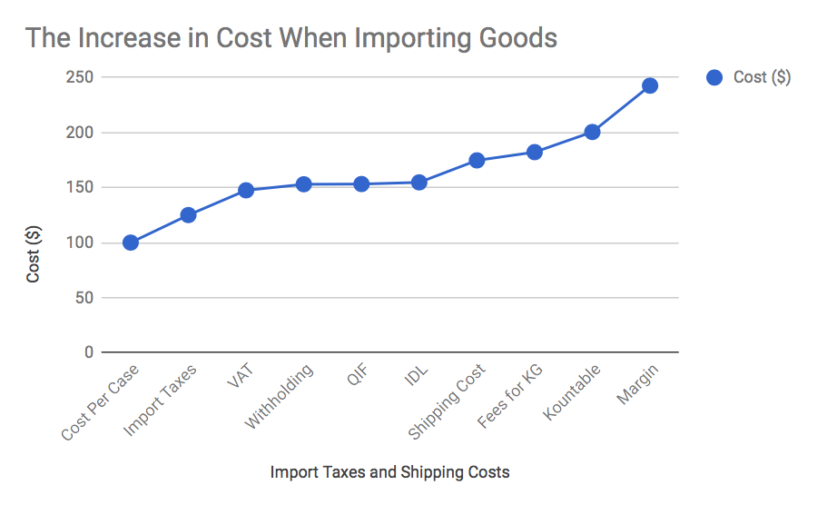

**Appendix 2:**

Tomatoes as an example of the Value Proposition of Get It:

* Price from farm per KG: RWF 520
* Get it price per Kg: RWF 600 (15% mark-up)
* Average market price per Kg: RWF 700 (35% mark-up from farmer to market)
* 17% saving - less than market price
* Get it reduces this by more than half (35% → 15%)

**Appendix 3:**

Example of Delivery Quantities:

|  |  |  |
| --- | --- | --- |
| **Product** | **Average Quantity Delivered per Day (kgs)** | **Average Quantity Delivered per Week (kgs)** |
| Eggs - Rwandan Each | 125 | 750 |
| Irish Potatoes | 75 | 450 |
| Onions | 22 | 132 |
| Carrots | 18 | 108 |
| Tomato - Open Field | 35 | 210 |
| Bananas | 22 | 132 |
| Pineapples | 18 | 108 |
| Avocados | 16 | 96 |
| Mango | 5 | 30 |
| Cucumber | 6 | 36 |

**Appendix 4:**

Original Supply Chain in Rwanda:

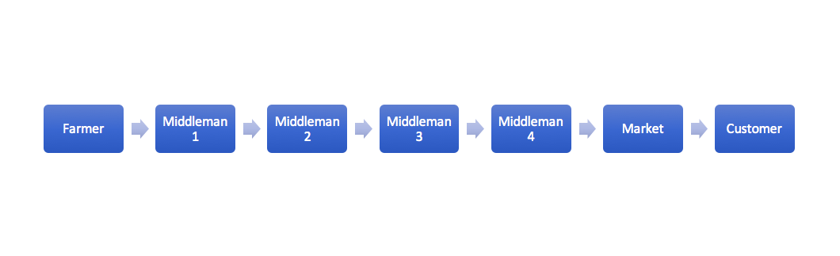

Get It’s Business Strategy and its impact on the Supply Chain:



Get It becomes the sole middleman and the market is cut out of the supply chain reducing costs by 17% for customers

Get It’s Operations:

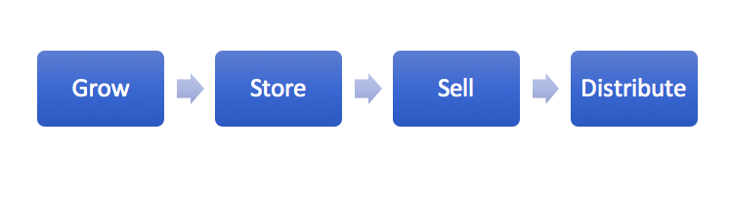

Get It’s Storage Flow:

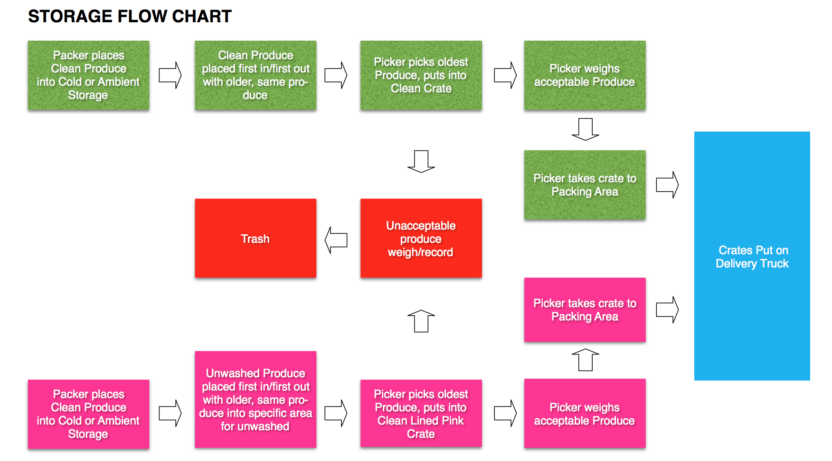

**Bibliography:**

“Agriculture and Food Security | Rwanda | U.S. Agency for International Development.” n.d. Accessed December 16, 2017. https://www.usaid.gov/rwanda/agriculture-and-food-security.

“Average Temperatures in Kigali, Rwanda Temperature.” n.d. Accessed December 16, 2017. http://www.rwanda.climatemps.com/temperatures.php.

“Climate & Agriculture.” n.d. Our Africa. Accessed December 16, 2017. http://www.our-africa.org/rwanda/climate-agriculture.

“Entrepreneur Quits Nike Job to Start Food Business in Rwanda.” n.d. Accessed December 15, 2017. http://www.bizcommunity.com/Article/178/423/170812.html.

“Golden Tulip Hotels Comes to Rwanda.” n.d. Accessed December 15, 2017. http://www.rdb.rw/news-pages/news-details/article/golden-tulip-hotels-comes-to-rwanda.html.

Magazine, Hope. n.d. “Agribusiness and Smallholders Seize $1 Trillion Food Market to Boost A.” Hope Magazine. Accessed December 15, 2017. http://hope-mag.com/index.php?com=news&option=read&ca=1&a=3223.

“Overview.” n.d. Text/HTML. World Bank. Accessed December 15, 2017. http://www.worldbank.org/en/country/rwanda/overview.

“Rwanda’s Tourism Earnings Seen up 25 Pct in 2016 from Last Year - Official.” n.d. Accessed December 15, 2017. https://af.reuters.com/article/africaTech/idAFKCN1190AD.

“The World Factbook — Central Intelligence Agency.” n.d. Accessed December 15, 2017. https://www.cia.gov/library/publications/the-world-factbook/geos/rw.html.

“Tomato Value Chain in Rwanda: Minimizing Food Losses.” n.d. TNO. Accessed December 15, 2017. https://www.tno.nl/en/about-tno/news/2017/5/tomato-value-chain-in-rwanda-minimizing-food-losses/.

1. “Agricultural and Food Security” USAID. https://www.usaid.gov/rwanda/agriculture-and-food-security
2. “The World Factbook: Africa - Rwanda” CIA library www.cia.gov/library/publications/the-world-factbook/geos/rw.html
3. “The World Bank in Rwanda” The World Bank, IBRD, http://www.worldbank.org/en/country/rwanda/overview
4. “The World Factbook: Africa - Rwanda” CIA library www.cia.gov/library/publications/the-world-factbook/geos/rw.html
5. Ibid.
6. “Rwanda - Climate and Agriculture” Our Africa. http://www.our-africa.org/rwanda/climate-agriculture
7. Niek Van Dijk, Youri Rijxhoorn and Siem van Merrienboer “SMART Tomato supply chain analysis for Rwanda - identifying opportunities for minimizing food losses.” Bopinc. https://agriprofocus.com/upload/Session3_SMART_supply_chain_Rwanda_BoPInc1454330726.pdf
8. Observed while on sight in Rwanda
9. Niek Van Dijk, Youri Rijxhoorn and Siem van Merrienboer “SMART Tomato supply chain analysis for Rwanda - identifying opportunities for minimizing food losses.” Bopinc.
10. “Average Temperatures in Rwanda” ClimaTemps. http://www.rwanda.climatemps.com/temperatures.php
11. Niek Van Dijk, Youri Rijxhoorn and Siem van Merrienboer “SMART Tomato supply chain analysis for Rwanda - identifying opportunities for minimizing food losses.” Bopinc.
12. Oluwabusayomi Sotundeon “Entrepreneur quits job at Nike to start food business in Rwanda” Bizcommunity. http://www.bizcommunity.com/Article/178/423/170812.html
13. Oluwabusayomi Sotundeon “Entrepreneur quits job at Nike to start food business in Rwanda” Bizcommunity. http://www.bizcommunity.com/Article/178/423/170812.html
14. Niek Van Dijk, Youri Rijxhoorn and Siem van Merrienboer “SMART Tomato supply chain analysis for Rwanda - identifying opportunities for minimizing food losses.” Bopinc.
15. “The World Factbook: Africa - Rwanda” CIA library
16. John Bikalamesa “Rwanda Vision 2020.” Fortune of Africa. http://fortuneofafrica.com/rwanda/2014/04/30/rwanda-vision-2020/
17. “Agribusiness and smallholders seize $1 trillion food market to boost African growth.” Hope Magazine - Rwanda. http://hope-mag.com/index.php?com=news&option=read&ca=1&a=3223
18. Niek Van Dijk, Youri Rijxhoorn and Siem van Merrienboer “SMART Tomato supply chain analysis for Rwanda - identifying opportunities for minimizing food losses.” Bopinc.
19. “Rwanda's tourism earnings seen up 25 pct in 2016 from last year - official” Reuters Staff https://af.reuters.com/article/africaTech/idAFKCN1190AD
20. “Golden Tulip Hotels Comes to Rwanda” Rwanda Development Board. RDB News. http://www.rdb.rw/news-pages/news-details/article/golden-tulip-hotels-comes-to-rwanda.html
21. Ibid.