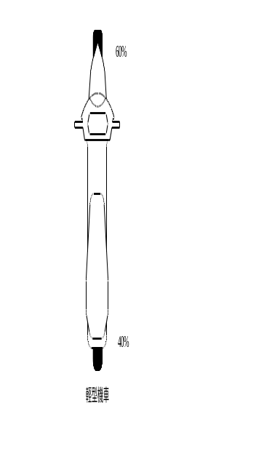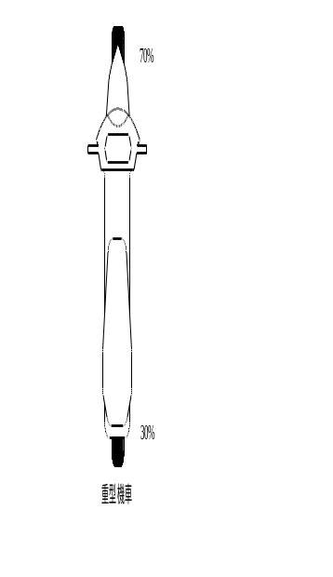

R.W. Rivers, Evidence in Traffic Crash Investigation and Reconstruction, Thomas, 2006.

