COORDINATION CHEMISTRY RESEARCH SOFTWARE
Complexation
Property Explorer
User Manual · Version 0.4.0
Purpose: Search, inspect, compare, and export metal-ligand stability-constant records from the unified, local read-only NIST SRD 46 and supplement database.

For coordination-chemistry researchers
Manual date: July 22, 2026
Repository: github.com/ccchaos12/complexation-property-explorer

1. Start here
Complexation Property Explorer is a local browser application for finding reported stability constants. Version 0.4.0 unifies NIST SRD 46 with a verified local supplement in one read-only SQLite database.

What the software does
- Filters records by metal species, ligand, reaction, value type, and measurement conditions.
- Shows reported source text alongside parsed, machine-readable values and source identity when available.
- Compares two records and shows linked references, strict duplicates, and exact-structure ligand matches.
- Exports the active filtered result set as UTF-8 CSV.

What it does not do
The all-verified release policy is a publication control, not a new independent verification of thermodynamic values. Check source records and primary literature before publication or model training.

Quick workflow
1. Filter. Choose a metal species, set the value type, and enter a ligand.
2. Inspect. Select a result and read the equilibrium, value, and conditions.
3. Compare. Check whether definitions and experimental conditions are compatible.
4. Verify. Confirm the value, source identity, and reference in the original literature.
5. Export. Save the filtered CSV with version, build, filters, and date.
Interpretation rule: Never rank constants by numerical magnitude alone. Confirm value type, equilibrium, stoichiometry, temperature, ionic strength, solvent, and electrolyte.

2. Install and launch

Requirements
- 64-bit Windows, macOS, or Linux computer
- Python 3.11, 3.12, or 3.13
- Internet access during the first start
- About 350 MB of free disk space

Windows
1. Download. On GitHub, choose Code > Download ZIP, then extract it to a writable folder.
2. Install Python. Install Python 3.11-3.13 and select Add python.exe to PATH.
3. Launch. Double-click start_windows.bat and keep the terminal open.

macOS
1. Open Terminal. In Finder, right-click the project folder and choose Services > New Terminal at Folder.
2. Allow launch. Run chmod +x run.command run.sh.
3. Launch. Run ./run.command. Later, run it again or double-click run.command.
If macOS blocks the file, Control-click run.command, choose Open, and confirm.

Linux
1. Open the project. Clone or extract the repository and open a terminal in the project directory.
2. Launch. Run ./run.sh.
First start: The launcher creates a private environment, installs pinned dependencies, verifies NIST files, includes the local supplement when present, builds SQLite, starts the server, and opens a browser.
Stop the app: Return to the terminal and press Ctrl+C. Closing the browser tab may not stop the local server.

3. Search the database
Use the filter sidebar, then review matching records in the main workspace. By default, strict cross-source duplicates are hidden from distinct results.
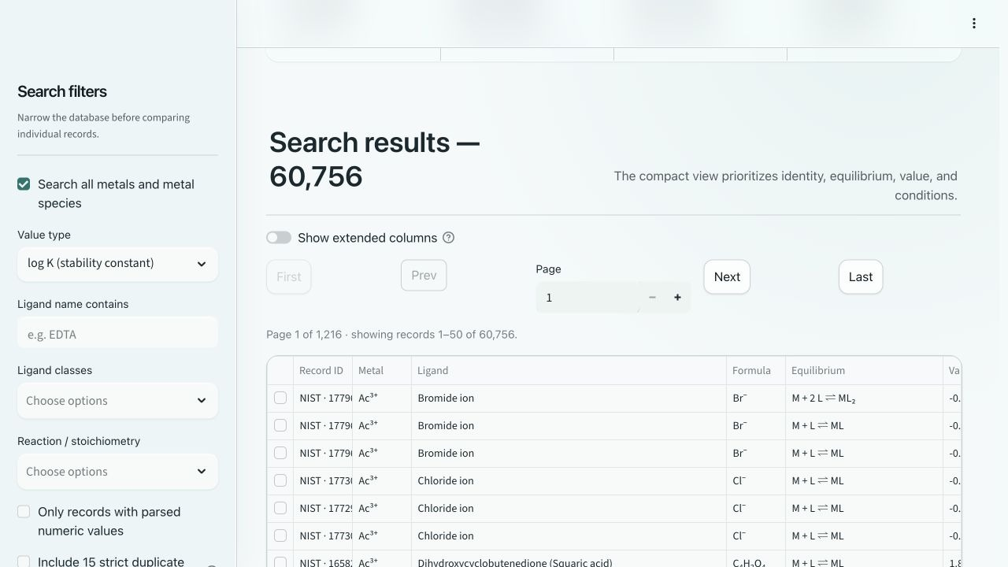
Figure 1. Main search workspace

Main filters
Control | Use
Metal species | Keep Search all metals selected, or clear it and choose specific species/oxidation states.
Value type | Choose log K or another supported thermodynamic value type.
Ligand | Enter a full or partial name; matching is case-insensitive.
Reaction | Filter formation stoichiometry, protonation, hydrolysis, phase, or coupled equilibria.
Numeric / duplicates | Filter numeric ranges; leave duplicates off for distinct results, or include all 15 retained source records.
Page size | Show 25-250 records per page.

4. Read and compare records

Results and details
- Use First, Prev, Next, Last, or enter a valid page number.
- Select Show extended columns to display more conditions and provenance fields.
- Click a row to open its record details.
The details panel shows identity, equilibrium, values, conditions, source, and notes. When available, v0.4.0 also flags strict duplicates and exact-structure ligand matches.
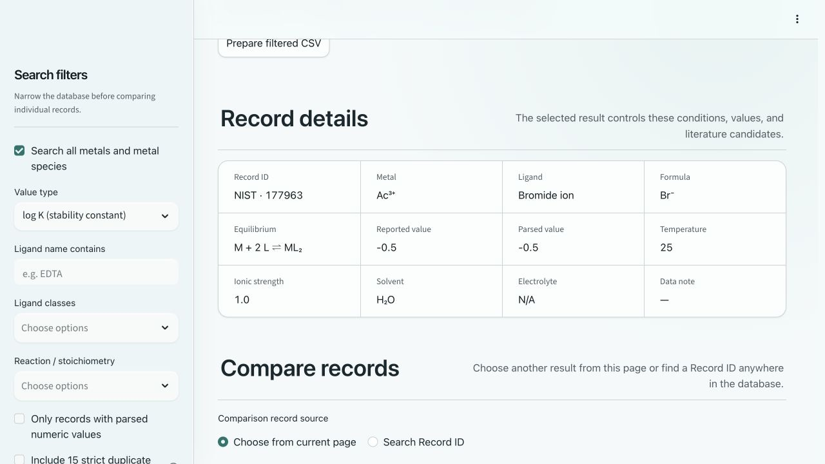
Figure 2. Selected-record details and comparison

Compare two records
1. Select the first record. Click a row in the results table.
2. Choose the second record. Select a page record or search by complete or partial Record ID.
3. Check compatibility. Compare species, ligand, equilibrium, value type, stoichiometry, and conditions.
Reported vs. parsed: Reported value preserves the source presentation. Parsed value is a separate numeric field and may be blank when the source is qualified, bounded, or non-numeric.

5. References and export

Candidate references
Supplement records have exact record-to-reference links. NIST links remain candidate ligand-plus-metal sources and are not proof that a reference reports the displayed value.
- Confirm the source, ligand identity, and metal species.
- Confirm the equilibrium, stoichiometry, and measurement conditions.
- Use the original primary measurement for publication or data curation whenever possible.

CSV export
1. Define the query. Apply specific chemical and numerical filters.
2. Prepare the file. Select Prepare filtered CSV.
3. Record context. Save the software version, database build identity, active filters, and export date.
Exports use UTF-8 and are limited to 50,000 records. Narrow the query if it exceeds the limit.

For analysis or machine learning
- Review data quality and resolve provenance offline before analysis.
- Keep source text separate from parsed or curated fields.
- Use an explicitly versioned, frozen release rather than a mutable working export.
Read-only boundary: The app listens only on the local interface and opens SQLite in query-only mode. Routine use does not alter the source or canonical database.

Current v0.4.0 unified build snapshot
Measure | Count
Metal and metal-species records | 230
Data sources / ligands | 2 / 5,931
Retained / distinct constants | 90,105 / 90,090
Retained / distinct log K records | 60,771 / 60,756
References / relationship links | 18,392 / 50 ligand / 15 duplicate

Release-build counts are shown: 90,105 source records are retained; 15 supplement duplicates are hidden from default distinct results.

6. Data sources and responsible use

Data sources
Cite the source dataset as: Burgess, D. R. (2004), NIST SRD 46. Critically Selected Stability Constants of Metal Complexes: Version 8.0 for Windows, National Institute of Standards and Technology. https://doi.org/10.18434/M32154 (accessed July 17, 2026).
The unified database preserves NIST SRD 46 and a verified local Excel supplement as separate sources. Supplement records use stable IDs and exact references. NIST extraction limitations remain; transformations are not independent verification.

Software citation
Use CITATION.cff for the current software citation. Cite the software, the underlying data source, and the primary literature used in your research.

Licensing
The Python application code is licensed under the MIT License. Source data is governed separately by the terms summarized in DATA_NOTICE.md. Raw archives and generated databases are not tracked in the repository.

Presentation and provenance
Legacy chemical markup is rendered as readable Unicode. Stored source text and source-scoped IDs remain unchanged; v0.4.0 adds relationship metadata without merging provenance.
Custom databases: Set COMPLEXATION_DB_PATH only for a compatible schema 2 canonical database. An incompatible database is rejected rather than rebuilt or overwritten.

7. Troubleshooting and links
Problem | Action
Python is missing on Windows | Install Python 3.11-3.13, enable Add python.exe to PATH, close the terminal, and retry.
Browser does not open | Copy the Ready: address from the terminal into a browser; it is usually http://localhost:8501.
Port 8501 is busy | Use the alternative Ready: address chosen automatically.
First start is slow | Keep the terminal open while dependencies, source files, and databases are prepared.
Database is damaged or outdated | Restart with the standard launcher; invalid generated files are preserved and rebuilt using canonical schema 2.
No records match | Clear restrictive filters one at a time; check the value type, metal species, and ligand spelling.
Export is over 50,000 rows | Narrow the metal, ligand, reaction, or numerical ranges.
App runs after browser closes | Return to the terminal and press Ctrl+C.

Project links
Repository: https://github.com/ccchaos12/complexation-property-explorer
Release v0.4.0: https://github.com/ccchaos12/complexation-property-explorer/releases/tag/v0.4.0
NIST SRD 46 record: https://data.nist.gov/od/id/mds2-2154
NIST dataset DOI: https://doi.org/10.18434/M32154

