# Compiling on Windows with CMAKE-Gui

CMake comes with a GUI which allows the user to generate the CMake files in a more user-friendly way. For configuring CMake in the command line, see the README file …\src\CMake\readme\readme

It is recommended to generate various CONFIGURATION_TYPES in separate directories.

# Setting up CMake-Gui

1) Select the location of the main CMakeLists.txt. This file is in …\src\CMake

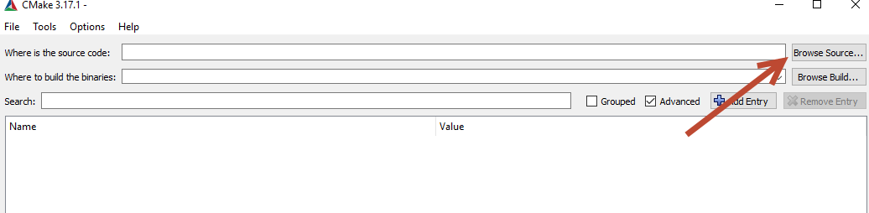

2) Select the destination path where the CMake files should be generated:

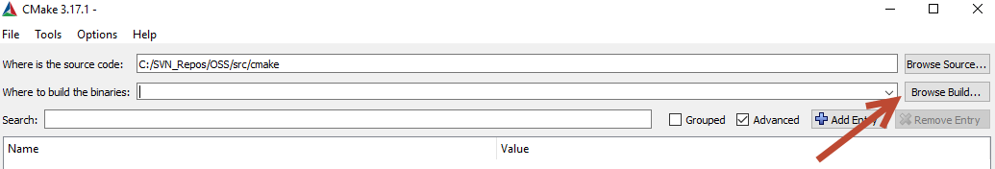

3) CMake will now display all variables and its corresponding values. Adjust the following variables when needed:

|  |  |  |
| --- | --- | --- |
| **Variable** | **Default value** | **Valid values** |
| CONFIGURATION_TYPE | Dflow_open | Dflow_open  Tests  Dimr_open |

4) Press “Configure” and set:

* The desired generator (for example Visual Studio 2017)
* The platform to generate the files for. Only x64 is supported at this moment

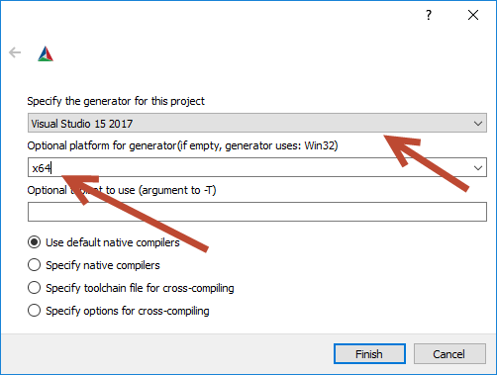

5) Press “Generate” to generate the desired .sln project file. This file can be opened from either the CMake file directory or from the CMake-Gui when pressing “Open Project.”

## Compiling the solution

Open the generated .sln file by the CMake-GUI. Configure the solution with the following settings:

|  |  |
| --- | --- |
| **Parameter** | **Value** |
| Solution configuration | Release |
| Solution platform | x64 |

The full solution will be compiled when <Ctrl><Shift>B

# Additional notes

The cache needs to be deleted when the user wants to reconfigure the solution for a different generator. This action can be done by going to “File” and press “Delete cache” or by deleting all the files from the target directory defined in step 2 of Section “Setting up CMake-Gui.”

