摇摇棒中的字怎样取字模？
以“欢”为例作为讲解
程序中的“欢”点阵是这样的：
//-- 欢 --
0x04,0x10,0x34,0x08,0xC4,0x06,0x04,0x01,
0xC4,0x82,0x3C,0x8C,0x20,0x40,0x10,0x30,
0x0F,0x0C,0xE8,0x03,0x08,0x0C,0x08,0x10,
0x28,0x60,0x18,0xC0,0x00,0x40,0x00,0x00,
为了直观，我们把它按PCB布线的方法把上面的点阵排类一下：
 | 1 | 2 | 3 | 4 | 1 | 2 | 3 | 4 | 1 | 2 | 3 | 4 | 1 | 2 | 3 | 4
P00 | 0 | 0 | 0 | 0 | 0 | 0 | 0 | 0 | 1 | 0 | 0 | 0 | 0 | 0 | 0 | 0
P01 | 0 | 0 | 0 | 0 | 0 | 0 | 0 | 0 | 1 | 0 | 0 | 0 | 0 | 0 | 0 | 0
P02 | 1 | 1 | 1 | 1 | 1 | 1 | 0 | 0 | 1 | 0 | 0 | 0 | 0 | 0 | 0 | 0
P03 | 0 | 0 | 0 | 0 | 0 | 1 | 0 | 0 | 1 | 1 | 1 | 1 | 1 | 1 | 0 | 0
P04 | 0 | 1 | 0 | 0 | 0 | 1 | 0 | 1 | 0 | 0 | 0 | 0 | 0 | 1 | 0 | 0
P05 | 0 | 1 | 0 | 0 | 0 | 1 | 1 | 0 | 0 | 1 | 0 | 0 | 1 | 0 | 0 | 0
P06 | 0 | 0 | 1 | 0 | 1 | 0 | 0 | 0 | 0 | 1 | 0 | 0 | 0 | 0 | 0 | 0
P07 | 0 | 0 | 1 | 0 | 1 | 0 | 0 | 0 | 0 | 1 | 0 | 0 | 0 | 0 | 0 | 0
P20 | 0 | 0 | 0 | 1 | 0 | 0 | 0 | 0 | 0 | 1 | 0 | 0 | 0 | 0 | 0 | 0
P21 | 0 | 0 | 1 | 0 | 1 | 0 | 0 | 0 | 0 | 1 | 0 | 0 | 0 | 0 | 0 | 0
P22 | 0 | 0 | 1 | 0 | 0 | 1 | 0 | 0 | 1 | 0 | 1 | 0 | 0 | 0 | 0 | 0
P23 | 0 | 1 | 0 | 0 | 0 | 1 | 0 | 0 | 1 | 0 | 1 | 0 | 0 | 0 | 0 | 0
P24 | 1 | 0 | 0 | 0 | 0 | 0 | 0 | 1 | 0 | 0 | 0 | 1 | 1 | 0 | 0 | 0
P25 | 0 | 0 | 0 | 0 | 0 | 0 | 0 | 1 | 0 | 0 | 0 | 0 | 1 | 0 | 1 | 0
P26 | 0 | 0 | 0 | 0 | 0 | 0 | 1 | 0 | 0 | 0 | 0 | 0 | 0 | 1 | 0 | 0
P27 | 0 | 0 | 0 | 0 | 1 | 1 | 0 | 0 | 0 | 0 | 0 | 0 | 0 | 1 | 0 | 0
其中1为亮 ，0为LED灭（为什么1是亮，0是灭，请亲们看一下程序和电路，2个结合起来看一下就明白了，这里就不再说明）
接下来为了方便看哪些是亮的，我们把0去掉：
P00 |  |  |  |  |  |  |  |  | 1
P01 |  |  |  |  |  |  |  |  | 1
P02 | 1 | 1 | 1 | 1 | 1 | 1 |  |  | 1
P03 |  |  |  |  |  | 1 |  |  | 1 | 1 | 1 | 1 | 1 | 1
P04 |  | 1 |  |  |  | 1 |  | 1 |  |  |  |  |  | 1
P05 |  | 1 |  |  |  | 1 | 1 |  |  | 1 |  |  | 1
P06 |  |  | 1 |  | 1 |  |  |  |  | 1
P07 |  |  | 1 |  | 1 |  |  |  |  | 1
P20 |  |  |  | 1 |  |  |  |  |  | 1
P21 |  |  | 1 |  | 1 |  |  |  |  | 1
P22 |  |  | 1 |  |  | 1 |  |  | 1 |  | 1
P23 |  | 1 |  |  |  | 1 |  |  | 1 |  | 1
P24 | 1 |  |  |  |  |  |  | 1 |  |  |  | 1 | 1
P25 |  |  |  |  |  |  |  | 1 |  |  |  |  | 1 |  | 1
P26 |  |  |  |  |  |  | 1 |  |  |  |  |  |  | 1
P27 |  |  |  |  | 1 | 1 |  |  |  |  |  |  |  | 1

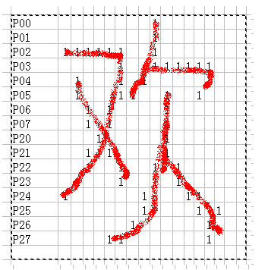
看到了吗，一个很大的“欢”字就出来了。上面的点阵我们是手动排列的。接下来教大家如何用软件取字模。
首先把点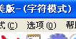中的选项，把软件设置为以下方式取字模：
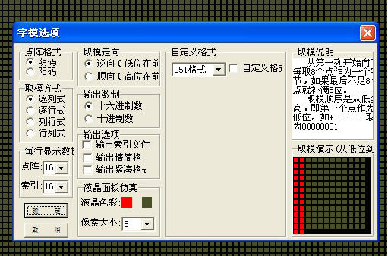
字体设置为：新宋体然后输入“欢”，点生产字模
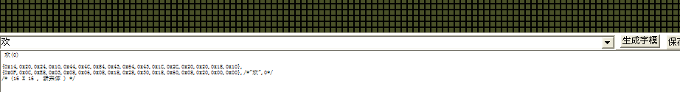
点完后我们会得到如下的字模：
欢(0)

{0x14,0x20,0x24,0x10,0x44,0x4C,0x84,0x43,0x64,0x43,0x1C,0x2C,0x20,0x20,0x18,0x10},
{0x0F,0x0C,0xE8,0x03,0x08,0x06,0x08,0x18,0x28,0x30,0x18,0x60,0x08,0x20,0x00,0x00},/*"欢
/* (16 X 16 , 新宋体 ) */

这个就是我们要的“欢”字的字模，很多亲们就会问，为什么软件取出来的字模和程序中的不一样，那是因为程序中的字模，我们是手动排列的。用软件取出来的字模也是可以的。
我们可以按照软件取出来的自模自己排列一下：
|
P00 |  |  |  |  |  |  |  |  | 1
P01 |  |  |  |  |  |  |  |  | 1
P02 | 1 | 1 | 1 | 1 | 1 | 1 |  |  | 1
P03 |  |  |  |  |  | 1 |  | 1 | 1 | 1 | 1 | 1 | 1 | 1 | 1
P04 | 1 |  |  |  |  | 1 |  | 1 |  |  |  |  |  | 1
P05 |  | 1 |  |  | 1 |  | 1 |  |  | 1 |  |  | 1
P06 |  |  | 1 |  | 1 |  |  |  |  | 1
P07 |  |  |  | 1 |  |  |  |  |  | 1
P20 |  |  |  | 1 | 1 |  |  |  |  | 1
P21 |  |  |  | 1 | 1 | 1 |  |  |  | 1 | 1
P22 |  |  | 1 |  |  |  |  |  | 1 |  | 1
P23 |  |  | 1 |  |  |  |  |  | 1 |  |  | 1
P24 |  | 1 |  |  |  |  |  | 1 |  |  |  | 1 | 1
P25 | 1 |  |  |  |  |  | 1 |  |  |  |  |  | 1 | 1 | 1
P26 |  |  | 1 | 1 | 1 | 1 |  |  |  |  |  |  |  | 1
P27 |  |  |  |  |  | 1
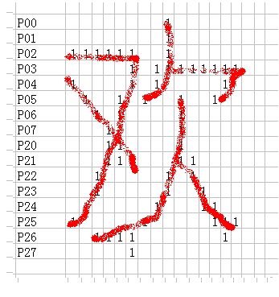
也是一个|“欢”，只是字体不一样。

