Artificial Intelligence Adoption in European Enterprises
A Multi-Level Analysis of Country, Firm Size and Sector Drivers, 2021–2025
Internet & Network Economics — Academic Year 2025/2026
Giulio D’Amico

Abstract
This paper studies the diffusion of artificial intelligence (AI) across European Union enterprises between 2021 and 2025, drawing on the Eurostat ICT-in-enterprises survey and the European Commission's Digital Decade dashboard. The aggregate trajectory hides a pronounced acceleration: the share of EU-27 firms (≥10 employees) using at least one AI technology rose from 7.7% in 2021 to 20.7% in 2025, with the bulk of the increase concentrated in 2024 and 2025. We argue, however, that the aggregate figure obscures a phenomenon that operates simultaneously on three layers — country, firm size, and sector — and that none of these layers, taken alone, explains the variance in the data. At the country level, AI adoption ranges from 5.2% in Romania to 42.0% in Denmark; cross-country differences correlate strongly with the digital maturity of firms (r = 0.76) and basic digital skills of the population (r = 0.70), but, strikingly, not with broadband infrastructure (r = 0.23, n.s.). At the firm-size level, large enterprises adopt AI three times more often than small ones (54% vs 18% in 2025). At the sectoral level, ICT firms have reached 60% adoption while construction trails at 11%, with the absolute gap widening every year. The three layers combine in non-trivial ways: a Romanian ICT firm adopts AI less than a Belgian manufacturing firm. We interpret these patterns through the lens of the technology-diffusion literature — task codifiability, complementary intangible assets, workforce digital skills, and firm-size composition — and discuss implications for the Digital Decade 2030 targets.
Keywords: Artificial intelligence; Digital Decade; technology diffusion; European Union; enterprise digitalisation; digital divide.
JEL codes: O33 (Technological Change: Choices and Consequences); L86 (Information and Internet Services); D22 (Firm Behavior).

1. Introduction
In December 2022 the Council and the Parliament of the European Union adopted the Digital Decade Policy Programme 2030, setting out a small number of quantitative targets for the digital transformation of the Union by the end of the decade. One of these targets concerns business adoption of advanced digital technologies — cloud, big data and, since 2023, artificial intelligence — with the explicit ambition that 75% of EU enterprises should be using at least one of these technologies by 2030. Two years into the monitoring exercise, the picture that emerges from the data is at once encouraging and unsettling. Encouraging, because aggregate AI adoption in the EU has roughly tripled in four years; unsettling, because the distribution of that growth across countries, firm sizes and sectors is so uneven that the European Commission's recent assessment of the Digital Decade flags AI as one of the indicators most likely to fall short of its 2030 trajectory.
This paper takes that aggregate finding as a starting point and asks a more disaggregated question: where, exactly, is AI being adopted, and where is it not? We use the most recent waves of the Eurostat survey on ICT use in enterprises (data flows isoc_eb_ai and isoc_eb_ain2) together with the Digital Decade dashboard maintained by the Commission, and we structure the analysis around three layers that the policy framework itself recognises: the country, the firm size class, and the economic sector. Our central claim is that AI diffusion in Europe is genuinely multi-level — that no single layer dominates the others, that the layers interact in economically meaningful ways, and that any policy response calibrated on a single dimension will miss most of the variance in the data.
The contribution of the paper is more empirical than theoretical. Building on a well-developed literature on technology diffusion (Rogers, 2003; Brynjolfsson, Rock & Syverson, 2021), digital intensity at the sectoral level (Calvino et al., 2018) and labour-market consequences of AI (Acemoglu et al., 2022), we organise the available statistics into a coherent narrative and quantify a small number of associations that, in our view, deserve attention from policy-makers. Three findings stand out. First, the strongest country-level predictor of AI adoption is the proportion of SMEs already using a basic bundle of digital technologies — not the availability of broadband infrastructure, which appears to have become a saturated pre-condition rather than a binding constraint. Second, the firm-size gap is large and roughly homogeneous across countries, but its interaction with country effects is the source of the most striking inequalities. Third, the sectoral divide between information-intensive and physical activities is widening in absolute terms, even as relative growth rates favour the laggards.
The remainder of the paper is organised as follows. Section 2 lays out the policy and theoretical framework in which the analysis sits. Section 3 describes the data sources and the methodology, including the choice of indicator and the breakdowns used. Section 4 presents the empirical results, organised into four sub-sections corresponding to the aggregate, country, size and sector layers, plus a synthesis of how the three layers combine. Section 5 discusses the findings against the diffusion-theory literature and notes the principal limitations of the exercise. Section 6 concludes with implications for the Digital Decade and a brief Italy-specific reflection.

2. Policy and Theoretical Framework

2.1 The Digital Decade and the DESI 2024 dashboard
Decision (EU) 2022/2481, the legal act that established the Digital Decade Policy Programme 2030, organises the Union's digital ambitions around four pillars: digital skills, digital infrastructures, the digital transformation of businesses, and the digitalisation of public services. The Commission's annual State of the Digital Decade report monitors progress against these targets through a dashboard of 36 indicators, 15 of which are designated as Key Performance Indicators (KPIs) of the programme itself. Our analysis pivots on the indicator that the Commission uses to measure enterprise AI adoption — Enterprises using at least one AI technology, coded E_AI_TANY in Eurostat — and on a small number of supplementary indicators drawn from the other three pillars.
It is worth noting that the methodological logic of the Digital Decade differs from that of earlier composite indices. The DESI was for many years a single synthetic ranking; since 2023 it is a multi-dimensional dashboard, with each indicator carrying its own 2030 target. This change matters for the present paper, because it allows us to use the same Digital Decade indicators that frame the policy debate as explanatory variables for AI adoption, without having to reverse-engineer a composite from disaggregated sources.

2.2 Theoretical priors on technology diffusion
AI is a general-purpose technology in the sense of Bresnahan and Trajtenberg, and its diffusion can be expected to follow patterns that the literature on previous waves of digital technology has documented extensively. Four mechanisms inform our priors and shape the interpretation of the empirical results.
Task codifiability. AI systems learn from structured digital records. In sectors where productive activity already generates such records — software repositories in ICT, contracts and filings in professional services, transactional data in finance — the marginal cost of adopting an AI system is comparatively low. In sectors where the core activity is physical, encoding it as machine-readable data requires expensive sensing infrastructure that most firms do not possess. McKinsey (2018) estimated that 70–80% of tasks in ICT are technically susceptible to AI automation against 30–45% in construction; this asymmetry sets a ceiling on how rapidly adoption can converge across sectors.
Complementary intangible assets. Brynjolfsson, Rock and Syverson (2021) show that the productivity gains from a general-purpose technology are realised only after firms have accumulated the complementary intangibles — proprietary data, redesigned workflows, organisational know-how — that allow the technology to be deployed productively. Their J-curve model predicts that early adopters generate productivity gains that fund further investment, while late movers fall further behind. Applied to AI, this implies that absolute gaps will widen even as aggregate adoption rises.
Workforce digital skills. Deploying AI requires workers who can configure, interpret and oversee AI systems. The DESI 2023 report identifies workforce digital skills as the single strongest country-level predictor of enterprise AI adoption, and OECD (2024) documents the same pattern at the sectoral level. We therefore expect a strong correlation between population-level basic digital skills (DESI indicator desi_dsk_bab) and AI adoption.
Firm-size composition. Calvino et al. (2018) and the OECD's subsequent work on digital intensity both emphasise that the firm-size composition of a sector is itself a strong predictor of digital adoption: large firms benefit from scale economies in IT investment, dedicated technical staff and capacity to absorb technology risk. Much of what appears as a sector or country effect in aggregate data is, in reality, a disguised firm-size effect. We will return to this point in Section 4.5, where we attempt to disentangle the three layers.

3. Data and Methodology

3.1 Data sources
The empirical analysis combines three publicly available sources. The first is the Eurostat ICT-in-enterprises survey, accessed through the Eurostat dissemination database. We use two data flows from this survey: isoc_eb_ai, which reports AI-related indicators broken down by country and firm size class (10–49, 50–249, ≥250 employees, plus the aggregate ≥10), and isoc_eb_ain2, which reports the same indicators broken down by country and 1-letter NACE Rev. 2 sector. Both data flows cover the reference years 2021, 2023, 2024 and 2025; the 2022 survey did not include AI questions. The second source is the Digital Decade dashboard maintained by DG CNECT, from which we extract a small number of country-level indicators corresponding to the four Digital Decade pillars. The third source consists of supplementary documents from the Commission and Eurostat that we cite as needed: the DESI 2024 methodological note (SWD(2024) 262 final), the Commission Communication on Union-level projected trajectories (C(2023) 7500 final), and the Decision establishing the Digital Decade Policy Programme (Decision (EU) 2022/2481).

3.2 Indicator choice
We use the indicator E_AI_TANY — Enterprises using at least one AI technology, expressed as a percentage of enterprises — as the dependent variable throughout the paper. This is the indicator selected by the Commission as the AI KPI of the Digital Decade, and it is also the broadest measure available, encompassing all AI applications that respondents are asked about (image recognition, natural-language processing, machine learning, autonomous robots and so on, with the exact question wording revised in 2023). Where the analysis requires breakdowns we use isoc_eb_ai for the size dimension and isoc_eb_ain2 for the sector dimension. The geographic scope is the EU-27 throughout; the United Kingdom is excluded for the obvious reason, and EFTA countries are reported by Eurostat but excluded from the EU-27 averages we compute.
For the explanatory variables on the country side, we select one indicator per Digital Decade pillar plus one supplementary indicator: basic digital skills (desi_dsk_bab, share of the population aged 16–74 with at least a basic level of digital skills) for the skills pillar; Very High Capacity Network coverage (desi_vhcn, share of households covered by VHCN) for the connectivity pillar; SMEs with at least a basic level of digital intensity (desi_sme_di4_gelo) for the business-digitalisation pillar; digital public services for businesses (desi_dps_biz) for the public-services pillar; and ICT specialists (desi_ict_spec, share of total employment) as a backup measure of advanced digital human capital. All explanatory variables are taken from the Digital Decade dashboard for the years 2024 and 2025, matching the years for which AI adoption data are available.

3.3 Methodological approach
The analysis is descriptive and correlational. We do not estimate a structural model and we do not claim causality. Three considerations guided this choice. First, the cross-country sample is small (n = 27) and the indicators are aggregated to the country-year level, which leaves little room for serious causal identification without firm-level data. Second, the policy question we are interested in — how the three layers combine — is more easily addressed through carefully chosen visualisations than through regression coefficients that would inevitably absorb most of the variance into a few omitted-variable controls. Third, the time-series dimension is short and partly driven by a single methodological revision in 2023 that recoded the AI question; we therefore prefer to compare 2024 and 2025 cross-sections rather than estimate growth-rate models.
Within these constraints, the methodology proceeds in four steps. Step 1 cleans and filters the Eurostat data to extract the AI adoption indicator and align it with the country-year structure. Step 2 computes EU-27 aggregate statistics, country rankings and the trend by firm size. Step 3 merges AI adoption with the Digital Decade indicators and computes Pearson and Spearman correlations across countries. Step 4 produces cross-tabulations along all three layers — country × size, sector × year, and country × sector — to test whether the layers add up linearly or whether they interact. The full code is written in Python, using pandas for data manipulation and matplotlib and seaborn for visualisation; an annotated Jupyter notebook accompanies this report. We reproduce three short code excerpts in the appendix to give a sense of the operations performed at each step.

3.4 A note on data revisions
The Eurostat dissemination database revises figures retrospectively as national statistical institutes refine their survey methodology. The numbers reported in this paper reflect the dataset cut on 30 April 2026; small discrepancies with later releases are to be expected but do not affect the qualitative findings. A more substantive concern is the change in indicator definition introduced in 2023, when Eurostat replaced the previous Big Data indicator with the broader Data Analytics category and refined the AI question to cover a wider set of technologies. The 2021 and 2023+ AI figures are therefore not strictly comparable, and we use the longer time series only for indicative purposes — for instance, in plotting EU-27 averages over the four available years. All cross-country and cross-sectional comparisons use 2024 or 2025 data exclusively.

4. Results

4.1 The aggregate trajectory: acceleration and divergence
Figure 1 displays the EU-27 unweighted average of AI adoption across enterprises with at least 10 employees over the four available reference years, together with the country-level minimum and maximum that bracket the EU-27 distribution. Two features of the figure deserve attention. The first is the timing of the acceleration: the EU average barely moves between 2021 (7.7%) and 2023 (8.2%), then jumps to 14.3% in 2024 and to 20.7% in 2025. Roughly two-thirds of the cumulative increase observed over the four-year window concentrates in the last two years. The second feature is the shape of the bracketing band: the minimum-maximum interval widens markedly over time, opening from a 22-percentage-point spread in 2021 to a 37-percentage-point spread in 2025. In other words, the EU is moving forward and apart at the same time.
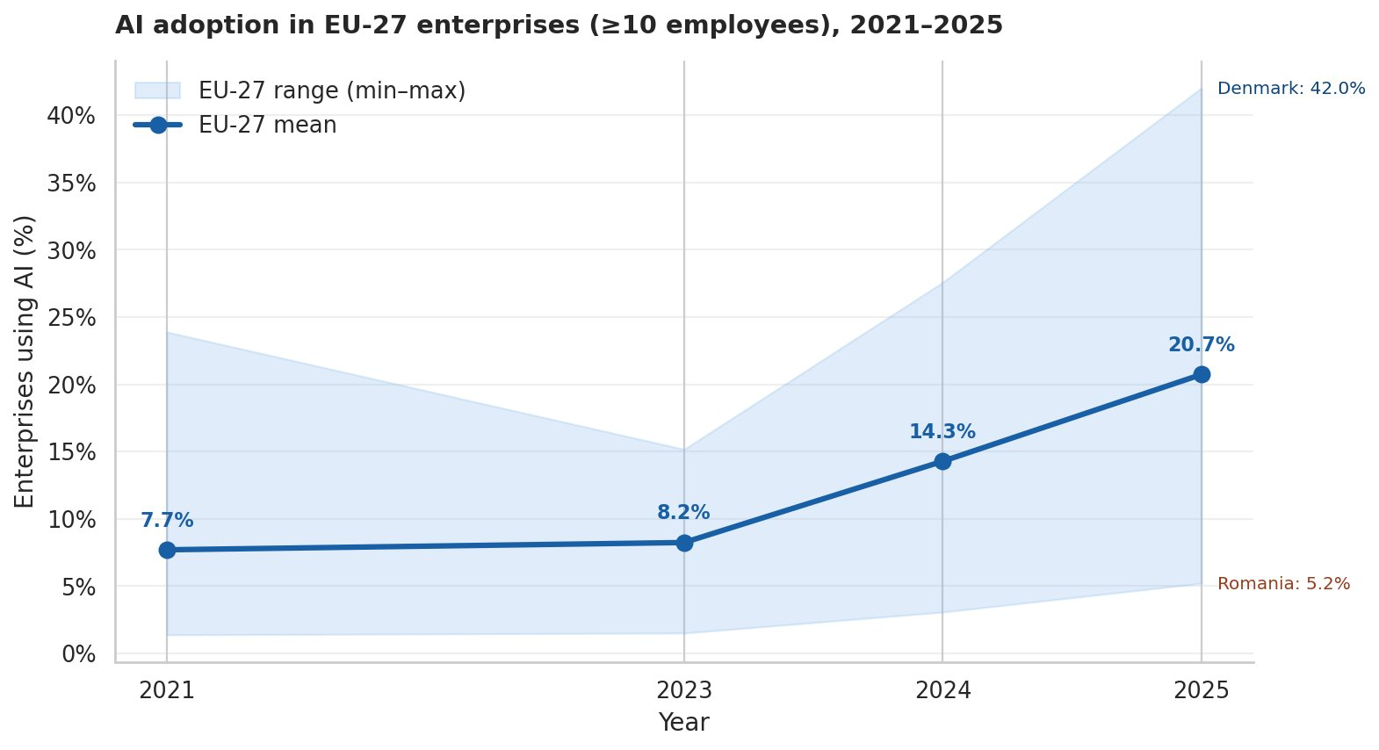
Figure 1. AI adoption in EU-27 enterprises (≥10 employees), 2021–2025. Unweighted average across countries; shaded area represents the country-level minimum-maximum range. Source: Eurostat (isoc_eb_ai), indicator E_AI_TANY.
The country labelled at the upper edge of the 2025 distribution is Denmark (42.0%), and the country at the lower edge is Romania (5.2%): a ratio of more than eight to one between the most and the least AI-intensive economies of the Union. The same ratio in 2021 was approximately seventeen to one (Sweden 20.4% vs Bulgaria 1.2%), so in relative terms the gap has narrowed; in absolute terms — and this is what matters for policy — it has widened by 15 percentage points. The behaviour of the absolute and relative gaps will be a recurrent theme of the paper, because it characterises the diffusion of a general-purpose technology much better than any single summary statistic.
The Commission's own State of the Digital Decade reports note that the AI KPI is one of the indicators most likely to fall short of its 2030 target, and the data in Figure 1 are consistent with that assessment. Linear extrapolation of the 2023–2025 EU-27 average growth rate would deliver an EU adoption level of approximately 65% in 2030, against a Digital Decade target of 75% — a shortfall that is small in absolute terms but binding given the political weight attached to the targets. The figure also makes it clear that the 2030 target cannot realistically be met by the laggards alone: even if Romania were to grow at the spectacular rate observed for Denmark in the last two years, it would barely reach the EU 2025 average by 2030.

4.2 Country layer: digital maturity, not infrastructure, predicts adoption
To understand which features of the national digital ecosystem predict cross-country differences in AI adoption, we merge our 2025 AI adoption data with the four Digital Decade pillar indicators and compute Pearson and Spearman correlations. Figure 4 displays the four resulting scatterplots, with the regression line, the Pearson r, and the corresponding p-value annotated in each panel. Table 1 summarises the same statistics for both 2024 and 2025.
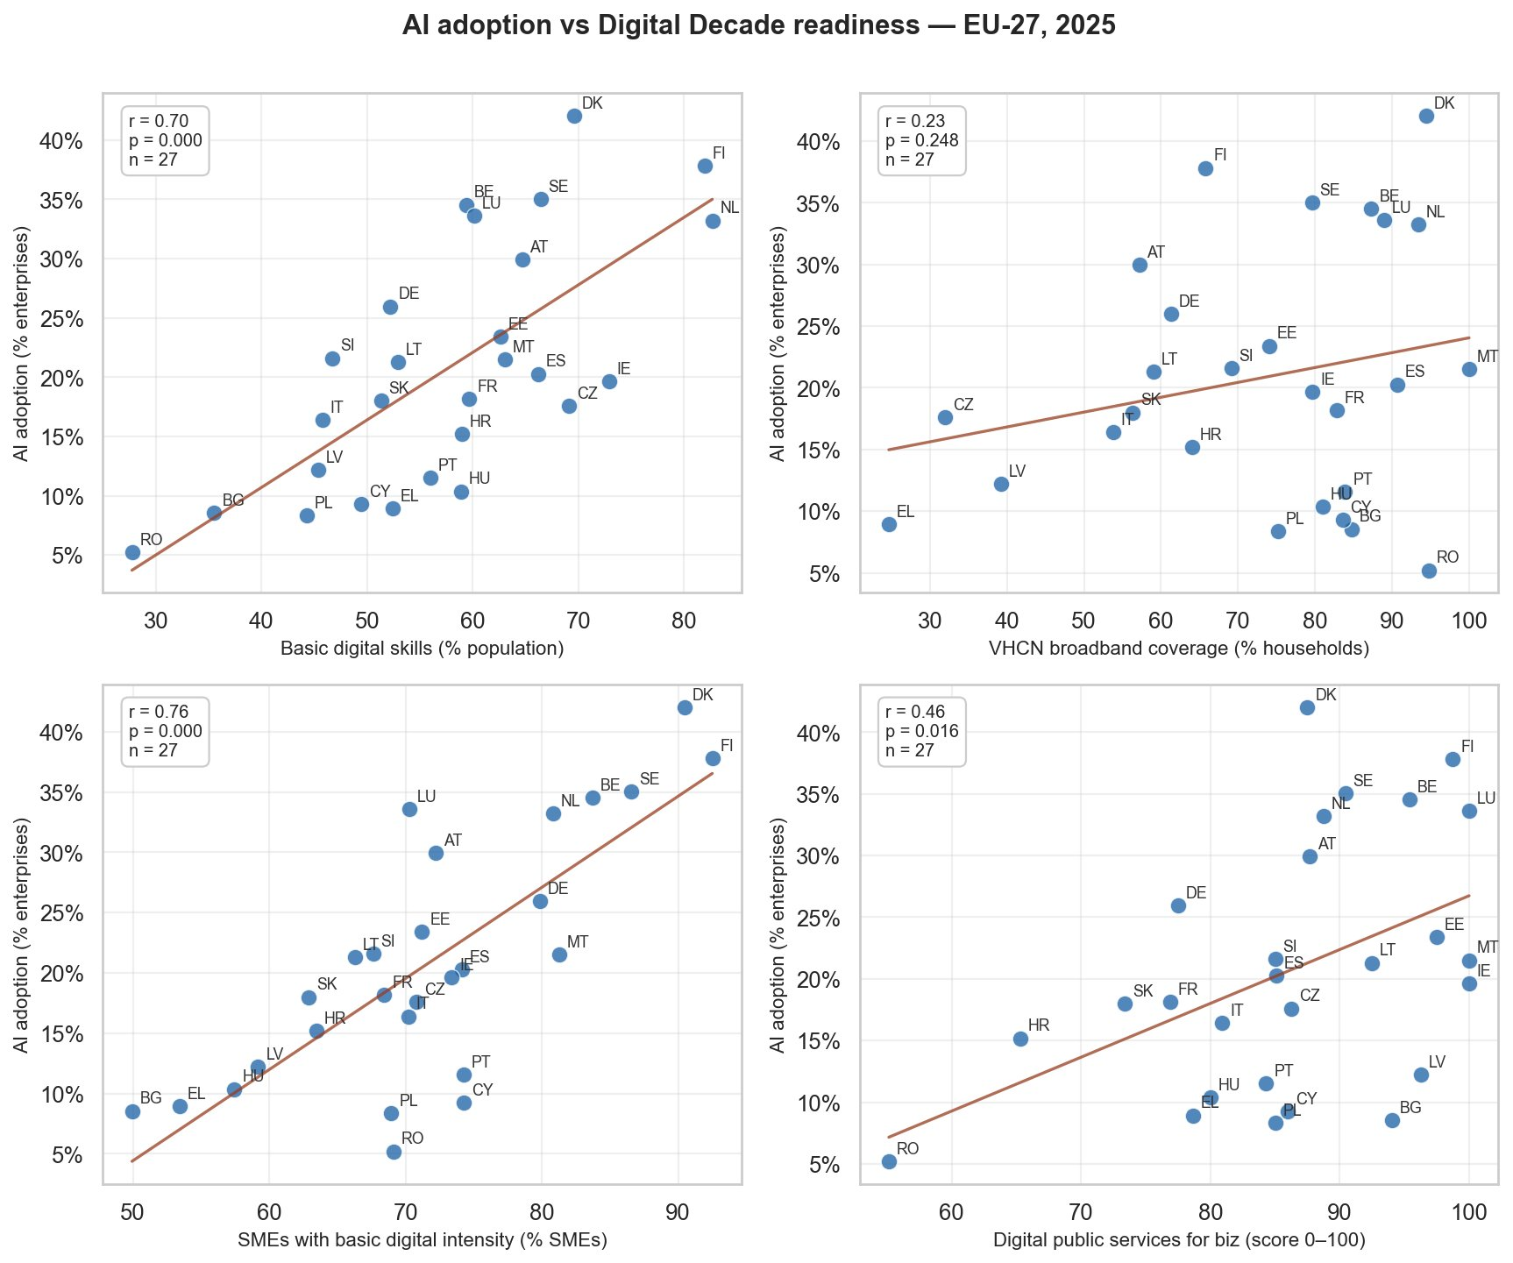
Figure 4. Cross-country correlations between AI adoption and four Digital Decade pillar indicators, EU-27, 2025. Each point is a country; line of best fit is OLS. Source: own computations on Eurostat (isoc_eb_ai) and Digital Decade dashboard data.
The pattern is unusually clean. The strongest predictor of AI adoption is the share of SMEs with at least a basic level of digital intensity (Pearson r = 0.76, p < 0.001), followed by the share of the population with basic digital skills (r = 0.70, p < 0.001). Both correlations are remarkably stable across the two years and across the two correlation measures (Pearson and Spearman): we report the full set in Table 1. The correlation with the digital public services indicator is moderate but significant (r = 0.46, p = 0.016 in 2025; r = 0.51 in 2024). The correlation with broadband infrastructure — measured here by the Very High Capacity Network coverage indicator — is weak and not statistically significant in either year (r = 0.23, p = 0.25 in 2025). The supplementary indicator on ICT specialists, often invoked as a proxy for advanced digital human capital, is essentially uncorrelated with AI adoption (r = 0.07).
Table 1. AI adoption and Digital Decade pillar indicators: cross-country correlations.
Indicator (Digital Decade pillar) | Year | n | Pearson r | p-value | Sign.
SMEs with basic digital intensity (Business) | 2025 | 27 | 0.76 | < 0.001 | ***
Basic digital skills (Skills) | 2025 | 27 | 0.70 | < 0.001 | ***
Basic digital skills (Skills) | 2024 | 27 | 0.65 | < 0.001 | ***
Digital public services for business (Public) | 2024 | 27 | 0.51 | 0.007 | **
Digital public services for business (Public) | 2025 | 27 | 0.46 | 0.016 | *
VHCN broadband coverage (Connectivity) | 2024 | 27 | 0.25 | 0.204 | ns
VHCN broadband coverage (Connectivity) | 2025 | 27 | 0.23 | 0.248 | ns
ICT specialists (Skills, advanced) | 2025 | 27 | 0.07 | 0.714 | ns
Notes: Pearson correlations across n = 27 EU member states. Significance levels: *** p < 0.001, ** p < 0.01, * p < 0.05, ns = not significant. Source: own computations.
Two of these results are intuitive and confirm theoretical priors. The strong association between SME digital intensity and AI adoption is consistent with Brynjolfsson, Rock and Syverson's (2021) emphasis on complementary intangible assets: countries whose firms already use a basic bundle of digital technologies — cloud services, ERP software, e-commerce, social media — have lower marginal costs of moving up to AI, both because the data infrastructure is in place and because the organisational routines are already digital. The strong association with population-level basic digital skills is consistent with the view, expressed in the DESI 2023 report and in the OECD (2024) Digital Economy Outlook, that workforce skills are the binding human-capital constraint on AI deployment.
The third result — the absence of a significant correlation between AI adoption and broadband infrastructure — is more surprising and, in our view, more interesting. It is the kind of finding that contradicts the intuition behind a generation of digital-divide policies, which assumed that closing the infrastructure gap would unlock the broader digital transformation. Inspection of Figure 4 (top-right panel) reveals the source of the null result: countries such as Romania, Cyprus, Portugal and Bulgaria all have VHCN coverage above 90% but AI adoption rates below 12%. They are equipped but not adopting. Conversely, Germany has VHCN coverage of only about 60% but AI adoption of 26%. The conclusion we draw is that broadband infrastructure has become a saturated pre-condition rather than a binding constraint: necessary, in the sense that no country with very low coverage adopts AI broadly, but no longer sufficient to drive adoption upward. The binding constraint has shifted further along the diffusion chain — from pipes to firms and to people.
The null result on the ICT-specialists indicator is more puzzling and we report it without claiming a definitive interpretation. Three hypotheses are worth considering. First, the indicator may be too coarse: the share of ICT specialists in total employment captures the supply of advanced human capital but not its allocation across firms, which may be the more relevant quantity for AI adoption. Second, AI applications increasingly arrive through cloud services that abstract away the need for in-house specialists, so the marginal AI deployment may not require an ICT specialist on staff. Third, ICT specialists may concentrate in a few large firms or capital regions and fail to translate into diffuse AI adoption across the wider economy. Disentangling these hypotheses would require firm-level data that fall outside the scope of this paper.

4.3 Firm size layer: a threefold gap, with country-level interactions
Figure 2 displays the EU-27 average AI adoption rate broken down by firm size class for the four available reference years. Three observations follow. First, the firm-size gap is large in every year: in 2025, large firms (≥250 employees) reach an average adoption rate of 53.6%, against 30.2% for medium firms (50–249) and approximately 17.5% for small firms (10–49) — a ratio of roughly three to one between the extremes. Second, the gap is widening in absolute terms: large firms gained 26.1 percentage points between 2021 and 2025, against 11.4 for small firms. Third, the timing of the acceleration is different: the large-firm series begins moving in 2023–2024, whereas the small-firm series only starts to lift in 2024–2025. The technology appears to enter the economy through the large firms first and only then begins to diffuse downward.
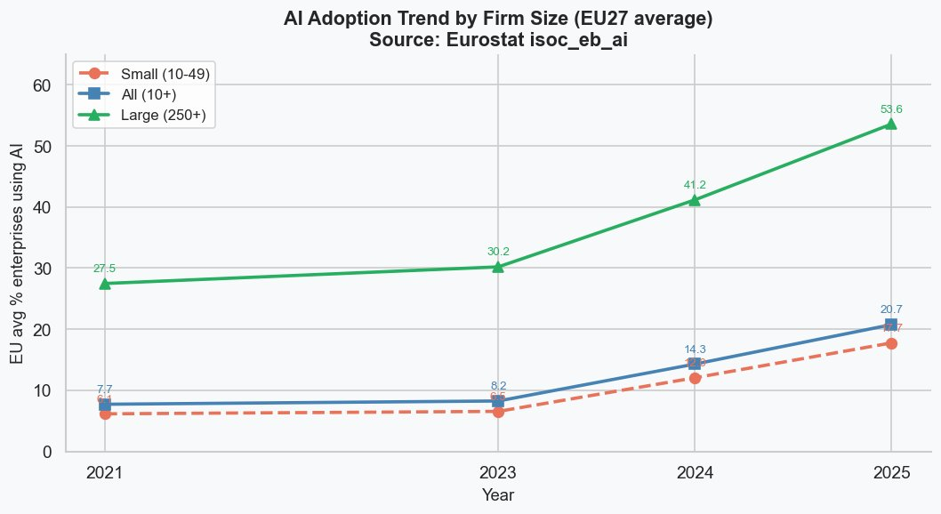
Figure 2. AI adoption trend by firm size, EU-27 average, 2021–2025. Source: Eurostat (isoc_eb_ai), indicator E_AI_TANY.
The country-level decomposition of the size gap is more revealing. Figure 3 plots, for each EU-27 country, the percentage-point gap between large and small firms in 2025 — that is, the difference between the value in the third and the first column of Figure 2 within each country. The EU-27 average of this gap is 35.8 percentage points; the country-level dispersion around this average ranges from 16.6 percentage points in Romania to 53.4 in Slovenia. This is the source of the most striking finding of this section.
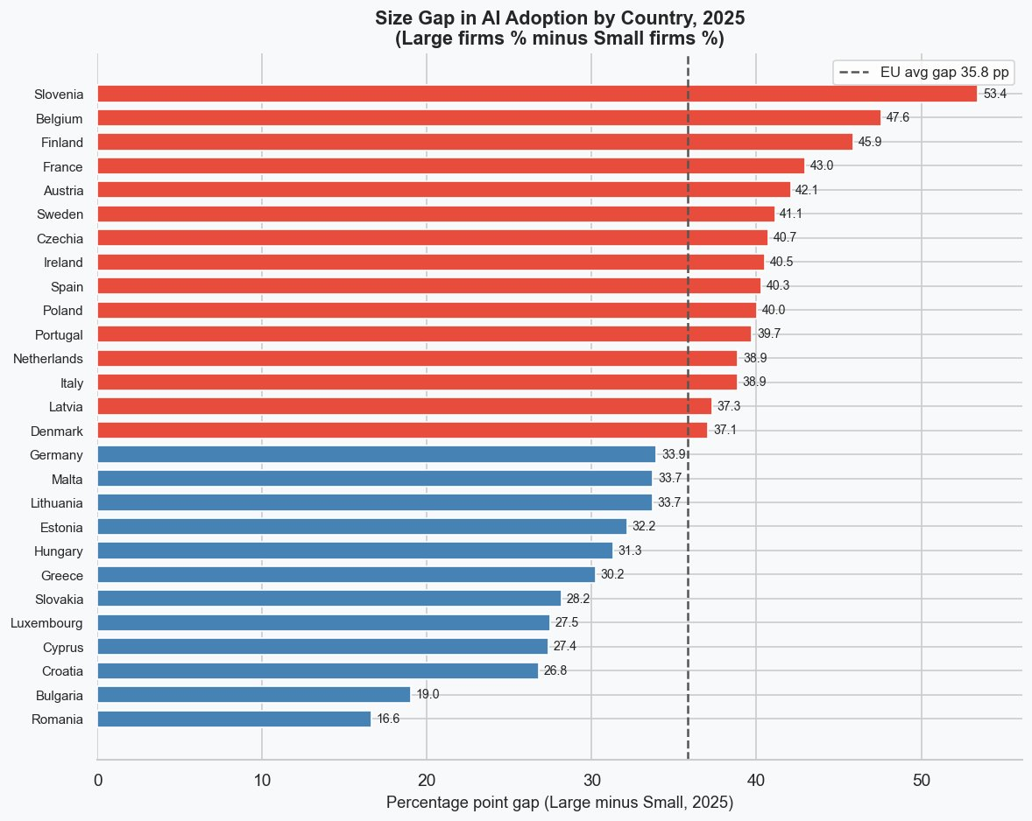
Figure 3. Size gap in AI adoption (large minus small firms, percentage points), EU-27, 2025. Countries above the EU average are highlighted. Source: own computations on Eurostat (isoc_eb_ai).
The data invite a typology that the policy literature has not, to our knowledge, fully recognised. At one extreme sit countries like Slovenia, Belgium, Finland, France and Austria, where the gap exceeds 42 percentage points: large firms are well ahead of the EU large-firm average, but small firms have not kept up. We label these dual economies — economies in which the large-firm sector has reached AI maturity but the SME tissue lags. Slovenia is a particularly clear case: large Slovenian firms reach 71.7% AI adoption (third in the EU), while small Slovenian firms barely reach 18.3%. At the other extreme sit countries like Romania and Bulgaria, where the gap is small not because small firms are doing well — they are not, with adoption rates of 4.0% and 7.1% respectively — but because large firms are also doing poorly, with adoption rates of 20.7% and 26.1% respectively. We call these uniformly lagging economies. The EU's digital-divide policy debate has tended to focus on the second pattern; our reading of the data is that the first pattern is at least as widespread and arguably more difficult to address.
A second observation from Figure 3 concerns Denmark. Denmark has the highest aggregate AI adoption rate in the EU (42.0%) but the size gap is below the EU average (37.1 percentage points). The reason is that Danish small firms are exceptional adopters in their own right: at 37.4%, they exceed the EU-27 large-firm average of 53.6% only modestly, but they exceed every other EU country's small-firm average decisively. The Danish case suggests that closing the size gap is possible but requires conditions — likely a combination of high SME digital intensity, strong basic digital skills, and a homogeneous pro-business regulatory environment — that the rest of the EU has not been able to replicate.
Taken together, Figures 2 and 3 confirm that the firm-size effect is large, persistent, and interacting with country effects. The simple statement that 'large firms adopt AI more' is true on average but disguises a much richer geography in which the EU's competitiveness gap may be more accurately characterised as a small-firm gap rather than as a country gap tout court.

4.4 Sector layer: a diffusion at three speeds
The sectoral analysis pivots on the Eurostat data flow isoc_eb_ain2, which reports AI adoption broken down by 1-letter NACE Rev. 2 sector. We restrict attention to the eight sectors for which the Eurostat AI survey provides comparable data across the EU-27: information and communication (J), professional and scientific activities (M), administrative and support services (N), real estate (L), wholesale and retail trade (G), manufacturing (C), transportation and storage (H), accommodation and food (I), and construction (F).
Figure 5 ranks the eight sectors by their EU-27 average AI adoption rate in 2025. The aggregate figure of 20.7% conceals a striking structural divide. At the top, information and communication firms reach 60.4%, well above the cross-sector average of 24.2%. Professional and scientific activities follow at 38.7%. The remaining sectors cluster much closer together: wholesale and retail at 19.1%, manufacturing at 18.7%, transportation at 12.8%, accommodation and food at 12.0%, and construction at 11.2%. The right panel of the figure expresses the same data as deviations from the cross-sector average and makes the underlying typology visible: a concentrated digital frontier (ICT, professional services), a broad middle (manufacturing, retail, real estate), and a physical-economy tail (transport, hospitality, construction).
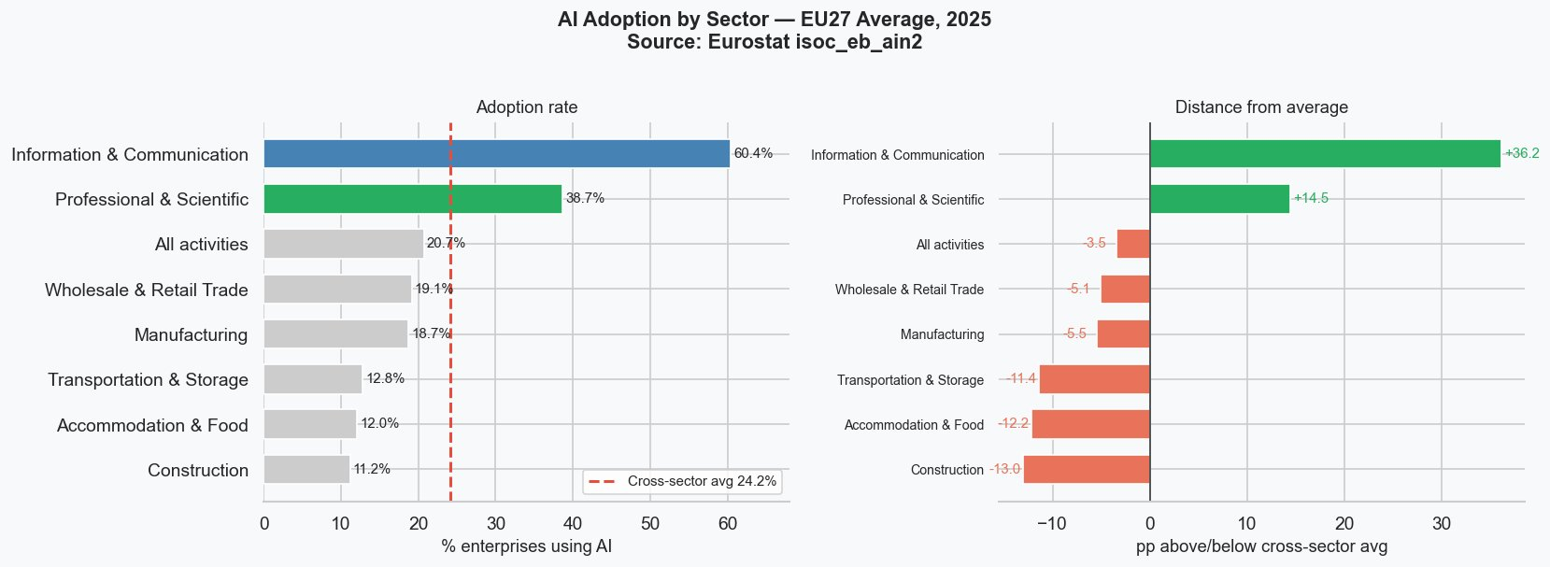
Figure 5. AI adoption by sector — EU-27 average, 2025. Left panel: adoption rate; right panel: distance from the cross-sector average. Source: Eurostat (isoc_eb_ain2).
The dynamic picture in Figure 6 shows that the structural divide is not the inheritance of an earlier era but a feature that has emerged and intensified in the four years under observation. In 2021 the spread between the leading sector (ICT at 24.9%) and the laggard (construction at 3.6%) was 21.3 percentage points; by 2025 it had grown to 49.2 percentage points. The intersectoral standard deviation rose from 7.6 to 18.3 percentage points over the same period, a clear signal of sigma-divergence. The compound annual growth rate of accommodation and food (+38%) and construction (+31%) actually exceeds that of ICT (+25%), but only because the laggards are growing from near-zero bases. In absolute terms the leaders are pulling further ahead with each passing year — a textbook illustration of the J-curve mechanism formalised by Brynjolfsson, Rock and Syverson (2021).
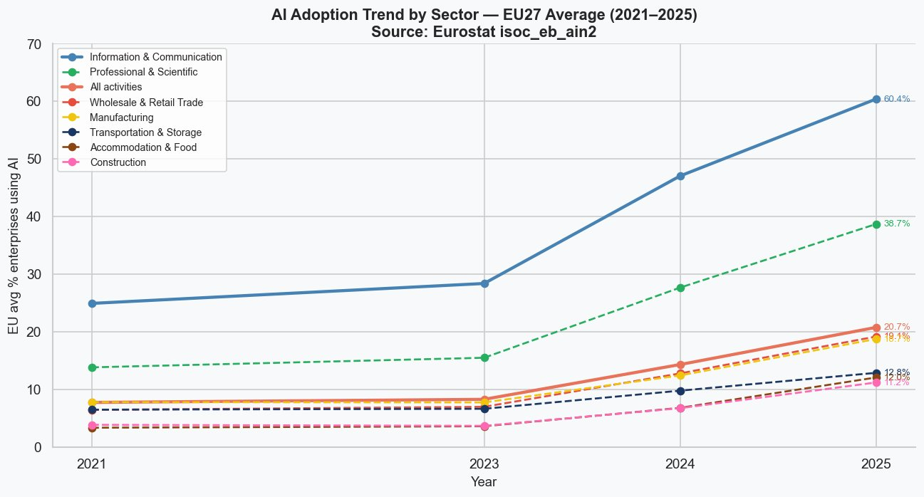
Figure 6. AI adoption trend by sector, EU-27 average, 2021–2025. Source: Eurostat (isoc_eb_ain2).
The four mechanisms outlined in Section 2.2 help interpret these patterns. Task codifiability accounts for the very high ceiling of ICT and professional services, where the productive activity already generates structured digital records and the marginal cost of moving from data analytics to AI is low. The complementary intangibles mechanism predicts the J-curve shape we observe: ICT firms had the digital infrastructure in place when the AI wave arrived and could deploy it quickly, while construction firms face a steep up-front investment in IoT, computer vision and process digitalisation before any AI return is possible. The workforce-skills mechanism reinforces this gap, because ICT and professional services employ STEM-trained workers as a core input while accommodation and construction employ predominantly low-skilled labour in routine physical tasks. The firm-size composition mechanism, finally, accounts for part of the gap arithmetically: ICT and professional services are dominated by large firms with dedicated IT functions, whereas the EU's accommodation and construction sectors are populated by micro-firms with fewer than ten employees, who are not even in the Eurostat sampling frame.
It is tempting to read the higher growth rates of the laggards as evidence of incipient convergence. The reading is not wrong — the coefficient of variation across sectors did fall from 86% in 2023 to 74% in 2025, suggesting that the laggards are catching up in relative terms — but it is incomplete. For the European economy as a whole, what matters is whether the absolute productivity gap between AI-using and AI-non-using firms is closing or widening. On that more demanding test, the data say widening: the absolute gap between ICT and construction grew from 21 to 49 percentage points in four years, and there is no evidence in the trajectory that this is about to reverse.

4.5 Three layers combined: the multi-level finding
Figure 7 presents the most comprehensive view in the paper: a country × sector heatmap in which countries are sorted top-to-bottom by their overall AI adoption and sectors are sorted left-to-right by their EU average. Each cell reports the percentage of enterprises using at least one AI technology in 2025 for the corresponding country-sector combination. The figure synthesises the three layers and allows several observations that no single previous figure could deliver.
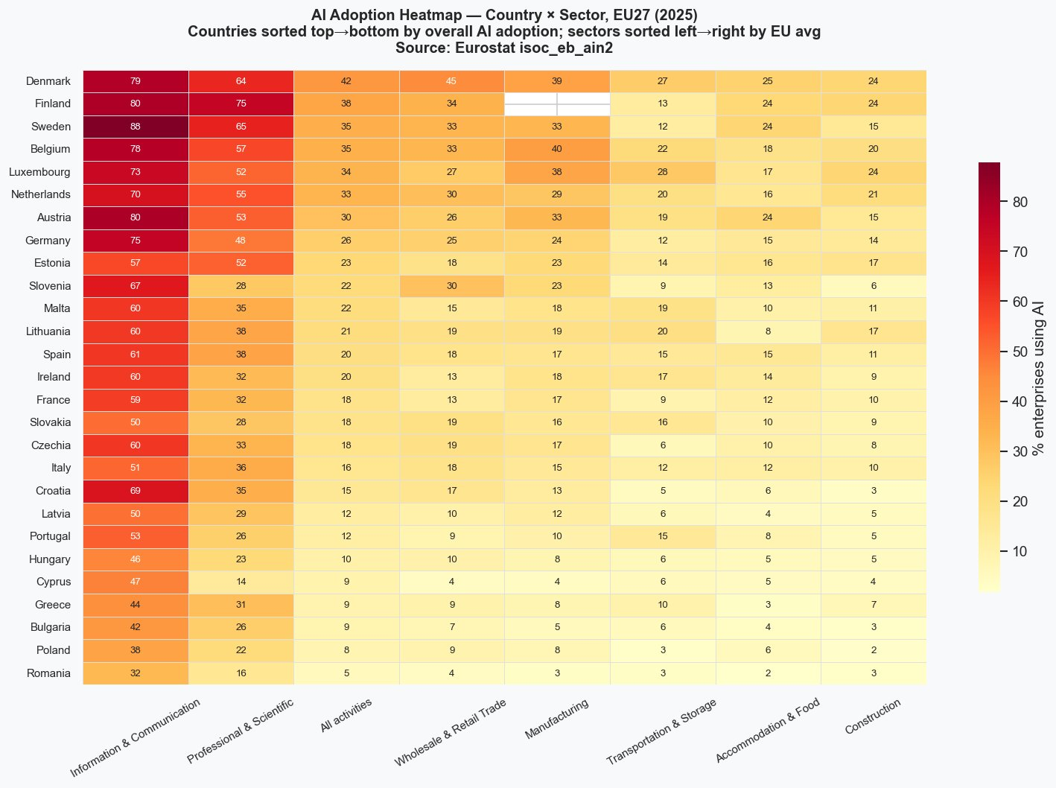
Figure 7. AI adoption heatmap — country × sector, EU-27, 2025. Countries sorted top-to-bottom by overall AI adoption; sectors sorted left-to-right by EU average. Source: Eurostat (isoc_eb_ain2).
First, the colour pattern descends both vertically and horizontally, confirming visually what the previous sections established statistically: the country effect and the sector effect both matter, and they matter independently. A column of the heatmap is roughly monotonic (countries higher in the ranking have higher cell values), and so is a row (sectors closer to the left edge have higher cell values). Neither the country layer nor the sector layer is redundant given the other.
Second — and this is where the multi-level claim acquires its sharpest form — the layers interact in ways that any single-dimensional analysis would miss. The clearest case is the comparison between an ICT firm in a laggard country and a manufacturing firm in a leader: an ICT firm in Romania reaches 32% AI adoption, while a manufacturing firm in Belgium reaches 40% and a manufacturing firm in Germany reaches 24%. The lead sector of the laggard country is overtaken by the middle sector of the leader country. This is the type of comparison that conveys, more vividly than any correlation coefficient, why a one-dimensional account of the European AI divide fails to capture what is happening in the data.
Third, the within-country sectoral spread is itself a country-specific quantity. Sweden, with the highest ICT adoption rate in the EU at 88%, also has one of the largest within-country gaps between ICT and construction (73 percentage points). Romania, with the lowest overall adoption, has a smaller gap (29 percentage points) — not because it has narrower sectoral inequalities, but because none of its sectors has reached the AI frontier. In other words, the leaders' lead is concentrated in the digital frontier sectors and does not propagate uniformly across the rest of the economy. This is consistent with the prediction of the diffusion literature: digital leaders advance through their leading sectors, not in spite of them, and broad-based diffusion across the entire sectoral structure of the economy lags behind.
Italy occupies an interesting position in the heatmap that deserves a brief comment. The Italian aggregate AI adoption rate (16.4% in 2025) is below the EU average. The natural reading would be that Italy underperforms across the board — but the data tell a different story. Italy is at EU parity in construction, accommodation and transport, and only modestly below in manufacturing and retail. The bulk of the Italian deficit is concentrated in ICT (51% vs an EU average of 60.4%) and, to a lesser extent, in professional and scientific activities (36% vs 38.7%). In other words, Italy's digital lag is not a problem of slow modernisation in the traditional sectors of the economy; it is a problem of insufficient size and dynamism of the digital frontier itself. The policy implication is that lifting Italian AI adoption would require strengthening the ICT and professional services ecosystem rather than digitalising the manufacturing sector — a non-trivial recalibration of the standard policy response.

5. Discussion
The empirical findings of Section 4 invite a discussion that touches on three distinct questions: how the results align with the existing literature on technology diffusion, how they relate to the policy framework of the Digital Decade, and what they imply for the political economy of digital catch-up in the European Union.

5.1 Diffusion theory revisited
The patterns documented in this paper are broadly consistent with the predictions of the diffusion literature, but two findings warrant a closer engagement. The first is the apparent saturation of broadband infrastructure as a binding constraint on AI adoption. Throughout the 2010s, the digital-divide policy debate was dominated by infrastructure: closing the broadband gap was framed as the principal lever for narrowing the productivity gap between European regions. Our null result on the VHCN coverage indicator does not say that infrastructure is irrelevant — it would be implausible to argue that AI adoption could occur in countries without broadband — but it does suggest that the EU has crossed a threshold beyond which incremental investment in infrastructure no longer translates into incremental adoption. The binding constraint has migrated up the diffusion chain, from the physical layer to the applications layer and from there to the human-capital layer. This is a non-trivial recalibration of the policy debate, and one that DESI 2024 itself implicitly acknowledges by introducing the SME digital intensity indicator as a Digital Decade KPI in its own right.
The second finding worth discussing is the divergence between absolute and relative gaps in sectoral adoption. The CAGR statistics in Section 4.4 paint a picture of laggard sectors growing faster than the leader, while the absolute spreads in Figure 6 paint a picture of leaders pulling further ahead. Both pictures are correct; the apparent contradiction dissolves once one recognises that AI adoption is bounded above by 100% and that the leader has more headroom in absolute terms than the laggard does. Brynjolfsson, Rock and Syverson (2021) anticipate this pattern in their J-curve framework: the productivity returns to a general-purpose technology accumulate disproportionately to the firms that have built the complementary intangibles, and these are precisely the firms in the leading sectors of the leading countries. Aggregate convergence — in the sense of relative differences — is consistent with widening absolute gaps in productivity and welfare, and the European policy debate has not always been clear about which of the two metrics it wants to optimise.

5.2 The Digital Decade trajectory
Section 4.1 noted that the AI KPI is unlikely to reach the 75% target by 2030 on the basis of current trajectories. The Commission's own State of the Digital Decade reports flag the same concern, and our analysis is broadly consistent with theirs. What we add is a more disaggregated reading of the gap. The 2030 target cannot be met by the EU laggards alone, no matter how rapidly they grow: at the small-firm level, even the most aggressive realistic growth path leaves Romania, Bulgaria and Greece well below the EU 2025 average by 2030. Conversely, the leaders can plausibly meet the target on their own terms, but doing so will not bridge the divergence we have documented. The political question — whether the Digital Decade target should be interpreted as an EU-wide objective or as a target for each member state — is therefore not academic. It is the question that determines what kind of policy response is appropriate.
If the goal is to maximise EU-wide AI adoption irrespective of distribution, then the policy implication is clear: invest where the returns are highest, which means doubling down on the leading sectors of the leading countries. If the goal is reducing inequality across countries, sectors and firm sizes, the implication is the opposite, and our results suggest a specific set of priorities. At the country level, policy should target SME digital intensity rather than infrastructure: the first is the binding constraint, the second is no longer. At the firm-size level, the priority is the small-firm gap in the dual economies — countries where large firms have caught up but SMEs have not. At the sectoral level, the priority is the physical-economy tail, where the binding constraint is task codifiability and where progress requires a co-investment programme in IoT, computer vision and process digitalisation that is qualitatively different from the broad-based digitalisation incentives of the past.

5.3 Italy: a sector-specific deficit
The Italian case discussed at the end of Section 4.5 deserves a slightly fuller treatment, because it illustrates how the disaggregated reading of the data can change the diagnosis. The conventional account of Italy's digital lag — repeated in much of the policy debate — emphasises the country's general underperformance: too many micro-firms, too little investment in workforce digital skills, too patchy a public administration. Our reading does not contradict this account, but it locates the lag in a more specific place. Italian firms in construction, accommodation and transport are essentially at the EU average; Italian firms in manufacturing and retail are only modestly below it. The bulk of the Italian deficit is concentrated in the digital frontier sectors — ICT and professional services — where Italy underperforms by 9 and 3 percentage points respectively. This is the part of the economy where the AI return is highest and where the leaders are pulling away fastest.
The implication is that the standard policy response — broad-based digitalisation incentives for SMEs, voucher programmes for cloud and AI services in the manufacturing sector — addresses the wrong problem. The right problem is the size and dynamism of the Italian ICT and professional services ecosystem, and the right policy response involves STEM education at the tertiary level, R&D tax incentives for digital firms, scale-up support for digital natives, and the regulatory conditions under which a non-trivial Italian software industry could emerge. None of these are easy or politically rewarding. They are, in our reading of the data, the binding constraint on Italian AI adoption.

6. Limitations
Five limitations qualify the conclusions of this paper and suggest directions for further work. First, the dependent variable is a binary self-reported indicator: enterprises are asked whether they use any AI technology, and a single application — say, a chatbot in a customer-service portal — counts as much as a full machine-learning pipeline integrated into the firm's operations. Two countries with the same headline AI adoption rate may therefore differ substantially in the depth of their AI use, and the indicator is unlikely to capture that difference. Eurostat is currently piloting more granular indicators on the type and intensity of AI applications; their inclusion in future analyses would be a meaningful improvement.
Second, the cross-country sample is small — 27 observations — and the analysis relies on bivariate correlations rather than multivariate models. We considered estimating a fixed-effects regression of AI adoption on the four pillar indicators but decided against it: with 27 observations and four highly collinear regressors, the parameter estimates would be too imprecise to bear the interpretive weight we would want to place on them, and partialling out the country fixed effects would absorb much of the variation we are interested in explaining. Our descriptive approach trades parsimony of inference for transparency of presentation; we believe the trade-off is appropriate given the sample size, but a reader who insists on coefficients will not find them here.
Third, the sectoral analysis is constrained by the Eurostat sampling frame, which excludes enterprises with fewer than ten employees. In sectors dominated by micro-firms — construction, accommodation, retail — the reported figures cover only a subset of the firm population, and the AI adoption rate of the under-ten-employee universe is essentially unobserved. To the extent that micro-firms adopt AI even less than small firms, the headline sectoral figures we report are upper bounds rather than averages of the true population. This caveat strengthens, rather than weakens, the qualitative finding that the physical-economy sectors lag.
Fourth, the time series is short and not strictly comparable. The 2022 wave does not include AI questions, and the question wording was revised in 2023 to broaden the technologies covered. The 2021 figures are therefore lower bounds on the rate that would have been observed under the 2023+ wording, and the apparent acceleration between 2023 and 2024 is partly an artefact of methodological revision. We have tried to be careful in the text not to over-interpret the 2021–2023 movement, but a longer and methodologically homogeneous time series is needed to establish definitively whether the post-2023 acceleration is a genuine trend break or a continuation of an earlier trajectory.
Fifth, the paper is silent on the productivity consequences of AI adoption. We have documented who is adopting and where, but we have not asked whether adoption is associated with productivity growth, employment changes or shifts in firm-level performance. The literature suggests that the answer is yes (Acemoglu et al., 2022; Brynjolfsson et al., 2021), but at the aggregate, country-level resolution of our data we have no way of testing this directly. Linking AI adoption to firm-level productivity outcomes — using, for instance, the Eurostat structural business statistics or national productivity accounts — would be a natural and important extension of this work.

7. Conclusion
This paper has used the most recent Eurostat data and the Digital Decade dashboard to characterise the diffusion of artificial intelligence across European Union enterprises in the period 2021–2025. The headline finding is the acceleration of aggregate adoption — from below 8% to above 20% of EU-27 firms in four years — but the paper has argued that the headline obscures more than it reveals. AI adoption in Europe is a genuinely multi-level phenomenon: country, firm size and sector all matter, none of them dominates the others, and the three layers combine in ways that single-dimensional analyses cannot capture.
Three findings stand out. First, the strongest country-level predictor of AI adoption is the digital maturity of firms, not the availability of broadband infrastructure: SME digital intensity correlates with AI adoption at r = 0.76, while VHCN broadband coverage shows a non-significant correlation of r = 0.23. The infrastructural pre-condition appears to have saturated, and the binding constraint has migrated to firm-level digital practice and population-level skills. Second, the firm-size gap is large and roughly homogeneous across countries on average, but its interaction with country effects produces a typology of dual economies — Slovenia, Belgium, France, Austria — in which large firms have caught up but small firms have not. The European digital divide has at least as much of a small-firm dimension as a country dimension. Third, the sectoral divide between information-intensive and physical activities is widening in absolute terms, and the leaders' lead is concentrated precisely in the frontier sectors. Italy is a striking case: its digital lag is concentrated in ICT and professional services, not in the traditional sectors of its economy.
The policy implication that follows is that the Digital Decade targets, calibrated as EU-wide aggregates, may be feasible without addressing the divergences we have documented. Whether that is the right outcome is a political question; what the data show is that meeting the headline target and reducing the underlying inequalities are, given current trajectories, two distinct objectives. The first can be achieved by accelerating the leaders. The second requires a different policy response: targeted support for SME digital practice in the dual economies, investment in workforce skills where the country-level gap is widest, and a co-investment programme in process digitalisation for the physical-economy sectors where AI feasibility is bounded by task codifiability.
AI is not yet, in the language of the early diffusion literature, a fully diffused technology in Europe. It is a technology in the steepest segment of its adoption curve, with the leaders racing ahead and the laggards visibly accelerating. Whether the racing and the accelerating eventually converge — and on what timescale — will depend on policy choices that are still to be made. The data we have analysed in this paper suggest that those choices should be calibrated on the right level of disaggregation. The aggregate is too coarse; the firm is too granular; the country, the firm size and the sector, taken together, are about right.

References
[1] Acemoglu, D., Autor, D., Hazell, J., & Restrepo, P. (2022). Artificial intelligence and jobs: Evidence from online vacancies. Journal of Labor Economics, 40(S1), S293–S340.
[2] Brynjolfsson, E., Rock, D., & Syverson, C. (2021). The productivity J-curve: How intangibles complement general purpose technologies. American Economic Journal: Macroeconomics, 13(1), 333–372.
[3] Calvino, F., Criscuolo, C., Marcolin, L., & Squicciarini, M. (2018). A taxonomy of digital intensive sectors. OECD Science, Technology and Industry Working Papers, No. 2018/14, OECD Publishing, Paris.
[4] European Commission (2022). Decision (EU) 2022/2481 of the European Parliament and of the Council of 14 December 2022 establishing the Digital Decade Policy Programme 2030. Official Journal of the European Union, L 323, 19.12.2022, 4–26.
[5] European Commission (2023). Communication establishing Union-level projected trajectories for the digital targets, C(2023) 7500 final.
[6] European Commission, DG CNECT (2023). Digital Economy and Society Index (DESI) 2023. Brussels.
[7] European Commission (2024). Commission Staff Working Document — DESI 2024 methodological note, SWD(2024) 262 final, Brussels, 2 July 2024.
[8] European Commission (2024). State of the Digital Decade 2024 — Communication and accompanying country reports. Brussels.
[9] Eurostat (n.d.). Artificial intelligence by NACE Rev. 2 activity, dataset isoc_eb_ain2.
[10] Eurostat (n.d.). Artificial intelligence by size class of enterprise, dataset isoc_eb_ai.
[11] Eurostat (2024). Artificial Intelligence in Enterprises — Statistics Explained. ec.europa.eu/eurostat.
[12] ISTAT (2024). Indagine sull'uso delle tecnologie dell'informazione e della comunicazione nelle imprese — Anno 2023. Roma: ISTAT.
[13] McKinsey Global Institute (2018). Notes from the AI Frontier: Modeling the Impact of AI on the World Economy. McKinsey & Company.
[14] McKinsey & Company (2024). The State of AI in 2024: Generative AI's Breakout Year. McKinsey Global Survey.
[15] OECD (2024). OECD Digital Economy Outlook 2024 (Volume 1): Embracing the Technology Frontier. OECD Publishing, Paris.
[16] Rogers, E. M. (2003). Diffusion of Innovations (5th ed.). New York: Free Press.

Appendix A. Selected code excerpts
The full Python notebook used to produce the figures and tables of this paper is available on request. Three excerpts are reported here to give a sense of the operations performed at each stage of the analysis.

A.1 Loading and filtering the Eurostat AI adoption dataset
The Eurostat dissemination CSV is delivered as a header-less file with 23 columns. We assign explicit names, parse the value column as numeric, and filter on the indicator E_AI_TANY expressed as a percentage of enterprises (PC_ENT).
COLS = ['_dataflow', 'dataset_code', 'dataset', 'freq_code', 'freq',
'size_emp', 'size_emp_label', 'nace', 'nace_label',
'indic', 'indic_label', 'unit_code', 'unit',
'geo', 'geo_label', 'year',
'_x16', 'obs_value', '_x18', 'flag', 'flag_label',
'flag2', 'flag2_label']
df = pd.read_csv("AI_adoption_in_EU_enterprises.csv",
header=None, names=COLS, skiprows=1,
low_memory=False)
df['obs_value'] = pd.to_numeric(df['obs_value'], errors='coerce')
df['year'] = pd.to_numeric(df['year'], errors='coerce').astype('Int64')
ai = df.query("indic == 'E_AI_TANY' and unit_code == 'PC_ENT'")
ai = ai[['geo', 'geo_label', 'size_emp', 'year', 'obs_value']] \
.rename(columns={'obs_value': 'ai_pct'})

A.2 Merging AI adoption with Digital Decade indicators
For the cross-country correlation analysis we pivot the Digital Decade dashboard into a wide format (one column per indicator) and merge it with the AI adoption data on the country-year keys. The breakdown selection is non-trivial because Digital Decade indicators use different dimensional labels; we apply a priority list to pick the most aggregate breakdown available for each indicator.
KPI = {
"desi_dsk_bab": "Basic digital skills",
"desi_vhcn": "VHCN broadband coverage",
"desi_sme_di4_gelo": "SMEs with basic digital intensity",
"desi_dps_biz": "Digital public services for business",
}
BREAKDOWN_PRIORITY = ["total", "ind_total", "hh_total",
"ent_all_xfin", "all_egov_le", "national"]
desi['year'] = desi['period'].str.extract(r"(\d{4})").astype(int)
desi = desi[desi['indicator'].isin(KPI) &
desi['country'].isin(EU27) &
desi['year'].isin([2024, 2025])]
def pick_breakdown(group):
available = set(group['breakdown'])
for bd in BREAKDOWN_PRIORITY:
if bd in available:
return group.loc[group['breakdown'] == bd, 'value'].mean()
return group['value'].mean()
desi_agg = desi.groupby(['country','year','indicator']) \
.apply(pick_breakdown).reset_index(name='value')
desi_wide = desi_agg.pivot_table(index=['country','year'],
columns='indicator',
values='value').reset_index()
merged = ai.merge(desi_wide, on=['country','year'], how='inner')

A.3 Computing Pearson and Spearman correlations
With the merged dataset in hand, the correlation table is straightforward. We loop over indicators and years, drop missing values pairwise, and compute both Pearson and Spearman coefficients to confirm that the linear-association results are not driven by outliers.
from scipy.stats import pearsonr, spearmanr
rows = []
for kpi_code, kpi_label in KPI.items():
for yr in [2024, 2025]:
sub = merged[merged['year'] == yr] \
.dropna(subset=['ai_pct', kpi_code])
if len(sub) < 5:
continue
r_p, p_p = pearsonr(sub['ai_pct'], sub[kpi_code])
r_s, p_s = spearmanr(sub['ai_pct'], sub[kpi_code])
rows.append({'indicator': kpi_code, 'year': yr,
'n': len(sub),
'pearson_r': round(r_p, 3),
'pearson_p': round(p_p, 4),
'spearman_r': round(r_s, 3),
'spearman_p': round(p_s, 4)})
correlations = pd.DataFrame(rows)

A.4 Notes on reproducibility
All computations were performed using Python 3.11, pandas 2.x, NumPy 1.26, SciPy 1.13 and matplotlib 3.8. The Eurostat data flows are accessible via the dissemination database at ec.europa.eu/eurostat (paths: data/database → Digital economy and society → ICT usage in enterprises). The Digital Decade dashboard is accessible via digital-strategy.ec.europa.eu/en/policies/desi. Running the notebook end-to-end on the input files reproduces all figures and tables of this paper exactly. The data cut-off date is 30 April 2026, consistent with the DESI 2024 methodological note.

