基本数据解析协议

一、 基站输出数据

基站输出的TDOA时间戳数据，是精确到亚纳秒的数据，被整理成如下格式：

#RT,124,F5024549,F5024552,00000047,8C2774773F,0034-08DF-076C-06DF-0077-076C,-86.5,-73.3,04

|  |  |
| --- | --- |
| #RT | 报头 |
| 124 | 序列号，从0~255轮转 |
| 05C78E1B  F5024549 | 标签ID，标签发出报文，全ID号为 00 00 00 00 05 C7 8E 1B  发出基站ID，全ID号为 00 00 00 00 F5 02 45 49 |
| F5024552 | 接收基站ID，全ID号为 00 00 00 00 F5 02 45 52 |
| 00000047 | 定位基站RX时间，高4位 |
| 8C2774773F | 定位基站RX时间，低5位 |
| 0034-08DF-076C-06DF-0077-076C | 噪音水平标准差stdNoise，  路径1强度firstPathAmp1，  路径2强度firstPathAmp2，  路径3强度firstPathAmp3，  信道最大冲击相应maxGrowthCIR，  接收前导包数 rxPreamCount， |
| -86.5 | 信道功率PW1 |
| -73.3 | 信道功率PW2 |
| 04 | NLOS概率值 |
| \r\n | 结尾 |

上述定义，在基站实际输出时，按照如下格式输出：

sprintf(nschar,"#RT,%03d,%02X%02X%02X%02X,%02X%02X%02X%02X,%08X,%02X%02X%02X%02X%02X,%04X-%04X-%04X-%04X-%04X-%04X,%5.1f,%5.1f,%02d\r\n",

uwbRxTimeLog[iCount].seqNum,

uwbRxTimeLog[iCount].DestAddr[4],uwbRxTimeLog[iCount].DestAddr[5],

uwbRxTimeLog[iCount].DestAddr[6],uwbRxTimeLog[iCount].DestAddr[7],

uwbRxTimeLog[iCount].SrcAddr[4],uwbRxTimeLog[iCount].SrcAddr[5],

uwbRxTimeLog[iCount].SrcAddr[6],uwbRxTimeLog[iCount].SrcAddr[7],

(uint32_t)uwbRxTimeLog[iCount].High17SecCnt,

uwbRxTimeLog[iCount].LowPsCount[4], uwbRxTimeLog[iCount].LowPsCount[3],

uwbRxTimeLog[iCount].LowPsCount[2], uwbRxTimeLog[iCount].LowPsCount[1],

uwbRxTimeLog[iCount].LowPsCount[0],

uwbRxTimeLog[iCount].Diag.stdNoise,

uwbRxTimeLog[iCount].Diag.firstPathAmp1,

uwbRxTimeLog[iCount].Diag.firstPathAmp2,

uwbRxTimeLog[iCount].Diag.firstPathAmp3,

uwbRxTimeLog[iCount].Diag.rxPreamCount,

uwbRxTimeLog[iCount].Diag.maxGrowthCIR,

rxpwr1, rxpwr2, ratio12_NLOS );

以上数据按照如下公式，推导出实际的纳秒值：

//1. 时间计算方法，原理性公式

((tmpTimeHigh * 0x10000000000 + tmpTimeLow_H * 0x100000000 + tmpTimeLow_L)/63897600000.0);

//2. 时间高位，四个字节

tmpTimeHigh = (unsigned long int)(tmpTimeH[3]*0x1000000)

+ (unsigned long int)(tmpTimeH[2]*0x10000)

+ (unsigned long int)(tmpTimeH[1]*0x100) + (unsigned long int)(tmpTimeH[0]);

//3. 时间低位，五个字节，最高字节组成tmpTimeLow_H，最低4字节组成tmpTimeLow_L

tmpTimeLow_H = (unsigned long int)(tmpTimeL[0]); //2^32 //5个字节中最高的第五个字节

tmpTimeLow_L = (unsigned long int)(tmpTimeL[1]*0x1000000)

+ (unsigned long int)(tmpTimeL[2]*0x10000)

+ (unsigned long int)(tmpTimeL[3]*0x100)

+ (unsigned long int)(tmpTimeL[4]);

RxMeasureTime = 17.207401025641025641025641025641*tmpTimeHigh + 0.06721641025641025641025641025641*tmpTimeLow_H + tmpTimeLow_L/63897600000.0;

二、引擎输出数据

软件将计算结果，转发到 127.0.0.1:6667 端口，客户想要获取数据，需要建立 UDP Server，侦听 6667 端口 的 udp 数据包；数据报文格式如下：

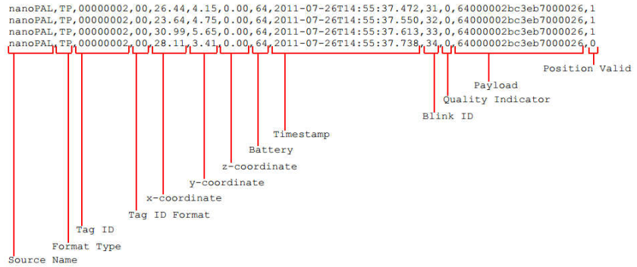

部分客户协议可定制！