Paul, Well done for getting your assignment uploaded. Some satisfactory work done here in your responses, but it was incredibly difficult to mark because of your formatting. Make sure in your next assignment, that you double check that you have upload the correct number of files. As you progress on other courses, you won’t be given a second chance.

It was helpful adding a header with all your information at the top of your TMA.

Below, you will find I have given you a few comments, as well as this summary. These comments may help you to develop your academic and professional skills and perhaps, encourage you to think about what, if anything, you might do differently on the next assignment. You will find below, my notes in green and any errors in yellow.

Question 1 was well answered. Through your academic career you will create a lot of notes, storing them appropriately is important. Part b) your OpenStudio submission link was incorrect.

Question 2 was generally OK, but you didn’t show evidence of your music reducing.

The database question, question 3 was the most difficult for you and you seemed to get a little mixed up.

You used a variety of HTML styles in question 4, to try and make your piece an attractive web page, but missed out a copy of your text and a screenshot. It is really important at this level to follow instructions to the letter.

Question 5a) was quite good, but missing examples.

5b) The purpose here was to start a PDP activity which will be continued through the next two assignments. PDP is an important process throughout the IT industry and something which external agencies such as the British Computing Society see as an important element in any computing degree. Your PDP attempt was fair, but again missing specifics. Such as: describe one occasion on which you have successfully demonstrated one of the following aspects.

You have demonstrated some fair practical skills and your writing style is also very good. Overall, you are working at a fair standard.

Remember to make use of the tutorials, both recorded and live? There are many tutorials on the topic of Block 2 and preparation for TMA02.

The next iCMA42 is due by 19th June. 2025 and TMA02 is due on 17rd Jul. 2025. As mentioned, there are a number of tutorials scheduled over the next few weeks, it’s well worth trying to get to some, as they will help in understanding the material and how to tackle the next TMA.

Try to visit our cluster group forum and post your Block 2 questions to that forum. You’ll also find many posts on Block 2 topics.

Ques 1

I make brief notes in a notebook which I can then type these up in more detail, including images and diagrams, in obsidian. This gives me a digital copy, which I can then search easily. I can use the canvas feature in obsidian to create a mind map, and hence start to see the links between the different topics. I can then use this to create a summary of the module. Good

WORD COUNT

b)

<https://learn2.open.ac.uk/mod/openstudio/content.php?id=2412848sid=1208013vuid=331035>

Paul, this link takes me to a shared content page rather than your actual page.

Ques 2 Keeping control over your online reputation essential. The internet stores vast amounts of data in places you might not be aware of. Party photographs for instance might affect the way future employers view you. Or your personal information getting into the wrong hands. This is why it is important to monitor your own online presence.

WORD COUNT

b)

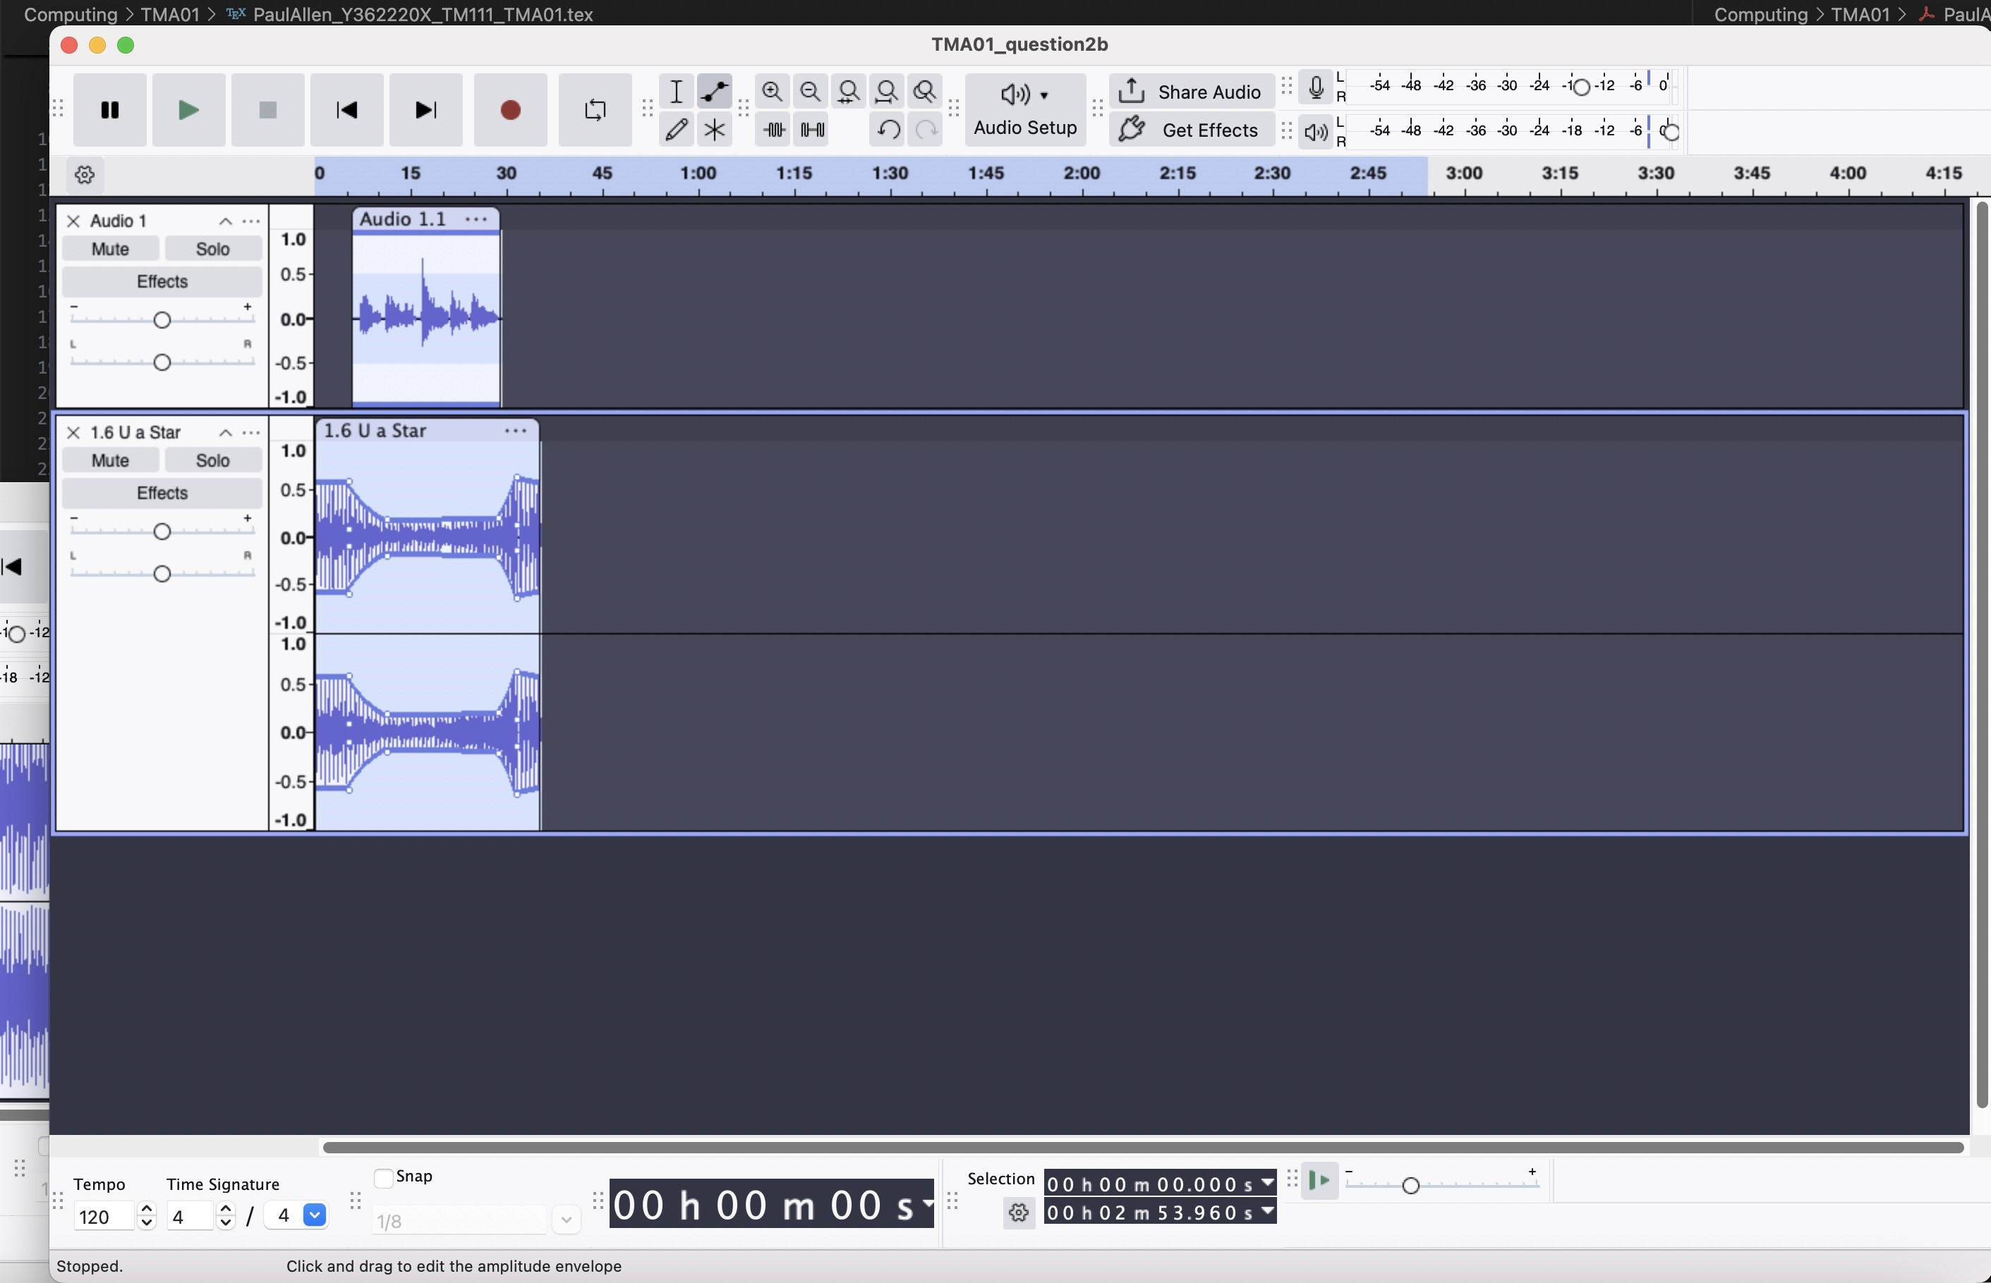

Mostly this is OK, but your music track should reduce in volume when you start speaking.

Ques 3

Passengers could be an entity for Table 1. This is because they are pysical objects and as such are tangible entities.

Ship (Cruise) could be an entity for Table 1. The name of a ship is is also tangible, hence a entity.

|  |  |  |
| --- | --- | --- |
| customer_ID | Forename | Surname |

b) passengers

Each customer is given their own ID number to uniquely identify them. The use of surname or forename is inappropriate as They are not necessarily unique to each customer.

|  |  |  |
| --- | --- | --- |
| ship_ID | Name | Month |

Ship

The table Ship, has a ’ship_ID’ which is unique to each ship and when it sails. The name of the ship is not unique as the same ship could be traveling a number of times a year. The month is not a good attribute as it does not uniquely identify a ship.

**Passenger_Table**

|  |  |  |
| --- | --- | --- |
| **Passenger_ID** | **Forename** | **Surname** |
| 1 | Margaret | Chen |
| 2 | Kofi | Kayiga |
| 3 | Barrington | Watson |
| 4 | Ebony | Patterson |
| 5 | Leonard | Chen |
| 6 | Guy | Harvey |
| 7 | Armet | Francis |

**Cruise_Table**

|  |  |  |
| --- | --- | --- |
| **Cruise_ID** | **Ship** | **Month** |
| 1 | Laurentic | January |
| 2 | Britannic | January |
| 3 | Britannic | March |
| 4 | Oceanic | March |
| 5 | Delphic | February |
| 6 | Homeric | September |
| 7 | Delphic | June |
| 8 | Britannic | December |
| 9 | Oceanic | October |
| 10 | Albertic | May |

Neither **Forename** nor **Surname** are suitable keys since surnames are not unique (e.g. Leonard Chen and Margaret Chen) and forenames are unlikely to remain unique as more passengers are added, so a key is needed for the Passenger table. Similarly, in the **Cruise** table there is duplication in **Ship** and **Month** fields. For example, Britannic sails in January, March and December. Two months, January and March, have more than one sailing. Using a *unique identifier*, a primary key, is the best way to identify each record.

You seem to have misunderstood what the question was asking for. Have a look at Activities 4.9 and 4.10 for advice on keys.

c)

|  |  |
| --- | --- |
| custormer_ID | ship_ID |

d)

Flat databases, such as Table 1 are not as efficient as relational databases. One reason for this is that they only at the moment the table can only accommodate for three voyages per year. This is not efficient as it does not allow for the possibility of more voyages, unless you expand the table and then there would potentially be lots of empty rows, and hence lots of wasted data storage.

Another reason is that the table is not normalised. This means that there are redundancies in the data. For example, the ship name is repeated for each voyage. This means that if the name of the ship changes, it would have to be changed in multiple places. Rather brief. Points you could have mentioned below:

* A large flat database can be inefficient because pieces of data may be repeated and there may be blank cells so it takes up more space and memory than a relational database.
* There may be an insufficient number of fields in the table to accommodate information needed.
* Changing data or correcting errors involves finding and editing every occurrence of the data in the table.
* When the same data is recorded in several places, there is always a possibility of clerical errors leading to inconsistency.
* In a relational database, data would be stored in just one place.

two examples from the table such as:

* Where only one cruise is booked for a customer a number of blank fields are added. Barrington Watson, Ebony Patterson and Guy Harvey show this.
* If someone wants to book a third cruise in one year, two additional columns would need to be added to the flat database for all rows. Margaret Chen and Leonard Chen are the examples.
* If the month of sailing, or the ship being used for the cruise is changed, each instance of that information would need to be found and edited. In a relational database, only one field would need to be changed.

a)

<https://tm111.open.ac.uk/opensites/users/pga47/Y362220X-TMA01.htm>

You were asked to Copy and paste your written explanation of XML and its use into your TMA document and provide a screenshot of your page. Neither are shown.

a)

User centred design (UCD) is a type of design process that constantly keeps the user in mind. Key questions need to be asked by the designer before beginning with the design process, such as; Who is the user? What experience do they have? What skill level do they have? and what is it that they will be doing with the system?✓

The principle approach to UCD is like a feedback loop between the designer and users. hence one approach would be to creat a prototype website and allow the members to use it. By observing the users and asking them questions about the system, the designer can then make changes to the system. Produce another iteration and repeat. Add examples:

You can sit down with one of the users and ask them to carry out a task on an existing website – perhaps order a train ticket, or order groceries online.

Accessibility is the inclusion of specific aspects of the design to ensure that the system is usable by all users, regardless of their ability, age, or any other factor. For people who have different physical, cognitive and developmental abilities

One example that could be pertinent to our members is ability to read text on the screen. This could be a problem due to eyesight or literacy level. So in order to allow for appropriate accessibility the website would be sure to include detailed alternative text for images or figures. This would allow for the text to voice program do describe the image to our users. This is in line with POUR principles, as it allows for the system to be used by all users.

* customisation
* equivalent content
* compatibility with assistive technologies
* follow conventions
* emphasis on keyboard functionality
* support navigation.

b)

# TM111 PDP self-evaluation

Please submit this form to your tutor via the eTMA system as part of TMA 01. Note that you can increase the size of each answer box below by clicking on the lower border and dragging it.

1. What made you decide to study this module or qualification?
   1. love coding, I started out learning HTML and CSS many years ago to make a website and blog for a photographer friend. Then I got back into Python a hobby from childhood. And whilst doing all my maths courses I learnt to typeset using LaTeX. So, with all this personal experience but no IT qualifications I thought let’s make something official out of this and hopefully learn the correct way to do things instead of my own self-taught approach.

1. How do you think your previous experience of work, education or everyday life might have prepared you for your current studies? It can be common for new students to feel apprehensive or anxious. Are there areas you feel uncertain about that you would like to share with your tutor?’
   1. have had no formal education in computing, so my major anxiety is discovering all my bad habits and not doing it the ‘proper’ way.

1. Briefly describe one occasion on which you have successfully demonstrated one of the following aspects of employability in the workplace, at home, through study or in your leisure activities:

•Self-management

•Team working

•Problem solving

•Communication and literacy

•Numeracy

•Application of information technology

•Business and customer awareness

My job is teaching GCSE maths and numeracy to, mainly, 16-19 year olds. So that entails pretty much all of the list above, except maybe business and customer awareness.

1. Identify at least one area where you feel you’d like to develop your capabilities (this could be work and/or study related, or something related to a leisure interest).
   1. would like to develop my typesetting skills so I can continue writing a tikz inspired Euclids elements.

1. When you have completed your module or qualification studies, what are your longer term personal, academic and career goals?

To develop my pottery skills enough to go part time in my job and peruse that as a more monetary endeavour.