Question 1:

a)

i.

Tutor comments:

TMA_01 Question 1 was well answered. Through your academic career you will create a lot of notes, storing them appropriately is important. Part b) your OpenStudio submission link was incorrect.

ii.

The feedback I received from the tutor at this point in my studies was very important to me. I have only ever studied maths modules before this course, and was not fully aware of the importance of making notes, As a lot of the work is solving problems, and most of the ’notes’ are given to us in the handbook, we just have to apply them. And the maths I have done so far there is very little need for collaboration, so sharing of working is limited at this low level of maths.

iii.

I have now started to organise my notes better, not only in this module, but I have invested in a reMarkable which I use not only to take notes directly onto .PDFs but also I can organised the hand written maths work and file them in folders, which I have setup to sync with my computer. This means I can easily search for topics and find my notes quickly.

Word count: 196

b)

i.

47.5ms = 47.5*×* 10*−*6 s

1

*−*6 s = 21053.2*...*

47.5*×* 10 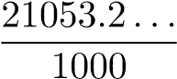 = 21.1kHz

*to 3 s.f.*

ii.

21.053*...×* 2.45 = 51.5*...*

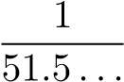 = 0.0194*...*

0.0194*...×* 1000 = 19.4*...*

= 19.4 µs

*to 3 s.f.*

c)

|  |  |
| --- | --- |
| Distance/Km | Signal power/W |
| 0 | 2.8*×* 10*−*1 W |
| 2.35 | 2.8*×* 10*−*2 W |
| 4.7 | 2.8*×* 10*−*3 W |
| 7.05 | 2.8*×* 10*−*4 W |
| 9.4 | 2.8*×* 10*−*5 W |
| 11.75 | 2.8*×* 10*−*6 W |

Hence the signal can tavel 11.75km before the signal power is attenuated to 2.8 µW.

d)

Convert 01100010-11101001-11110001-11000111-10101011-01011101 into hexidecimal, first split it into nibbles;

0110 *→* 6 0010 *→* 2

1110 *→ E*

1001 *→* 9

1111 *→ F*

0001 *→* 1

1100 *→ C*

0111 *→* 7

1010 *→ A* 1011 *→ B*

0101 *→* 5

1101 *→ D*

So the hexadecimal representation is 62 : *E*9 : *F*1 : *C*7 : *AB* : 5*D*.

Question 2:

a)

i.

I would select a class 2 bluetooth device because with a maxium power output of 2.5mW it has a range of about 10m, and it is intended for personal area networks for tings like mobile phones. Whereas class 1 is designed for business or industrial use with a higher power output of 100mW and a range of about 100m. And class 3 has a very short range of about 1m with a power output of 1mW.

ii.

Both Bluetooth and WIFI are great for short range wireless communication. But they differ in their properties and uses. Class 2 bluetooth devices use about 2.5mW with a range of about 10m and a bitrate between about 1-3 Mbits*−*1. Making it ideal for accessories like keboards of headphones, where energy and hence battery, efficiency matters.

WIFI on the other hand operates a power output up to 100mW and offers a range of about 80m with bitrates in the hundreds of Mbits*−*1. This allows for large data intensive tasks such as video streaming of file sharing. But with this comes high energy usage it makes WIFI less suitable for battery-powered devices.

Word count: 110

b)

i.

let *d*1 be 333m with a power measurment of 27 µW

let *d*2 be 1320m with a power measurment of *P* and using the inverse cube

rule

330 1 = 1320 4

3

=

*P* 1

=

27 µW 64

27 µW

*P* =

64

= 0.421875 µW = 4.22*×* 10*−*1 µW

*to 2 d.p.*

ii.

let *d*1 be 330m with a power measurment of 27 µW let *p*2 be 216nW with a distance of *d*2 and using the inverse cube rule

*d*13 *p*2 = *p*1

*d*2

*p*1 *d*2 = *d*1

*p*2

27*×* 10*−*6 

= 330 216*×* 10*−*9

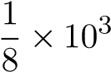 

= 330*×*

*√*

= 330*×*( 3 125)

= 330*×* 5

= 1650m

= 1.65*×* 103 m

*to 2.d.p.*

c)

i.

Accourding to the sampling theorem, if each speech signal has a bandwidth of 4kHz, the minimum sampling rate would be 8kHz, which is

8000bits*−*1.

ii.

The number of bits required to represent 256 quantised levels is log2(256) = 8bit

Therefore we needs

8 + 1 = 9 bits per sample, including the 1 bit for TDM sycronisation

using our 8000bits*−*1

9*×* 8000 = 72000bits*−*1

= 72ks*−*1 = 7.2*×* 101 kbits*−*1

*to 2 d.p.*

iii.

Given there are 48 users the total bitrate would be

48*×* 7.2*×* 101 kbits*−*1

= 3456kbits*−*1 = 3.46Mbits*−*1 *to 2 d.p.*

Question 3: a)

i.

https://www.nist.gov/blogs/taking-measure/tale-two-errors-measuringbiometric-algorithms?utm*source* = *chatgpt*.*com*

The resource I have chosen is a NIST blog post that explains the trade-off between False Match Rate (FMR) and False Non-Match Rate (FNMR) in biometric identification. Although the article is three years old and some of the statistics may have changed, the overall relationship remains the same. The article succeeds in connecting everyday biometric use, such as unlocking a phone, with high-stakes contexts like crime detection.

I found it particularly interesting that as early as the late 1990s, NIST developed the detection error trade-off curve, which still remains the sector standard today. This shows that the fundamental challenge of balancing false matches with false non-matches is not a limitation of computing power but of the nature of biometric systems themselves. No matter how advanced or fast algorithms become, the trade-off between these two types of error will always exist.

Word count: 140

ii.

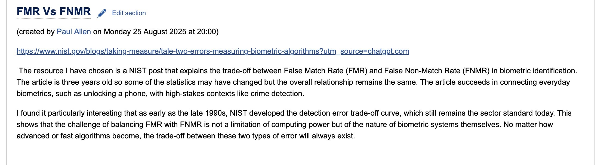

A comment from Paul Allen

I found your resource on digital triage really interesting, especially in showing how practices adapted during the pandemic. I agree that the efficiency gained from online tools like consultations and messaging is a major benefit, particularly in helping clinicians manage time and resources, including the use of non-clinical staff. I also appreciated how the article balanced the positives with the challenges, such as accessibility for patients who may struggle with technology. The article also contains plenty of links to further information making it easy to explore the topic in more depth.

Word count: 96

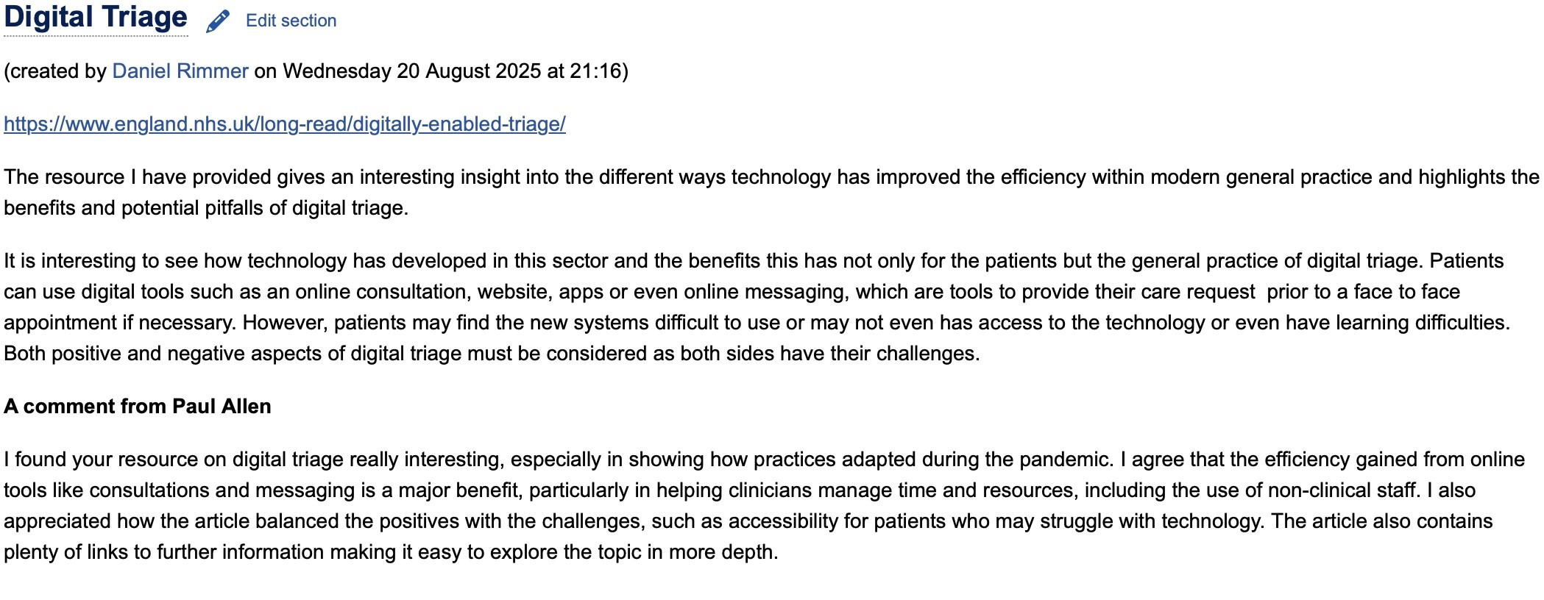

iii.

When using the tutor group wiki allowed me to reflect on its usability.

In terms of effectiveness: the wiki did as it should; it provides a centralised space for student to post resources and text and allows other people to contribute in the form of comments, as in our case. I was able to add a section for myself without difficulty, and my comment to another student appeared as it should under their post. Showing that it could be used as intended.

In terms of efficiency: there is a bit more to reflect on. The layout is not immediately intuitive, and it took me to read the instructions again use the ’add new section’ button, as at first I thought this would take me away from the tutorial section. But after re-reading the instructions the process was reasonably quick.

And finally in terms of satisfaction: I found it useful way for students to share resources and add comment of their own. If felt collaborative despite the interaction being asynchronous. However, the interface itself felt a little dated, in comparison to modern tools like forums of chat apps.

Overall the wiki is effective but could be improved in terms of ease of use and overall updating is design elements.

Word count: 208

b)

i.

The need for accurate age verification online has become an important issue for society as children and young people increasingly access social media, gaming platforms and other online services. Without effective checks, under-18s can be exposed to harmful content such as violent material, online grooming or even the purchase of weapons. For companies, there is also the matter of legal compliance, as UK and international regulations place a duty of care on providers to protect young users. Reliable age verification helps balance the benefits of digital participation with the necessary safeguards.

One leading approach is biometric facial analysis. This works by asking a user to provide an image of their face, which is then compared against large datasets of known age profiles. The system analyses markers such as bone structure, skin texture and facial ratios to estimate whether someone falls above or below a required age threshold. A key advantage is that it can be carried out quickly without official documents, which some users may not have or may be reluctant to share. Increasingly, the process is being integrated with live images or video to minimise fraud.

Artificial intelligence plays a major role here. AI systems are trained on huge numbers of facial images of known ages, which improves the reliability of estimates. The technology can refine its predictions by learning subtle patterns invisible to humans. However, this also raises questions of fairness, as accuracy may be lower for people from under-represented demographic groups if training data lacks diversity.

The accuracy of biometric age verification is improving, with studies suggesting that current systems can estimate ages within two to three years. This is sufficient for many purposes, such as distinguishing whether a user is under 13 or over 18. Nevertheless, no system is flawless, and for higher accuracy some services adopt a layered approach, combining AI-driven facial analysis with document checks or parental consent.

ii.

Additional resource: Ofcom (2024) Children and parents: media use and atti-

tudes report 2024. Available at: https://www.ofcom.org.uk/siteassets/resources/documents/researchand-data/media-literacy-research/children/childrens-media-use-andattitudes-2023/childrens-media-use-and-attitudes-report-2023.pdf (Accessed 28 August 2025).

I found this report by searching Google with the terms Ofcom children online report. It was useful because it gave up-to-date statistics on how children in different age groups access media and on which devices. It also highlighted risks faced by young people and parents’ responses, which helped me explain why strong age verification is important. Word count:

393