PT3

Paul, well done for getting you assignment uploaded early.

Your response to the set problems throughout was excellent and on your future courses, such as TM112, thisProblem Solving theme will continue, through using Python. It develops the ideas you have been introduced to in Block 2 of this module: variables, calculations, strings and lists, selection and repetition, modular programming and algorithms, and shows how those same structures are used in Python, one of the most popular programming languages. You seem to have had no problems with the programming questions and so perhaps choosing TM112 as your next course, would seem to be a natural choice.

Question 1(a) was very well answered. You have obviously got an good grasp of algorithms and OUBuild,

Question 2 was fully correct.

Question 3, was perfect. Well done.

By far, the most difficult question, question 4, did not cause you real any problems.

Your response to the PDP question was good, but lacked specific detail, such as “Naming modules, Time planning?”.

Perhaps take a look at examples of action plans on the PDP website: <https://learn1.open.ac.uk/mod/oucontent/view.php?id=10113&section=4.3>

You have made excellent progress so far and should feel confident about your next Assignment. *As well as covering topics from Block 3, TMA03 will help you develop your skills: of numeracy, for which the 'Using numbers' booklet; online communication, which involves using the tutor group wiki; and personal development again, following on from Question 5 of this TMA*.

Block 3 is also about getting connected, in the widest sense. It covers networking technology, the internet, wireless communication, the 'internet of things', and then human communication online and the 'networked society', all very interesting and important topics.

As always, I would suggest you print off TMA03 and have it 'to hand' as you progress through the block.

Just a gentle reminder that Block 2 is assessed in iCMA43, which it would seem won't cause you any problems and opens on 14th August.

Question 1:

a)

The user is asked to enter a pupil’s name. Their input, ’Keon’, is stored in the variable *name*.

The user is asked to enter the number of birds counted out of 80. Their input, 70 is stored in the variable *count result*. ✓

This variable, ’70’, *count result* is multiplied by 1.25 and rounded to the nearest whole number. The result, ’88’, is then stored in a variable called *count percentage*.✓

The sprite then displays the message 88% for 2 seconds. ✓

The program then checks to see if *count percentage* is greater than 85.

The name *Keon* is then added to the list *wren list*.✓

b)

i.

The number 1*.*25 could be stored as a constant. Good

ii.

This constant could be called *percentage multiplier*. Good.

c)

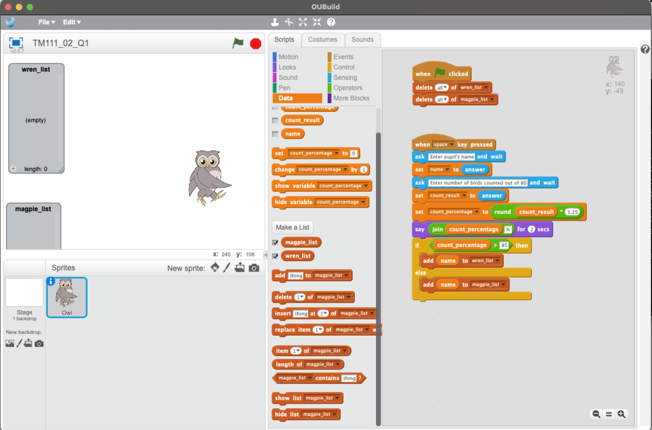

Perfect. Try to remember to crop your screenshots, to make it easier to read.

d)

i.

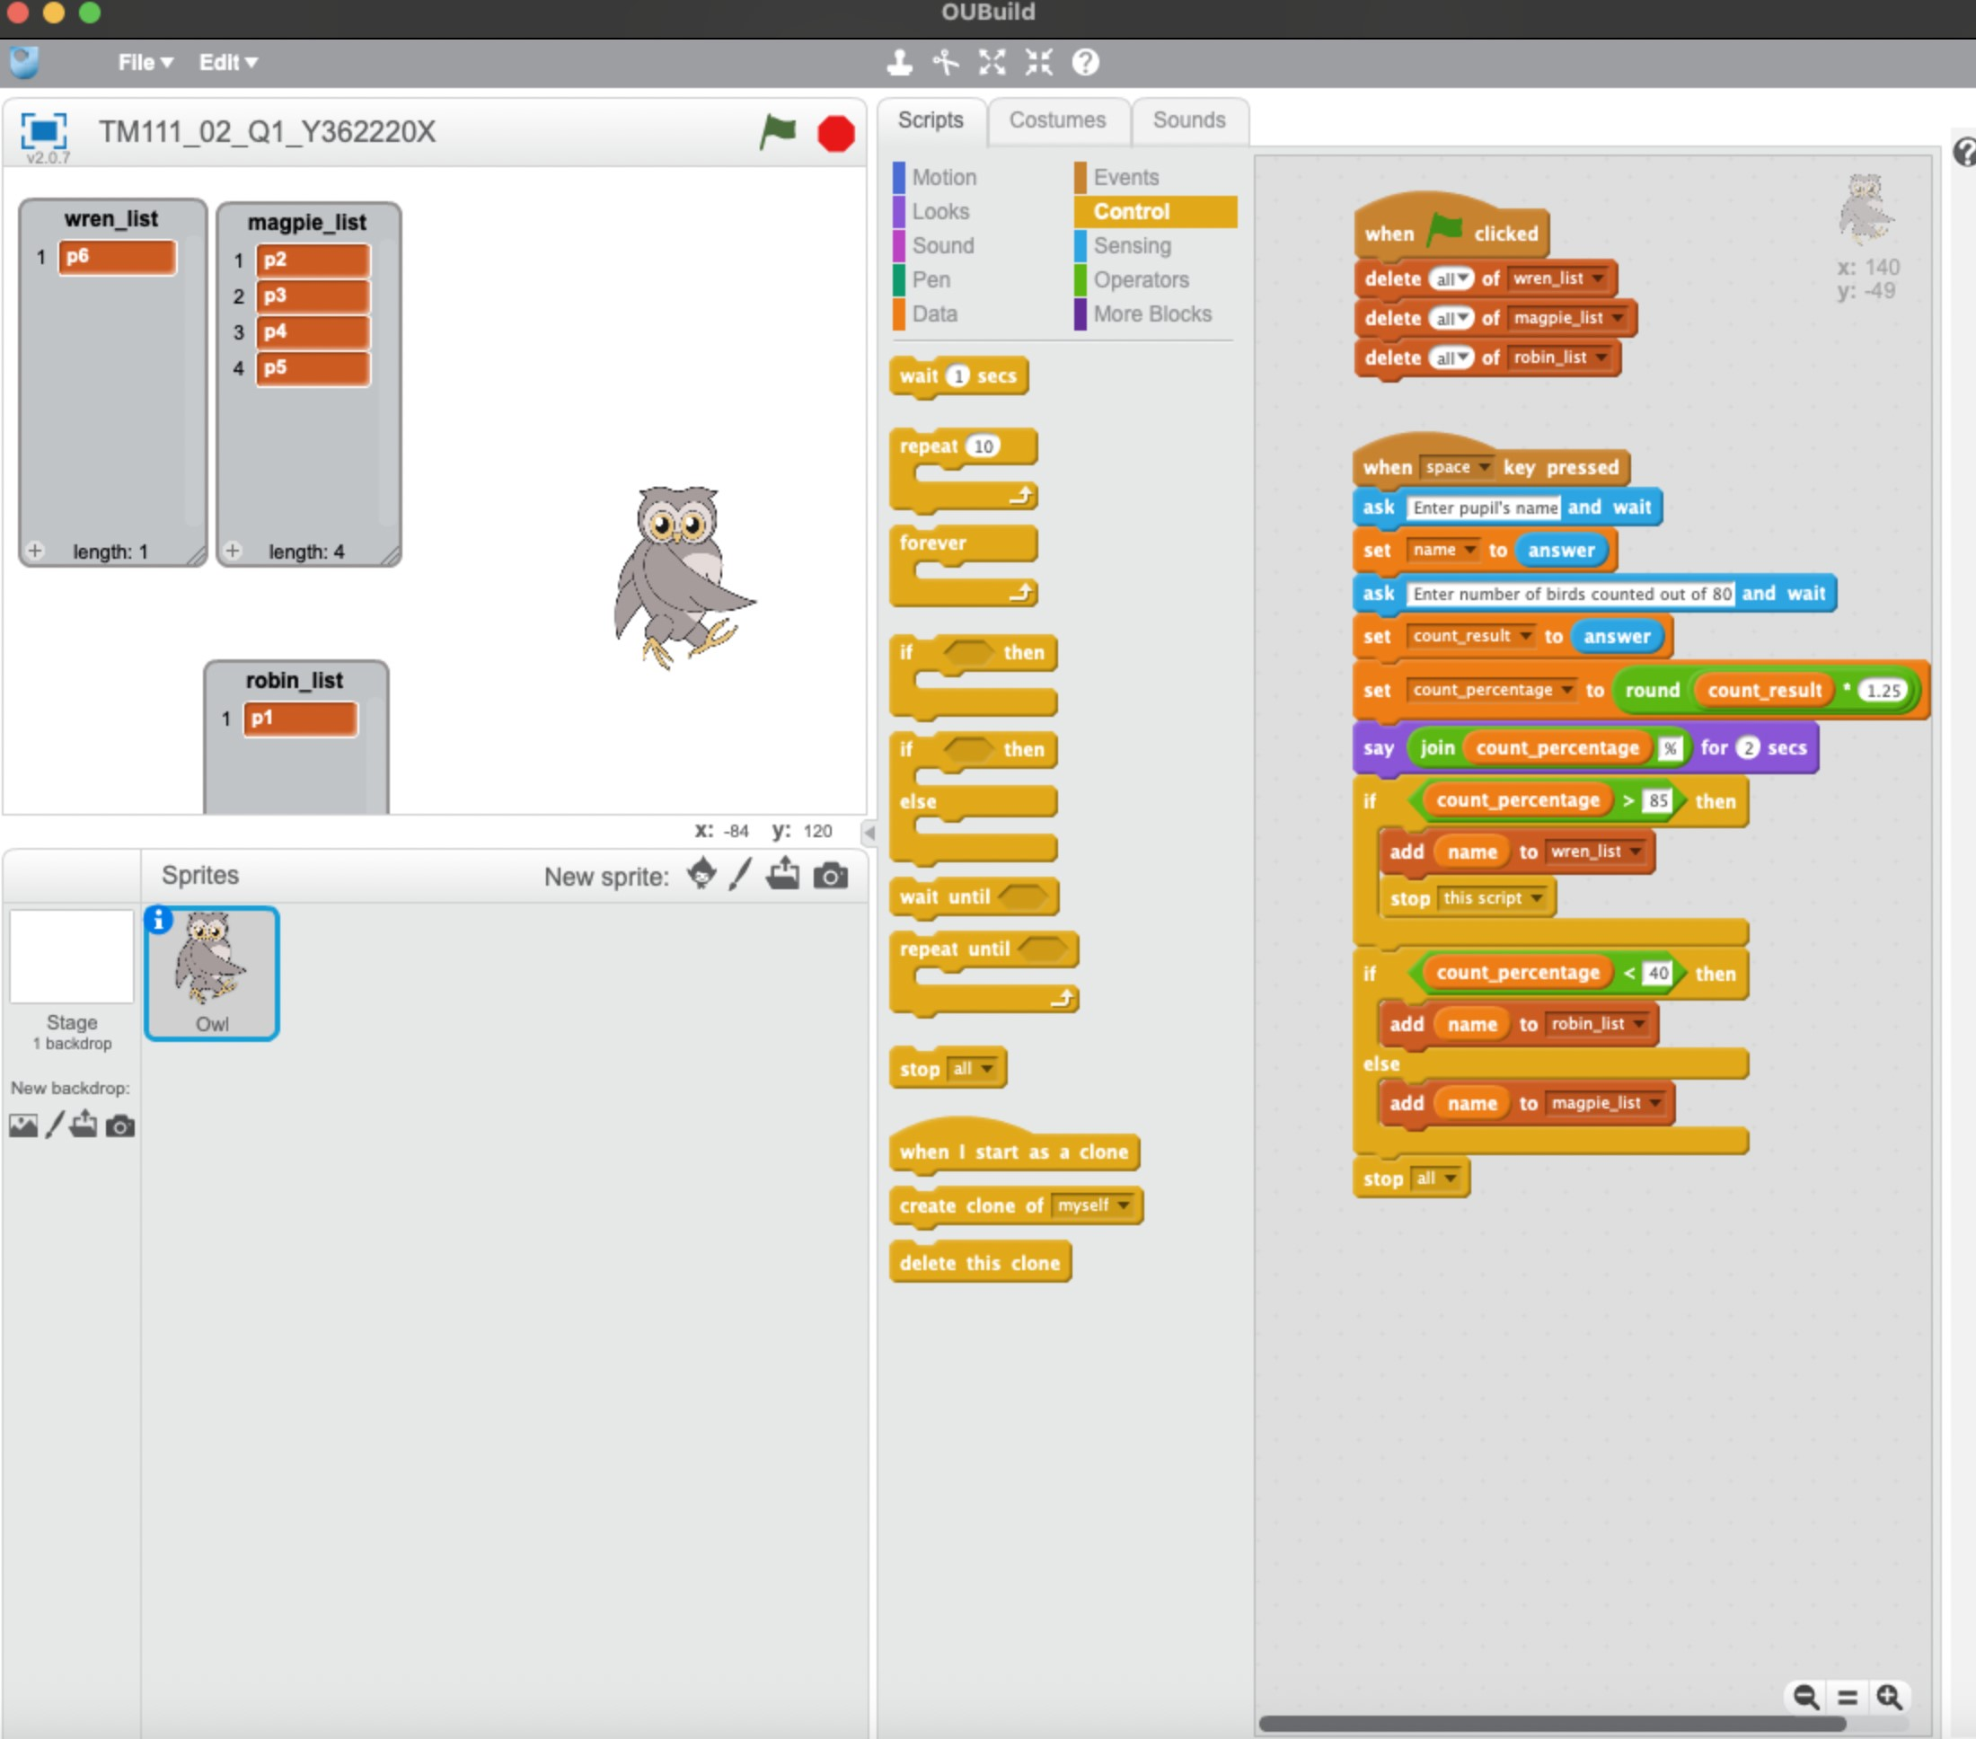

Good

ii.

I could have used three (Nested) if statements, one for each of the three possible lists.✓

Question 2:

a)

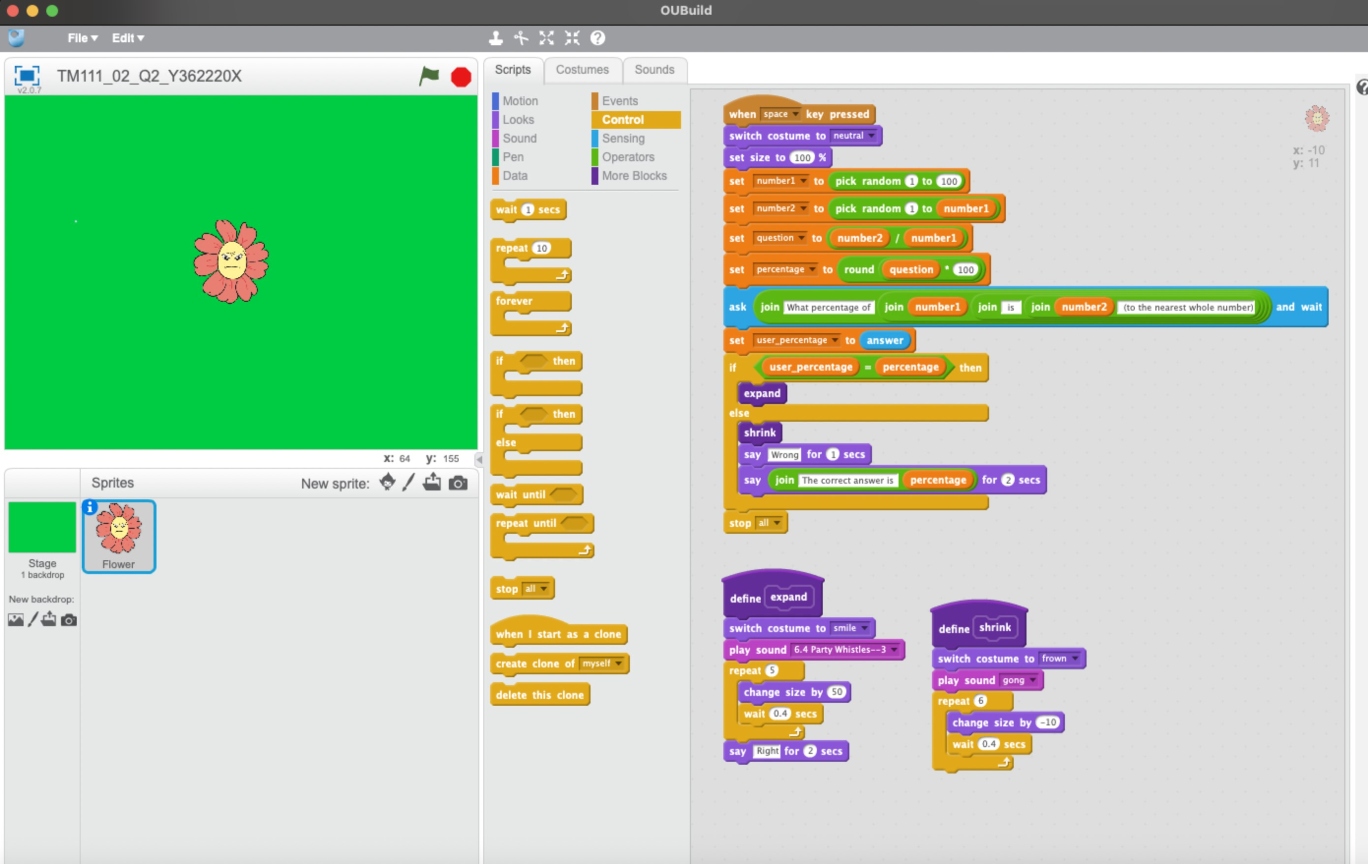

Perfect

b)

Question 3:

a)

Clear all variables, input word ✓Repeat until end of word ✓

if

check if character *i* is in the banned list. ✓

is on list *i + 1*

else add character to *result* say *result* end ✓

Very good. Watch your formatting.

b)

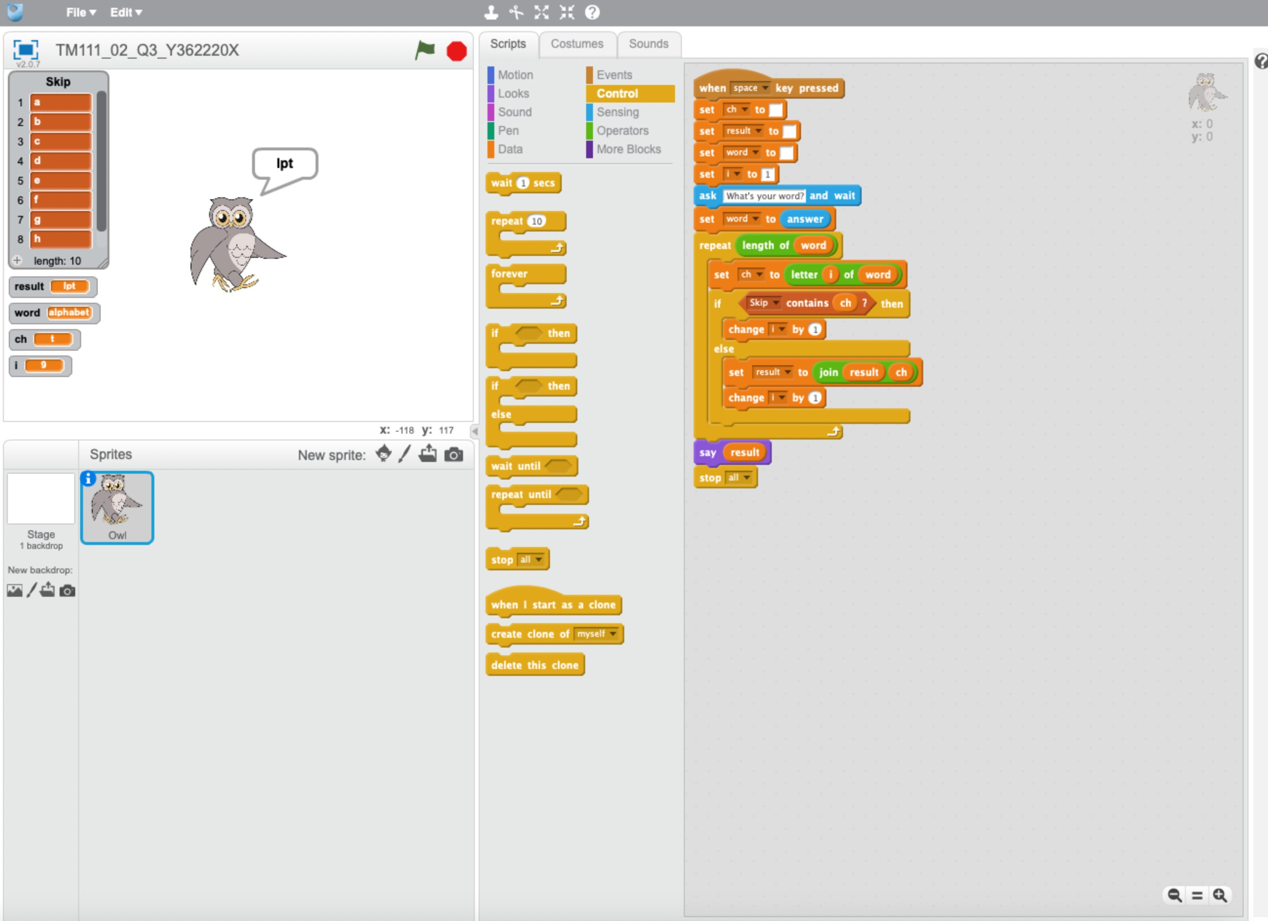

Works well, just hard to read answer. Better to put in bubble.

c)

|  |  |  |  |
| --- | --- | --- | --- |
| Test number | Test purpose | input | Expected result |
| 1 | Frist and last letters are in the first ten letters of the alphabet | apple | ppl |
| 2 | Double letters from the first ten letters of the alphabet | keep | kp |
| 3 | Program works despite case of input | BoOkKeEpEr | oOkKpr |

Correct.

Question 4:

a)

|  |  |  |  |  |
| --- | --- | --- | --- | --- |
| Test number | Test purpose | Existing data | Expected result | |
|  |  | names | least | greatest |
| 1 | Least name at position 1, greatest at position 3 | B, I, X, E, R, Q, W, V, D, S | 1 | 3 |
| 2 | Least name at position 2, greatest at position 1 | Y, A, C, F, H, J, L, M, O, P | 2 | 1 |
| 3 | Least name at position 1, greatest at position 6 | G, T, K, N, U, Z, H, L, J, O | 1 | 6 |

Correct

b)

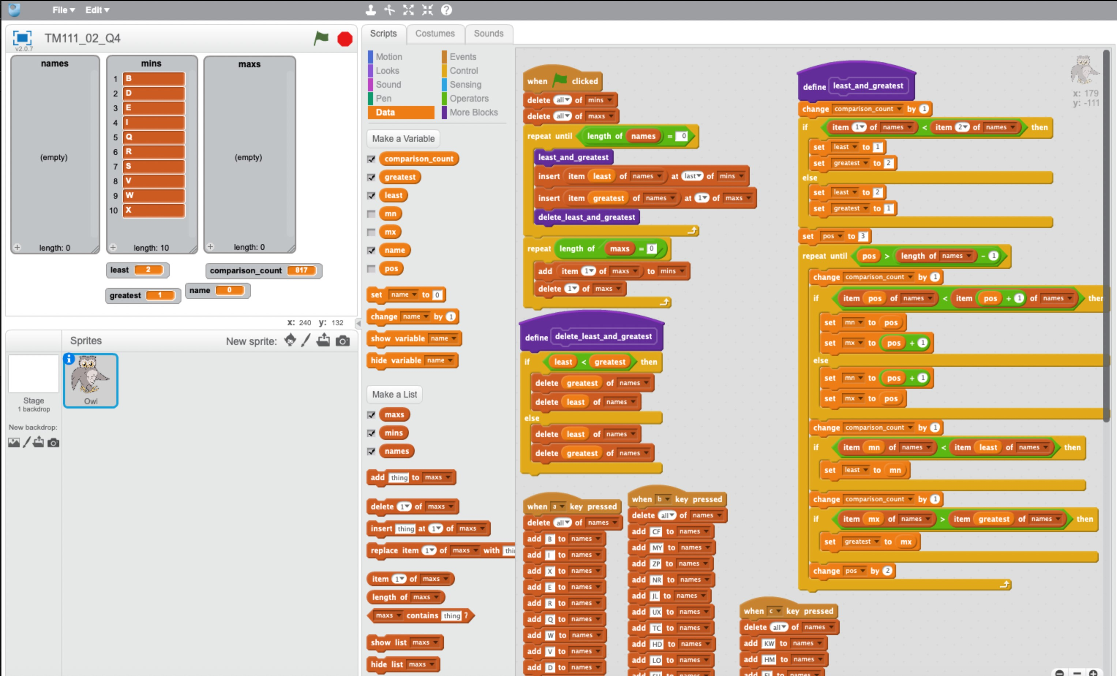

This works well

c)

i.

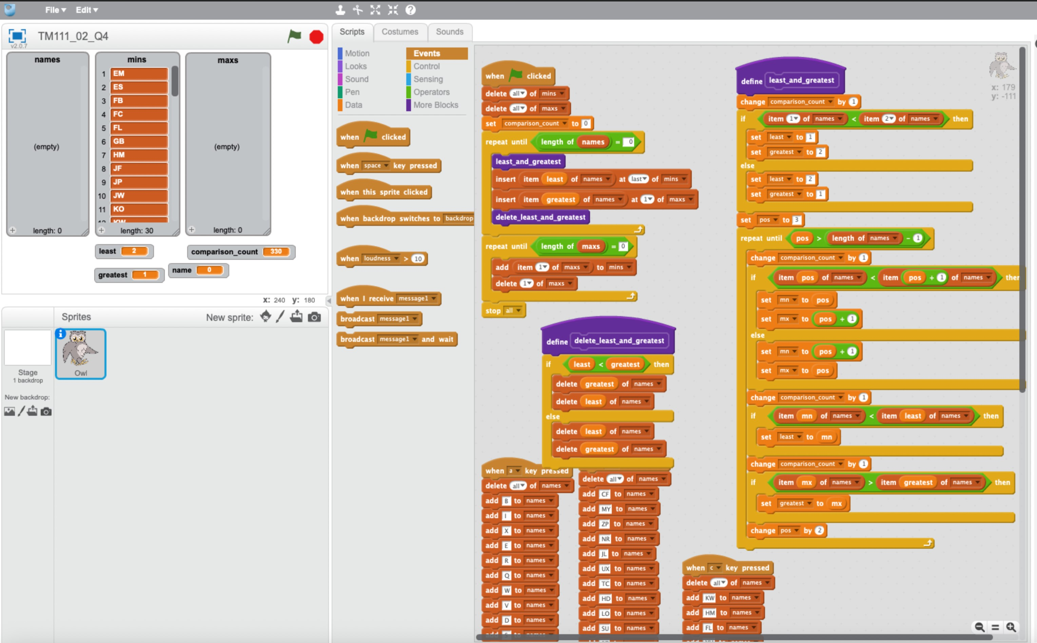

Good

ii.

|  |  |  |  |
| --- | --- | --- | --- |
| size of list | 10 | 20 | 30 |
| Number of comparisons | 35 | 145 | 330 |

Correct  
iii.

The number of comparisons is not linear because the number of comparisons does not increases by the same amount each time the list increases by the same amount.

iv.

|  |  |  |  |
| --- | --- | --- | --- |
| size of list (n) | 10 | 20 | 30 |
| *n ×*(*n −*1)2 | 45 | 190 | 435 |
| 0*.*75*× n ×*(*n −*1)2 | 34 | 143 | 327 |

All good.

The number of comparisons made is close to the theoretical maximum number of comparisons, which is *n ×*(*n −*1)2, multiplied by 0.75 as program expected a 25% improvement.

Given that the number of comparisons has remained close to the theoretical number for our 3 test, we can assume that this will continue for larger lists. Therefore, if we were sorting a list of 1000 names, the number of comparisons would be approximately

0*.*75*×*1000*×*9992 = 374625.

d)

The double selection sort algorithm would lie approximately in the middle of the selection sort and the bubble sort 1 algorithm.✓