Statistical Inference Course Project

Sohail Munir Khan

14 June 2015

This is an R Markdown document. Markdown is a simple formatting syntax for authoring HTML, PDF, and MS Word documents. For more details on using R Markdown see <http://rmarkdown.rstudio.com>.

When you click the **Knit** button a document will be generated that includes both content as well as the output of any embedded R code chunks within the document. You can embed an R code chunk like this:

x = 40  
lambda = 0.2  
nosim = 1000  
fill.matrix = function(expr, nrow=1, ncol=1) {  
 matrix(eval(expr, envir=list(x=nrow*ncol)), nrow=nrow, ncol=ncol)  
}  
dataMatrix = fill.matrix(rexp(x, rate=lambda), nrow=nosim, ncol=x)

You can also embed plots, for example:

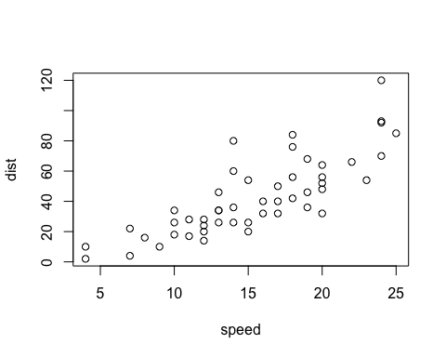

Note that the echo = FALSE parameter was added to the code chunk to prevent printing of the R code that generated the plot.