Charles Dunn

ccdunn@stanford.edu — 27950 Elena Road, Los Altos Hills, CA 94022 — 224-628-0603

Education

Stanford University Coterminal MS in Electrical Engineering – Signal Processing Concentration, Class of 2012  
Stanford University BS in Electrical Engineering – Circuits and Devices Concentration, Class of 2011

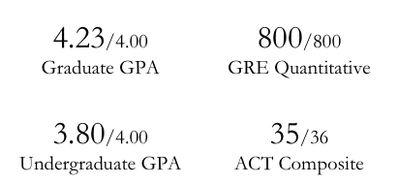

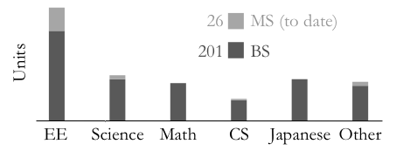

Work and Research Experience  
   
Johns Hopkins University Applied Physics Laboratory, Global Engagement Department — 2010, 2011  
 GPS C/A code generation in Simulink and Matlab, RF antenna field testing and post-processing — 2011  
 PCB layout and fabrication for GPS systems, GPS satellite signal integrity study — 2010  
 Contact: Martin Sommerville (Martin.Sommerville@jhuapl.edu, 443-778-7630)

Stanford University Electrical Engineering, VLF Group — 2008, 2010

Cubesat thermal control simulation and testing —2010

Circuit construction and microprocessor programming for LEO Cubesat ground station tracking — 2008

Contact: Dave Lauben (dsl@stanford.edu, 650-723-3965)

Hitachi Works, Nuclear Power Plant Division, Radiation Shielding Group – Hitachi-shi, Ibaraki-ken, Japan — 2009  
 Monte Carlo particle simulations for radiation therapy enclosure design

Active DOD Security Clearance

Awards  
   
Tau Beta Pi Engineering Honor Society  
Dean of Students Outstanding Achievement Award for Down With Gravity (Club President 2009-2011)  
SPARK Arts Grant Recipient   
US National Physics Team Semifinalist (200 nationwide)    
National AP Scholar, AP Scholar with Distinction

Rolling Meadows High School Physical Science Senior Medallion

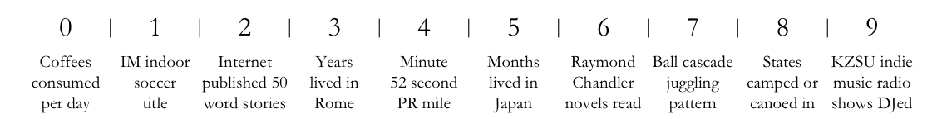Personal Interests