CSCE 611 Operating Systems Summer 2017

825008857 Chaiwei Chang

MP1

My github repo for this project is : https://github.tamu.edu/hunkywei/CSCE610-Operation_system/

Originally, my OS kernel looks like the following figure.

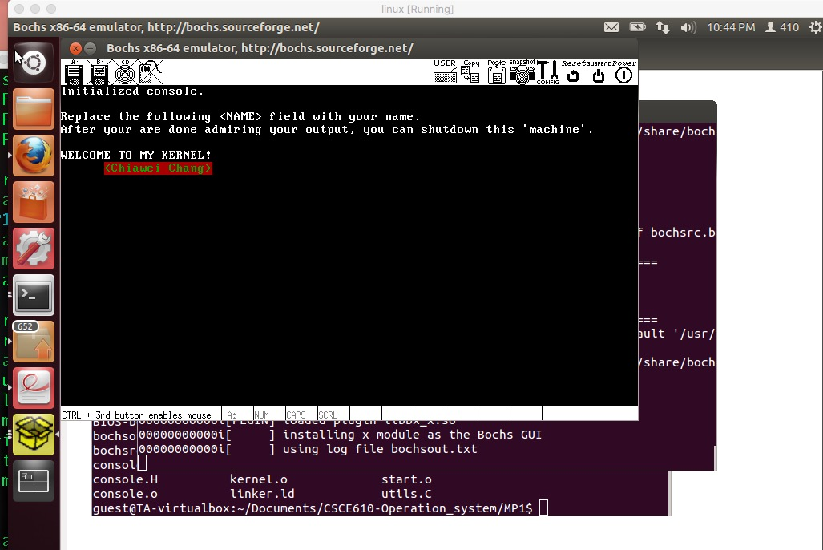Firstly, I downloaded the Get Bochs package from the web page documented in our instruction. Secondly, since gdb can be used to remotely debug the Bochs Environment, I follow the instruction to enable the gdb stub in the Bochs configuration file. After I set up the gdb debugger and modified the bochsrc.bxrc file, it will then waiting for the pre-set port first while we run it. I opened up two terminal and connected the gdb with boch locally like the picture shows bellow.

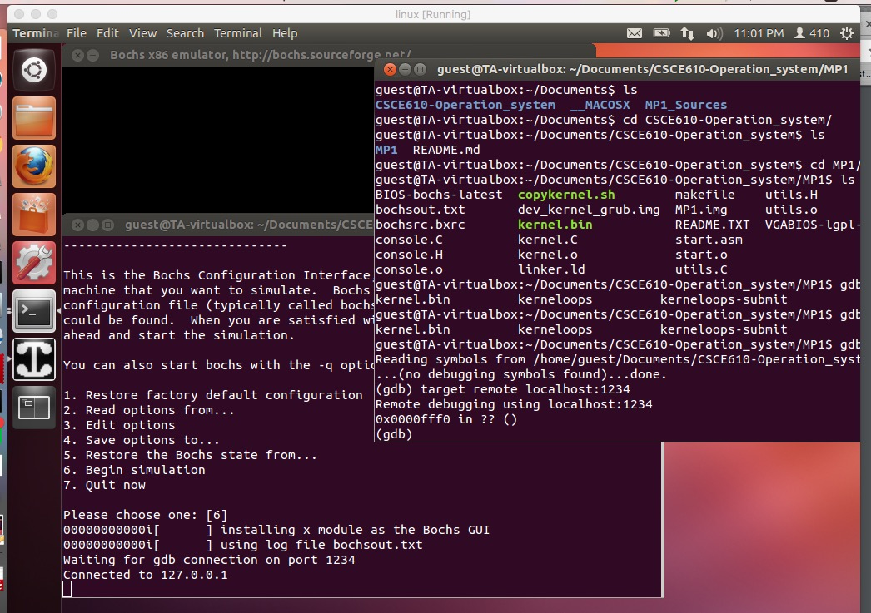

Finally, I set some break point to test our gdb is well functional and fully installed.

