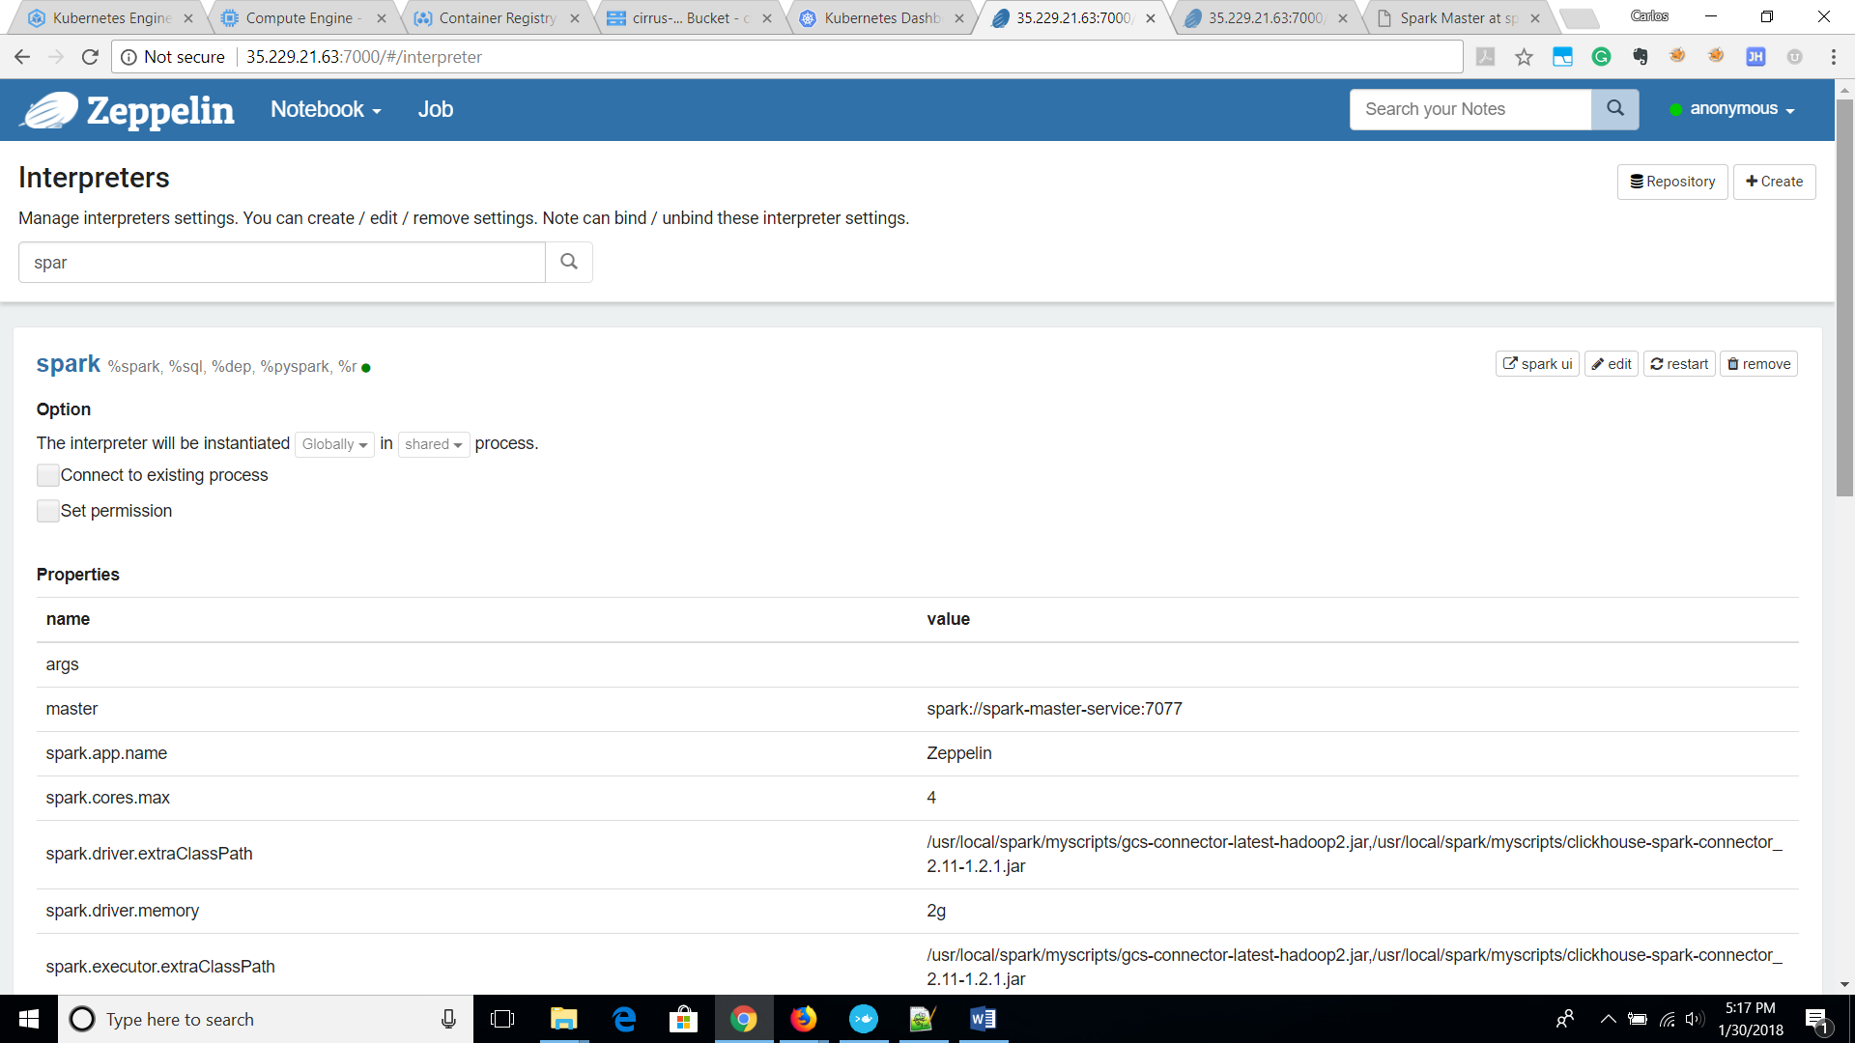

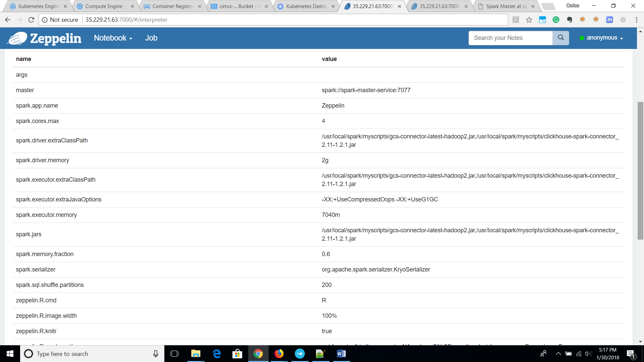

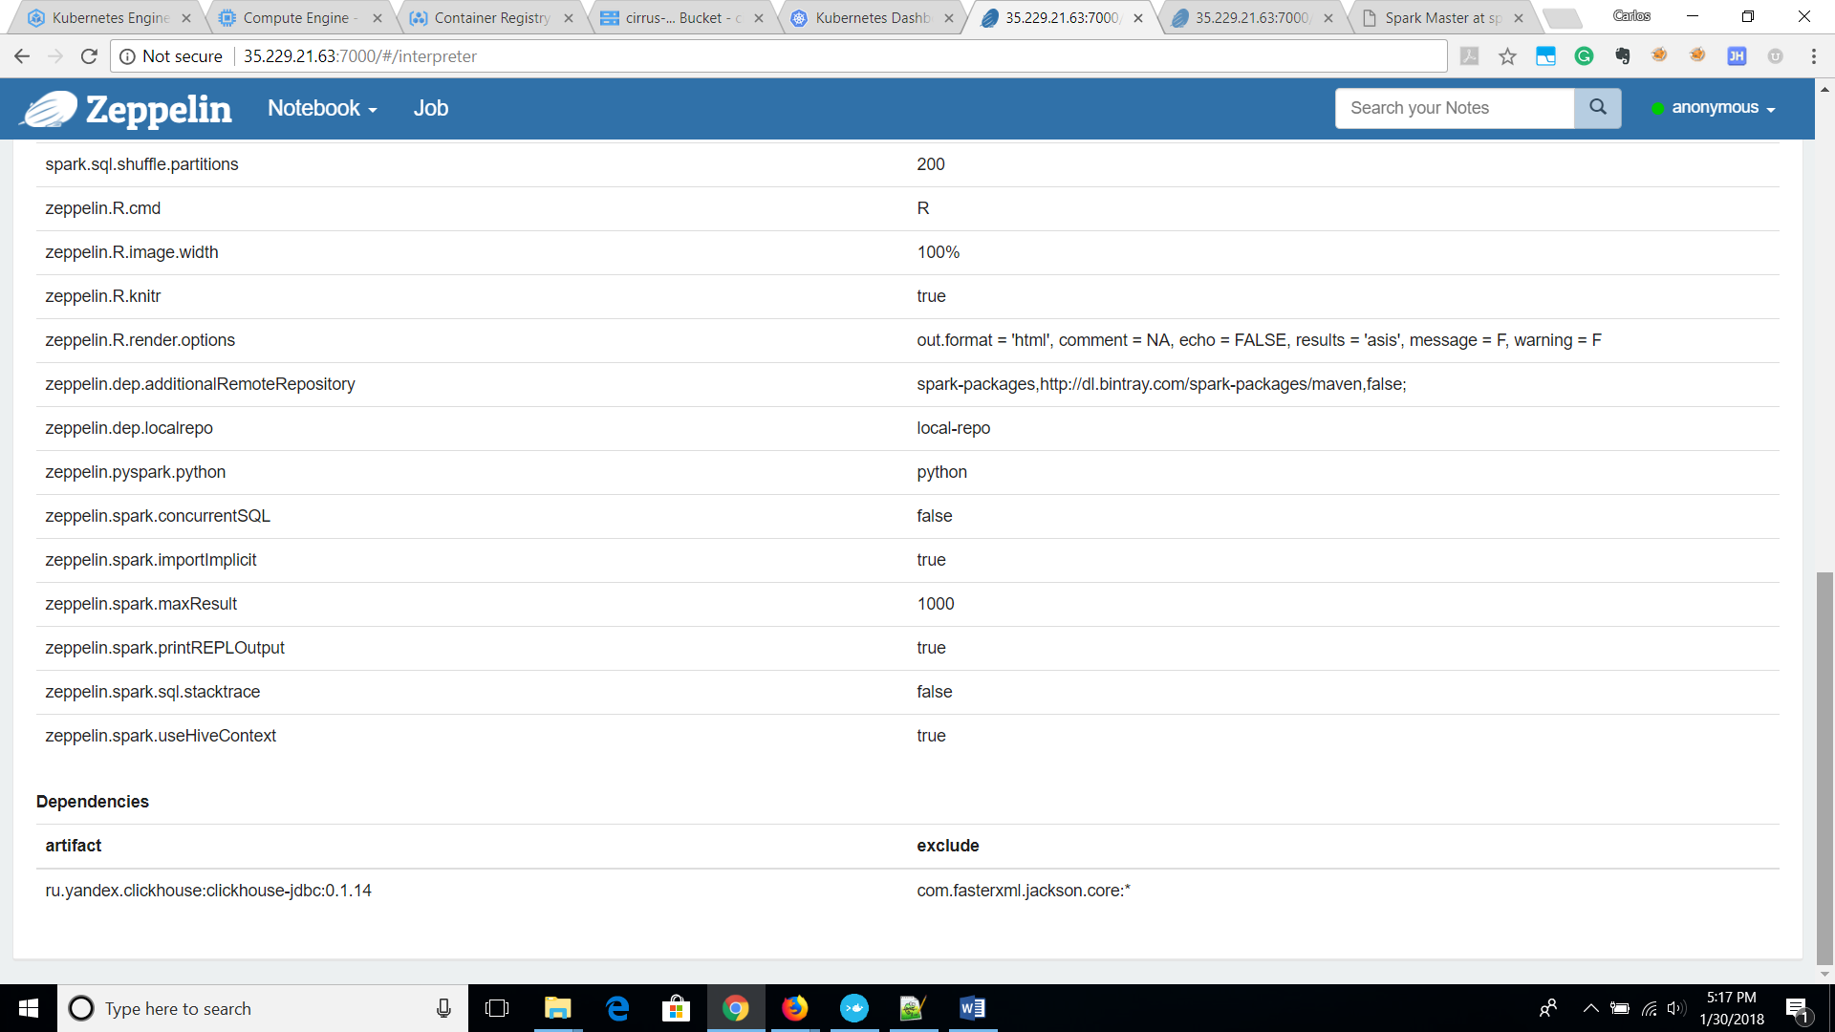

Final Config Anthem

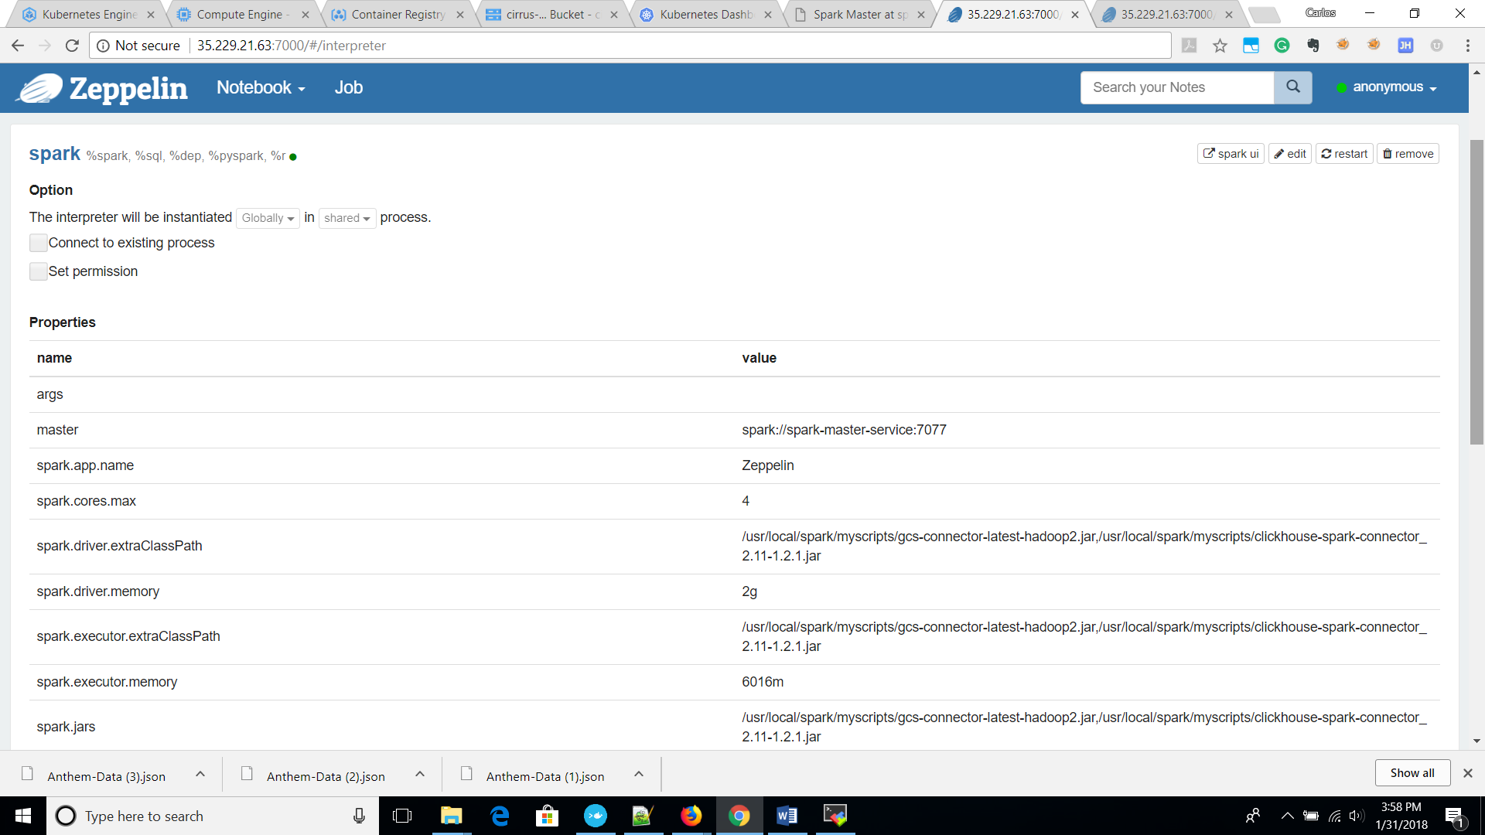

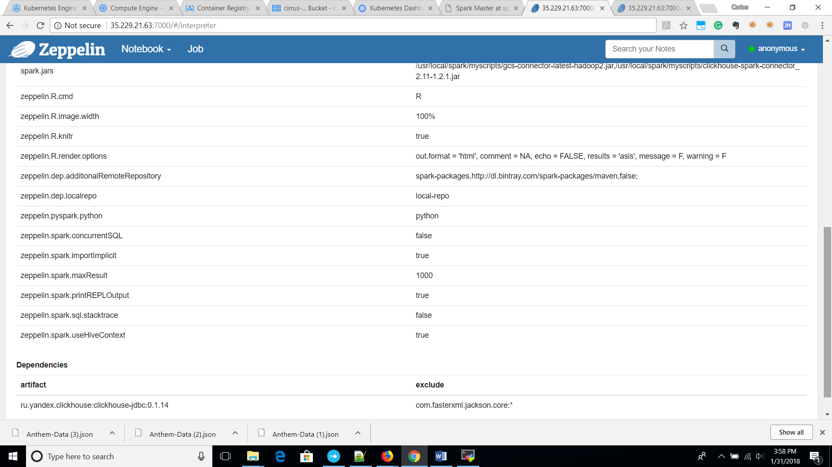

| **name** | **value** | |
| --- | --- | --- |
| spark.cores.max | 4 | |
| spark.driver.extraClassPath | /usr/local/spark/myscripts/gcs-connector-latest-hadoop2.jar,/usr/local/spark/myscripts/clickhouse-spark-connector_2.11-1.2.1.jar | |
| spark.driver.memory | 2g | |
| spark.executor.extraClassPath | /usr/local/spark/myscripts/gcs-connector-latest-hadoop2.jar:/usr/local/spark/myscripts/clickhouse-spark-connector_2.11-1.2.1.jar | |
| spark.executor.extraJavaOptions | -XX:+UseCompressedOops -XX:+UseG1GC | |
| spark.executor.memory | 6016m | |
| spark.jars | /usr/local/spark/myscripts/gcs-connector-latest-hadoop2.jar,/usr/local/spark/myscripts/clickhouse-spark-connector_2.11-1.2.1.jar | |
| spark.memory.fraction | 0.6 | |
| spark.serializer | org.apache.spark.serializer.KryoSerializer | |
| spark.sql.shuffle.partitions | 200 | |
| **artifact** | | **exclude** |
| ru.yandex.clickhouse:clickhouse-jdbc:0.1.14 | | com.fasterxml.jackson.core:* |