Installation and usage: pulsar_filterbank
Marcus Leech
Canadian Centre for Experimental Radio Astronony
Introduction
This document describes the installation, system requirements, and usage of the Gnu Radio application known as pulsar_filterbank.
System Requirements
This document assumes that you have already installed Ubuntu 18.04 LTS onto your system. The instructions given here would need to be modified for other Linux distributions, and Ubuntu is one of the more popular distributions.
The system hardware should be a fairly-modern, multi-core system, preferrably X86-based, but some of the higher-end ARM SBCs, like the Odroid N2 and XU4 will also work, albeit at lower sample rates.
There should be at least 2G of system memory, with a basic clock speed of at least 1.4GHz for X86 systems, and 1.8GHz for ARM systems.
There needs to be a reasonably-fast storage subsystem—any modern SSD on an X86 system, or a faster eMMC or uSD card on ARM embedded systems should work. Beware of cheap uSD cards—they are VERY slow, and will cause problems with writing filterbank files. Choose a class 10 card that supports 80Mbyte/sec or faster read speed, and 50Mbyte/sec or faster read speed.
Caveats
This document DOES NOT cover basic system installation procedures and requirements. If you aren't familiar with Ubuntu 18.04 installation procedures, and basic system management tasks, you should BECOME FAMILIAR WITH THOSE FIRST.
SDR requirements
The software supports many different SDR hardware platforms:
- USRP products: B2xx series, and N2xx, X3xx and N3xx series
- RTLSDR dongles
- HackRF
- LimeSDR and LimeSDR-mini
- AirSpy R2 and AirSpy mini
This document will NOT cover installation requirements for this hardware, as that information is generally provided by the manufacturers.
Prerequisite Installation
There are certain prerequisites for the pulsar_filterbank software that must be satisfied before installing the software.

Development Tools
sudo apt-get install build-essential
sudo apt-get install git
sudo apt-get install python-pip
sudo pip2 install ephem

Gnu Radio
sudo apt-get install gnuradio gnuradio*

Application: pulsar_filterbank
In your home directory:
git clone https://github.com/ccera-astro/pulsar_filterbank
cd pulsar_filterbank
make
sudo make install
cd $HOME

This will build the software, and install its components into /usr/local. The executables are in /usr/local/bin, and the pulsar database is in /usr/local/share. You will likely need to add /usr/local/bin to your PATH variable in your .bashrc if it isn't already there.
Helper Script: observe_pulsar
Applicaton includes a helper shell script that makes it much easier to start observations than using the underlying Gnu Radio flow-graphs. It does a number of things automatically to fill in the parameters required by the flow-graph, including automatically scanning your system to determine which SDR you likely have installed, and gleaning the required run-time parameters from a local static pulsar database.
The script assumes that data can be written to /mnt/extra (if it exists), or to your $HOME directory, or, to the location described in the PSR_DATA_LOCATION environment variable, which you can set in your .bashrc file if desired.
The parameters are as follows (in positional order):
name - name of the pulsar, as listed in the database (b0329+54, etc)
freq - center frequency, in MHz
bandwidth – bandwidth in MHz
gain - RF gain (usually in dB, depending on hardware)
obs-time - observing time, in minutes
longitude – local longitude, in decimal degrees, negative is west

The script makes very little attempt to sanitize the hardware parameters. If you ask for an unsupported bandwidth (sample rate), you'll get an error from the underlying hardware driver, similarly with center frequency and gain.
A typical invocation might look like:
observe_pulsar b0329+54 432.50 10.0 25 45 -76.03

Once the script has been invoked, it will look up the pulsar parameters (w50, DM, etc), scan for the hardware, and then enter a loop waiting for the given object to “rise” given your local longitude. Once the object is likely entering your beam-width (as described by the obs-time parameter), the underlying flow-graph is called, with the run-time parameters determined by the script.
USRP Hardware Notes
For USRP hardware, special variants of the underlying flow-graph are invoked that improve the start-of-observation information in the header that is ultimately produced in the output filter-bank file. The start-up script will determine whether there's a GPSDO present also, which will improve the start-time estimate even further.
It's VERY IMPORTANT to allow the GPSDO in your USRP to stabilize and acquire lock before starting the observing run. Not just because the resulting start-time will be better, but because the application will stall waiting for GPS LOCK to occur. Plan accordingly.
Underlying flow-graph guide
The build process builds three different variants of the underlying flow-graph, pulsar_filterbank.grc, which is shown below.
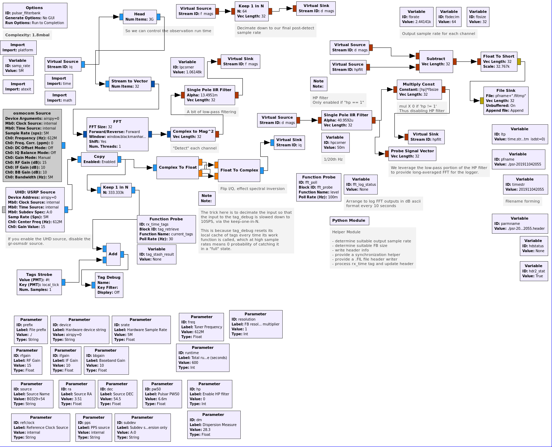
In this flow-graph, there are two different sources – an osmocom source for all devices other than USRPs, and a uhd source for USRP devices.
The Makefile arranges to produce three variants of the generated Python code:

Code: pulsar_filterbank_none.py
This variant is used for ALL non-USRP devices, and uses the osmocom source block. It will record a start-time in the header of the filter-bank file that is very approximate (within approximately 100msec), since none of the non-USRP devices provide any kind of precise time-stamping facility. Since we strongly recommend that your host computer be synchronized via NTP, this will be adequate some types of timing analysis, but cannot provide precise TOA.

Code: pulsar_filterbank_gps.py
This variant is used for USRP devices when an on-board GPSDO is detected. It provides very precise (within a few 10s of nanoseconds) precision that is locked to the GPS time information. It can be used for precise TOA analysis.

Code: pulsar_filterbank_ntp.py
This variant is used for USRP devices when no on-board GPSDO is detected. It provides precision as good as the underlying NTP synchronization (a few milliseconds) in estimating the start-time, and thus TOA.

Command-line Arguments for all Variants
Options:

-h, --help show this help message and exit

--bbgain=BBGAIN Set Baseband Gain [default=10.0]

--dec=DEC Set Source DEC [default=54.5]

--device=DEVICE Set Hardware device string [default=airspy=0]

--dm=DM Set Dispersion Measure [default=28.3]

--freq=FREQ Set Tuner Frequency [default=612.0M]

--hp=HP Set Enable HP filter [default=0]

--ifgain=IFGAIN Set IF Gain [default=10.0]

--pps=PPS Set PPS source [default=internal]

--prefix=PREFIX Set File prefix [default=./]

--pw50=PW50 Set Pulsar PW50 [default=6.6m]

--ra=RA Set Source RA [default=3.51]

--refclock=REFCLOCK Set Reference Clock Source [default=internal]

--resolution=RESOLUTION

Set FB resolution multiplier [default=1]

--rfgain=RFGAIN Set RF Gain [default=15.0]

--runtime=RUNTIME Set Total runtime (seconds) [default=600]

--source=SOURCE Set Source Name [default=B0329+54]

--srate=SRATE Set Hardware Sample Rate [default=5.0M]

--subdev=SUBDEV Set Subdev spec, UHD-version only [default=A:0]

The –bbgain argument is used to set the baseband gain on some hardware that supports it as a separate parameter. The –dec parameter is used to set the declination of the observation. The –device parameter is the device string, as appropriate for the osmocom or uhd source, whichever is being used. The –dm parameter sets the expected dispersion measure for the observation. The –freq parameter sets the tuning center frequency, in Hz. The –hp parameter is used to enable (value = 1) or disable (value=0) a high-pass filter in the channel-bank detector pathway. The –ifgain parameter sets the IF Gain on some hardware that supports it. For UHD hardware, the –pps and –refclock parameters are used to set the corresponding parameters in the uhd source block. The –prefix parameter specifies the prefix used for writing filter-bank files, and should include a trailing “/”. The –pw50 parameter specifies the W50 parameter for the observation (specifying the half-width of the pulse profile), this parameter is in seconds. The –ra parameter is used to set the right ascension of the observation. The –resolution parameter can be used to increase the resolution of the filter-bank by a fixed integer, power-of-2 value; for example if the automatic procedures determined a size of 32 bins, specifying a –resolution value of 2 would increase it to 64 bins. The –rfgain parameter specifies the RF Gain for the hardware—all hardware types support this parameter. The –runtime parameter specifies the desired run-time, in seconds for an observation—it is usual to make this commensurate with your beam-width transit time for transit-type instruments. The –source parameter is used to specify the name of the source under observation, such as “b0329+54” or “j0332+5434”. The –srate parameter specifies the desired sample-rate for the hardware. The –subdev parameter is used for USRP sources to specify the desired sub-device.

Filterbank File
The output file will be formatted as a 16-bit SIGPROC-compatible filterbank file. The file-name will be of the form:
psr-YYYYMMDDHHMM.fil

These files can be quite large, depending on the observed pulsar parameters—pulsars with higher DM, and/or smaller W50 will produce larger files than those with smaller DM and/or wider W50.
Write rates will also go up accordingly, so it's best to have a good-quality SSD or fast uSD card on SBC/embedded systems.

SIGPROC and PRESTO
The building and installation of post-processing tools, like SIGPROC and PRESTO are described in other documents. We at CCERA tend to have our receiver machines separate from our post-processing machines, and it would be a good practice to only undertake the herculean task of installing these tools on a single machine, and then transferring observation files from the receiver systems to the analysis system as-required.

See: https://github.com/ccera-astro/pulsar_filterbank

