Anomaly#1

TV display faces

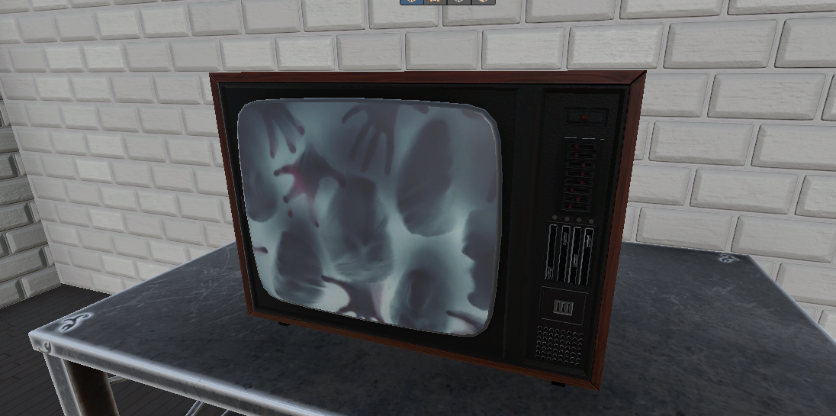

Anomaly#2

Bobbing paintings

Anomaly#3

Closed Eye

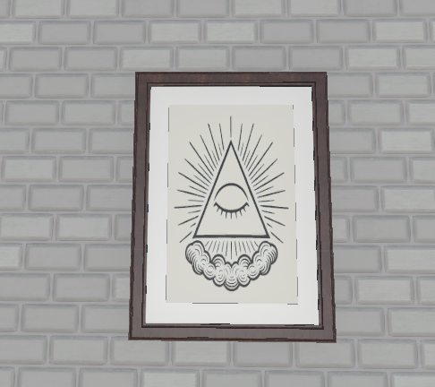

Anomaly#4

Head replaced by Ghost

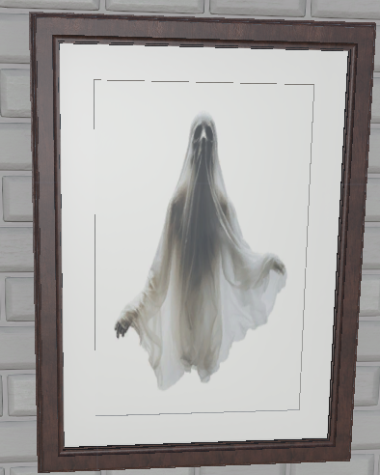

Anomaly#5

Red-light from Helmet

乐高玩具

AI 生成的内容可能不正确。

Anomaly#6

Upside-down lunar lock poster

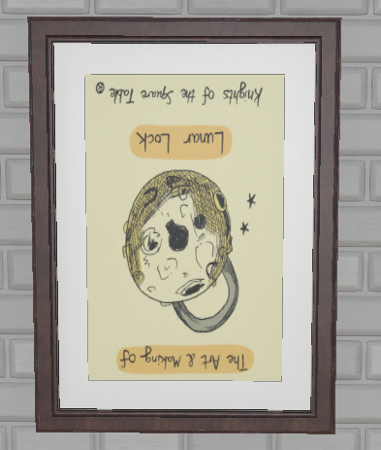

Anomaly#7

Knight without a sword

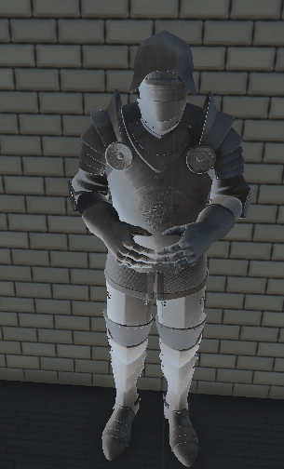

Anomaly#8

Different sofa

图片包含 室内, 家具, 沙发, 床

AI 生成的内容可能不正确。

Anomaly#9

Different TV(more modern)

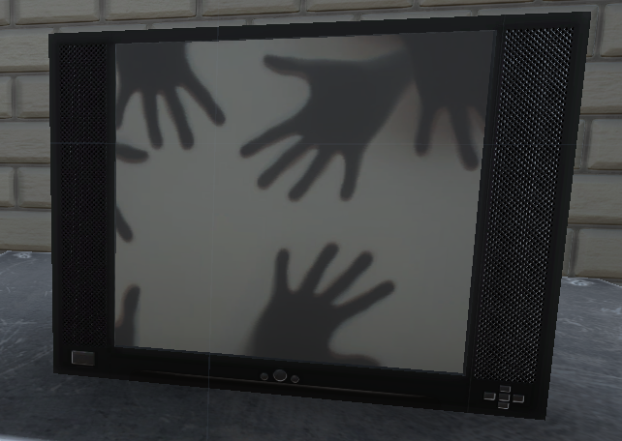

Anomaly#10

Misplaced wall

卫生间的砖墙

AI 生成的内容可能不正确。

Anomaly#11

Man standing

图片包含 建筑, 小, 房间, 体育

AI 生成的内容可能不正确。

Anomaly#12

Anomaly#13

Anomaly#14

Anomaly#15

**Anomaly ideas:**

##The little girl (Jump scare)

The anomaly would be a girl standing in the end of the corridor face to the wall. The player will only see her back. And once approached to a certain distance. The flashlight will be turn off for a short period of time and the girl will be stand in front of player and facing player. This will send the player back to the start.

##Do not look away??

##Headless man