
Doubling Coffee Incomes for 1 million East African Smallholder Farmers
July 11, 2007

Executive Summary

Raising African rural incomes is a significant challenge. Much of rural Africa is characterized by semi-subsistence agriculture which offers little opportunity for wealth accumulation. Small landholdings, degraded soil, volatile commodity markets, poor transportation infrastructure, lack of credit and a host of other factors conspire to keep millions in a state of extreme poverty. The litany of problems is well documented. For more than 50 years concerted efforts have been made in this challenging landscape to raise people out of poverty. The results have been mixed at best, leading many to question whether philanthropic efforts can successfully raise incomes for those in poverty.
Specialty coffee has significant potential to raise smallholder farmer incomes in East Africa. African smallholder farmers face a challenging environment; however, business opportunities do exist. One of these opportunities, which has emerged only in the past ten years, is specialty coffee. Coffee is a mature commodity market growing at less than 2% per year. However, the specialty coffee segment (450,000 metric tons per year) has been growing rapidly and now accounts for more than 5% of global coffee sales. Specialty coffee requires specific agro-climatic conditions of altitude, soil and climate that exist only in very limited regions around the globe. In Africa, these conditions can be found primarily in the highlands of Burundi, Ethiopia, Kenya, Rwanda and Tanzania. This specialty coffee segment offers three significant benefits for smallholder coffee farmers: higher incomes, lower price volatility, and a defendable competitive advantage against more efficient, low-cost countries such as Brazil.
An opportunity exists to help 1 million smallholder farmers double their coffee incomes within 12 years. The specialty segment was, until the late 1990s, a small niche of the coffee market. As a result, the skills and processes required to produce quality coffee are not widely practiced throughout the coffee-growing regions of East Africa. In particular, quality management systems are required during coffee processing. Transferring skills regarding the business practices and quality systems required enables smallholder farmers to increase the export price and the share of export price they receive. This price premium provides profits that permit a virtuous cycle of further quality improvement, farm investment for higher yields and social investment such as secondary education. This opportunity is not available for all farmers in East Africa and the opportunity is not limitless; it is bounded by the market demand for East African specialty coffee. At present, market projections suggest that demand for 2 million incremental bags per year of East African specialty coffee attracting premiums of ~30 US cents per lb ($US 0.66 per kg) above the New York “C” price will emerge by 2019. This translates into the potential to double coffee incomes for approximately 1 million smallholder farmers within 12 years.
TechnoServe (TNS)’s approach works. TNS’s approach works despite poor roads, high fertilizer prices, aging trees, inadequate property rights, uneven government policy and a host of other barriers to progress. Most importantly, this approach has proven successful even when market prices collapsed to record lows around the year 2002. This success is a function of the significant price premiums that are possible within a short period of time, in combination with the very modest outlay required of farmers and the short payback period. The TNS approach and the results achieved are endorsed not just by farmer clients, but also by industry organizations, exporters, governments and multinational roasters. This project does not seek to pilot new innovations but rather seeks to “scale-up” a proven approach to reach 1 million smallholder farmers.
Africa may miss this opportunity. There is widespread consensus regarding the opportunity outlined above and there has been significant activity by governments and philanthropists to support this agenda over the past five years. Nevertheless, there is a very real chance that Africa will miss this opportunity. East Africa has potential, but this potential must be converted into an efficient industry producing consistent specialty coffee delivered on-time if African farmers are to reap the rewards. The demands of specialty buyers require significant changes in processes and procedures from traditional commodity coffee production. While there are numerous ongoing philanthropic efforts in the coffee industry in East Africa, the collective funding levels and the impact they are likely to have are relatively modest compared to the size of the opportunity. TNS’s approach complements rather than duplicates initiatives taking place in the field. For example, the Rwandan government is launching a tree replanting program for coffee farmers. TNS’s approach will help farmers understand the value of tree replanting and permit additional income as a buffer for farmers during the period required for new seedlings to reach maturity.
Five elements are required for East Africa’s potential to be achieved:
- Quality coffee – including the business systems to produce quality consistently and the cupping skills and market incentives to identify and reward quality
- Agronomic best practices – to manage land resources in a sustainable and optimal manner both environmentally and commercially
- Conducive government policy – to provide an enabling environment for a specialty industry to evolve and grow
- Market linkages – to connect quality coffee with the marketplace
- Commercial credit – for investments in processing facilities and working capital.
Each of these five elements will be addressed in the project.

Background and Rationale

Why Coffee?
At first glance, coffee does not seem to provide a compelling opportunity to improve the lives of African smallholder farmers. The industry has been growing at less than 2% for the past hundred years and coffee consumption in the United States has been in long-term decline for several decades. Two nations, Brazil and Vietnam, have lower costs of production than African nations, and have been gaining global market share in recent years as a result of this competitive advantage. In addition, the industry is plagued by volatile prices that have created repeated humanitarian crises in producing countries over the past two hundred years. Nevertheless, a closer look at this industry demonstrates an exciting opportunity to help 1 million smallholder African farmers and their families capitalize on a competitive advantage that can not only change their lives but permit these farmers to participate in the global economy on an equal footing, with dignity and without charity.
A Mature Industry
Coffee grows best in a warm, humid climate with a relatively stable temperature all year round. As a result, coffee is typically grown between the tropics of Cancer and Capricorn. There are at least 10 million farmers throughout the world exporting more than 7 million metric tons each year (see Exhibit 1). Exports are sourced from efficient agribusinesses that employ modern agronomic techniques as well as from smallholder farmers that have far lower productivity but very few cash outlays. Coffee represents a major source of cash income for millions of smallholder farmers and a significant source of export earnings for many African nations. The industry is mature and well-organized. A coffee futures market has been in operation in New York for more than 100 years. Distribution channels are well established via a combination of formal and informal businesses that manage the processing, transportation and regulatory requirements of coffee from farm-gate to roaster. The industry average annual growth rate for the past hundred years has been less than 2% and coffee consumption in the United States has been in long-term decline (see Exhibits 2-3).

- Coffee is grown between the Tropics of Cancer and Capricorn
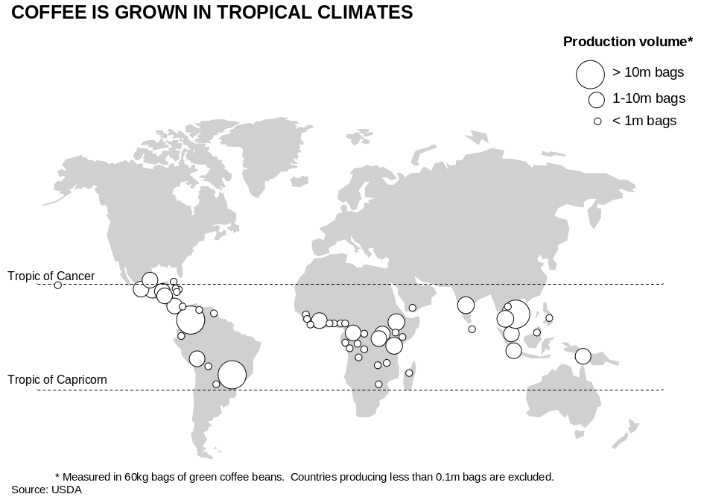
- Demand for coffee has been growing at less than 2% since 1900
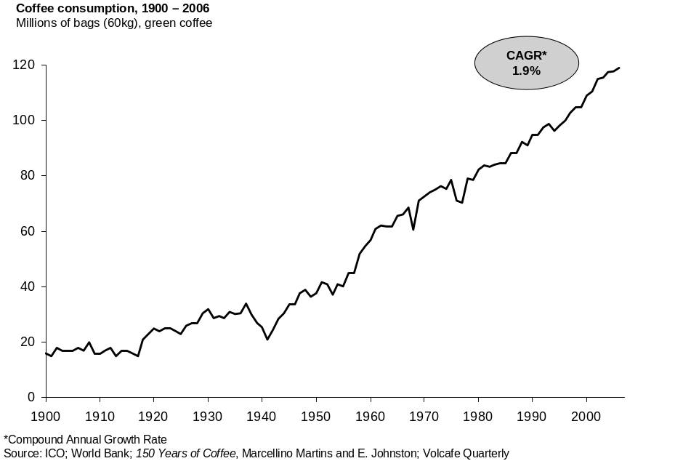

- US coffee consumption has been in long-term decline
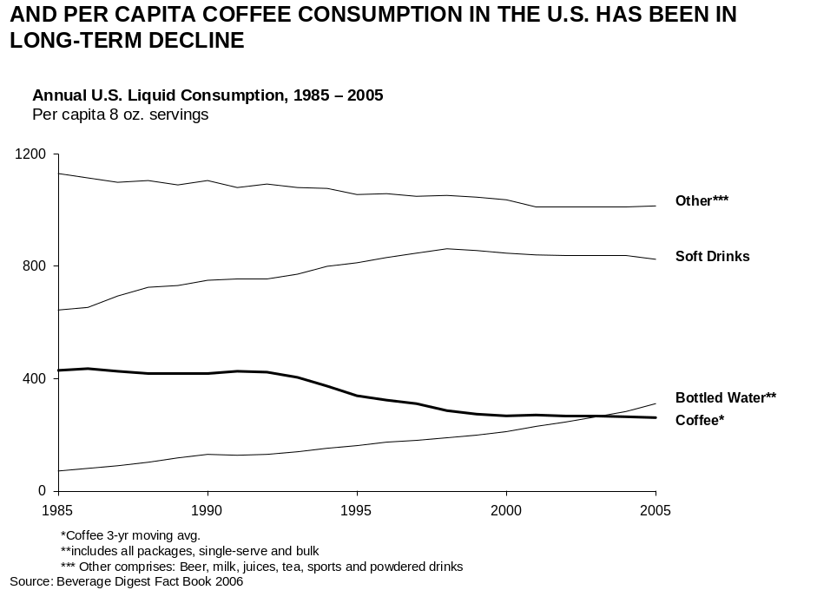

Volatile Prices

Coffee has historically experienced significant price volatility (see Exhibit 4). Several factors contribute to coffee’s price volatility. Brazil represents a large share (currently 36%) of global production. Events in Brazil therefore have a dramatic effect on global volume and prices. Agro-climatic events such as droughts and frosts have generated dramatic spikes in global prices while a decline in the value of the Brazilian Real contributed to sustained low prices in the late 1990s. In addition to the Brazil factor, volatility is amplified by lag effects. Coffee is a tree crop which takes several years to reach maturity. When coffee prices are high, farmers plant more trees, increase husbandry and increase inputs such as fertilizer to improve yields. These actions result in supply increases which take several years to emerge, sowing the seeds for industry oversupply and price decline. The economics of smallholder farming also contribute to this “boom-bust” cycle. For many smallholders, coffee is one of several sources of income. Their livelihood consists of a diversified portfolio of subsistence agriculture, cash crops (including coffee) and off-farm labor. When coffee prices are low, there are no cash costs associated with smallholder coffee farming. No inputs are applied and all harvesting is completed by unpaid family labor. The “floor price” for smallholders is, therefore, the opportunity cost of family labor during the coffee harvest. This situation ensures that excess production and excess capacity are slow to exit the market when the industry is oversupplied. As a result of these forces supply has historically oscillated around demand (see Exhibit 5).

- Coffee prices have historically been volatile

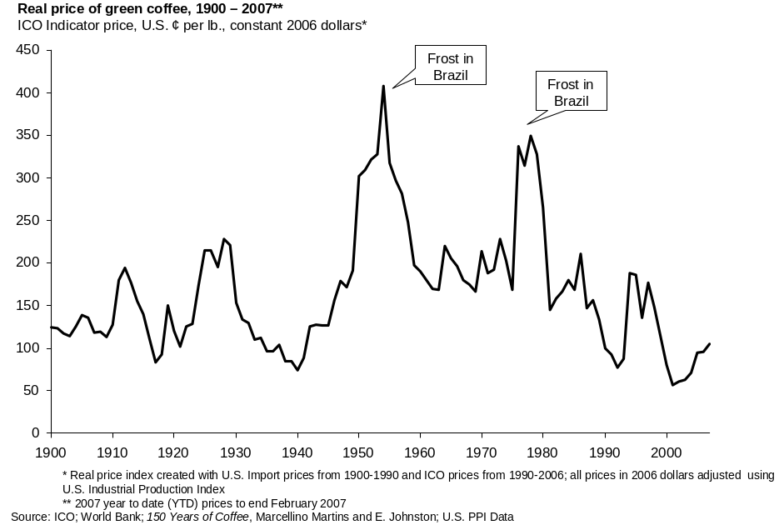
- Supply has historically oscillated around demand
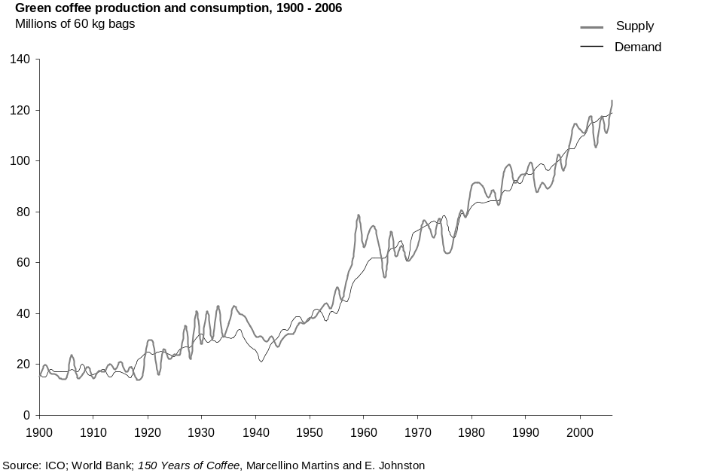

Two Main Coffee Varieties: Arabica and Robusta
Arabica represents approximately 65% of all coffee exports. It is more difficult to cultivate than Robusta, but typically receives higher prices due to flavor and aromatic characteristics. These characteristics are enhanced by growing conditions at higher altitudes. The best Arabicas are generally grown between 1,000 and 2,000 meters above sea level. Robusta represents approximately 35% of global production and is grown at lower elevations. This variety is easier to grow, produces higher yields and is more disease resistant than Arabica (hence its name). Robusta is typically sold at a lower price than Arabica and is an important contributor as a blend to the soluble coffee market as well as being sought out by various espresso markets due to its foaming characteristic (referred to in the industry as “crema”). Soluble coffee consumption has been growing faster than “Roast and Ground” coffee consumption which has driven demand for Robusta at a higher rate than Arabica (see Exhibits 6-7). Demand for Robustas has also been driven by at least two other inter-related factors: new technologies in the 1990s that permitted roasters to enhance the flavor characteristics of Robusta, such as steaming techniques to reduce bitterness, and the emergence of Vietnam as a low-cost Robusta producer which widened the price differential between Arabicas and Robustas.

- Soluble coffee has been growing faster than “Roast and Ground”
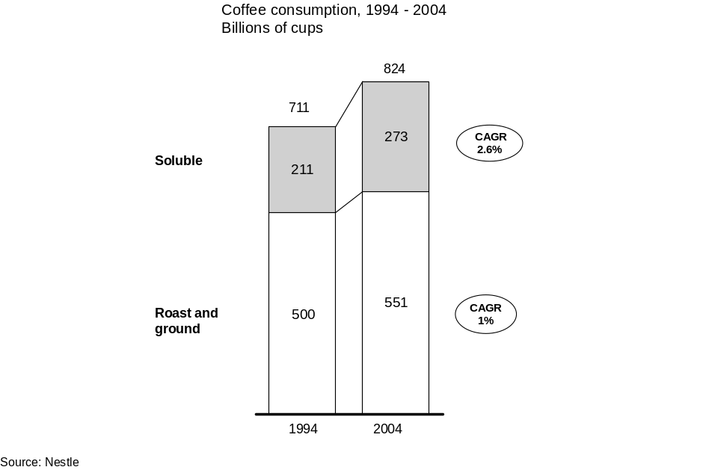

- Demand for Robusta growing faster than Arabica
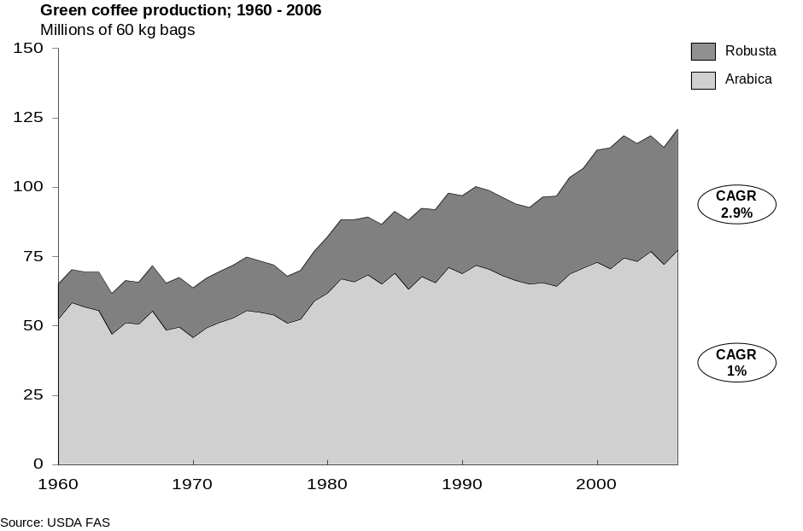
- Half of the world’s coffee is produced by Brazil and Vietnam
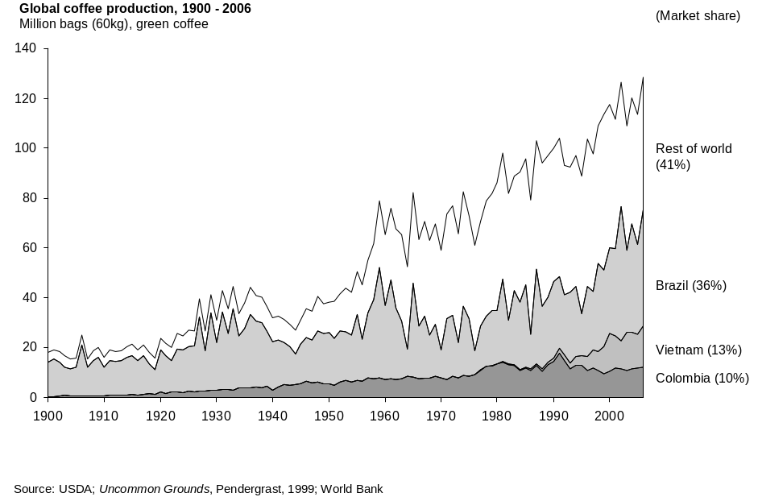

Two Dominant Producers: Brazil and Vietnam
Half of the world’s coffee is produced by two nations: Brazil and Vietnam (see Exhibit 8). These two nations have been increasing their market share in both Arabica and Robusta over the past 15 years due to a competitive advantage as low-cost producers (see Exhibit 9).

- Brazil and Vietnam have been increasing market share
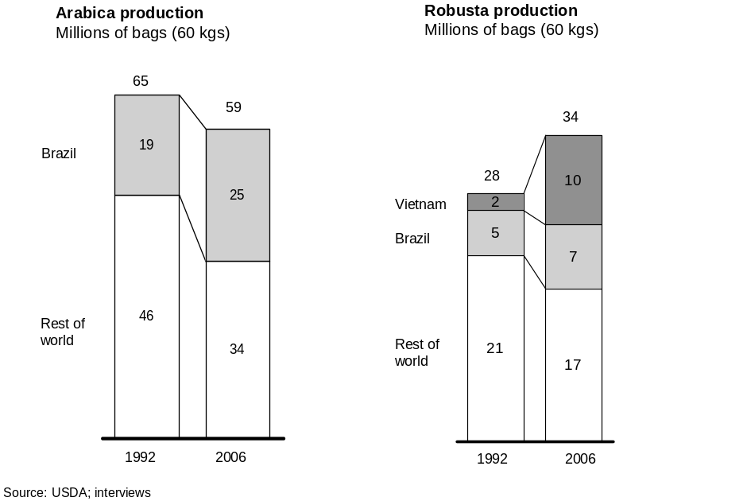

An Opportunity for Africa

The discussion thus far is not heartening for African smallholder coffee producers: an industry with low growth rates; dominant competitors increasing their market share due to a defendable low cost competitive advantage and volatile prices in a commodity setting. However, within this bleak market assessment lays an exciting business opportunity for smallholder African farmers. This opportunity is the specialty coffee segment which has been growing strongly over the past decade and rapidly emerging from its status as a small niche to a major force in the coffee industry. This is good news for African Arabica smallholder coffee farmers.

The Specialty Coffee Segment

The top 5-10% of Arabica coffee is considered specialty coffee. There are no generally agreed-upon definitions for this segment; however, approximately 500,000 metric tons of green coffee receive premiums of more than 10 US cents per lb ($US 0.22 per kg) above the New York Board of Trade’s “C” contract price. To be conservative TNS has used a slightly lower estimate of 450,000 metric tons (7.5 million 60-kg bags) as the 2007 market estimate for specialty coffee. This segment has been growing strongly in recent years due primarily to the success of specialty roaster retailing. Starbucks is the most visible company in this sector, accounting for approximately 30% of specialty coffee. Starbucks has been growing at more than 20% per year while other specialty roasters have also been experiencing strong growth (see Exhibit 10).
- Starbucks retail outlets, 1999-2007
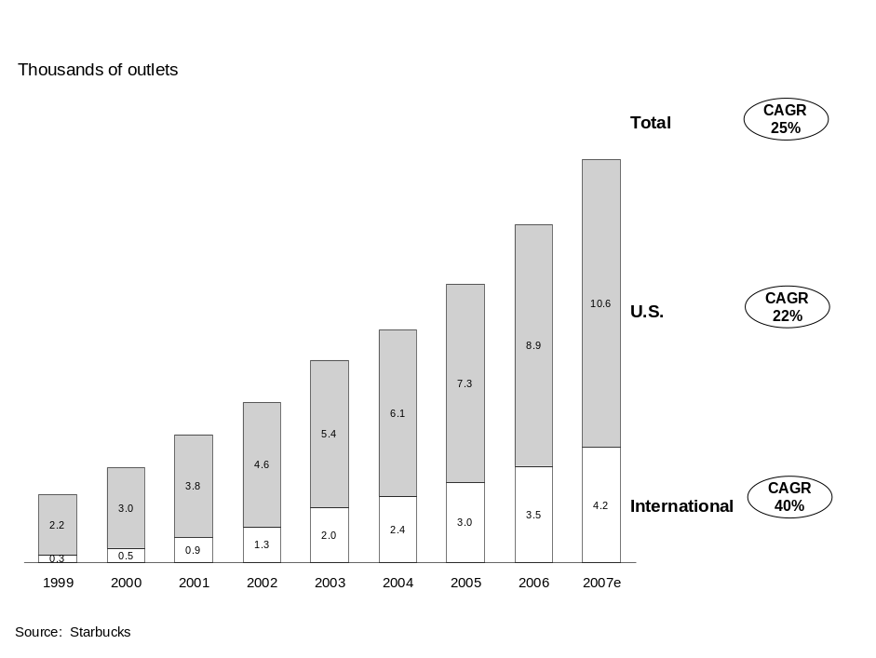

Growth is Expected to Continue
Starbucks’ corporate guidance and current share-price suggests continued annual growth of approximately 20% for at least the next three to five years. Due to non-coffee business opportunities for Starbucks, this growth may not translate exactly into green coffee purchases; however, comparable store sales growth has not yet plateaued, providing confidence in untapped market potential (see Exhibit 11). Other market participants are providing similar guidance.

- Starbucks comparable store sales still growing
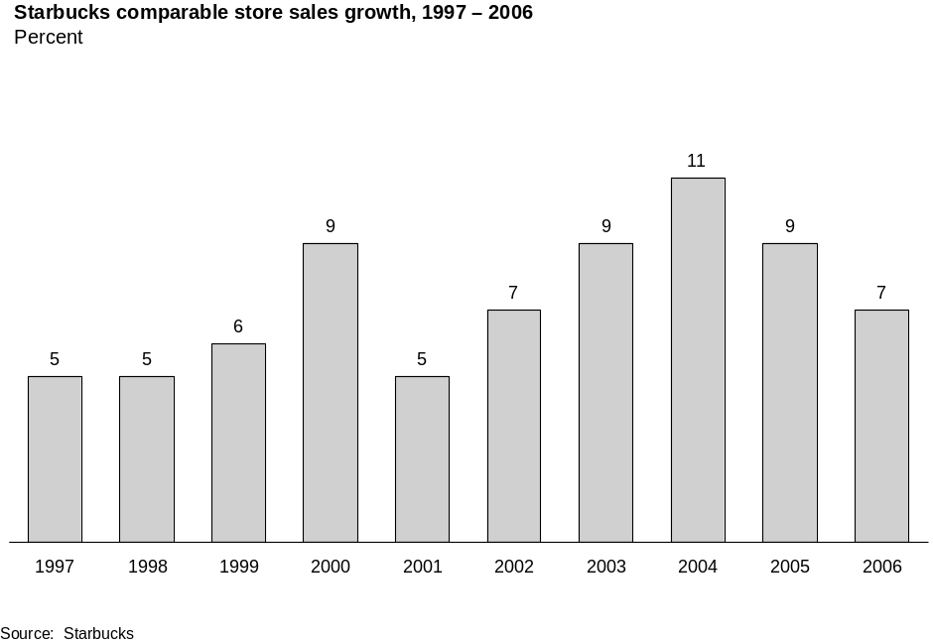
- Specialty coffee demand expected to reach 18 million bags
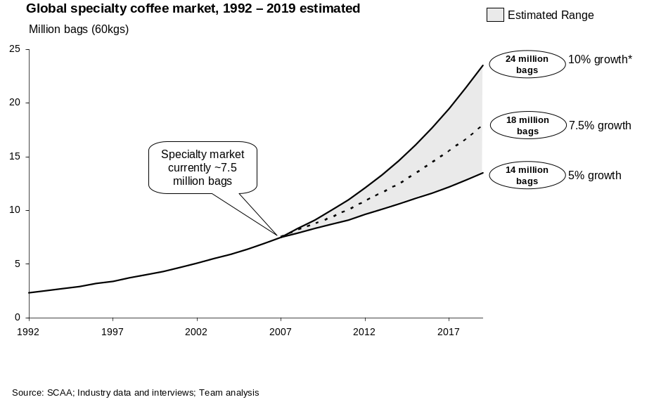
Peet’s Coffee and Tea Chief Executive Patrick O’Dea recently forecast that Peet’s could grow “in the 20% range for as far as the eye could see.” Nespresso’s sales have been growing at a compound annual growth rate of over 30% for the past 15 years. The specialty market may grow at these rates; however, TNS has used more conservative estimates to model market demand for specialty coffee over the next decade. TNS has assumed global demand will grow within the range of 5-10% per year for the next 12 years. At the high end, if global demand grows at 10% per year, demand would reach 1.4 million metric tons (24 million 60-kg bags) by 2019. Assuming a more conservative annual growth rate of 5%, demand would reach 0.8 million metric tons (14 million 60-kg bags) by 2019 (see Exhibit 12). TNS has assumed a compound annual growth rate of 7.5%, generating demand of 1.1 million metric tons (18 million 60-kg bags) by 2019, implying an incremental need for 600,000 metric tons (10 million 60-kg bags) of specialty coffee by 2019. This new demand will represent both new coffee consumption and cannibalization of lower priced coffee sales.
Africa has a Competitive Advantage
In the global marketplace, Africa enjoys few competitive advantages. Africa does, however, have a competitive advantage in terms of premium Arabica coffee. Specialty coffee requires a specific set of agro-climatic conditions relating to altitude, soil and climate. Specifically, higher altitudes produce higher quality, with the most sought after Arabica coffee beans being found 1,500-2,000 meters above sea level. While these conditions can be found in a range of locations including Indonesia, Central America and the highlands of East Africa, suitable locations are finite. Brazil and Vietnam enjoy a competitive advantage in the production of Robusta and lower-altitude Arabica; however, both nations have very limited coffee growing areas at high altitude. East Africa, therefore, finds itself with a defendable competitive advantage in a rapidly growing market paying above-market premiums. Five countries in particular have significant potential over the next decade: Burundi, Ethiopia, Kenya, Rwanda and Tanzania. Several other countries also have potential; however, they either have more challenging environments in which to put in place quality systems (such as the Democratic Republic of Congo) or have smaller production volumes (such as Malawi and Uganda).
Specialty Coffee Offers Significant Benefits to Smallholder Farmers
Specialty coffees receive above-average market prices. This premium typically does flow back to provide a higher price at the farm or cooperative level. Producing specialty coffee involves more cost; however, the incremental costs are less than the premiums received, meaning that the smallholder farmer’s net income is improved with specialty coffee (see Exhibit 13). In addition to higher prices, specialty coffee also provides reduced market volatility (see Exhibit 14). Reduced volatility holds important benefits for smallholder farmers with very limited access to risk-management tools and limited financial reserves to withstand market downturns.

- Smallholder incomes could be doubled over 12 years
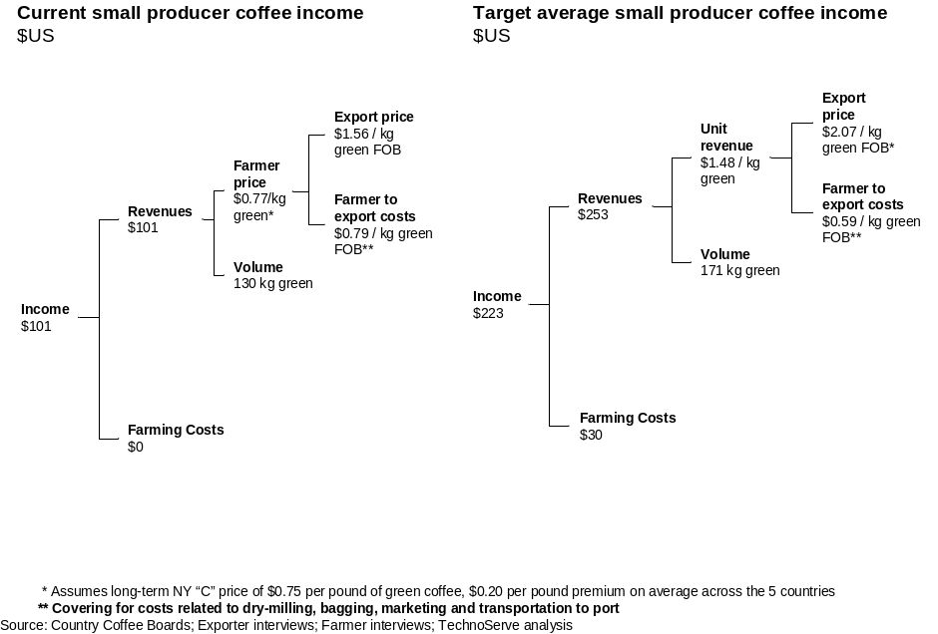

- Specialty coffee prices tend to be less volatile
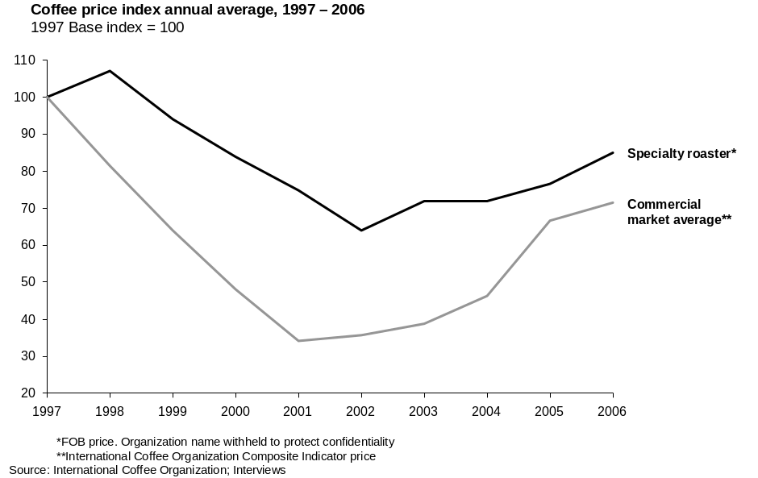

An Opportunity Exists to Help 1 million East African Smallholder Farmers
Much of the demand for incremental specialty coffee over the next 12 years will be filled from existing sources such as Colombia (see Exhibit 15). Nevertheless, industry sources confirm that of the projected 10 million bags required, it is reasonable to assume East Africa could provide 2 million bags. There are approximately 3 million smallholder coffee farmers in the five countries mentioned above with the appropriate agro-climatic conditions for specialty coffee (see Exhibit 16). Assuming a potential annual production of approximately 170 kg per farmer of green coffee implies a market opportunity for approximately 1 million smallholder farmers to upgrade their current coffee quality to achieve market premiums. The project will therefore penetrate approximately one third of the potential population.

- Colombia is the world’s major producer of specialty coffee
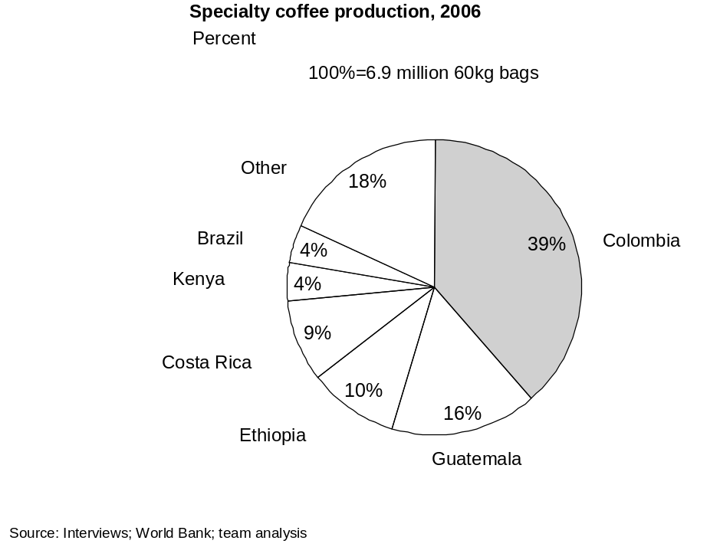

- Annual gross income per East African Arabica farmer
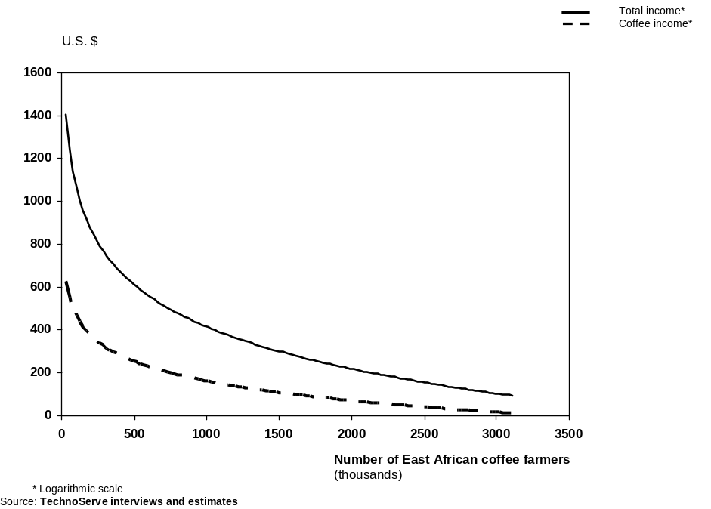

Quality is the Key
Specialty coffee requires more rigorous business practices than those needed for traditional commodity coffee markets. There are three main requirements: high-quality cherry from the farm; high-quality processing and consistent delivery. For these requirements to be met, three changes are required to business as usual:
- A price mechanism which rewards farmers for quality. This provides the right financial incentives for farmers to undertake the additional cost and effort to deliver high-quality cherry
- A well-run mechanical processing business which has the business systems and quality systems in place to process high-quality cherry without destroying value
- Business processes and procedures that ensure consistent delivery.
These changes represent a departure from current practices. In a traditional commodity coffee setting, coffee is aggregated with few price distinctions or processes in place that can reward high-quality coffee over lower-quality coffee. Coffee in many cases is processed manually, rather than mechanically, and without quality control systems. This results in lower and more variable quality. In a commodity setting, a certain level of tolerance exists for quality variation. Specialty markets require more specific cup profiles with lower tolerance for variation.
These more rigorous practices are not in place throughout much of East Africa for understandable reasons. Until very recently, the specialty coffee segment represented a small niche of the coffee industry. It is only in the past ten years that the segment has grown to a size to be of considerable interest to a broad population of East African smallholder coffee farmers.
Coffee is Not the Only Answer
While this opportunity makes sense, it does not suggest that smallholder farmers should specialize in coffee at the exclusion of other crops. Given the uncertainty of markets, climate, crop disease, and policy, a diversified portfolio of income opportunities reduces risk and may maximize income for smallholder farmers. Importantly, this proposal does not require farmers to shift land allocation into coffee. The impact described assumes that yield is increased from existing coffee trees by improved agronomic practices, and that the price received rises. Bananas or dairy, for example, may provide similar income on a per hectare basis (depending on fluctuating market prices) and also provide opportunities for income improvement.
East Africa May Miss this Opportunity
East Africa has the potential to supply the specialty market; however, the outcome is not assured. There is widespread agreement at an industry and government level in East Africa on the nature of this opportunity, and many initiatives have been undertaken to capitalize on the growing specialty market. These initiatives include efforts to replace aging trees, reform pricing mechanisms and government auctions, and encourage mechanical processing. These initiatives are generally complementary to TNS’s approach; however, in TNS’s experience it is easier to find funding to build plant capacity (in this case mechanical processing capacity) than to ensure that these businesses have a sustainable and efficient business model. Without the right business systems, quality systems, and management skills in place (whether the business is privately owned or a cooperative), the success of these efforts may be short-lived as working capital evaporates and plants either continue to operate inefficiently at low levels of utilization or are abandoned. TNS has observed this outcome many times in various industries and developing countries.

International Coffee Organization (ICO)
TNS estimate
TNS estimate
Several other nations also have potential; however, they have either limited volumes (Uganda, Malawi, Zambia) or political challenges (Democratic Republic of Congo).
TNS estimate
7.3 million metric tons 2006/07 estimate. Source: International Coffee Organization (ICO)
In Burundi, Ethiopia and Rwanda, coffee is the leading foreign exchange earner, representing approximately 60%, 37% and 30% of total export earnings, respectively.
79 million bags in 2006/07. Source: FAO
43 million bags in 2006/07. Source: FAO
TNS estimate
Nestle’s gourmet Nespresso division has enjoyed 30% top-line growth over the past 5 years. Source: Nestle
Los Angeles Times June 11, 2006
Nestle
Costa Rica’s specialty coffee exports may decline over the next decade due to economic incentives for real estate development in coffee regions

