# ⟨B|raket|S⟩

### Created by Chris Ferrie

**2 PLAYERS | AGE 10+ | 15 MINUTES**

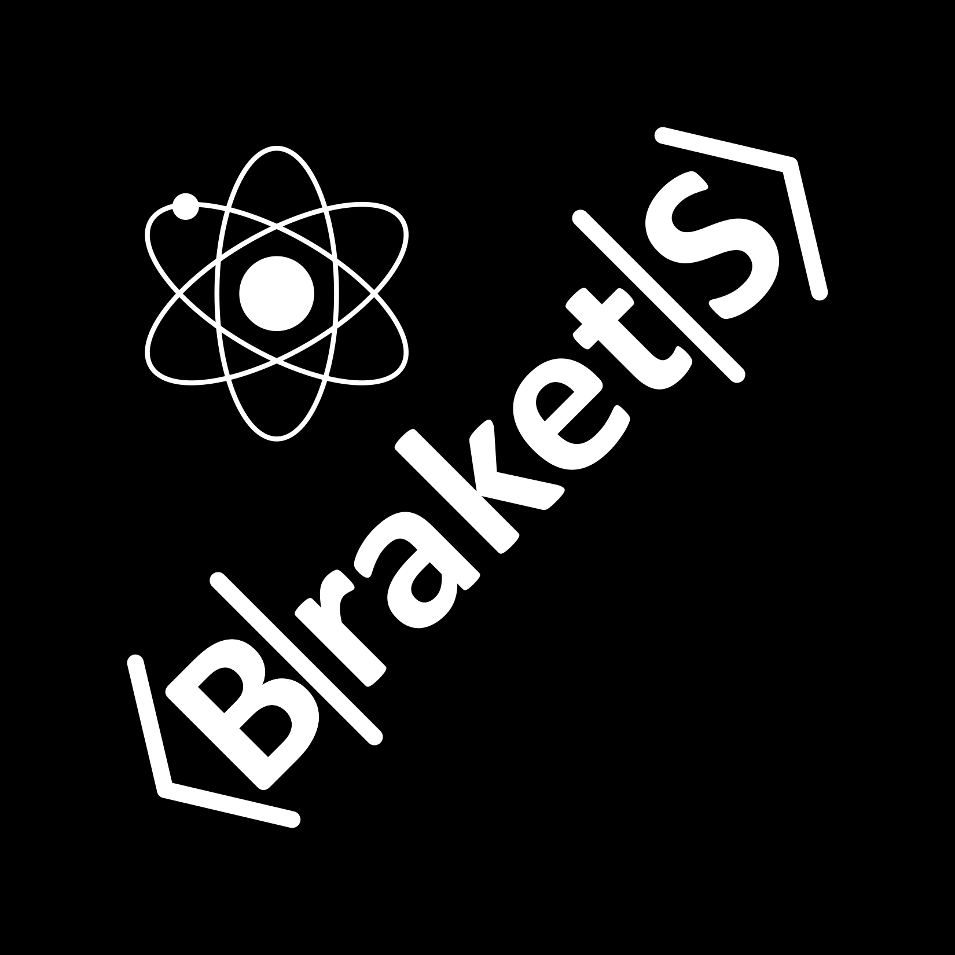

Welcome to ⟨B|raket|S⟩! The object is to close **brakets**, the tools of the quantum mechanic! You’ll need to create these quantum brakets to maximize your probability of winning. But, just like quantum physics, there is no complete certainty of the winner until the **measurement** is made!

No knowledge of quantum mechanics is require to play the game, but you will learn the calculus of the quantum as you play. Later in the rules, you’ll find out how your moves line up with the laws of quantum physics.

# Set-up

**What you need:** A deck of ⟨B|raket|S⟩ cards, a coin, and a way to keep score.

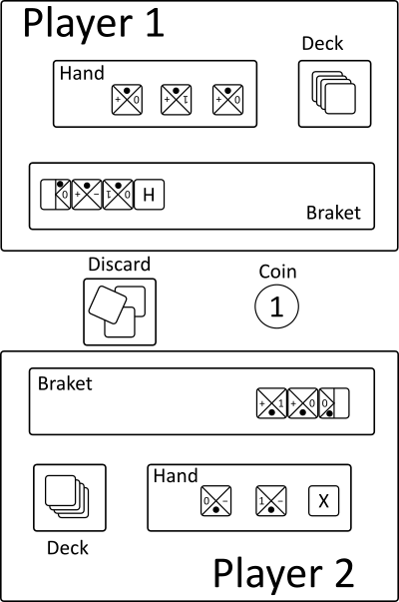

Set aside the two end zero **kets**  and the zero **bra**  cards.

Shuffle the deck and split the remaining cards between each player. Split the zero bra cards and shuffle them into each player’s deck. Each player sets their deck aside face down.

Each player always has 3 face up cards in their hand.

Each player has a braket space. This is the play area. Each player’s zero kets  remains in the play area for the entire game.

The coin and discard pile are common to both players.

# Quick Start

Flip the coin to decide who will start.

You may play on either player’s braket. Generally speaking, the **goal** is to *make your braket as long as possible* and/or *close the other player’s braket as soon as possible*.

Alternate turns until one braket is closed.

When a braket is closed with a zero bra , the coin determines who wins a victory point.

The player with the closed braket flips the coin. Suppose it is you, the one reading this. Count the number of **amplitudes**. For example, this case  has 3. Flip the coin that many times. If, and only if, each toss comes up 0 (or tails), your opponent wins the point. Otherwise, you win the point.

Discard all cards on your braket except your zero ket.

Continue playing until all zero bra cards have been played. The player with the most victory points wins.

# Rules

## Quantum Rules

⟨B|raket|S⟩ teaches you the rules of quantum mechanics. What are those rules? Here’s the summary.

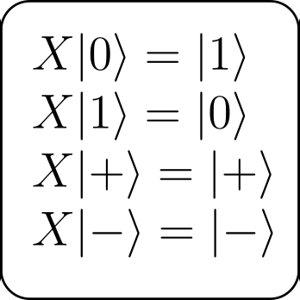

First, the *identity block*  does nothing. That’s it. The other lettered blocks change kets. So you have to be careful! The *X block*  is often called the bit-flip operator. It swaps the |0⟩ and |1⟩ kets, but it does nothing to |+⟩ and |-⟩ kets.

Similarly, the *Z block*  does the equivalent thing to the opposite states. That is, it flips the |+⟩ and |-⟩ kets and does nothing to the |0⟩ and |1⟩ kets. Some terminology: |0⟩ and |1⟩ together are called a basis. And, |+⟩ and |-⟩ are a different basis. We’ll see in a moment what that means. But first...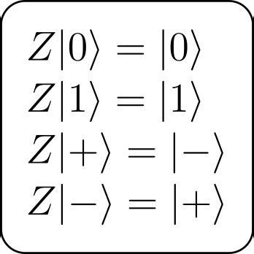

The *H block*  does something a bit different in switching the bases. That is it turns |0⟩ to |+⟩ and |1⟩ to |-⟩, and vice versa. The lettered blocks don’t close kets to make brakets. For that you need the blocks with ket-bras. Some of these blocks have pairs from the same basis  and some do not 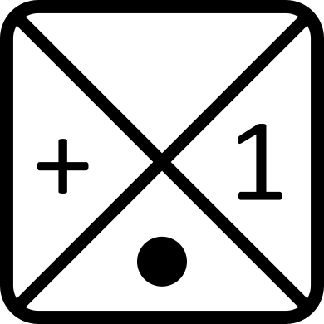.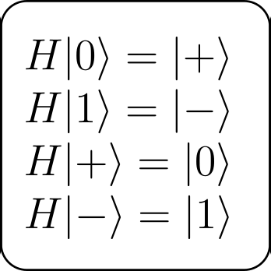

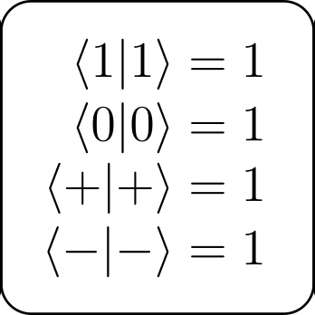

In some sense, the pair on the block is not so important. It’s what the block is connected to that matters. The connection is called an **amplitude**. If a block is touching another block with the same symbol, nothing happens. In the calculus, the amplitude has a value of 1. And, since we a multiplying numbers, multiplying by 1 does nothing.

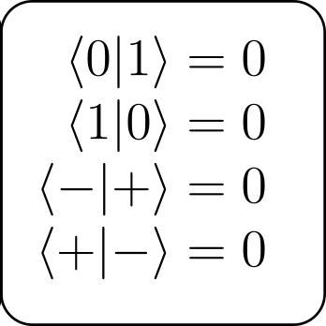

Now, the opposite is true when the block connects with a pair from the same basis. In this case, the basis symbols are known as *orthogonal*. This means they completely cancel! In ⟨B|raket|S⟩, this is generally a bad idea. But perhaps you might find some strategy for it.

The pairs that do all the work in ⟨B|raket|S⟩ are the connections between symbols from different basis. When an amplitude is created from any pair of the four combinations of symbols, the answer is ½. When a braket is finally closed with a *0 bra* , you simply count up the number of these amplitudes with pairs from opposite bases. For example,  has 3 such brakets. In this case, the final product is ⅛.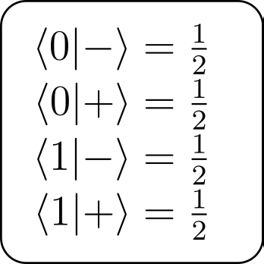

## Probability

This number, the final product, is the probability that *your opponent wins*. It will sometimes be 1, in which case, too bad for you! If the probability that your opponent wins is 1, then they win—it’s certain. Otherwise the probability will be less than 1. In fact, it will always be a multiple of ½.

If a braket is closed, for example this one , and equals ½, then each player has a 50:50 chance of winning—a probability of ½! How do you reconcile a 50:50 bet? You toss a coin, of course. If the coin lands tails (which represents our 0 quantum state), then your opponent wins.

Now here is where the math comes in. This braket  has the value ¼. How do reconcile a 3:1 bet, or an event with ¼ probability? Well, what is the probability of two tosses of a coin landing tails *both* times. There are four possibilities and this is one of them. So, the probability is ¼. This is exactly what you do in ⟨B|raket|S⟩ as well. If your braket has the value ¼, then you flip the coin twice and your opponent wins if both tosses come up tails.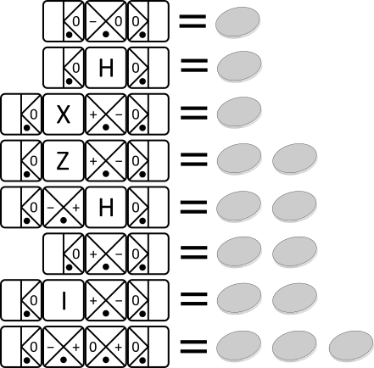

Every time the probability (the value of the braket) *halves*, you toss the coin one extra time—¼ is two tosses and ⅛ is three tosses and so on. If each and every coin toss comes up tails, your opponent wins. With three tosses, for example, three tails is a ⅛ chance event.

At the right are some examples of how to calculate how many coins to flip.

## 

## Play summary

1. Set-up the board area as above.
2. Remove the two  cards and 10  cards. Shuffle the rest of the cards and split them between the players. Each player gets one  which remains in play the entirety of the game. The 5  get shuffle into each player’s deck.
3. Play begins with a single  on each player’s braket space.
4. Each player removes the top three cards and places them face-up in their hand. After making a move, replace the card with the top card from your deck. There should always be 3 cards in your hand, unless your deck is empty.
5. Players take turns placing one card from their hand to either player's braket.
6. Play continues until one of the brakets is closed with a .
7. When a braket is closed, the players agree how many closed amplitudes **from different bases** exist in the braket. Suppose it is three, as in this example .
8. The player whose braket is closed flips the coin that many times. If the outcome of every coin toss is 0, the other player wins a point.
9. Discard all cards except  and continue play until all 10  are used. The player with the most points wins.

## Invalid moves

1. The cards have an orientation. The dot must face the player whose braket it appears on.
2. You may not zero out your own braket by creating an orthogonal amplitude. (You lose a victory point if you zero your opponents braket, but maybe there is an advantage to doing so anyway.)

Endnotes

License: this work is licensed under a [Creative Commons Attribution-NonCommercial-ShareAlike 4.0 International License](http://creativecommons.org/licenses/by-nc-sa/4.0/).

Disclaimer: we have taken some liberties with the rules of quantum physics above. Nothing conceptually major, but the numbers are not technically correct. In real quantum calculations there are more minus signs and square roots. But, that just makes things needlessly complicated for ⟨B|raket|S⟩. And, you’ll still understand the mechanics of how quantum works without the nitty-gritty details. However, **do not use the boxed equations above to complete your quantum homework assignments**!