Question 1. Run Mage
First, let's run Mage with Docker Compose. Follow the quick start guideline.
What's the version of Mage we run?
(You can see it in the UI)

From <https://github.com/DataTalksClub/mlops-zoomcamp/blob/main/cohorts/2025/03-orchestration/homework.md>

v0.9.73

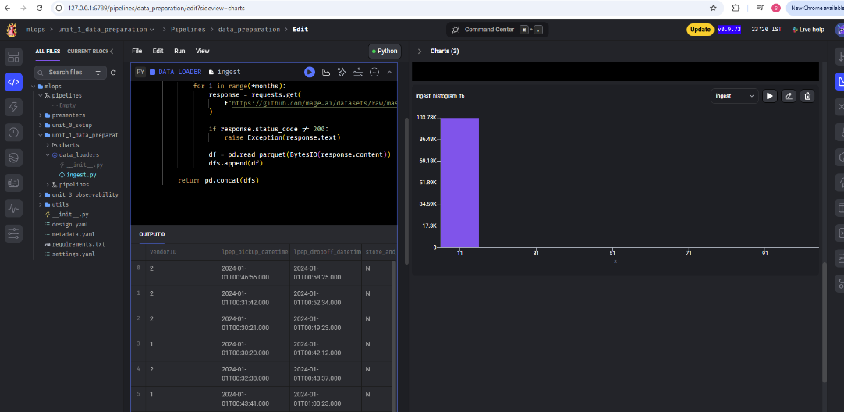

Question 2. Creating a project
Now let's create a new project. We can call it "homework_03", for example.
How many lines are in the created metadata.yaml file?
- 35
- 45
- 55
- 65

From <https://github.com/DataTalksClub/mlops-zoomcamp/blob/main/cohorts/2025/03-orchestration/homework.md>

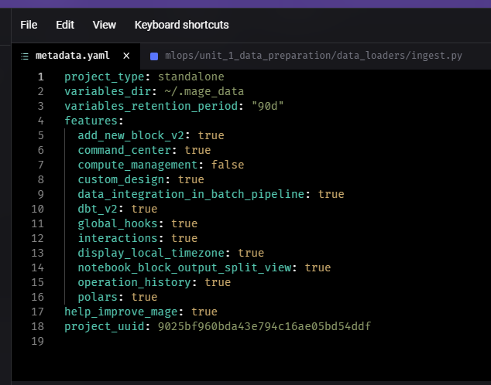

Question 3. Creating a pipeline
Let's create an ingestion code block.
In this block, we will read the March 2023 Yellow taxi trips data.
How many records did we load?
- 3,003,766
- 3,203,766
- 3,403,766
- 3,603,766

From <https://github.com/DataTalksClub/mlops-zoomcamp/blob/main/cohorts/2025/03-orchestration/homework.md>

110128 rows x 20 columns

From <http://127.0.0.1:6789/pipelines/data_preparation/edit?sideview=charts>

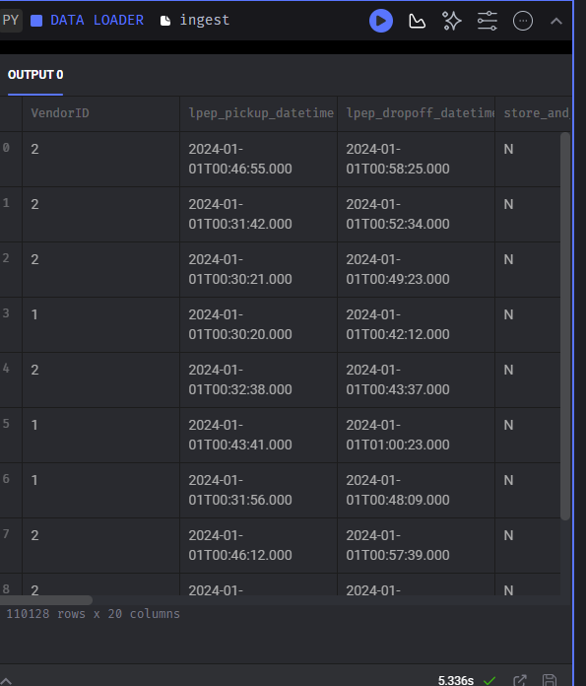
Question 5. Train a model
We will now train a linear regression model using the same code as in homework 1.
- Fit a dict vectorizer.
- Train a linear regression with default parameters.
- Use pick up and drop off locations separately, don't create a combination feature.
Let's now use it in the pipeline. We will need to create another transformation block, and return both the dict vectorizer and the model.
What's the intercept of the model?
Hint: print the intercept_ field in the code block
- 21.77
- 24.77
- 27.77
- 31.77
Question 6

From <https://github.com/DataTalksClub/mlops-zoomcamp/blob/main/cohorts/2025/03-orchestration/homework.md>
Find the logged model, and find MLModel file. What's the size of the model? (model_size_bytes field):
- 14,534
- 9,534
- 4,534
- 1,534

From <https://github.com/DataTalksClub/mlops-zoomcamp/blob/main/cohorts/2025/03-orchestration/homework.md>

