- Setup matlab 32 bit
- Check compiler: setup visual c ++ 2010
- In the matlab command window type run : mex-setup
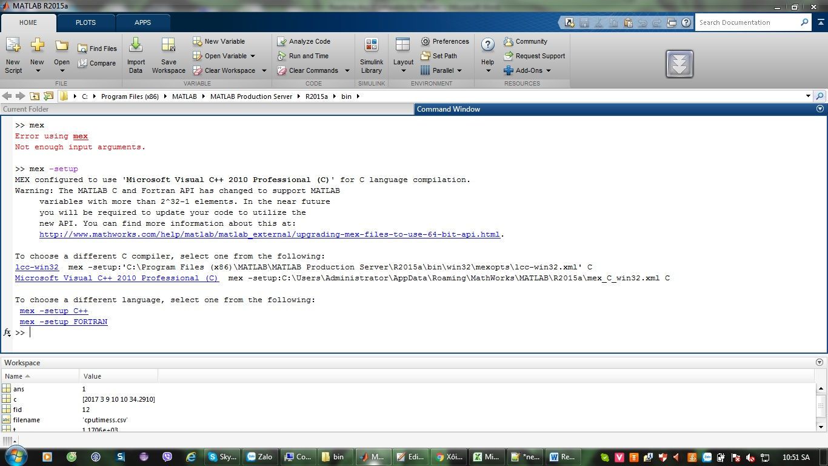
Choose compiler : Microsoft Visual C++ 2010 Professional (C) (just click);
Then choose mex -setup C++

- Check library filepaths in your solution downloaded:
For your 32 bit matlab:
- All dll file must be in bin/win32
- Lib files in lib/win32 folder
- All *.h file in include folder
- Check your license:
If you want to run eeglogger.m, You must be sure the license available to get EEG data. You can get EmotivTool to check the license (https://github.com/Emotiv/community-sdk/tree/master/tools/EmotivTools/Win ):
+ your license is EEG or EEG+PM type
+ Total quota > Total quote used

