What Must Be Trained and What Can Be Prompted: A Per-Capability Study of Tutor Redirect Behavior
Miles Yung — Independent Research (milesyung2026@gmail.com)
Abstract
Deploying a small language model as an English tutor forces a question a flat “good-dialogue” corpus never does: which tutor behaviors can be elicited by an explicit system prompt, and which must be demonstrated through fine-tuning? We answer this per-capability under a matched-prompt protocol — the identical fully-specified prompt given to a fine-tuned 0.8B student and to prompt-only baselines up to a 9B teacher. A sharp boundary emerges (established in Qwen, then replicated in a trained Llama student). Behaviors one clause elicits — locale fidelity, role-swap deflection, topic re-anchoring — reach prompt-only parity. Behaviors the prompt describes but cannot install do not: on persistence (firing a session-end sentinel on the third same-axis violation) the 9B teacher reaches $≤$ 0.06 recall zero/few-shot and only 0.63 with native chain-of-thought (below the student’s 0.83); on pedagogical withholding, prompt-only models manage 0.09–0.45 versus the student’s 0.61. The boundary replicates in a second trained family: a Llama-3.2-1B student, against its own untrained base under the same prompt, reaches 0.91 persistence recall and 0.50 withholding versus 0.25 and 0.11 prompt-only — isolating training from scale. All experiments run on one RTX 3060 12GB GPU.

1. Introduction
Problem. We ask, for each behavior a deployed English tutor needs, whether a sufficiently explicit system prompt is enough or the behavior must be demonstrated in fine-tuning. A deployed tutor is governed by a long system prompt that already states most of what it should do — stay in character, ground culture in the learner’s locale, refuse role swaps, give one short example rather than a grammar lecture, escalate to a session-end signal under sustained abuse. If stating a behavior were sufficient, the data-side problem would be trivial.
Why it matters. It is not: the behaviors split cleanly into ones a prompt clause elicits and ones it only describes, and knowing which is which is exactly the decision a practitioner faces when building a task-specific model on consumer hardware — spend the data budget only where a prompt will not do. The tutor setting makes the question answerable because each target behavior corresponds to a clause already present in a realistic deployment prompt (§3): the language of instruction, lesson topic, role structure, persona, pedagogical contract, locale frame, and general appropriateness.
Gap. The prompting-versus-fine-tuning trade-off has been studied at the level of general alignment — that a small demonstration set installs broad instruction-following (Zhou et al. 2023; Ouyang et al. 2022), and that in-context demonstrations often convey format more than new capability (Min et al. 2022) — but not resolved per behavior for a deployed task model. Synthetic-instruction pipelines and tutor-LLM datasets (§2) target general instruction-following with a uniform recipe; none asks, per behavior, whether the deployment prompt already elicits what the data teaches.
Approach and contributions. We supply the same fully-specified deployment prompt at evaluation to a fine-tuned 0.8B student and to a ladder of prompt-only baselines (0.8B base, 0.8B instruct, 4B instruct, and the 9B teacher that generated the training data; Figure 2). Because the instruction is present for every condition, a prompt-only failure cannot be blamed on under-specification. Our contributions:
- A per-capability map of the train-versus-prompt boundary (Figure 3): promptable when a single clause both describes and elicits the behavior (locale fidelity, role-swap and topic re-anchoring), not promptable when it requires cross-turn state-tracking (persistence) or the suppression of a strong competing prior (pedagogical withholding).
- An evidenced negative result about the conventional metric: per-axis redirect F1 is a context-blind type classifier that ties a 0.8B student with the 9B teacher; we replace it with matched per-capability instruments (§5).
- Reusable apparatus: a locale-aware, yield-aware generation pipeline (§3) and a partially validated trigger-position decorrelation construction for the persistence sentinel (§5).
All experiments run on one RTX 3060 12GB GPU — the regime where the boundary matters most, since a large general-purpose model is not deployable there. We evaluate one family (Qwen; a genuine limitation, §6) and one locale (which does not limit the persistence/withholding boundary, both structural behaviors independent of the locale backdrop).

2. Related Work
Synthetic instruction data. Teacher-to-student bootstrapping was popularised by Self-Instruct (Wang et al. 2023) and Evol-Instruct / WizardLM (Xu et al. 2024); UltraChat (Ding et al. 2023) extends to multi-turn dialogue, and Tulu-3 (Lambert et al. 2024) composes datasets from sub-pools. These target general instruction-following with a uniform recipe and do not ask which taught behaviors a prompt already elicits.
LLM-as-judge filtering. Prometheus (Kim et al. 2024), JudgeLM (Zhu et al. 2023), and PandaLM (Wang et al. 2024) propose dedicated judges; a strand documents position, length, and self-preference bias (Saito et al. 2023; Panickssery et al. 2024), mitigated by multi-judge consensus. Our pairwise eval (§5) follows this with a cross-family constraint so no judge shares the teacher’s lineage; we add a negative result about a judged metric (context-blind redirect F1).
Tutor and educational LLMs. EduChat (Dan et al. 2023) and MathDial (Macina et al. 2023) target educational dialogue; CEFR-aligned corpora (EFCAMDAT (Geertzen et al. 2014), TLE (Berzak et al. 2016)) are learner-produced, not tutor-side. None asks, per behavior, whether the deployment prompt already suffices. MathDial’s scaffolding moves are the closest analogue to our pedagogical-withholding axis.
Safety, persona, and shortcut learning. Adversarial safety data (Parrish et al. 2022; Mazeika et al. 2024; Zou et al. 2023) and persona consistency (Zhang et al. 2018; Deshpande et al. 2023) mostly treat redirection as single-turn. Our three-strike persistence is multi-turn and carries a shortcut-learning (Geirhos et al. 2020; McCoy et al. 2019) risk: a positionally-regular sentinel invites a position-as-trigger shortcut, which our decorrelation construction (§3) targets.
Positioning. The prompting-vs-fine-tuning question has been examined for general alignment (Zhou et al. 2023; Ouyang et al. 2022; Min et al. 2022); we localize it to the per-behavior level for a deployed task model, under a matched-prompt protocol giving the same prompt to trained and prompt-only models alike.

3. Method
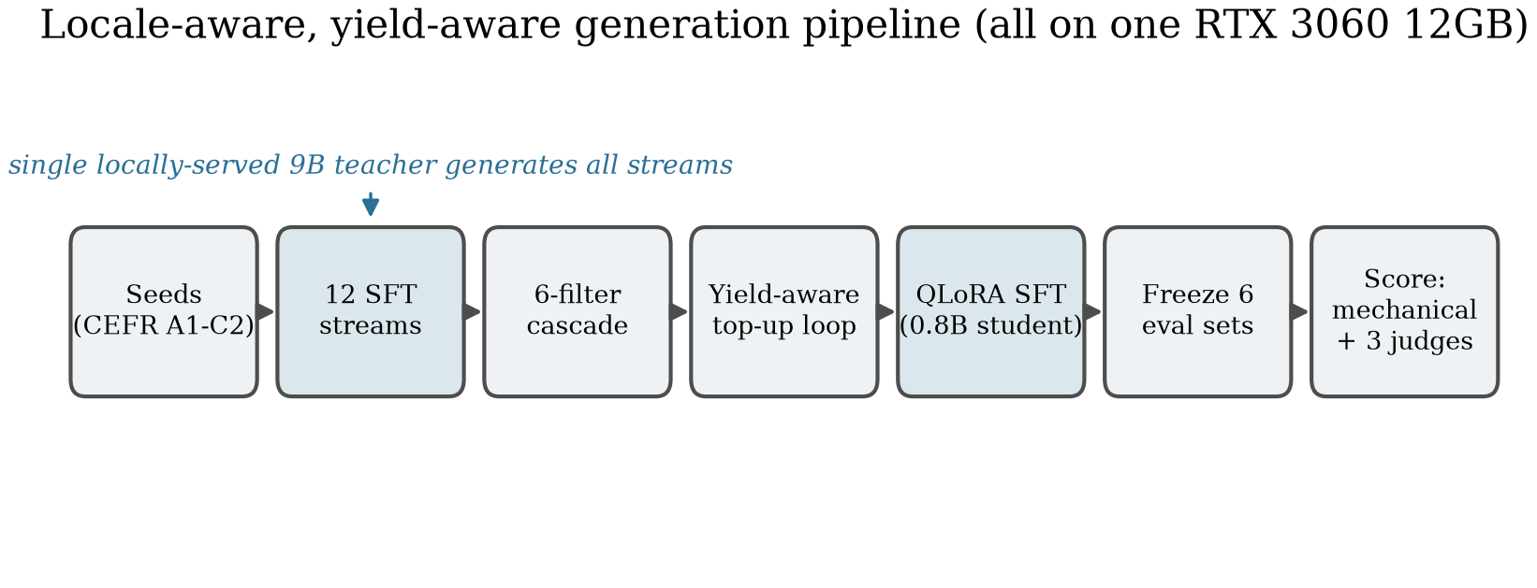
The locale-aware, yield-aware generation pipeline. A single locally-served 9B teacher drives twelve SFT streams; a six-filter cascade and a yield-aware top-up loop shape the corpus, which trains a 0.8B QLoRA student scored on six frozen held-out sets — all on one RTX 3060 12GB.
Pipeline. A single locally-served 9B teacher generates all training data from a pool of CEFR-stratified scenario seeds through twelve parallel SFT streams, a six-filter cascade, and a yield-aware top-up loop (Figure 1). The teacher receives a prompt of exactly the shape the student sees at deployment, so there is no distribution shift between demonstration and inference. Full pipeline mechanics (top-up equations, filter cascade, hash-deterministic split) are in the appendix and the released code.
An invariant-based taxonomy. We read the redirect axes off the deployment prompt rather than intuiting them. A tutor is the keeper of a set of interaction invariants, each corresponding to one commitment the prompt makes; a learner violation breaks exactly one, and the correct redirect is the minimal repair that restores it (Table 1). This makes the axis list auditable (one clause ↔ one axis) and converts “a generic redirect stream is insufficient” into a per-axis falsifiable prediction: specialized data should help exactly on axes whose repair is not already supplied by assistant priors or a prompt clause (§5).
The seven single-shot redirect axes as invariant/violation/minimal-repair triples, read off the deployment prompt.
Invariant / violation | Minimal repair
Language (code-switch to L1) | Acknowledge, steer back to target language
Topic (off-topic drift) | Re-anchor to the subject
Role (“you be the learner”) | Decline, reassert tutoring structure
Persona (“are you a chatbot?”) | Reassert the frame, continue in persona
Pedagogy (“just give the answer”) | Scaffold rather than supply the answer
Locale (out-of-locale reference) | Brief in-locale redirect
Appropriateness (politics/etc.) | Generic safe redirect (catch-all)
The pipeline realises this through twelve streams: normal scaffolded dialogue (1), single-shot redirects (7, one per axis), and persistent 3-strike streams (4, for the axes where repeated violation warrants escalation to a session-end sentinel).
Deployment prompt. Every axis appears as an explicit [guidelines] clause, and a [persistence] block specifies the full three-strike protocol: first warm redirect, second shorter redirect, third a warm sentence plus the exact literal sentinel [SESSION_END: <axis>]. This is what makes the boundary interpretable — when a prompt-only model fails on persistence or withholding (§5), it fails despite the behavior being spelled out.
Trigger-position decorrelation. A fixed-turn sentinel makes turn position a perfect proxy for “third strike,” inviting a positional shortcut. We resample the sentinel turn over a parity-constrained set {5, 7, 9, 11} (hash-deterministic per seed; every variant holds the trigger at exactly three strikes, varying only lead-in scaffolding). We report this as partially validated (§5).

4. Experimental Setup
Models and recipe. Student base Qwen3.5-0.8B-Base; teacher Qwen3.5-9B-UD-Q4_K_XL (4-bit, llama.cpp), which also serves as the strongest prompt-only baseline (B4). All experiments on one RTX 3060 12GB. Every trained condition uses the same recipe — QLoRA (Dettmers et al. 2023) (NF4 4-bit) with LoRA (Hu et al. 2022) rank 16 / alpha 32, 2 epochs, no DPO — so each ablation is single-variable (hyperparameters in the appendix).
Conditions. A1 — the student, full 12-stream mix. A3 — A1 minus the six specialized single-shot redirect streams (the generic-SFT baseline). A5 — A1 with persistence rebuilt fixed-turn-7 (the decorrelation contrast). Prompt-only: B1 0.8B base, B2 0.8B instruct, B3 4B instruct, B4 9B teacher. All see the identical deployment prompt (Figure 2).
Held-out sets (frozen, locale=china): Tutor-Scenario (224), Redirect-Probe (143), and four persistence probes isolating recall (Persistent-Probe, 159 positives) from two false-positive channels (Persistent-FP-Probe benign negatives at trained positions; Persistent-Premature-Probe under-threshold negatives) and off-grid firing (Persistent-OffPosition-Probe).
Metrics. Persistence and locale leakage are mechanical (judge-free): sentinel-firing recall against literal [SESSION_END: <axis>] strings, and Western-default leakage via a word-boundary gazetteer. Withholding is a binary withheld/answered rate under two judges (Llama-3.1-8B, Gemma-2-9B). Repair quality on the promptable axes is a pairwise preference under a cross-family three-judge ensemble (Prometheus / Llama-3.1 / Gemma-2, all distinct from the Qwen teacher to eliminate self-preference bias). The load-bearing A1/A3 conditions are reported over three seeds (42/123/7); others single-seed.

5. Results: The Train-versus-Prompt Boundary
Every condition is evaluated under the same fully-specified deployment prompt (§3), so a prompt-only failure isolates promptability rather than under-specification (Figure 2). The behaviors separate sharply (Figure 3, Table 2).
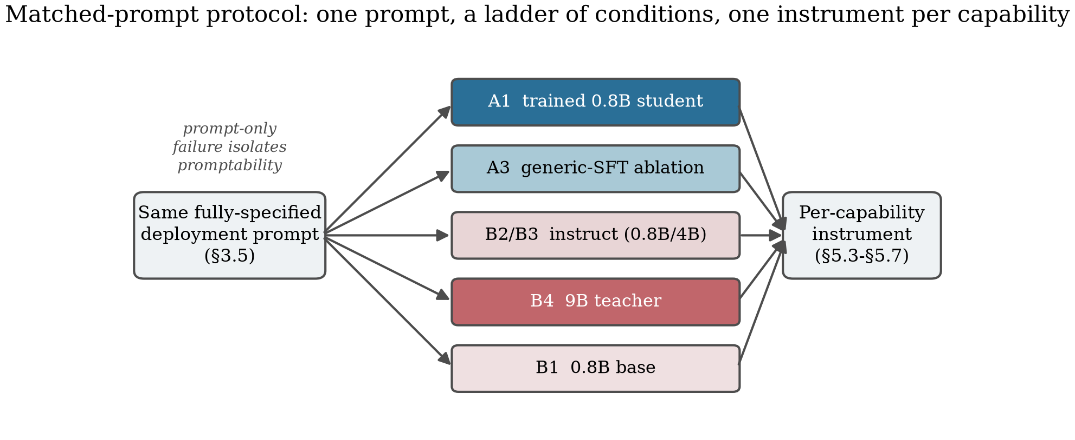
Matched-prompt protocol. The identical deployment prompt is given to a fine-tuned 0.8B student, a generic-SFT ablation, and prompt-only baselines up to the 9B teacher; each is scored by the instrument matched to the capability.
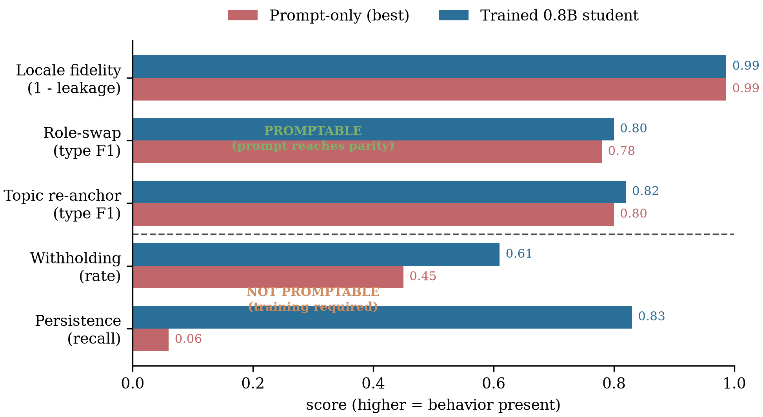
The boundary. Top: behaviors one clause elicits — prompt-only reaches parity. Bottom: behaviors the prompt describes but cannot install — prompt-only falls far short of the trained 0.8B student. Values from Table 2.
The boundary. Top: not-promptable (the 9B teacher and, for persistence, the no-data ablation A3 fail despite the explicit instruction). Bottom: promptable (prompt-only parity). Persistence prompt-only is the 9B teacher’s zero/few-shot recall; native CoT reaches 0.63 (§5.1). Withholding prompt-only spans B1–B4 (9B teacher 0.45).
Capability (metric) | Prompt-only | Trained
Persistence (recall) | $≤$ 0.06 / A3 0.000 | 0.83
Withholding (rate) | 0.09–0.45 | 0.61
Locale (1$−$leakage) | 0.987 | 0.987
Role-swap (type F1) | 0.71–0.86 | 0.75–0.86
Topic (type F1) | saturated | saturated

5.1 Not promptable I — multi-turn persistence
On the third same-axis violation the tutor must emit the exact literal sentinel. Under the fully-specified prompt, no prompt-only model fires it reliably: the 9B teacher reaches $≤0.06$ recall zero/few-shot, and the no-data ablation A3 fires on 0.000 of positives, while every model trained on the persistent streams fires (A1 recall 0.83, 3-seed mean $0.85±0.04$).
The gap is not an artifact of zero-shot prompting. We ran a prompting ladder on the strongest prompt-only model (the 9B teacher; few-shot exemplars span positions {5,7,9,11} so they cannot teach a fixed turn). Table 3 and Figure 4 (left) show few-shot and an output counting-scaffold do not help ($≤0.06$); only Qwen3.5’s native chain-of-thought moves recall, to 0.63 — still below the trained 0.83, and at 1.6–3.2k reasoning tokens/turn with frequent delivery failures (the fire decision is reached inside <think> but omitted from the visible answer). Persistence is thus a relocated boundary: it resists zero/few-shot outright and is only partially recovered by native CoT, at an accuracy, reliability, and inference-cost deficit SFT removes.
Persistence resists prompting up to, but not including, native CoT — and even that stays below the trained student. Recall on Persistent-Probe positives (n=159).
9B teacher prompting condition | recall
zero-shot instruction | 0.025
+ few-shot exemplars | 0.013
+ CoT output scaffold (no-think) | 0.057
+ native chain-of-thought | 0.63
A1 trained 0.8B (reference) | 0.83
Decorrelation, partially validated. In an isolated matched contrast (A1 4-variant vs A5 fixed-turn-7, 1-epoch budget), decorrelation removes the positional recall bias — the fixed-turn design recalls best at its trained turn 7 and degrades off-position (overall 0.56), while the 4-variant fires uniformly across positions (0.82) — but does not reduce premature firing (0.208 vs 0.119). At 0.8B the premature over-firing tracks accumulated violation count and conversation depth (peaking at turn 9, not the trained 7), so it is threshold-laxity, not a positional shortcut for decorrelation to suppress.

5.2 Not promptable II — pedagogical withholding
The tutor must withhold the requested answer and scaffold instead, an instruction the prompt states explicitly. We score 63 held-out probes under two judges (Table in Figure 4, right). The trained student withholds at 0.61; the no-specialized-data ablation A3 collapses to 0.12, near the untrained-base rate — clean evidence the behavior is installed by demonstration (A1-vs-A3 clears significance under each judge, $z=5.9$ / $5.6$, $p≪0.001$). Every prompt-only model, including the 9B teacher (0.45), withholds less than the trained 0.8B student despite the identical instruction: a model an order of magnitude larger, told plainly to scaffold, complies on under half of probes. (The student-beats-teacher comparison is directional only at n=63; the boundary rests on the teacher’s absolute non-compliance and the A3 ablation.) Scaffolding requires suppressing the model’s strong helpfulness prior — a clause can describe that suppression but not produce it.
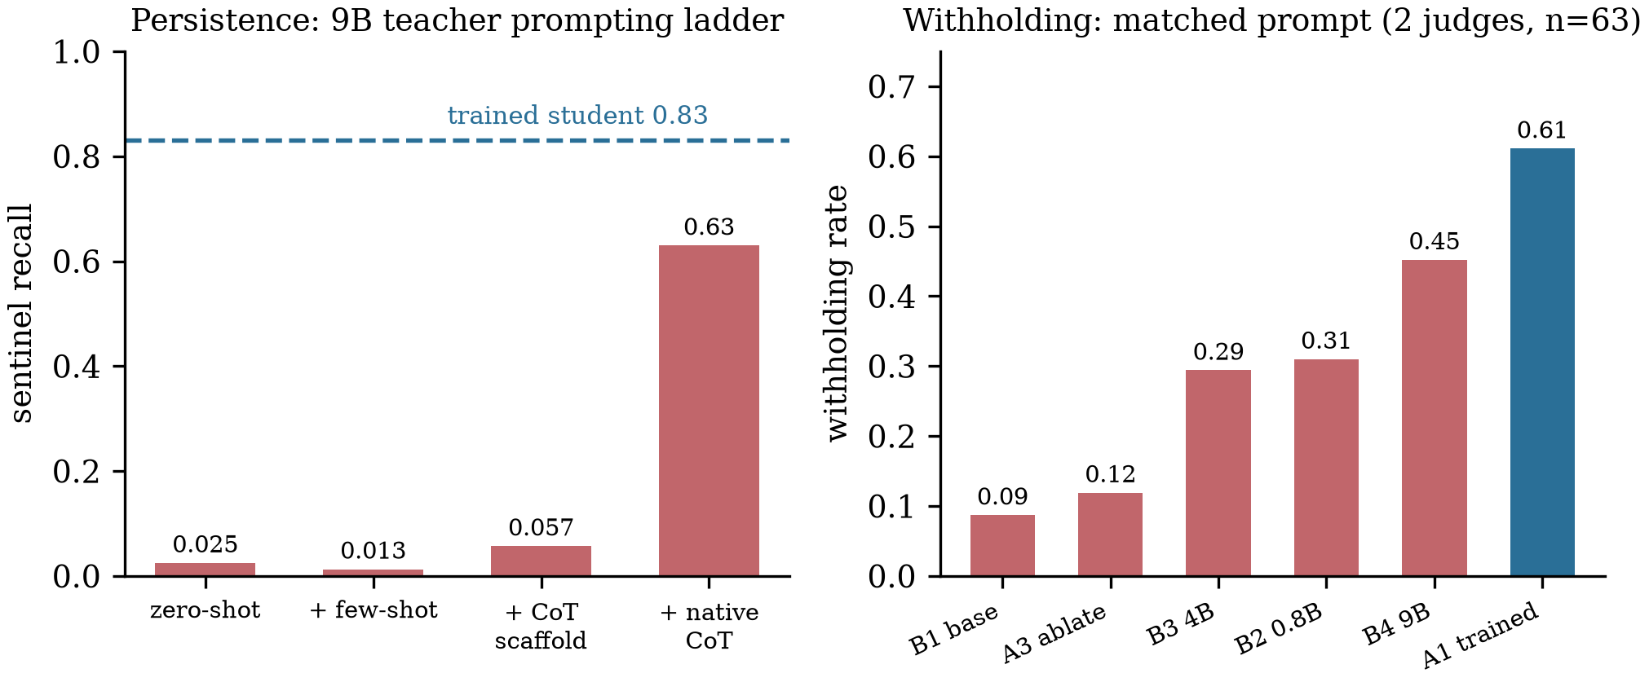
The two not-promptable behaviors. Left: on persistence, the 9B teacher stays at $$0.06 through few-shot and an output CoT scaffold; only native CoT moves it, to 0.63 — still below the trained 0.83 (dashed). Right: on withholding, every prompt-only condition (incl. the 9B teacher, 0.45) falls below the trained 0.61, and the no-data ablation A3 collapses to baseline.

5.3 Promptable axes — type is prompted, quality is refined
Redirect-axis F1 from a context-blind judge is uninformative: it is a type classifier that floors on axes with no context-free surface form (locale, language, topic) and ceilings on axes every model satisfies (persona, role-swap), tying A1, B2, and the 9B teacher at 0.409. We therefore score quality on the promptable axes with a pairwise preference (A1 vs A3, both SFT-only, differing only in the specialized streams). Every axis favors A1; the largest effect is role-swap (win-rate 0.87) — on an axis F1 called saturated parity, so the F1 ceiling concealed a real, large specialized-data effect. A generic-redirect negative control (both conditions train on it) sits at 0.55, so the wins are axis-specific, not a global “A1 is better” artifact. Locale fidelity is prompt-driven: Western-default leakage is statistically indistinguishable across trained and prompt-only models (A1 1.34%, A3 0.89%, B1 1.34%), and ablating the locale stream does not increase leakage — it is carried by one prompt clause.

6. Discussion and Conclusion
Under a matched-prompt protocol, tutor redirect behaviors separate along an interpretable line: promptable when a single clause both describes and elicits the behavior, and not promptable when it requires cross-turn state-tracking (persistence) or the suppression of a strong competing prior (withholding) — things a clause can name but not produce. The boundary tells a deployer of a small model which behaviors a prompt gives for free (locale, role-swap, topic) and which require the pipeline (persistence, withholding). Reaching it cleanly required retiring the conventional context-blind redirect-axis F1 — a type classifier that ties a 0.8B student with a 9B teacher — for matched per-capability instruments, which recover the largest specialized-data effect in the study (role-swap quality, win-rate 0.87) on an axis F1 called saturated parity.
Cross-family replication. The boundary is not a Qwen artifact: it replicates in a second trained family. A Llama-3.2-1B student, evaluated against its own untrained base under the identical prompt, lifts both not-promptable behaviors far above prompt-only — persistence recall 0.25$$0.91,withholding0.11$$0.50(twojudges)—isolatingtrainingfromscale,sincestudentandcontrolshareonebase.AlargerLlama−3.1−8Bprompt−onlyprobestayslowevenwithchain−of−thought(persistence0.27$$0.55; withholding 0.22–0.32). The boundary’s direction is robust across families; the magnitude is family-dependent (Llama trained withholding 0.50 vs Qwen 0.61, and Llama attains more prompt-only persistence than the Qwen teacher). One asymmetry: the Llama student trains from an instruct checkpoint, since Llama-3.2-1B-Base could not learn the rare turn-end token under LoRA-SFT.
Threats to validity. Single locale does not threaten the central boundary: persistence and withholding are structural behaviors independent of the locale backdrop. Judged-metric power: the trained-vs-teacher withholding gap is directional at n=63; the strong claim is the teacher’s absolute sub-50% compliance. Decorrelation is partially validated (fixes positional recall, not premature firing).
Future work, in priority order: (i) broader cross-family replication (a third family, a base-checkpoint student, multi-locale) — the trained Llama student above establishes the boundary in a second family; breadth remains; (ii) larger-scale decorrelation, where the positional route is cheaper relative to the semantic one; (iii) a better-powered pedagogy teacher comparison; and (iv) transfer of the matched-prompt methodology to other rare, semantically-triggered markers (refusal-token and tool-call emission), where the same “describable but not promptable” question applies.
Conclusion. Which tutor behaviors must be trained and which can be prompted is answerable per capability, and the answer is sharp: a prompt clause installs a behavior only when it both describes and elicits it. Persistence and pedagogical withholding are described by the prompt but installed only by demonstration — the central finding, established on a single consumer GPU where the distinction matters most.

Ethics and data statement
All training and evaluation data are model-generated (distilled from a locally-served teacher) and contain no personal data or PII; no human subjects were involved. The intended use is research on data curation and the train-versus-prompt boundary for small task-specific models.

Code and Data Availability
Code, training/evaluation scripts, configuration, and the synthetic training/evaluation datasets are available at https://github.com/cch-ai922/tutor-train. The released datasets are model-generated (teacher-distilled) and contain no personal data. A full-length version of this paper reports the per-capability statistics and the complete confound analysis.

A. Reproducibility and Hyperparameters
Training. QLoRA (Dettmers et al. 2023) (NF4 4-bit, double-quant, bfloat16) with LoRA (Hu et al. 2022) rank 16, alpha 32, dropout 0.05 over the seven linear projections of the language tower; 2 epochs, peak LR $2×{10}^{−4}$ cosine, effective batch 8, max sequence length 1792, paged_adamw_8bit, SDPA attention. No DPO enters any condition. Teacher served via llama.cpp (context 32 768, 80 GPU layers); teacher and trainer are swapped since they cannot co-reside on 12 GB.
Persistent-variant codomain. Sentinel positions {5,7,9,11} are forced: dialogues open on a learner turn (only odd positions valid), with $≥5$ to fit three strikes and two probes and $≤11$ to stay under the 1792-token cap. Variant assignment int(sha256(seed_id)[:8]) % 4 is seeded (not random) so re-generation is stable and the train/eval split stays coherent.
Pipeline filters. Six filters run cheap-to-expensive: five mechanical (script, banned terms, schema, naturalness) then one LLM-judge (locale_judge). An audit of the locale_judge found ~85% false positives on its rejections (common English sentence-initial words, locally-canonical landmarks), remediable with static allowlists (global pass rate 70.1% $→$ 88.4%) — a reusable caution for any capitalization-based entity filter.
Artifacts. One Python codebase; generation driven by config/generation.yaml, training by per-condition YAMLs, the six held-out sets frozen by scripts/build_eval_sets.py. The full-length version of this paper reports the per-capability statistics, the F1-bimodality negative result, and the complete confound analysis.
Code and Data Availability. All code, training configurations, seeds, frozen evaluation sets, judge prompts, synthetic datasets, and per-condition score outputs are released at https://github.com/cch-ai922/tutor-train, with a reproducibility/ guide mapping each result to the script and config that produce it. Trained adapters are deltas over the public base models (Qwen3.5-0.8B-Base; Llama-3.2-1B-Instruct) and are available on request.
Berzak, Yevgeni, Jessica Kenney, Carolyn Spadine, et al. 2016. “Universal Dependencies for Learner English.” Proceedings of the 54th Annual Meeting of the Association for Computational Linguistics (Volume 1: Long Papers) (Berlin, Germany), 737–46. https://doi.org/10.18653/v1/P16-1070.
Dan, Yuhao, Zhikai Lei, Yiyang Gu, et al. 2023. “EduChat: A Large-Scale Language Model-Based Chatbot System for Intelligent Education.” arXiv Preprint arXiv:2308.02773.
Deshpande, Ameet, Vishvak Murahari, Tanmay Rajpurohit, Ashwin Kalyan, and Karthik Narasimhan. 2023. “Toxicity in ChatGPT: Analyzing Persona-Assigned Language Models.” Findings of the Association for Computational Linguistics: EMNLP 2023 (Singapore), 1236–70.
Dettmers, Tim, Artidoro Pagnoni, Ari Holtzman, and Luke Zettlemoyer. 2023. “QLoRA: Efficient Finetuning of Quantized LLMs.” Advances in Neural Information Processing Systems 36 (NeurIPS 2023).
Ding, Ning, Yulin Chen, Bokai Xu, et al. 2023. “Enhancing Chat Language Models by Scaling High-Quality Instructional Conversations.” Proceedings of the 2023 Conference on Empirical Methods in Natural Language Processing (EMNLP) (Singapore).
Geertzen, Jeroen, Theodora Alexopoulou, and Anna Korhonen. 2014. “Automatic Linguistic Annotation of Large Scale L2 Databases: The EF-Cambridge Open Language Database (EFCAMDAT).” Selected Proceedings of the 2012 Second Language Research Forum (SLRF) (Somerville, MA).
Geirhos, Robert, Jörn-Henrik Jacobsen, Claudio Michaelis, et al. 2020. “Shortcut Learning in Deep Neural Networks.” Nature Machine Intelligence 2 (11): 665–73. https://doi.org/10.1038/s42256-020-00257-z.
Hu, Edward J., Yelong Shen, Phillip Wallis, et al. 2022. “LoRA: Low-Rank Adaptation of Large Language Models.” The Tenth International Conference on Learning Representations (ICLR).
Kim, Seungone, Juyoung Suk, Shayne Longpre, et al. 2024. “Prometheus 2: An Open Source Language Model Specialized in Evaluating Other Language Models.” Proceedings of the 2024 Conference on Empirical Methods in Natural Language Processing (EMNLP) (Miami, Florida, USA), 4334–53.
Lambert, Nathan, Jacob Morrison, Valentina Pyatkin, et al. 2024. “Tulu 3: Pushing Frontiers in Open Language Model Post-Training.” arXiv Preprint arXiv:2411.15124.
Macina, Jakub, Nico Daheim, Sankalan Pal Chowdhury, et al. 2023. “MathDial: A Dialogue Tutoring Dataset with Rich Pedagogical Properties Grounded in Math Reasoning Problems.” Findings of the Association for Computational Linguistics: EMNLP 2023 (Singapore), 5602–21.
Mazeika, Mantas, Long Phan, Xuwang Yin, et al. 2024. “HarmBench: A Standardized Evaluation Framework for Automated Red Teaming and Robust Refusal.” Proceedings of the 41st International Conference on Machine Learning (ICML), Proceedings of machine learning research, vol. 235: 35181–224.
McCoy, R. Thomas, Ellie Pavlick, and Tal Linzen. 2019. “Right for the Wrong Reasons: Diagnosing Syntactic Heuristics in Natural Language Inference.” Proceedings of the 57th Annual Meeting of the Association for Computational Linguistics (ACL) (Florence, Italy), 3428–48.
Min, Sewon, Xinxi Lyu, Ari Holtzman, et al. 2022. “Rethinking the Role of Demonstrations: What Makes in-Context Learning Work?” Proceedings of the 2022 Conference on Empirical Methods in Natural Language Processing (EMNLP).
Ouyang, Long, Jeffrey Wu, Xu Jiang, et al. 2022. “Training Language Models to Follow Instructions with Human Feedback.” Advances in Neural Information Processing Systems (NeurIPS).
Panickssery, Arjun, Samuel R. Bowman, and Shi Feng. 2024. “LLM Evaluators Recognize and Favor Their Own Generations.” Advances in Neural Information Processing Systems 37 (NeurIPS 2024).
Parrish, Alicia, Angelica Chen, Nikita Nangia, et al. 2022. “BBQ: A Hand-Built Bias Benchmark for Question Answering.” Findings of the Association for Computational Linguistics: ACL 2022 (Dublin, Ireland), 2086–105.
Saito, Keita, Akifumi Wachi, Koki Wataoka, and Youhei Akimoto. 2023. “Verbosity Bias in Preference Labeling by Large Language Models.” arXiv Preprint arXiv:2310.10076.
Wang, Yidong, Zhuohao Yu, Zhengran Zeng, et al. 2024. “PandaLM: An Automatic Evaluation Benchmark for LLM Instruction Tuning Optimization.” The Twelfth International Conference on Learning Representations (ICLR).
Wang, Yizhong, Yeganeh Kordi, Swaroop Mishra, et al. 2023. “Self-Instruct: Aligning Language Models with Self-Generated Instructions.” Proceedings of the 61st Annual Meeting of the Association for Computational Linguistics (Volume 1: Long Papers) (Toronto, Canada), 13484–508. https://doi.org/10.18653/v1/2023.acl-long.754.
Xu, Can, Qingfeng Sun, Kai Zheng, et al. 2024. “WizardLM: Empowering Large Pre-Trained Language Models to Follow Complex Instructions.” The Twelfth International Conference on Learning Representations (ICLR).
Zhang, Saizheng, Emily Dinan, Jack Urbanek, Arthur Szlam, Douwe Kiela, and Jason Weston. 2018. “Personalizing Dialogue Agents: I Have a Dog, Do You Have Pets Too?” Proceedings of the 56th Annual Meeting of the Association for Computational Linguistics (Volume 1: Long Papers) (Melbourne, Australia), 2204–13.
Zhou, Chunting, Pengfei Liu, Puxin Xu, et al. 2023. “LIMA: Less Is More for Alignment.” Advances in Neural Information Processing Systems (NeurIPS).
Zhu, Lianghui, Xinggang Wang, and Xinlong Wang. 2023. “JudgeLM: Fine-Tuned Large Language Models Are Scalable Judges.” arXiv Preprint arXiv:2310.17631.
Zou, Andy, Zifan Wang, Nicholas Carlini, Milad Nasr, J. Zico Kolter, and Matt Fredrikson. 2023. “Universal and Transferable Adversarial Attacks on Aligned Language Models.” arXiv Preprint arXiv:2307.15043.

