ECE 4429

Lab section 003

Due Wednesday, October 7, 2020

Chandan Chandel

250914472

Sampling Experiments:

* 1. A sharp noise was observed when playing the signal sampled at 8000 Hz. Below is the plot for the sampled signal.

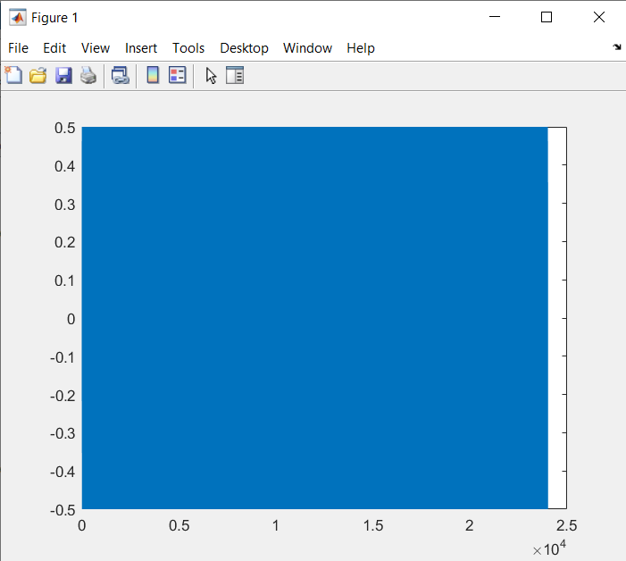

* 1. A sharp noise was observed when playing the signal sampled at 3000 Hz. Below is the plot for the sampled signal.

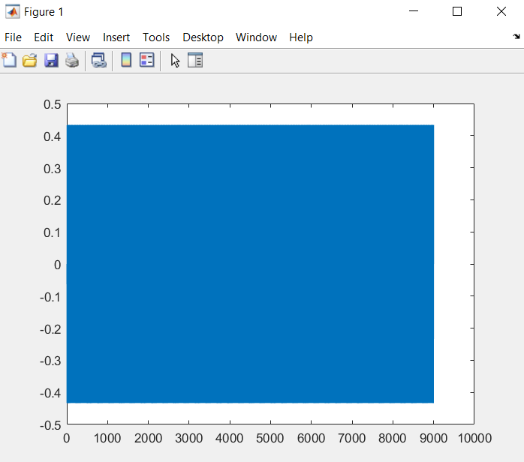

The signal sampled at 8000 Hz had a higher pitch than the signal sampled at 3000 Hz. This is to believed to have happened because the higher sampling frequency of 8000 Hz in the first signal resulted in a higher frequency noise output than in the second signal, which had a lower sampling frequency of 3000 Hz.7

1. The commented Matlab script is included below. Spectrogram displayed a signal at 1 kHz for the 1 kHz signal. It also displayed a signal at 1 kHz for the 7 kHz signal. This is believed to have occurred since both frequencies were sampled at 8 kHz, and although this sampling frequency resulted in a non-aliased signal of the 1 kHz signal, it resulted in aliasing while sampling the 7 kHz frequency since 8 kHz is more than double the 1 kHz frequency, but not more than double the 7 kHz frequency. Spectrogram did not display a signal for the 4 kHz signal since that signal is at the edge of the Nyquist interval. The plotted frequencies are included below.

1000 Hz

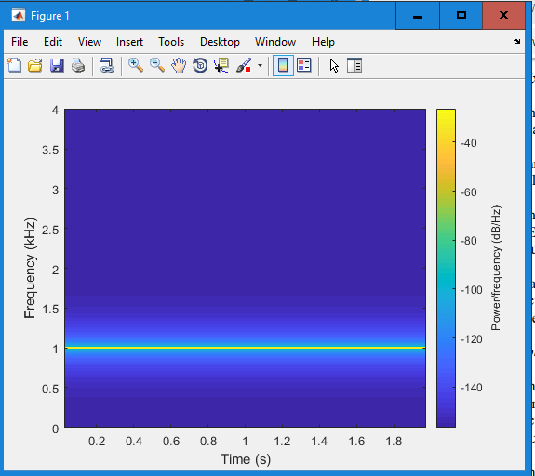

4000 Hz

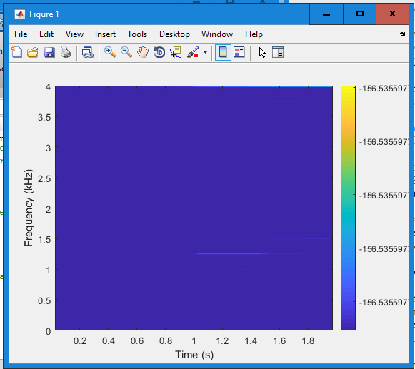

7000 Hz

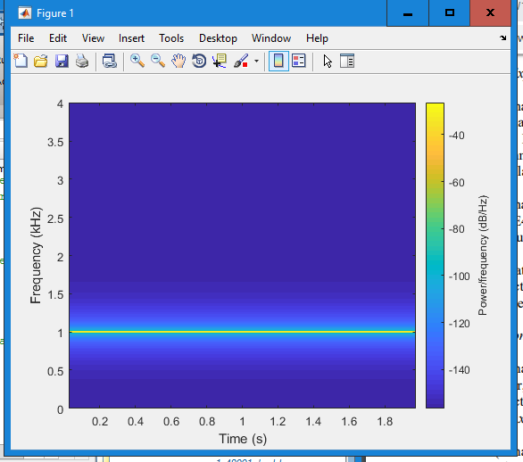

Quantization Experiments:

1. The function was uploaded to the Lab1 folder. The function file is called Quantization.m.
2. 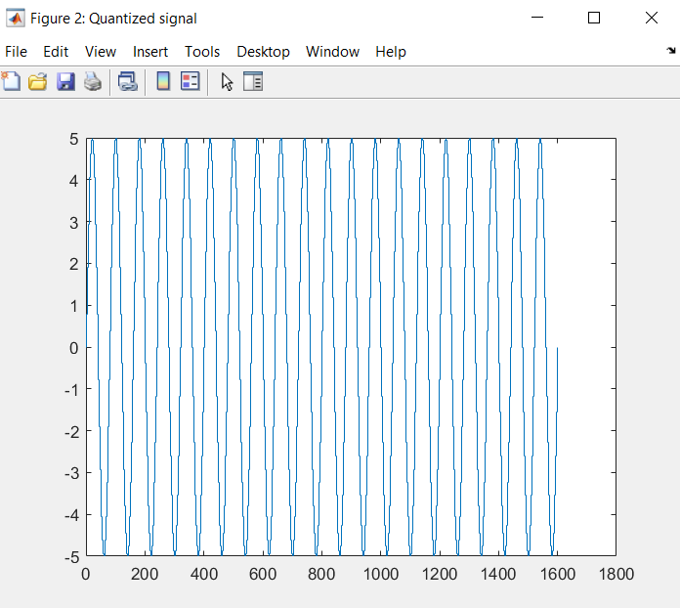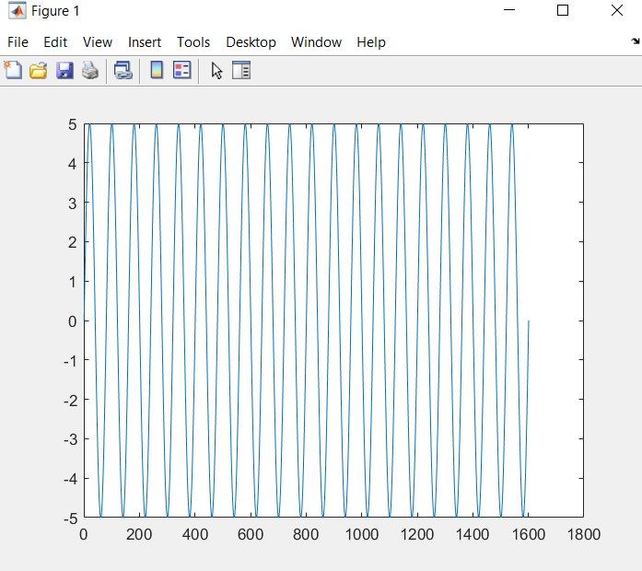a. The plots of the original and quantized sinusoids are included below:
   1. The recorded SNR value was 37.8845. The theoretical SNR value was 37.8845.