a)

Expected Threshold = 1:

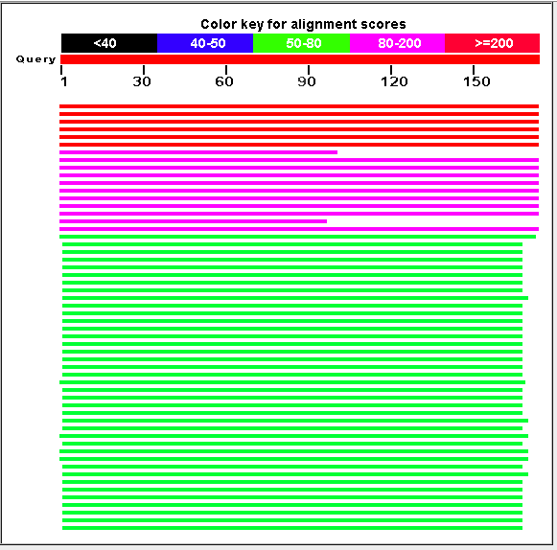

Expect Threshold – 1e-5:

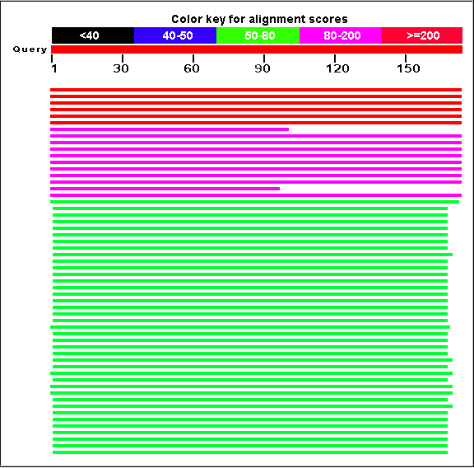

Q: Does the change affect the number of sequences retrieved? No. The E value for the sequences returned were much lower than 1e-5.

b)

BLOSUM 80: (56)

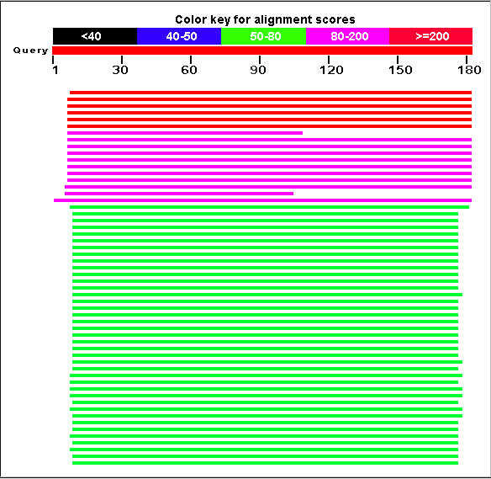

PAM 30:

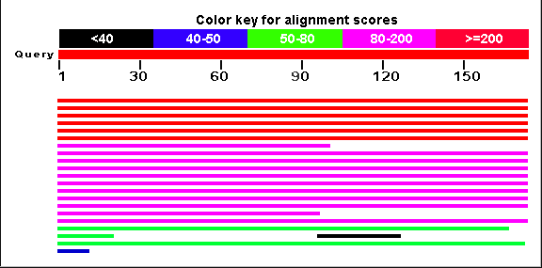

Q: Why do the two scoring matrices differ in terms of the number of

sequences retrieved? Also specify the number of sequences for the

two matrices.

A: PAM 30 and BLOSUM 80 use different scoring matrices, so different sequences have different scores and thus may or may not pass the scoring threshold.

c)

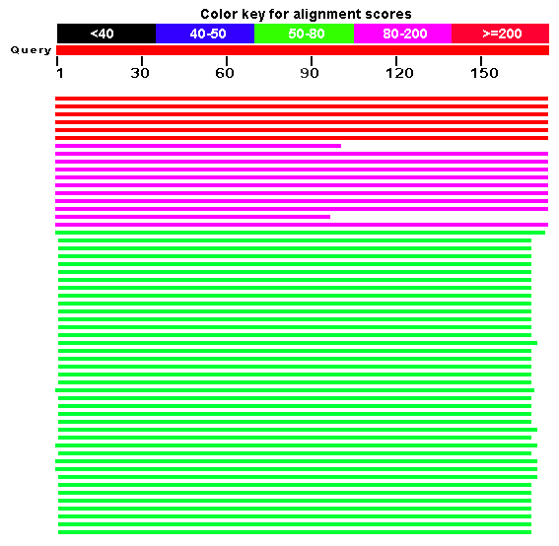



The was no difference in the top three sequences with the alternatives gap scores. This is because the sequences matched perfectly and had no gaps.