**Opportunistic Sampling of the Great Atlantic *Sargassum* Belt**

**on GO-SHIP lines A20 and A22**

Draft March 12, 2021

|  |
| --- |
|  |
| Figure 1. Satellite-based *Sargassum* abundance February 2016-2021 from USF *Sargassum* Watch System (SaWS)[[1]](#footnote-1). |

Upcoming occupations of GO-SHIP lines A20 and A22 by R/V *Thomas G. Thompson* offer an exceptional opportunity to sample the Great Atlantic Sargassum Belt (Wang et al. 2019). Satellite imagery indicates another significant bloom is beginning, with the abundance of *Sargassum* in February of 2021 near the top of that observed in Februaries of the last five years, second only to February 2018. Given the seasonality of the phenomenon, *Sargassum* abundance is expected to increase in the coming months.

Recent evidence suggests a long-term shift in the elemental stoichiometry of the seaweed (particularly N:P), which may reflect changes in nutrient supply fueling these blooms (Lapointe et al. submitted). *Sargassum* tissue samples in the high-abundance region of the tropical and southern subtropical Atlantic are very few in number, with opportunistic sampling by the R/V *Thomas G. Thompson* in August 2019 providing most of the measurements of which we are aware.

Clearly more observations are needed to test the hypothesis of a long-term shift in N:P and its implications for nutrient supply and *Sargassum* bloom dynamics. Both A20 and A22 cut extend into the high-abundance region (Figure 2, left), and the core hydrographic and inorganic nutrient measurements will be extremely valuable for interpreting satellite-based *Sargassum* abundance. The critical need for opportunistic sampling is *Sargassum* tissue. Alas, the clearances that are in hand for TN389 and TN390 will not allow for seaweed collection within the EEZs of coastal states, significantly curtailing sampling opportunities for TN390 (Figure 2, right). Nevertheless, it would still be highly valuable to collect *Sargassum* samples on both cruises whenever the seaweed is present in sufficient abundance to acquire by dipnet when on station or approach/departure.

Seaweed sampling is to be conducted by dipnet affixed to a standard recovery pole. A standard sample is 30-40g, an amount that fits easily into a quart-sized Ziploc bag. If there is sufficient biomass available, we would ideally like 12 samples per station, 6 dried and 6 frozen, each comprised of triplicates for the two species *S. fluitans* and *S. natans* which are easily distinguishable (see below). In the event that sufficient biomass is not available, the dried samples should be prioritized. Protocols for each method follow below, along with an ID guide and a log sheet for each station.

Please direct any questions to Dennis McGillicuddy, [dmcgillicuddy@whoi.edu](mailto:dmcgillicuddy@whoi.edu), 508-498-3825.

|  |  |
| --- | --- |
|  |  |
| Figure 2. Station plans for A20 and A22 (left) and cruise tracks with EEZs indicated (right). | |

**Cruise schedules**

TN 389 - A20 – Ryan Woosley, Chief Scientist

March 12 – load

March 16 – Depart WHOI

April 16 – Arrive St. Thomas

April 18 – Unload

TN 390 - A22 – Viviane Menezes, Chief Scientist

April 19 – load

April 20 - Depart St. Thomas

May 17 – Arrive WHOI

May 19 – Unload

**Sargassum Sampling – Dried Samples**

1. Collect samples with a dip net affixed to a recovery pole, making sure to keep the seaweed out of contact with metal, and as free from exhaust or other contamination as possible.

|  |
| --- |
|  |
| *Sargassum* tissue samples prepared for drying oven. |

2. Handling the samples with rubber gloves, separate each sample into *S. natans* and *S. fluitans* portions (see key below).

3. Separate each species into 3 replicate samples of 50 to 60 grams (what comfortably fits in a quart sized Ziploc bag).

4. Rinse with DI water, shake or blot dry and place each sample in drying oven on parchment paper with name of designated species and station (one sample per shelf spread out).

5. Drying oven temperature should be set between 55 and 65 C. Use thermometer inserted into top dryer vent to check temperature periodically.

6. Once sample is “bone dry” or crispy (typically 24-48 hours), place sample in Ziploc bag and label with species, station location collected and date of collection.

7. If drying ovens get backed up due to sample load, store samples in Ziploc bags in a dark cooler (air conditioning in lab is ok) until they can go into the oven. They will last several days in a cooler like this.

|  |
| --- |
| C:\Users\15084\AppData\Local\Temp\IMG_7916.jpg |
| Drying ovens (right) and sampling supplies (left) set up in a laboratory on the R/V *Thomas G. Thompson*. |

**Sargassum Sampling – Frozen Samples**

1. Remove vertebrates/invertebrates and other debris and return to the water. This can be accomplished by hand or by shaking handfuls of *Sargassum* while still in the water to expedite the process.

2. Separate *Sargassum* by species: *S. fluitans* (SF) and *S. natans* (SN) inside shallow pan.

3. Fill 3 Ziploc bags with ~30 grams of SF/SN sample. Collect three replicates for each species from any given location.

4. Label bags carefully with a code referencing date, location, type (SF or SN), and replicate (1-3).

5. Remove excess water (with paper towel) prior to sealing bags and store bags in a freezer and cover with a black blanket (just want to keep samples dark).

6. Record additional sample details on log sheet, including Date, Time, Location, GPS etc.

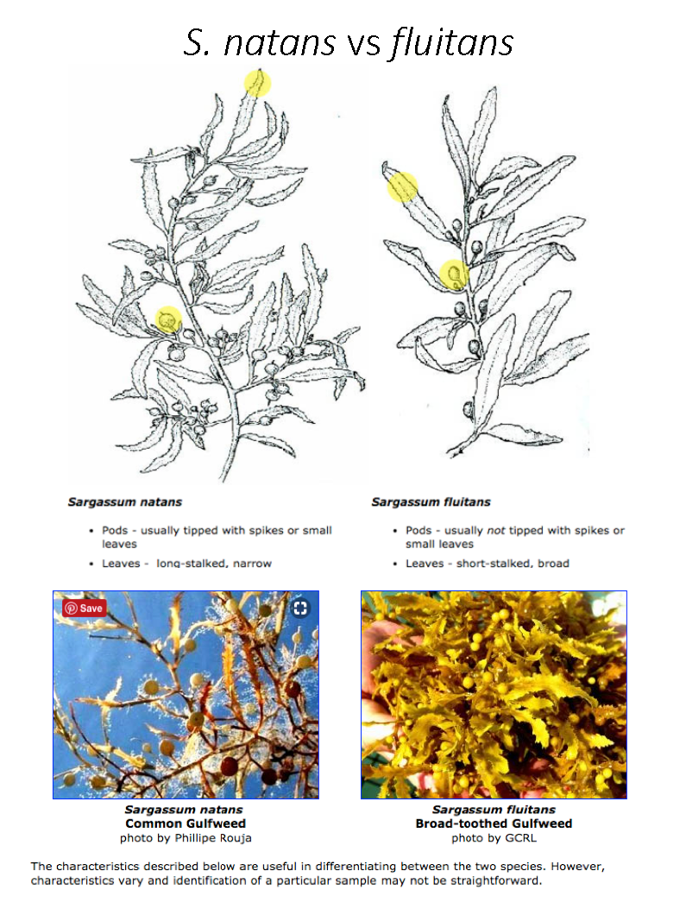

**References**

Lapointe, B. E., R. A. Brewton, L. W. Herren, M. Wang, C. Hu, D. J. McGillicuddy, S. Lindell, F. J. Hernandez, and P. L. Morton, submitted: Nutrient content and stoichiometry of pelagic *Sargassum* reflects increasing nitrogen availability in the Atlantic Basin. *Nature Communications*.

Wang, M., C. Hu, B. B. Barnes, G. Mitchum, B. Lapointe, and J. P. Montoya, 2019: The great Atlantic *Sargassum* belt. *Science*, **365,** 83-87.

**Instructions for reporting *Sargassum* sightings**

**Contact Info**: Mengqiu Wang (University of South Florida, USA)

**Email**: mengqiu@mail.usf.edu

**Items needed**:

* Log sheet (back page)
* Pen or pencil
* Smart phone or digital camera

**Steps**:

For each *Sargassum* mat sighting:

1. **Take a photo of the *Sargassum* mat**

(Try to include a reference object in your photo (see below), so the size of the *Sargassum* mat can be estimated.)

1. **Fill out the log sheet**

The most important information is the date, location, and estimated size.

1. **Email photos of *Sargassum* mat and log sheet to mengqiu@mail.usf.edu**

**Email 2 photos for each Sargassum sighting:**

* **Sargassum mat**
* **Log sheet**

**Take photo of Sargassum**

**Fill out the log sheet**

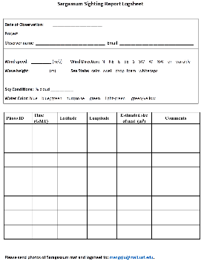 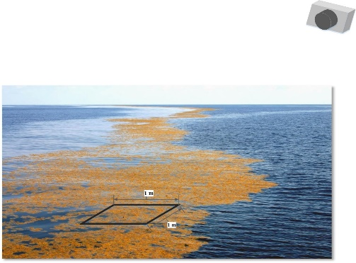

***Sargassum* Sighting Report Log sheet**

**Date of Observation**: \_\_\_\_\_\_\_\_\_\_\_\_\_\_\_\_\_\_\_\_\_\_

**Project**: \_\_\_\_\_\_\_\_\_\_\_\_\_\_\_\_\_\_\_\_\_\_

**Observer name**: \_\_\_\_\_\_\_\_\_\_\_\_\_\_\_\_\_\_\_\_\_\_\_\_\_\_\_\_\_\_\_  **Email**: \_\_\_\_\_\_\_\_\_\_\_\_\_\_\_\_\_\_\_\_\_\_\_\_\_\_\_\_\_\_\_\_\_

**Wind speed**: \_\_\_\_\_\_\_\_\_ (m/s) **Wind Direction:** N NE E SE S SW W NW or variable

**Wave height**: \_\_\_\_\_\_\_ \_(m) **Sea State:** calm swell chop foam whitecaps

**Sky Conditions**: % cloud \_\_\_\_\_\_\_\_\_\_

**Water Color**: blue blue/green turquoise green light-green green/yellow

|  |  |  |  |  |  |
| --- | --- | --- | --- | --- | --- |
| **Photo ID** | **Time (GMT)** | **Latitude** | **Longitude** | **Estimated size of mat (m2)** | **Comments** |
|  |  |  |  |  |  |
|  |  |  |  |  |  |
|  |  |  |  |  |  |
|  |  |  |  |  |  |
|  |  |  |  |  |  |
|  |  |  |  |  |  |
|  |  |  |  |  |  |
|  |  |  |  |  |  |

1. <https://optics.marine.usf.edu/projects/saws.html> [↑](#footnote-ref-1)