**EEC172 Lab 0 Lab Report**

Name: Chen Chen SID: 998820114

Name: Weidong Wu SID: 912341051

**Introduction**

This Lab covers the basic software development tools that will be used in this course. We basically learned how to configure the board, write codes in CCS, implement some simple orders and flash the final code onto the board.

**Verification sheet** and the **original code** will be attached to the end of this report. The hard copy of the code contains **main.c**, **pin_mux_config.h** and **pin_mux_config.c**. The rest of the files can be found in the soft copy submission of Lab 0.

**Moore State Transition Diagram**

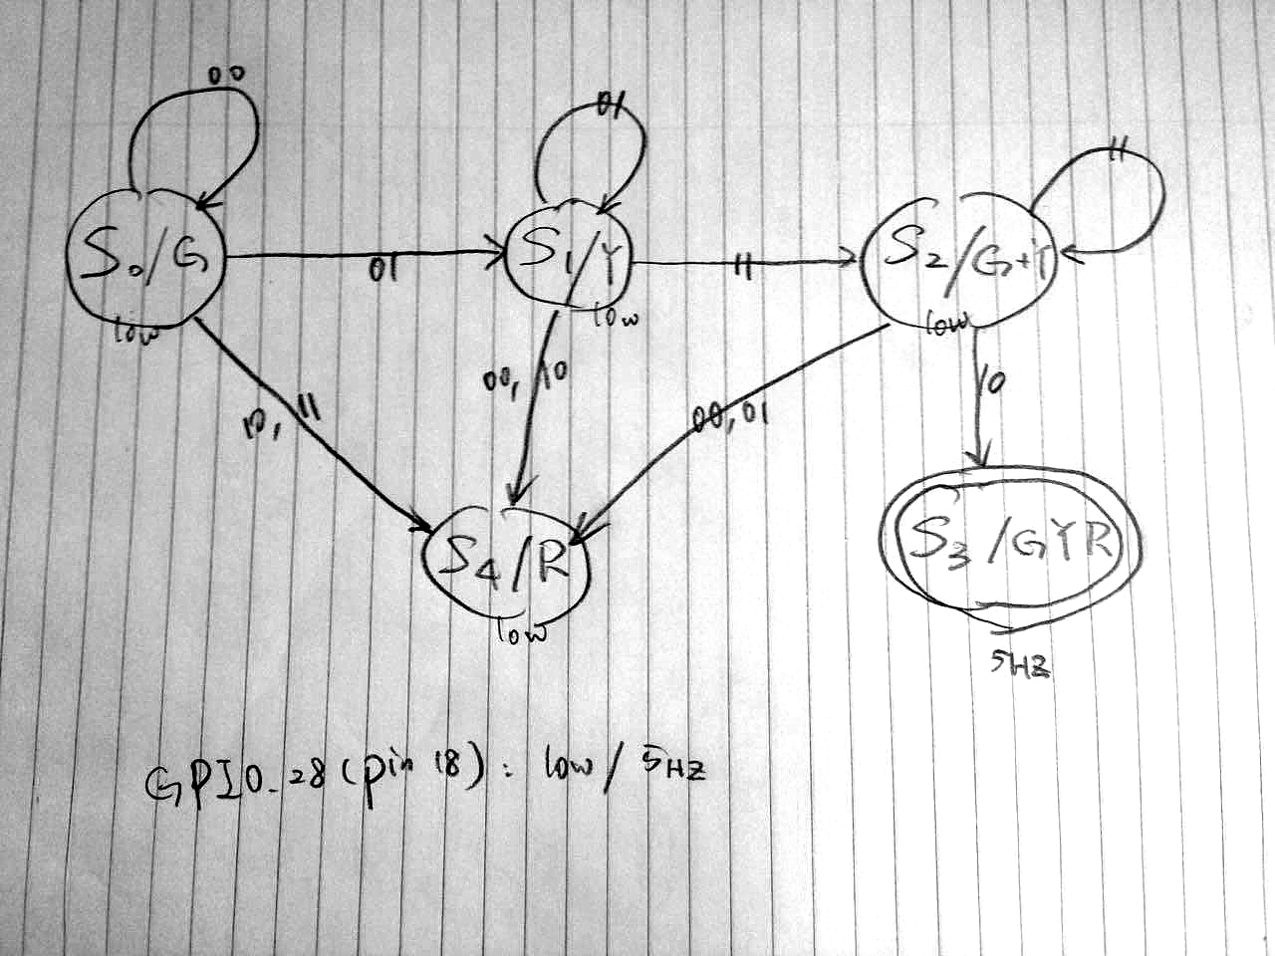

**LED Circuit Schematics**

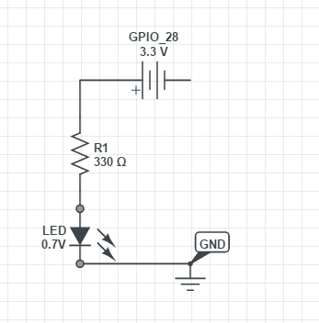

**Current Calculation**

$$V_{LED}=0.7V$$

$$R=220Ω$$

$$V_{28}=3.3V$$

$$V=V_{LED}+V_{R}=V_{LED}+I∙R$$

$$3.3V=0.7V+I∙330Ω$$

$$I=0.00788A$$

**Challenge: Baud Rate Mismatch**

When our group finished with all the code and tried to print some messages to the Tera Term console simulation, we got garbage messages that did not make any sense. We later found out that the baud rate of the port and the Tera Term software were not configured properly to match the baud rate of the board. The baud rate of the board in this case is 115200. We had to first go to the Windows Device Manager to set the port baud rate to 115200, then we configured the software to receive and process the information at 115200 too.