Computer programming

Final Project

Report

I.E.S. San Vicente
San Vicente del Raspeig (Alicante)
2015/2016

Teacher:
José Ignacio Cabanes

Student:
Chen Chao

1. Introduction
Project name
CCAD

Made by
Chen Chao

Short description of the project
CCAD is an application with which user can create technical 2D drawings, such as plans for buildings, interiors and two-dimensional objects. Everything that user can imagine. It is a graphical application that uses the windows forms library.

2. Functionality of the project

CCAD has been developed to allow users to create 2D images, offering a very simple and intuitive interface. A new canvas is created as soon as the program is opened, then, the user have the following options.

Drawing lines

A line can be drawn by clicking in 2 points of the screen, by clicking 1 point and typing the angle and length of the line in the command box or by using “orto” option to draw 0º or 90º lines only.

Drawing circles

Circles can be made introducing a centre point and radius or two opposed points.

Drawing rectangles

A rectangle is created by entering two points (opposite vertices) by clicking on screen or introducing the relative size in command box after the first click.

Drawing arcs

To draw an arc is needed a centre point, a radius and an angle. Other options are indicating two points and angle or typing the insertion point in the command box.

Drawing ellipse

An ellipse needs 3 clicks. First, user has to click in the canvas to indicate the centre of ellipse, the second click defines the radius of the minor axis or it can be typed in the command box, and thirdly, another click indicates the radius of the major axis or it can be also typed in command box.

Drawing polygons

Polygons are drawn from two points and x number of vertices. The first click defines the centre and the second click is for the radius (distance between the clicked point and centre) of the circle that contains the polygon.

Drawing polylines

Finally polylines are easily created giving several points by clicking on screen.

Other tools

There are more tools to help the user to create drawings such as zooming in/out with mouse wheel or hotkeys, panning, selecting using the button or mouse click and area selected, redoing/undoing actions, input/output saved files, property editor to edit selected line, scale line, mirror, move/copy/paste actions, measuring tools, and action commands.

3. Screen prototype
The game screen will look like this:

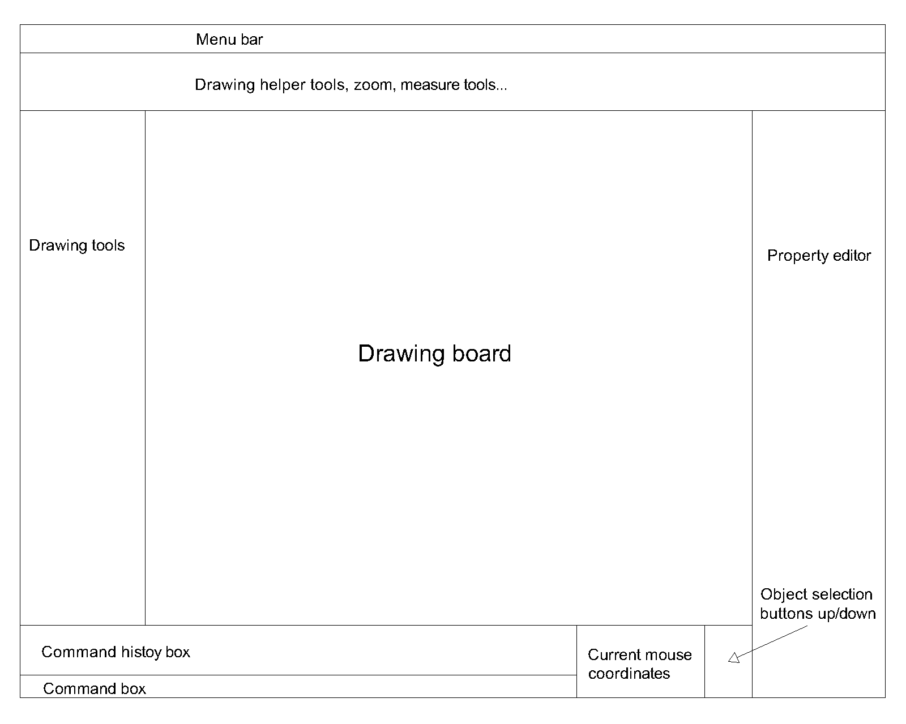

4. Analysis

4a. Requisites
Requisite | Date achieved
The program will allow user to draw simple points. | 01-06-2016
The program will allow user to draw straight lines.  Draw by clicking in 2 points of the screen, by clicking 1 point and typing the angle and length of the line in the command box or by using “orto” option to draw 0º (horizontal) or 90º (vertical) lines only. | 25-26-2016
The program will allow user to draw circles.  Draw by introducing a centre point and radius or two opposed points. | 30-05-2016
The program will allow user to draw rectangles.  Draw by introducing two points by clicking on screen or introducing the size in command box after the first click(optional). | 07-06-2016
The program will allow user to draw arcs.  Draw by clicking a centre point, a radius and an angle. | 01-06-2016
The program will allow user to draw ellipses.  Draw by clicking in the canvas to indicate the centre of ellipse, radius of the minor axis or it can be typed in the command box (optional), and another click that indicates the radius of the major axis or it can be also typed in command box (optional). | 07-06-2016
The program will allow user to draw polygons.
Draw by clicking in two points of the screen (first click, centre, second click, radius of the circle that contains the polygon) and x number of vertices introduced in the command box.
The program will allow user to draw polylines.  Draw by clicking on screen several points, to create a unique line. | 06-06-2016
The program will have zoom in/out with mouse wheel or hotkeys.
The program will have selections tools.  Selection by mouse, selection by buttons, area selection(optional). | 31-05-2016
The program will have 3 thickness of line. | 25-05-2016
The program will have 10 colours of line (white, green, blue, red, yellow, magenta, orange, cyan, grey and brown). | 25-05-2016
The program will have 3 types of line.
The program will have redo/undo option.
The program will have load/save files option with the “.ccad” extension. | 27-05-2016
The program will have a property editor.
The program will have scale, mirror and measuring tools.
The program will have move action.
The program will have copy/paste actions. | 06-06-2016
The program will have action commands
The program will allow user to pan the image.
The program will have a help screen.
The program will be in English.
The program will be in Spanish.
The program will be in Chinese.

4b. Basic pseudocode (not finished)

Program body:
Create new project when opened
firstClick = true, secondClick = false, drawLine = false, drawRectangle = false,
drawEllipse = false, drawPolyline = false, drawPolygon = false, drawCircle = false,
drawArc = false, drawImage = false, drawPoint = false, drawText= false, move = false, copy = false, mirror = false, scale = false, select = false, currentZoom = 1,
zoomIn = 0.1, zoomOut = 0.1, entities = new List<Entity>()
while true
If menu button pressed, display list of menu
If list item == new then create new project
Else If list item == open then
Select a file and open
If first line == “CCADv2016” then
While next line != null
text = Read next line
if text == Point then
tempText = Read next line
tempColor = tempText
tempText = Read next line
parts = split tempText
create new point with tempColor, parts[0] and parts[1] and
add in entities list
else if text == Line then
create array of 2 points
for I = 0; I < 2; i++ loop
tempText = Read next line
tempColor = tempText
tempText = Read next line
tempLineWidth = tempText
tempText = Read next line
for j = 0; j < tempText; j++ loop
tempText = Read next line
parts = split tempText
create new point with parts[0] and parts[1] and add in
arrayOfPoint[i]
end for
end for
else if text == Text then
// TO DO
end if
end while
End if
Else If list item == save then
If currentPath == “” then
Call save as method
Else
Call save method
End if
Else if list item == save as then
Select destination folder,
Call save method
Else if list item == exit, exit program
End if
Else if help button pressed, display help screen
Else if selection button pressed
firstClick = true, secondClick = false, drawLine = false, drawRectangle = false, drawEllipse = false, drawPolyline = false, drawPolygon = false, drawCircle = false, drawArc = false, drawImage = false, drawPoint = false, drawText= false, move = false, copy = false, mirror = false, scale = false, select = true
Else if zoom in button pressed, zoom in
Else if zoom out button pressed, zoom out
Else if selection up button pressed and myCanvas.GetDrawing().Count >
myCanvas.currentSelection then
myCanvas.currentSelection++;
select previous entity
Else if selection down button pressed and 0 <=
myCanvas.currentSelection then
myCanvas.currentSelection--;
select next entity
Else if redo button pressed, redo undone action
Else if undo button pressed, undo redone action
Else if straight line button pressed, drawLine = true, select = false
Else if point button pressed, drawPoint = true, select = false
Else if rectangle button pressed, drawRectangle = true, select = false
Else if ellipse button pressed, drawEllipse = true, select = false
Else if polyline button pressed, drawPolyline = true, select = false
Else if polygon button pressed, drawPolygon = true, select = false
Else if circle button pressed, drawCircle = true, select = false
Else if arc button pressed, drawArc = true, select = false
Else if text button pressed, drawText = true, select = false
Else if image button pressed, drawImage = true, select = false
Else if scale button pressed, scale = true, select = false
Else if mirror button pressed, mirror = true, select = false
Else if copy button pressed, copy = true, select = false
Else if move button pressed, move = true, select = false
Else if key == ESC
firstClick = true, secondClick = false, drawLine = false, drawRectangle = false, drawEllipse = false, drawPolyline = false, drawPolygon = false, drawCircle = false, drawArc = false, drawImage = false, drawPoint = false, drawText= false, move = false, copy = false, mirror = false, scale = false, select = true
End if
If Canvas_MouseClick and !Draw then
For I = 0; I < entities.Count; i++
If entities[i].IsInRange(mouseX, mouseY) then
itemSelected = true;
entities[i].Selected();
else
itemSelected = false;
entities[i].Free();
End for
Refresh();
Else if Canvas_MouseMove then
For I = 0; I < entities.Count; i++
If entities[i].IsInRange(mouseX, mouseY) then
Entities[i].SetTemporalColor();
Refresh();
Else
Entities[i].Free();
End if
End for
End if
If drawLine == true then
If click on screen and firstClick == true then
startPoint.X = mouseX, startPoint.Y = mouseY
firstClick = false
else if click on screen and firstClick == false then
endPoint.X = mouseX, endPoint.Y = mouseY
Line tempLine = new Line(currentColor, currentLineWidth, startPoint,
endPoint)
entities.add(tempLine)
startPoint = endPoint
else if command box text length > 0 and key pressed == Enter then
text = command box text split
try
endPoint.X = cos(text[0]) * text[1]
endPoint.Y = sin(text[0]) * text[1]
firstClick = false
catch exception
lbxCommands items add “Error input data, input format
“#angle;length””
end if
add line to entities
Else if drawPoint == true
If click on screen
startX = mouseX, startY = mouseY
end if
add point to entities
Else if drawRectangle == true then
If click on screen and firstClick == true then
startPoint.X = mouseX, startPoint.Y = mouseY
firstClick = false
else if click on screen and !firstClick then
endPoint.X = mouseX, endPoint.Y = mouseY
PointF rightTopPoint = new PointF(endPoint.X, startPoint.Y)
PointF leftBotPoint = new PointF(startPoint.X, endPoint.Y)
Line[] lines = new Line[4]
lines[0] = new Line(currentColor, currentLineWidth, startPoint,
rightTopPoint)
lines[1] = new Line(currentColor, currentLineWidth, rightTopPoint,
endPoint)
lines[2] = new Line(currentColor, currentLineWidth, endPoint,
leftBotPoint)
lines[3] = new Line(currentColor, currentLineWidth, leftBotPoint,
startPoint)
Rectangle rect = new Rectangle(currentColor, lines)
Entities.Add(rect)
Refresh()
firstClick = true
end if
Else if drawEllipse == true
If click on screen and firstClick == true then
startPoint.X = mouseX, startPoint.Y = mouseY
firstClick = false
secondClick = true
else if click on screen and secondClick == true then
endPoint.X = mouseX, endPoint.Y = mouseY
secondClick = false
else
Ellipse ellipse = new Ellipse(currentColor, startPoint,
currentLineWidth, endPoint, new PointF(mouseX, mouseY))
entities.Add(ellipse)
Refresh()
firstClick = true
end if
Else if drawPolyline == true
Instructions…
Else if drawPolygon == true
Instructions…
Else if drawCircle == true then
If firstClick == true then
startPoint.X = mouseX, startPoint.Y = mouseY
firstClick = false
else if firstClick == false then
radius = math.sqrt(math.pow(mouseX-startPoint.X, 2) +
math.pow(mouseY-startPoint.Y, 2))
Circle circle = new Circle(currentColor, startPoint, currentLineWidth,
radius)
firstClick = true
entities.Add(circle)
Else if drawCircleOpposite == true then
If firstClick == true then
startPoint.X = mouseX, startPoint.Y = mouseY
firstClick = false
else if firstClick == false then
radius = math.sqrt(math.pow(mouseX-startPoint.X, 2) +
math.pow(mouseY-startPoint.Y, 2)) / 2
centrePoint.X = (startPoint.X + currentX) / 2
centrePoint.Y = (startPoint.Y + currentY) / 2
Circle circle = new Circle(currentColor, centrePoint,
currentLineWidth, radius)
entities.Add(circle)
firstClick = true
Else if drawArc == true
If click on screen and firstClick == true then
startPoint.X = mouseX, startPoint.Y = mouseY
firstClick = false
else if click on screen and firstClick == false then
endPoint.X = mouseX, endPoint.Y = mouseY
secondClick = false
else
Arc arc = new Arc(currentColor, startPoint, endpoint, new
PointF(currentX, currentY), currentLineWidth)
Entities.Add(arc)
Refresh()
firstClick = true
end if
Else if drawText == true
Instructions…
Else if drawImage == true
Instructions…
Else if move == true
Instructions…
Move entity
Else if copy == true
Instructions…
Copy entity
Else if scale == true
Instructions…
Scale entity
Else if mirror == true
Instructions…
Copy inversed entity
Else if orto == true then
If firstClick == false then
if Math.Abs(currentX – startPoint.X) > Math.Abs(currentY –
startPoint.Y) then
endpoint = new Point(currentX, startPoint.Y)
else
endpoint = new Point(startPoint.X, currentY)
end if
end if
End if
Draw entities
End while

4c. Classes diagram

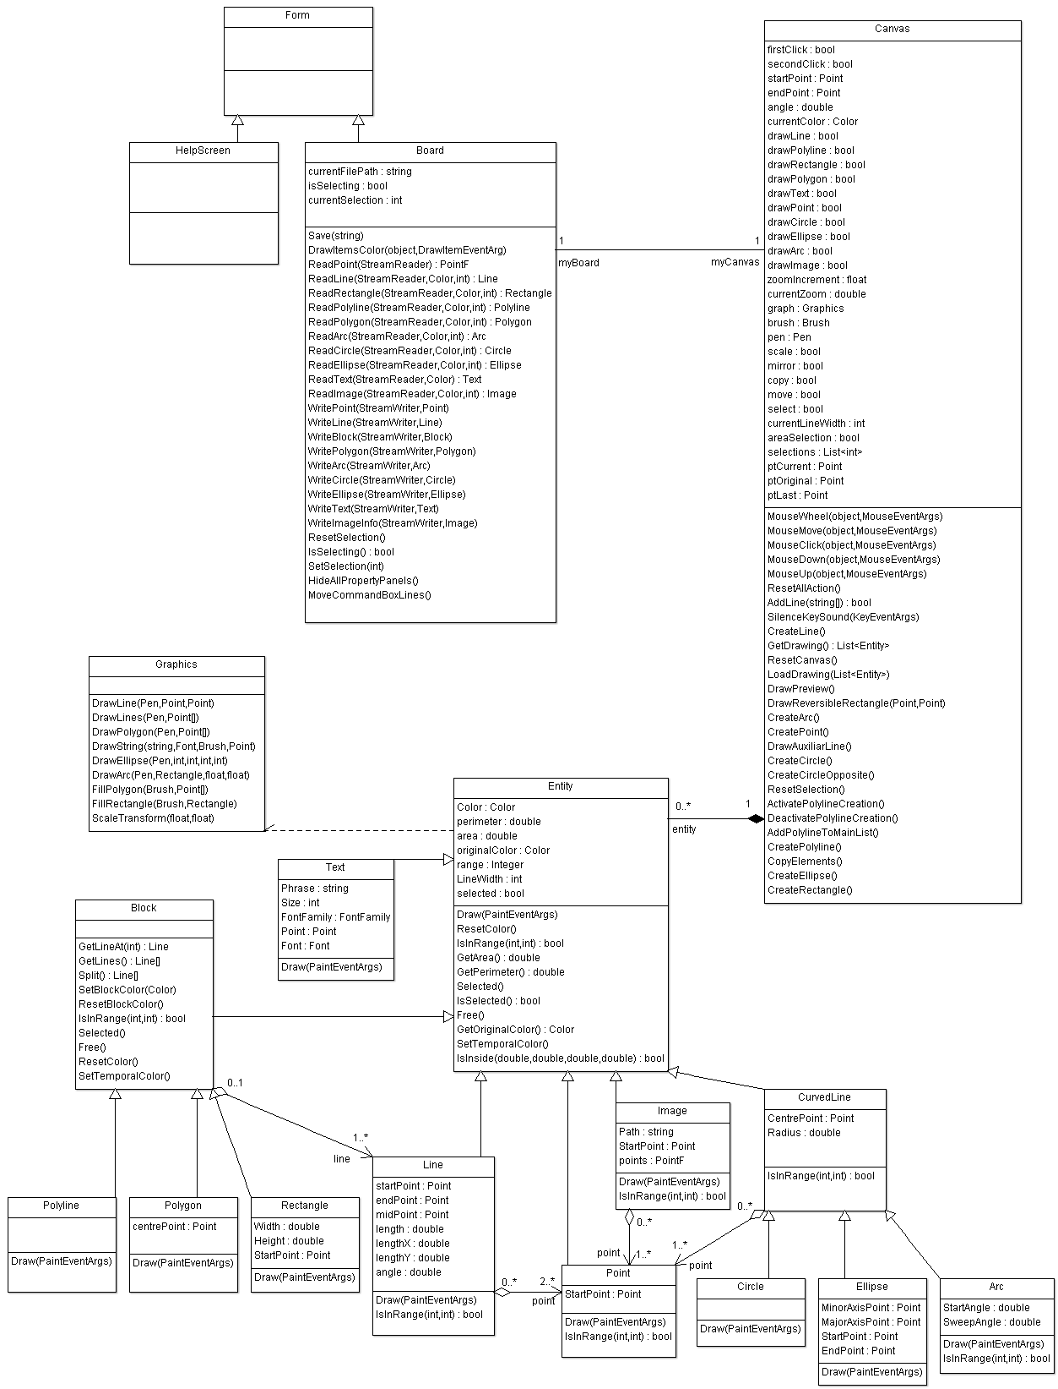

5. Initial planning and expected deliveries

5a. Expected deliveries (all actions need buttons clicked or commands)
- Version 1: Program’s user interface.
- Version 2:
- Classes Entity, Line, CurvedLine, Block, Arc, Polylines, Circle, Rectangle, Polygon, Ellipse.
- Properties of the classes: startPoint (StartX, StartY), endpoint (EndX, EndY), midpoint (MiddleX, MiddleY), LengthX, LenghtY, Length, Angle, centrePoint (CentreX, CentreY), Color, perimeter, area, Array of Points (Block, Polylines, Rectangle, Polygon) all properties calculated after line created.
- Version 3:
- Lines:
- Two points (mouse click)
- horizontal / vertical (orto) only lines with 0º and 90º when button activated
- Given relative angle and length after first click (typed in command box).
- Version 4:
- Input / Output “.ccad” and DXF (optional)
- (Save / Load with check for valid file method for load (extension, “.ccad”)) (Check if the extension is valid, and if the file hasn’t been modified)
- Version 5:
  - Line selection by Buttons (optional) (selection by clicking 2 buttons, up and down, increasing or decreasing array’s index to select them and then change temporally the colour to blue)
  - Line selection by Mouse Click (optional) (when mouse is inside the maximum range of each line, circle, and more, even miss click, can select the line)
  - Area selection. (Optional)
- Version 6:
- Circles:
- Centre, radius (first click centre, second click radius)
- Two opposed points (first click start point, second click opposite point)
- Version 7:
  - Points:
- Single points (draw after each click)
- Arcs:
- Given centre, radius, angles (first click centre, second click radius, third click for angle)
- Two points and angle (first click for start point, second click for end point, third click angle)
- Version 8:
- Rectangle:
- Given 2 points (first click up left corner point, second click bottom right corner point)
- Ellipse:
- Given 3 points (first click centre of ellipse, second click radius minor axis or typed in command box, and third click radius major axis or typed in command box)
- Version 9:
  - Property editor (start point, end point, length, radius, centre point, colour, thickness, angle respect 0º, diameter, area)
- Version 10:
  - Polylines:
- Given several points (points by clicks with mouse)
- Scale (select the line to modify and type the scale value (percentage) in the command box)
- Version 11:
- Mirror (select the line, then click in one point on the screen, and create a new line in the other side of the point equidistantly)
- Move / Copy / Paste lines (select the line, click the action button for each case, except paste action, and then click on screen to paste the line)
- Version 12:
- Polygon:
- Polygon from two points and x number of vertices (first click centre, second click radius (distance between point clicked and centre), to calculate the length of each side, divide a circle into x parts, calculate the angle and get points)
- String:
- Given text, font, size, colour and point (all typed in command box, except point, by click)
- Version 13:
  - Measuring tools
- Area (Ellipse, Rectangle, Triangle, Circle) (select the line, and return the area in the command box)
- Perimeter (Rectangle, Triangle, Circle) (select the line and return the area in the command box)
- Version 14:
- Zoom in/out (mouse wheel or hotkeys, increase or decrease a counter, then calculate the new size on screen of each line, the property would not be modified by zoom)
- Panning (move all elements on screen when mouse middle button pressed)
- Version 15:
- Commands (line, spline, circle, arc, rectangle…) (typing the commands in the command box, after that, introduce all necessary parameters)
- Version 16 (Optional):
  - 5 line thickness (create 5 different thickness for lines)
  - Solid fill (fill polygon’s area)
- Import bitmaps into drawing
- Export drawing as bitmap BMP
- Version 17 (Optional):
- Dashed lines
- Block edition (split blocks into lines, duplicate the end point of each line in the box)
- Version 18 (Optional):
- Redo / Undo options (Stack) (save in 2 stacks of actions, 1 for redo actions, 1 for undo actions, if redo stack pop, undo push redo’s pop)

- Version 19 (Optional):
- Multi-Language (save the actual language to a configuration file, when start program, check the actual language to load the corresponding language file. clicking on language option button, can change language, loading text from a “.txt” file and set all text of the application to the new language)
- English
- Spanish
- Chinese
- Version 20 (Optional):
- Help (English)
- Version 21 (Optional):
- Help (Spanish)
- Version 22 (Optional):
- Help (Chinese)

5b. Real deliveries
- Version 1 (May 23): As expected: User interface, and advanced the class Entity
- Version 2 (May 24): As expected : All classes created, and defined each class method
- Version 3 (May 25): As expected: 3 line creations added, “orto” mode created, and added an improvement, dynamic entry.
- Version 4 (May 27): As expected: input / output options added.
- Version 5 (May 30): As expected: circles creation added
- Version 6 (May 31): As expected: Mouse and button selection, and added 1 way of area selection and added an improvement, line drawing preview
- Version 7 (June 1): As expected: arc and point creation added, and added an improvement, arc drawing preview.
- Version 8 (June 6): Expected delivery: rectangle and ellipse creation, but client modified priority for this delivery: polyline creation added and copy lines action added, added an improvement, copy preview.
- Version 9 (June 7): Not as expected because of client modification: done 8th delivery, added ellipse and rectangle creation, and added an improvement, ellipse and rectangle preview.
- Version 10 (June 8):
- Version 11 (June 9):
- Version 12 (June 10):

6. File formats

6a. Plain files format
All entity is saved to a “.ccad” file, which contains a header “CCADv2016”, then in the following lines, save an entity type using GetType() method, it will return “CCAD.” And the class name, in the second line write the colour of the entity, in the third line write the width of the line, in the fourth line, write the number of points of the entity (Line, Point, Arc, Circle, Ellipse, Image and Text) or number of lines of the block (Rectangle, Polygon, Polyline), and save each point of each line, by saving x and y of each point in different lines, specially, for the image, also save the file path and for the text, save the text content, and so on, until saved all entities, as in this example:

CCADv2016
Point ← Type Point
1 ← line width
Red
100 ← X
200 ← Y
Line ← Type Line
1 ← line width
Yellow
Point ← start point of line
200
50
Point ← end point of line
10
20
Rectangle ← Type Rectangle
1 ← line width
Green
4 ← number of lines
Line
Point ← start point of line
200
50
Point ← end point of line
10
20
Line
Point
200
50
Point
10
20
Line
Point
200
50
Point
10
20
Line
Point
200
50
Point
10
20
Polygon ← Type Polygon
3 ← line width
Brown
Point ← CentrePoint
300
200
3 ← number of lines
Line
Point
200
50
Point
10
20
Line
Point
200
50
Point
10
20
Line
Point
200
50
Point
10
20
Polyline ← Type Polyline
1 ← line width
Blue
2 ← number of lines
Line
Point
200
50
Point
10
20
Line
Point
200
50
Point
10
20
Circle ← Type Circle
1 ← line width
Red
Point ← CentrePoint
300
500
5 ← This is the radius of the circle
Ellipse ← Type Ellipse
1 ← line width
Green
Point ← CentrePoint
200
500
Point ← MinorAxisPoint
200
300
Point ← MajorAxisPoint
500
500
Arc ← Type Arc
3 ← line width
Yellow
Point ← CentrePoint
200
400
Point ← StartPoint
300
500
Point ← EndPoint
600
700
Text ← Type Text
Red
Point
200
300
Esto es un texto de prueba ← Phrase
FontFamily.GenericSerif ← FontFamily
12 ← Size
Image ← Type Image
White
Point
1000
200
C:\Users\dk\Desktop\hola.png ← Path

6b. Entity-Relationship Diagram (If needed)
(…)

7. Problems found and solutions
I preferred not to use the SDL library, which I found difficult to use in this project, so I have used Windows Form.

Although in the level 3 (hard) I check the next three movements, sometimes the computer makes foolish moves, but always in the first column. I have not found where the bug is, but I think the problem may lie in this portion of code, in which I check each column versus the previous one: (...)

I noticed that if I take the game to another computer which has not the DotNet Framework installed in it, the program closes without any error or warning message (...)

(…)

8. Improvements or restrictions to the starting design
I have had time enough to include the effect of animation when the pieces fall (…)

I have not been able to implement (…) because of (…)

9. Screenshots of the final project
(…)

10. Source code of the final project
(…)

