

Enthusiastic and self-drive User Experience Designer with a Bachelor of Architecture from Virginia Tech actively seeking an opportunity in the field. Through my online education at Bloc.io I have strengthened my design skills specifically in the area of user research, designing wireframes and creating prototypes







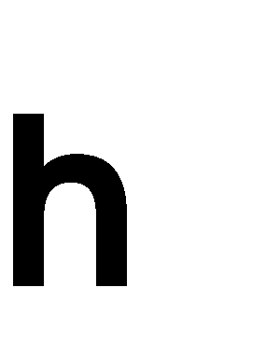
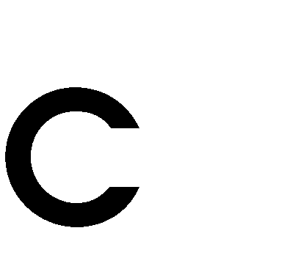

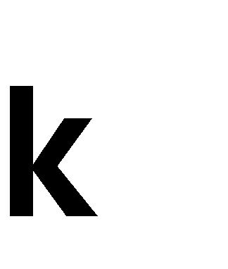

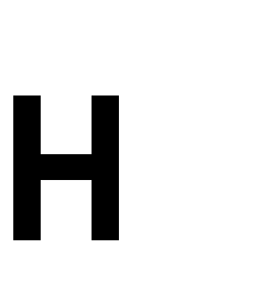
BlocShop May 2017 - Jul 2017
Designed and developed an online shopping platform targeted for print and graphic designers to share and sell their works through paper prints and shirts.
BlocJam Jan 2017 - May 2017
Built an alternative version of Spotify using JQuery, JavaScript, HTML and CSS.
Paycrave Dec 2017
Designed an Android mobile application for finding food trucks and ordering food.
BlocStarter Nov 2016
Created a web application for people to crowd-fund donations for charities and foundations.
BlocBox Oct 2016 - Nov 2016
Designed and developed dash board and home page to a cloud storage webpage with JavaScript, HTML and CSS.


Bloc.io Oct 2016 - Jul 2017
Web Design and Development Apprenticeship

Developed rounded UIUX skills through a 36 week course with the mentorship of the co-founder of Made by Munsters.

Formulated branding and visual mockups by conducting user research to meet business needs.

Produced wireframes with Photoshop and prototypes with Invision for user testing.

Developed basic front-end interfaces with HTML5, CSS3, Java Script and jQuery.

Teel Construction Jul 2016 - May 2017
Assistant Superintendent

Collaborated with Superintendent for the completion of projects. Supervised construction crew of 20 people and delivered a $500,000 project on time as an assistant which in turn saved the company $5,000 in staffing cost.

Proposed strategies to compete against large corporation in the acquisition of student talents resulted in decreased staffing cost, increased flexibility for senior superintendents and advertised the name of the company.

isARK Studio May 2015 - July 2016
Architectural Intern

Bridged communication between 6 subcontractors and supervisor.

Aided the design process from schematic design and design development to the production of construction drawings of 4 projects.

Summer Architecture Studio Summer 2013 & 2016 Teaching Assistant
Aided students during concept development of studio projects and provided technical supports including Adobe Creative Suite.

480 840 5065
hankchen9299@gmail.com
www.hankchen.us github.com/cchen9299 Fairfax, VA


User Experience Design User Interface Design User Research
User Experience Testing Product Design Prototyping
User Flows
Responsive Wireframing
Branding & Identity Visual Mockups

TOOLS & SOFTWARES

HTML5 & CSS3
JavaScript
JQuery
Adobe Creative Suites Invision
Draw.io
Balsamiq Google Forms
Google Analytics WordPress Axure RP 8


Virginia Tech
Aug 2010 - May 2016

B.Arch. Architecture 2016 Minor Industrial Design

