MSBD 5013 Report

1. Primary Analysis

In order to do the prediction, we try to find a seasonal pattern or relation between current and previous price. Therefore, we have run several analyses before building the model. These analyses are mainly focus on the stationarity and seasonality test about the time series from different aspects.

* 1. Single Crypto Currency Price Analysis

The first and the most direct attempt is simply run the test on the currency data directly. If the data show an obvious seasonal trend during a curtain period, it would very helpful to build the model. As BTC is the most popular crypto currency, we will use it as the target data.

* + - Stationarity

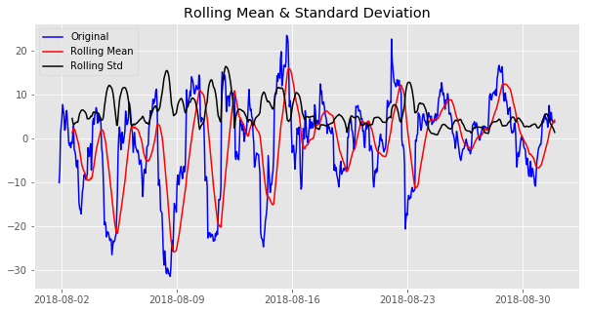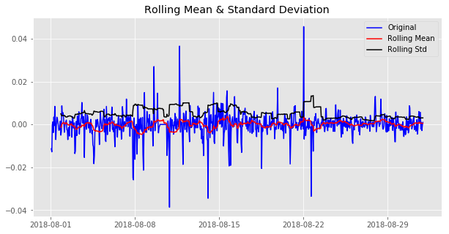

The two graphs above shows the price of BTC during August, the one in right use the log value while the right one doesn’t. The red line shows the rolling mean of the price which fluctuate significantly, even with the log value is unstable. Due to unstable of BTC price, we will use the log value to test its trend and seasonality.

* + - Trend and Seasonality

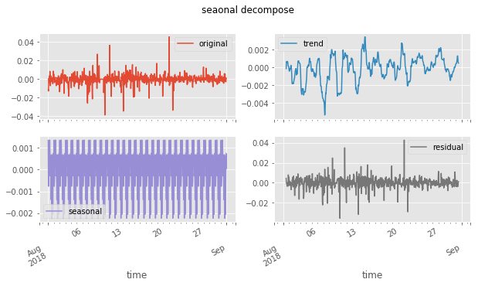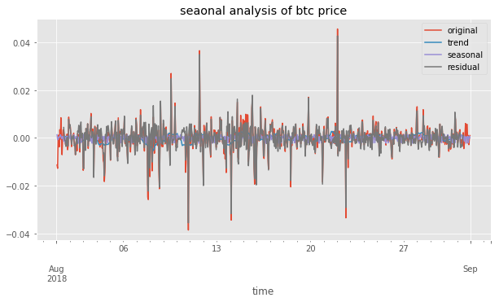

Both of the trend and seasonal components have small volume, while the residual construct most of the fluctuation. This shows the data don’t show a seasonal pattern, at least in this month.

* 1. Open / Close Price Analysis

During the trading, it would be enough for a model that provide a signal of rising or falling rather than a specific price. Thus, the second analyze will try to find a pattern focusing on the price changing in one day. The two graphs below show the changing of max price of a day or hour. It seems have some seasonal pattern.

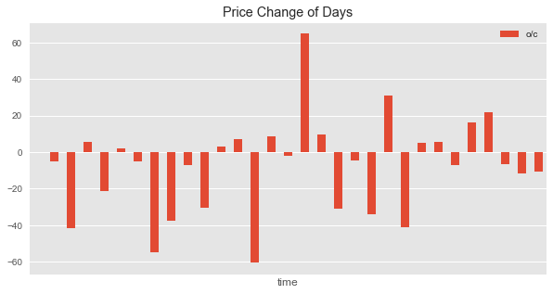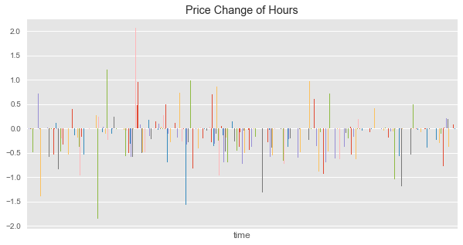

* + - Trend and Seasonality

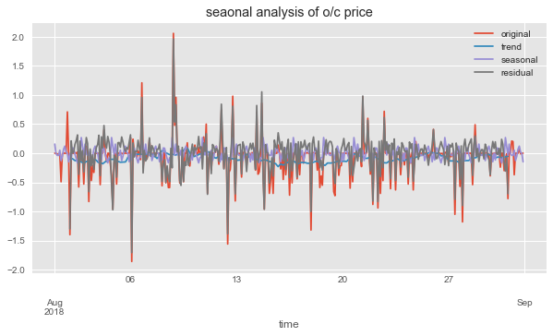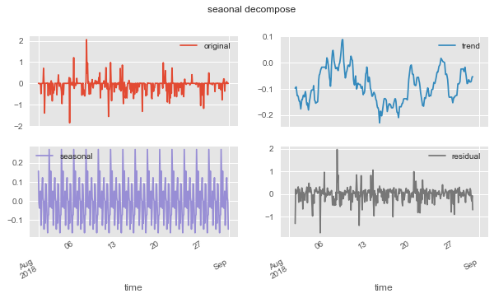

While the analyze result shows the seasonal component don’t make significant influence. Most of the value are contributed by the trend and residuals. These features are hard to provide information to build the model.

* 1. Crypto Currencies Relation Analysis

Although it seems no pattern can be found in the currency trend, we still find there is one information might be the breakpoint of the project. We think relation between 4 crypto currencies may have some useful information.

* + - Correlation

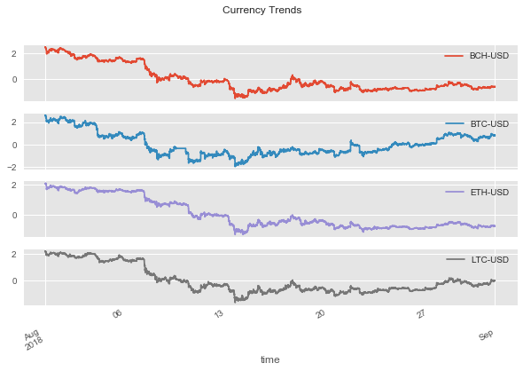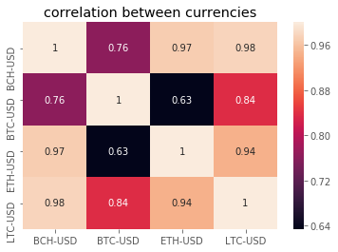

From the graph above, we found there is a strong correlation between the trend of four crypto currency, as well as the price in most of the detail changing. We hope to identify one or two *leading currency* whose price always change first before others, to function as an indicate signal of the price change. This feature will be very useful for both modeling and strategy.

* + - Standardized Difference Seasonality

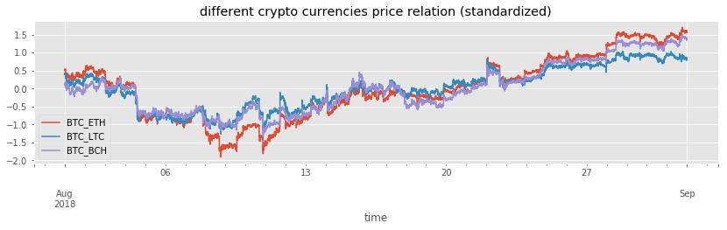First, we standardized the price of each currency. As for BTC occupy most of the crypto currency market, we then choosing BTC as the *leading currency* to check its relationship with others. The Graph below is the differ during August between BTC and other three crypto currency.

The seasonality analysis is based on BTC-ETH price relation as an example. We can see from the graph below, a relative period stable seasonal pattern, even though the changing volume is unstable.

Despite the residual and trend component take the most part of the total volume, they all show a character of stable rise/fall period. Based on the relatively stable relation, we can build model even only a none-model strategy to do the trading.

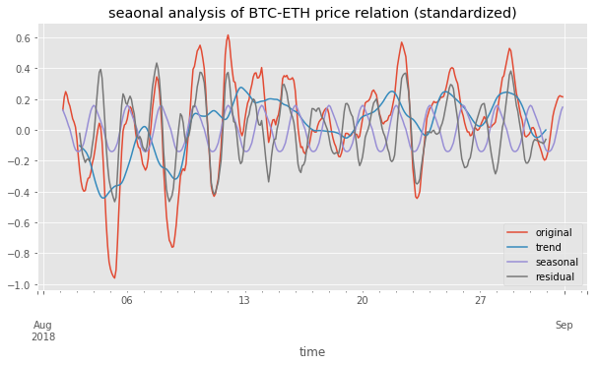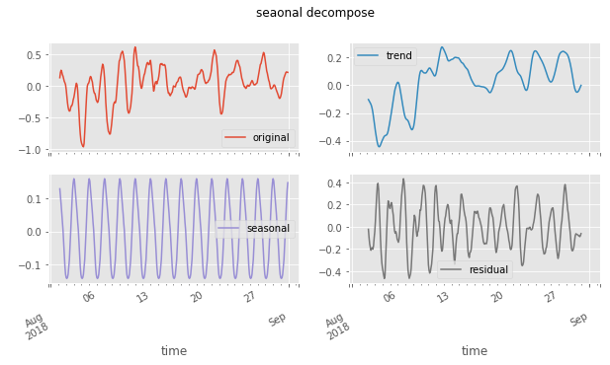

* 1. Conclusion

Considering the characteristic of the data, the result is just as we expected. On the one hand, it is hard to find any seasonal pattern directly in the price, which is easy to understand. The crypto price is like stock market, there are many influential factors beyond the data itself and most of them are hard to be cachet and integrated in the model. On the other hand, despite the uncertainty in a single currency, the relationship between currencies are relatively stable or at least show a stronger seasonal pattern. The reason is obvious, once there is a price difference, people can use it to make money and the price gap will be filled. As the result, all crypto currency has strong correlation between each other.

Although it is difficult to predict the price directly, we still build several models upon the price and other features generated from it. These models may not have an outstanding performance, but they are different attempts taking different aspects and features. Despite the poor accuracy they may have, the thought behind them might be inspiring.

Based on the thought of ensemble learning, we will finally combine all the weak models, to get a stronger model.

1. Linear Model

This model attempt to use the relationships between different currency to predict the price or the trend of a certain currency in a period. In this case, we use BTC-USD as the target predict currency. This part will show several different parameter combinations and comparing the performance as well as do interpretation.

* 1. Features

Model Features: The price of 4 crypto currency in N period before.

Model Prediction: The mean price of price of BTC-USD in next 10 minutes.

Here N and M are hyperparameters. For example, we can use previous 5 minutes’ data to predict the average price of next 10 minutes.

* 1. Implement

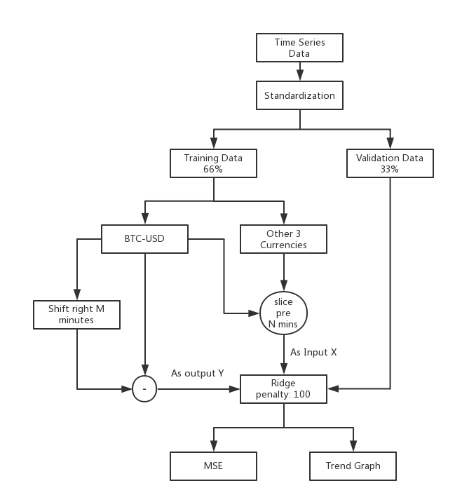

The modeling process as graph above shows, uses data of all three currencies price from N minutes ago to predict the BTC currency price at one minutes later. Here we have tried two different outputs, one is just directly predicting the price while another is predicting the mean price of next 10 minutes. Since we don’t need to do the feature selection, we choose Ridge as the linear mode with the penalty factor settled as 1 and 100 for 2 kinds of outputs respectively. Moreover, the training data & validation data are separate by 66% and 33%.

Finally, we use MSE to measure the performance for the regression model.

* 1. Performance / Evaluation
     + MSE

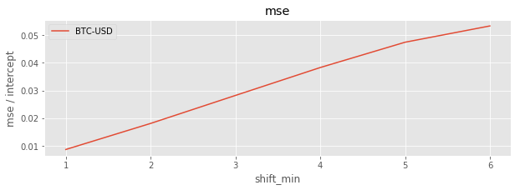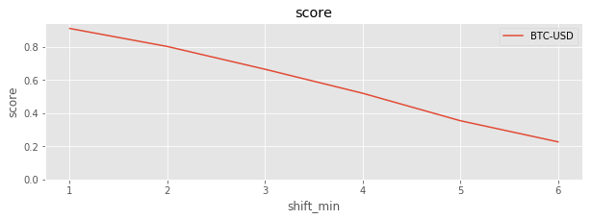

The X axis is the shift minutes of the input data, which increase one unit represents add another four features as input for the model. As we can see, the accuracy will gradually decay by the increase the offset length.

* + - Trend of predict next minutes

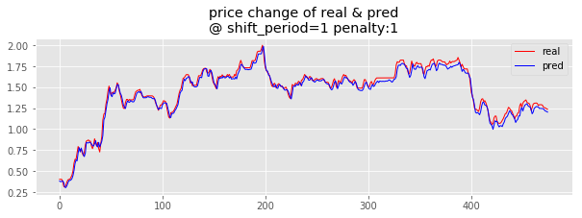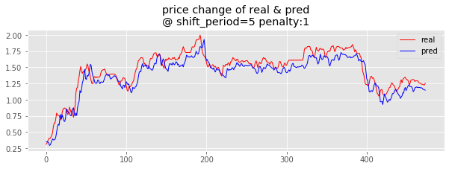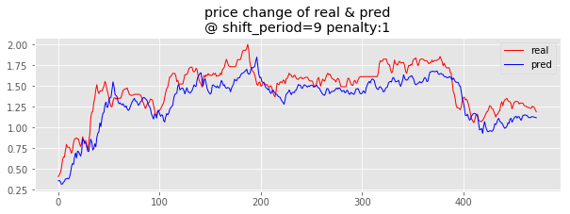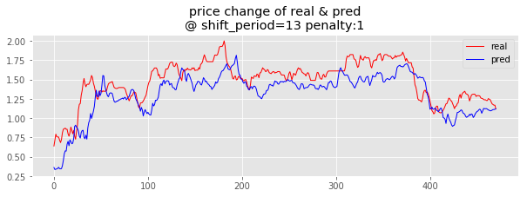

From these four pictures we can find 2 things. Firstly, the difference between fitted value and the real trend keeping increase with the larger shift period. While the general trend keeping same all the time. Secondly, just look at the first 2 graphs, the difference between prediction and true value also extend for later time.

* + - Trend of predict mean value of next 10 minutes

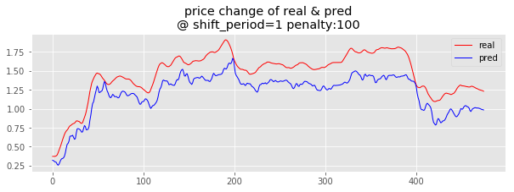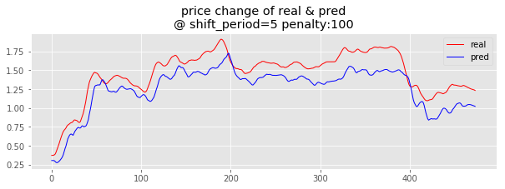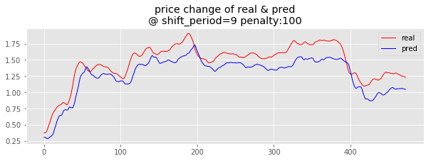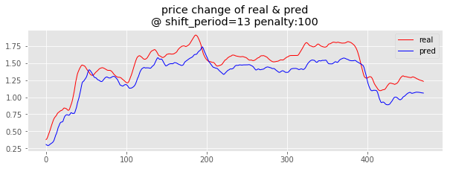

While the direct price prediction has very frequent fluctuations which bring many noises to the model. Thus, we use the mean price of the nearest 10 minutes and strong penalty to smooth the curve. As the result shows as above, the more time points we use as input, the smoother the prediction it is. And still the prediction, it keeps the general trend of the real value.

* + - Interpretation

Although the performance seems very good, it can only prove a roughly linear relationship between the four currencies price. In fact, the fitted price curve is guided by the previous true value. As we can find that the blue line which represents the prediction, is always have an offset to the left comparing with the red line. Such offset means the prediction is behind the real value, especially for those turning points. Therefore, it can hardly be used for the strategy to provide long/short single.

However, it doesn’t mean the model is meaningless, we can still generate some features such as the changing rate between currencies, which could have a strong correlation between each other, to do the future modeling.

And in the next step, we have tried to avoid making prediction on the price, we simply swift to a classification approach to predict the rising or falling trend.

1. Boosting Classification

As it is not necessary to know the exact price to do the trading, we make a simple classification model to prediction the future trend to support our strategy.

* 1. Features

As same as the linear model, we use the same features as input, while simply change the output to a binary value which indicate the rise or down of future price. Since a linear predictor didn’t provide the valuable prediction, we switch the core model to AdaBoost.

Model Features: The price of 4 crypto currency in N period before.

Model Prediction: Raise or fall of the mean price of BTC-USD in next 10 minutes.

* 1. Implement

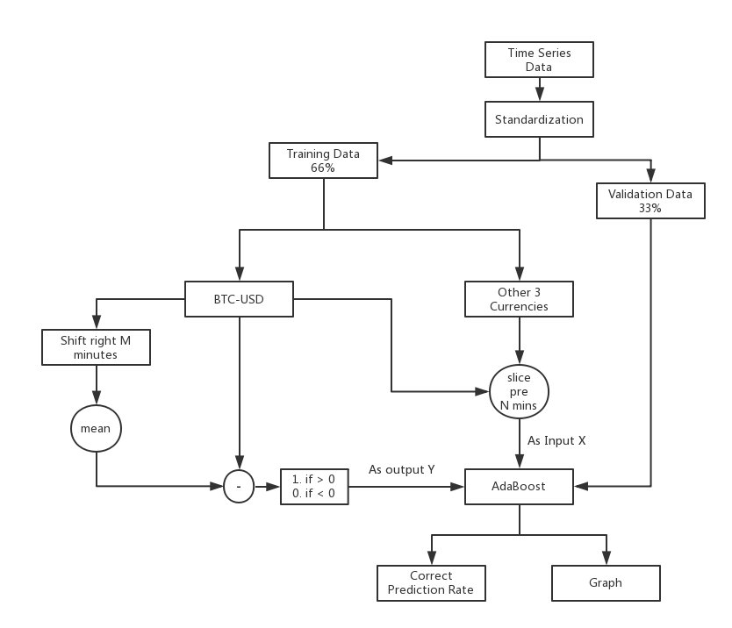

The modeling process is similar with the linear model, with a major modification which transform the output to a binary value. And we use the correct prediction rate to judge the performance of the classifier.

* 1. Performance / Evaluation
     + Trend Graph & indicators

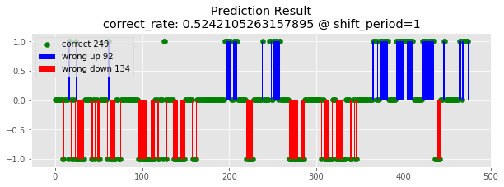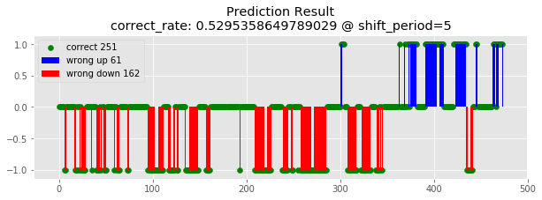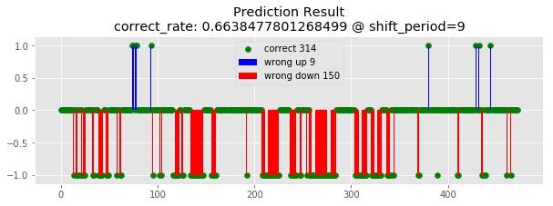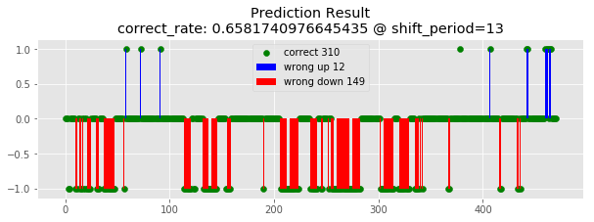

The graph shows the prediction results. The red bars indicate the wrong prediction of price fallen, and the blue bar means the error on price raising. Each point represents one prediction and the green dots in the X axis are the correct prediction. It shows with more past data as input, the more accurate the model reach.

* + - Interpretation

After running multiple times of the model, we find the performance is not stable. The result depends on the trending of the currency price in the week. It tends to make more wrong prediction on the opposite direction. Such case can be explained by the model only learn the trend of previous data. If the old data contains more falling, the model will make more prediction as falling, vice versa. Furthermore, the problem of this model is it cannot judge the violent drop or jump, and it treat all price changing as same. But in fact, the wrong prediction will do more damage if the price varies violently.

1. Strategy

Apart from the prediction model, strategy is another important component. It should not only decide the timing and quantity of long and short, but also need to monitor the balance level in case it is too low to continue the trading. Furthermore, due to the low accuracy of the model, the strategy will need to have a mechanism to do the correction or even handle the corrupted model as well. This chapter will introduce our strategy from these aspects.

* 1. Details

Comparing to the simplest strategy, which is completely passive to the long/short signal, one of the advantages of the active strategy is it have a mechanism of stop-losses and a proper money management which will try to make the best use of all the resources.

The process graph above illustrates our strategy. In each minute, we will first store the currency data to support the model making prediction. Once the system judges current time as the trading time, a prediction period unit (30 mins~4 hours) of previous observed data will be sent to the model and get a prediction. Normally the prediction result will be transferred to a probability of currency trend as the long/short signal. Based on the probability and other pre-settled factors, we will calculate a target price and generate a trading record. The formula will consider both confidence, average price fluctuation of the specific crypto currency and a prior judgement of the trend of next week made by ourselves. Such prior will also play a role to handle the dirty trading (those cannot be sold before the next prediction period).

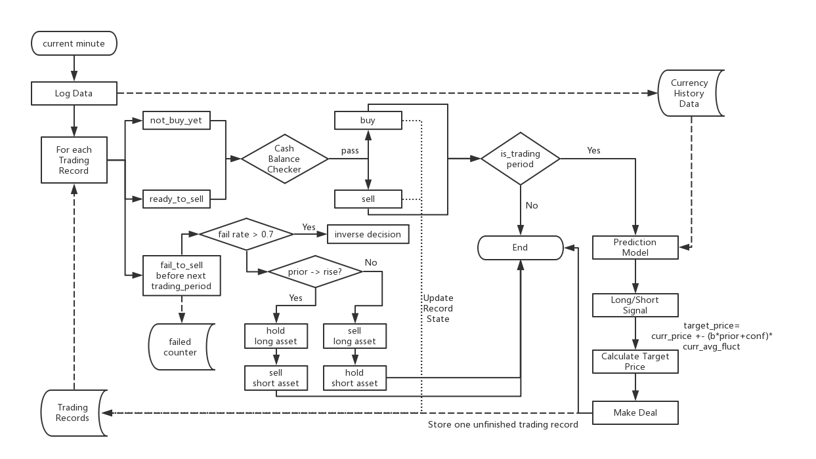

Whether this trading will be success or not depends on the next minute price. On the one hand, in order to avoid the influence of noise (meaningless fluctuation), we will only make new prediction and trade after a prediction-period which is defined as the time span the model required. On the other hand, during the trading gap, we will keep monitor the price changing, once the price reaches the target price of a trading record, the strategy will automatically sell and close the trading. Here by sell means short the longed assets or long the shorted assets, and it depends on the trading record type. While every change of the asset balance needs to pass through a cash balance checker to make sure the cash balance will not lower than the limitation to avoid the framework stop any further trading.

However, not every trading will be normally closed. It is inevitable to have some failed trading left after one period due to the wrong prediction or the unsuitable target price. In such case, the system will count the failed times, after a certain number of trading, if the failure rate is higher than 70%, it will trigger the prediction flip mechanism. Furthermore, how to handle the failed trading will depend on the pre-settled prior. If we think there are more chance that the currency will rise in next week, all longed assets will be hold till the end while the shorted assets will be sold immediately to stop losses, vice versa.

The existence of these mechanism will help us avoiding many unnecessary loss, making up some short comes of the model, and to improving the trading performance.

* 1. Evaluation

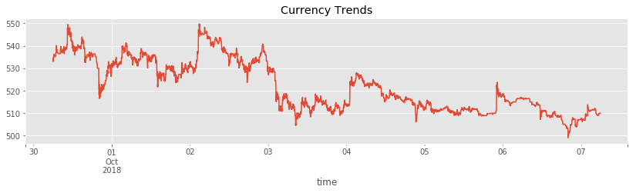To illustrate the performance of the strategy, we choose the data from Sep 30th to Oct 7th. And making a comparation with one of the demo strategies.

The graph is the currency trend in that week, as we can see have several big wavs and show a general trend of decrease in final.

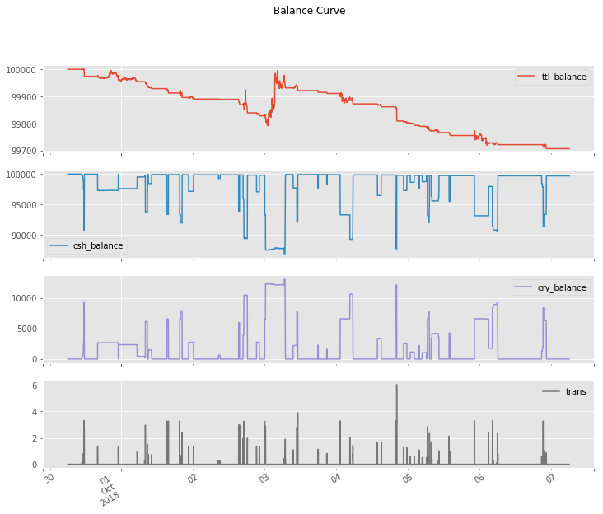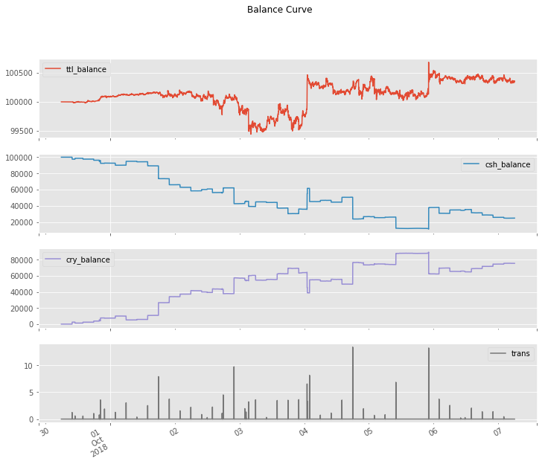

The graphs in the right is the balance curve of our strategy, while the left is the three-white-solider demo. Comparing them two, it is obvious that the former one reduces many unnecessary trading which bring a relatively continues increase of the total balance during the stable stage of the currency price. Although there is still violent changing during the whole week, these shortcomings are mostly due to the inaccurate prediction which is less relatively to the strategy.

Furthermore, this strategy also tries to make the best usage of all resources while still keeping the cash balance in the safe level. On the contrast, the demo strategy only uses 1/10 cash during the whole process. To achieve this, we have invested in all four crypto currencies at each trading period and using the specific trading unit respectively.

Comparing to the demo, the strategy finally results in a positive gain during the decrease of the market.