Talus Rich Content Acceptance

Section 1: Chemistry (Base)
1. Identify the coefficient of water in 2 H₂ + O₂ → 2 H₂O(l). Compare CO₂, H₂SO₄, Ca(OH)₂ and Unicode H₂O, CO₂, H₂SO₄, Ca(OH)₂.
Compare ions Mg²⁺, Fe³⁺, SO₄²⁻, NH₄⁺ with Unicode Mg²⁺, Fe³⁺, SO₄²⁻, NH₄⁺.
Context ΔH, ΔE, α, β, γ, θ, λ. NaCl(s) → Na⁺(aq) + Cl⁻(aq). Units kJ/mol.
A. 1
B. 2
C. 3
D. 4
Answer: B

Section 2: Physics (Proficient)
Use 9.81 m/s² and preserve three significant figures in 2.50 × 10³ kg/m³.
2. Identify the given small measurement 3.5 × 10⁻⁴. Compare 6.02 × 10²³, v₀, v², Δt and Δx.
A. 3.5 × 10⁴
B. 3.5 × 10⁻⁴
C. 3.5 × 10⁻³
D. 3.5 × 10⁻⁵
Answer: B
3. Write the stated particle count to three significant figures.
Answer: 6.02 × 10²³

Section 3: Mathematical Models (Exemplary)
4. At a=6, b=4, c=2. Compare E4A $\frac{a+b}{c}$ with E4B $a+\frac{b}{c}$. State whether their values agree.
Answer: 5 versus 8.
5. At x=2, n=3. Compare E5A $x^{n+1}$ with E5B $x^{n}+1$. State whether their values agree.
Answer: 16 versus 9.
6. At x=8. Compare E6A $\sqrt{x+1}$ with E6B $\sqrt{x}+1$. State whether their values agree.
Answer: 3 versus approximately 3.828.
7. For the sequence a_k=2k at i=2. Compare E7A $a_{i+1}$ with E7B $a_{i}+1$. State whether their values agree.
Answer: 6 versus 5.
8. Evaluate E8A $\frac{9}{2+\frac{6}{3}}$ and E8B $\sqrt[3]{27}$.
Answer: 2.25 and 3.
9. Identify the index and exponent in E9A $v_{0}^{2}$ and evaluate E9B $\left[7−4\right]×5$.
Answer: Index 0, exponent 2, and 15.
10. Evaluate E10A and E10B below.
$$\sum_{k=1}^{4}{k}$$
$$\cos\left(0\right)$$
Answer: 10 and 1.
11. Which expression gives one half?
A. $\frac{1}{3}$
B. $\frac{1}{2}$
C. $\frac{2}{3}$
D. $\frac{3}{2}$
Answer: B

Section 4: Lab Analysis
12. MIX-START Use E12A $v=\frac{Δx}{Δt}$ to analyze this run. MIX-AFTER.
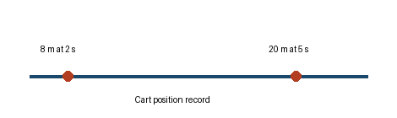
Between diagrams record the baseline.
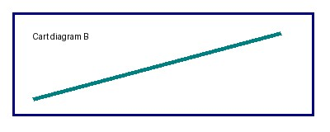
After diagrams compare the reading. Bold marker Italic marker
Time (s) | Position (m) | Instrument
2 | 8
5 | 20 | Laser
MIX-END E12B $\frac{20−8}{5−2}$ gives the average speed.
Answer: $4$ m/s.

Section 5: Instrument Calibration
13. Calibration grid. Explain which reading is highest.
Run group |  | Notes
Series V | 14.250 | m/s
Series V | 2.50 | kg/m³
Last | 6.02 × 10²³ | H₂O ratio $\frac{7}{4}$
Answer: Compare the stated measurements.

