Option 1 – Solr

## Solution Description

The Scopus PoC is an add-on effort to the ScienceDirect FAST migration PoC that was conducted in the second half of 2013. Specifically, the development teams determined that the Scopus product/datasets exhibited some distinct attributes that were not adequately investigated as part of the ScienceDirect PoC. The most significant of these attributes are: more distinct documents with a higher update volume, numerous high cardinality facets with exact counts, the need to incorporate accurate corpus-wide statistics, and more complex scoped queries. Since many of the Scopus requirements had been proved out in the ScienceDirect Hothouse, they were not repeated here and we focused on those key functional differentiators as well as ensuring performance would meet the defined targets. All development/sizing was based on the Elsevier Scopus Search Prototype Version 1.0 (March 17,2014) document. If these requirements change, this must be taken into consideration should the Solr approach be adopted.

One major design decision the team decided on early was to perform updates offline to the active index being searched. This decision was made to remove the impact of high update volumes adversely impacting the query performance as well as providing a solution to guarantee accurate corpus-wide statistics (e.g. publication and citedby counts). This solution dictates that updates to the index will only be released at predetermined intervals and implies that updates will not be immediately viewable on the system. Currently the team has proposed a daily promotion of the index (although it is possible it could happen more frequently depending on the amount of time needed to complete all processing work). We will discuss the proposed solution for this approach in more depth later in the document.

For the Solr PoC we leveraged release 4.6.0 of the software using Solr Cloud, Oracle’s Java version 1.7_17, and ran all of our componentry in the Amazon AWS cloud. Specifically we leveraged Amazon SQS for workflow management, S3 as a content repository, DynamoDB as an inventory control database, Redshift to calculate corpus wide statistics present in Scopus, and Kinesis to populate data into Redshift as individual documents are updated.

**1.1.1 Document Indexing Control System**

We leveraged Amazon SQS (Simple Queue Service) as a simple workflow management system. We add individual entries onto the content type specific queue for each document that needs to be processed in addition to the action to take (add, delete, update), and timestamp from the XFab system to ensure the order of changes to the index. The Document Indexing Program (detailed later in this section) reads these messages in order to process a document.

We also leveraged Amazon’s DynamoDB as an inventory control master for our solution. By using this repository, we can perform synchronization checks against the associated S3 content repository and XFab system that has provided to content to process in order to make sure we have processed all the changes to date.

**1.1.2 Search Index and Document Schema**

For the PoC, we manually crafted an index schema based upon the SC13-3 V52 Scopus FAST CIP for each of the three content types. We also defined a number of analyzers (tokenizers plus filters) to represent the various permutations needed to support the stated requirements. Due to the variety of tokenization strategies needed to support things like punctuation sensitivity, stop word processing, faceting, etc. we were forced to define alternate “shadow” fields for many of the large textual fields in the CIP (similarly to what FAST needs to do today). These shadow fields have the side effect of drastically increasing the size of the index on disk (e.g. 2 shadow fields for different phrase matching for a given document field adds 2X to the required index storage for that field). Additionally, we had to define group fields to map to the concatenated fields generated by FAST (e.g. all, allmed, auth, etc.) during their indexing of content. As we were using a dump of the Scopus data in “storage format”, we did not have all of the merged data fields present in the documents (e.g. Affiliation fields in author profiles). In some cases, we were able to find the data from other fields in the document and in others we were unable to populate those fields. This implies that some of the queries captured from the Scopus logs will not find results when run. Finally, there were a number of fields that were generated by FAST as part of their indexing that were not present in the ingested content and we did not have the ability to reproduce. In those cases, we provided a standard default value when possible. When all was done, we had defined an index profile of approximately 160 fields (A number of fields were not present in our mappings as they are created during the FAST indexing pipeline and were not available in the XML).

**1.1.3 Solr cluster configuration(s)**

For the PoC, we actually had three separate Solr Coud clusters, one for each content type. This was intentional, as it allows us to target each content type to the appropriate sized hardware based on index size as well as query throughput/response time requirements. In discussions with external Solr consultants that were engaged as part of the PoC, we determined that Solr is typically RAM throttled. This means that in order to get maximum performance out of a deployment, you want to have as much of the index resident in memory as possible. This was the guiding light as we sized and deployed our test clusters.

Both the affiliation and author indexes were small enough that we were able to run them on smaller, single machines with a single shard per content type. The cores index was significantly larger and required us to configure it for 5 shards and run it on five separate large memory footprint machines. All of the indexes store only the fields that are defined as being returnable in the Scopus CIP so any reloading of the content requires a re-fetch from the S3 buckets and a reprocessing of the entire document. The sharding of documents is done with a simple approach using the individual content types’ primary id.

In addition to sharding, Solr Cloud also supports the replication of shards. A replica is a complete copy of a shard. To increase query capacity, as well as provide for HA deployments, you can increase the replication factor for an index and add additional processing data nodes into the cluster. Unlike sharding, the replication factor for an index can be adjusted in real time. Our cluster currently has no replicas configured currently. This implies that losing a single EC2 instance would degrade search performance by limiting the set documents that could be returned by a search (the problem shard’s data could not be returned via search until the shard was restored although searches would still run). In the case of the single-sharded content types, search would be unavailable. A HA solution can be provided by replicating the entire solution (loader and search cluster) into an additional availability zone.

In addition to the actual data nodes in the cluster, we also have a collection of three Zookeeper nodes that are responsible for cluster management. They take care of making sure data nodes are still alive, organization the migration of primaries and replica shards as needed and other housekeeping duties. In addition, our Solr clients are configured to leverage the Zookeeper nodes when determining what Solr nodes are available to use to satisfy requests. Our cluster requires that a quorum of master nodes is available for the cluster to function properly.

**1.1.4 Content Indexing program**

As part of the PoC, we developed a custom Java program for each content type to drive the indexing of documents in Solr. This program performs the following tasks for each record it processes:

* Read an entry from the SQS queue
* Retrieve the associated document from S3 and copy it to local disk (to avoid Amazon S3 I/O errors encountered while attempting to process the content as a stream from S3).
* Apply a large collection of XPath expressions to extract the textual content from our documents (as defined by the CIP for that content type) and convert it into a JSON representation that will be indexed. This includes massaging the content as needed to support specific functionality (e.g. scoped searching, group fields, etc.).
* Submit JSON document to Solr cluster for indexing
* Update DyanmoDB inventory control for that document with the new metadata information.
* For Core content only: extract out the associated author and affiliation ids as well as the ids for documents being cited by that paper. This information is then sent to AWS Redshift via AWS Kinesis for later batch processing to generate the corpus wide statistic counts to be merged back into all three content types’ indices.

This piece of code would need to be re-implemented for each distinct content type implementation. As the overall task of processing documents for indexing can be highly parallelized, we utilize the same program to do ongoing updates as well as bulk loads of content. We merely start up the appropriate number of boxes, each running multiple copies of this program.

**1.1.5 AWS Kinesis/Redshift**

As previously mentioned, when core records are indexed, the indexing program will extract key information from the record that will be fed into the calculations of author and affiliation publication counts as well as citedby statistics. As a single document can spawn changes in multiple other records in the system and multiple documents can be processed in parallel, it is not possible to perform real time updates to these calculated statistics and guarantee their accuracy at a given point in time. A “batch” calculation approach against a snapshot of all the data provides a solution to this problem. We are leveraging AWS Redshift to provide the “batch” calculation environment. Redshift is Amazon’s large-scale data warehouse offering. In our case, it essentially has a large datastore that contains all of the publication (author and affiliation) relationships as well as the cited-by relationships. As documents are processed, changes are posted to the datastore so it will eventually become consistent before the calculations are performed. After the calculations are performed, the results are exported out as flat files to AWS S3, and then promoted to the individual Solr services as external data files where the values can be used in queries, sorting, etc. without requiring an update to the underlying document.

As Redshift is not designed to accommodate the high update load from all of our generated changes, we are leveraging AWS Kinesis. Kinesis is a managed service for real-time processing of streaming data at massive scale. The core indexer posts the metadata into Kinesis where they are grouped together in a batch and updated into Redshift in a single update.

**1.1.6 Load Driver Program**

We use a standard load driver script that was written as part of the hothouse effort to submit the proper mix of queries into the Solr Search cluster for a specific content type. Specifically, we take the load test query set and process them through a XSL stylesheet to transform them into Solr specific syntax. These Solr specific queries are stored in Dynamo DB with a key that relates them to the original query set. In order to generate a query mix to run, we create a list of all the DynamoDB keys and randomly shuffle the entries (the correct percentages of each type of query is maintained). The load test script then submits POST requests to a small Node.js application that retrieves the preformatted query and submits it to the Solr REST endpoint for processing. This node app captures performance information and logs it to a file where it is collected and transmitted to a Kibana installation where we can monitor the results and generate reports.

## Architecture Diagram of POC

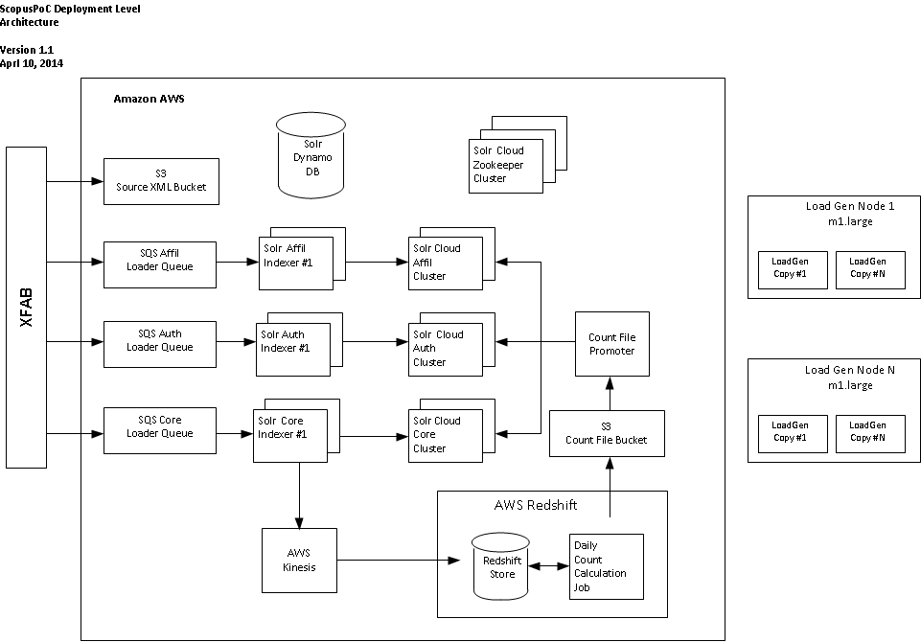

## Affiliation Testing Results

### Affiliation Content Loading

We were able to complete the initial bulk load of 8,163,349 records in approximately 2 hours and 30 minutes. We should note that due to current Scopus CIP restrictions, only a percentage of the records are actually searchable in the product (essentially only top-level affiliations). As a result we dropped those records that were not top-level affiliations during processing which resulted in only approximately 3.5 million records ending up in the index. The dropping of the records had a significant impact on our throughput levels compared to the other content types. We observed less than 50% CPU utilization during the initial load and update runs.

While loading, Solr was configured to use a maximum of 8 indexing threads as well as a modified ramBuffer from the default. Specifically, the ramBufferSize was set at 1536MB with a maxBufferedDocs of 100,000. These settings control how much processing Solr will do in memory before committing to disk in the transaction log and represents the amount of work that can be lost if a machine goes down. Finally, the autoCommit maxTime was set to a max time of 10 minutes. This controls how frequently transaction log records are merged into the Solr index segments. Reducing the log size reduces the recovery time needed to replay the log entries against the checkpointed index should a machine go down. Finally, at the end of indexing, we optimize the index to reduce the size and increase the search performance characteristics. We do this as we anticipate flipping indexes at which point the newly optimized index will become read only and only used for query resolution.

Machine/Solr details:

* AWS m1.xlarge
  + 4 vCPUs
  + 15GB RAM
  + 4 x 240GB Ephemeral Drives
  + High Network performance
    - Note: attempts to use a m1.large instance with a “Good” Network performance profile resulted in significant increase in measured time from the test drivers relative to the Solr reported query time. Upgrading to a m1.xlarge removed that delay without changing the reported Solr response time.
* Solr Config
  + -XX:+UseParallelGC
  + –Xms4G
  + –Xmx4G
  + 2 x 240GB drives in raid 0 array.

**Notes:**

* We did not actually compute the corpus wide statistics for the test dataset. Records were loaded with dummy values for the publicationCount field that encompass the corpus wide statistics for affiliations.

Table 1: Affiliation Bulk Load statistics

|  |  |
| --- | --- |
| Queue Size | 8,163,347 (2 records dropped during queue population) |
| Solr cluster | 1 x m1.xlarge instance |
| Number of indexer processes | 5 x cc1.4xlarge instances (20 indexer processes/instance) |
| Dynamo DB Read/Write rate | 1500/1500 |
| Processing Time | 2:26 |
| Index Rate | approx. 3,265,000/hr |
| Pre-optimize index size | 1.15 GB |
| Optimize time | 0:02 |
| Post optimize index size | 1.07GB |
| Total processing time | 2:28 |

Table 2: Affiliation 1x Update Load Statistics

|  |  |
| --- | --- |
| Queue Size | 250,000 |
| Solr cluster | 1 x m1.xlarge instance |
| Number of indexer processes | 5 x m1. xlarge instances (5 indexer processes/instance) |
| Dynamo DB Read/Write rate | 300/300 |
| Processing Time | 0:36 |
| Index Rate | approx. 500,000/hr (note indexers warming up during this run) |
| Optimize time | 0:02 |
| Total processing time | 0:38 |

Table 3: Affiliation 3x Update Load Statistics

|  |  |
| --- | --- |
| Queue Size | 750,000 |
| Solr cluster | 1 x m1.xlarge instance |
| Number of indexer processes | 5 x m1. xlarge instances (5 indexer processes/instance) |
| Dynamo DB Read/Write rate | 400/400 (increased from 1X run. Noticed some Dynamo DB capacity warning from previous run). |
| Processing Time | 1:05 |
| Index Rate | approx. 750,000/hr |
| Optimize time | 0:02 |
| Total processing time | 1:07 |

### Affiliation Query Load Testing

For the full query set, we had an overall target of an average rate of 4 qps with no average overall response time. In addition we had specific average response times for the two identified query types (navigators and no navigators). We ran one load test box with one copy of the load test script. The script ran for 15 minutes to warm the cluster before official measurements were taken. We were able to far exceed the target Scopus requirements, reaching 27 QPS on average. In fact, we exhausted our test query set in under the hour allocated for the test. In addition, Solr was able to surpass all of the existing specific query type measurements/requirements.

The single Solr server was running on one m1.xlarge instance. The Server was configured to use at most 4GB of the 15 available on the instance (leaving enough to run a separate update cluster on the same instance without impacting performance). This amount of RAM can easily contain the entire index in memory to get optimal performance from Solr. In addition to being memory sensitive, the Solr deployment is also sensitive to the Network I/O available. We had tried running on an m1.large instance type but were seeing a wide discrepancy between the request times measured at the load test box and those reported by Solr itself. We attributed this to the limited I/O bandwidth associated with the m1.large instance type and upgraded the hardware for the official run.

The instance itself showed minimal CPU usage during the tests that would seem to indicated significantly more capacity could be extracted from the hardware. One other item to note is that we had no replicas configured in the cluster to simulate an HA deployment. Adding a second instance would effectively double the query capacity to at least 54 QPS. It may be possible to investigate combining the affiliation cluster onto the same hardware as the author cluster to save costs (assuming an instance type with adequate RAM for both indexes can be identified).

Table : Query Mix for Affiliation Test set – Navigator Based

|  |  |  |
| --- | --- | --- |
| **Query Type** | **Number of queries** | **Percentage of mix** |
| Navigator | 737 | 1% |
| No Navigator | 64,115 | 99% |

Table : Affiliation full query mix 1 hour overall averages (Note ran out of queries after approx. 45 minutes)

|  |  |  |  |  |
| --- | --- | --- | --- | --- |
| **Query Type** | **AVG Request Rate** | **Max**  **Request**  **Rate** | **Avg Response Time** | **Max Response Time** |
|  |  |  |  |  |
| Scopus Targets | 4 qps | 8 qps | N/A | 3,643 ms |
| Solr Observed | 27 qps | 29 qps | 20 ms | 1,024 ms |

|  |  |  |  |  |
| --- | --- | --- | --- | --- |
| **Query Type** | **Mean** | **Median** | **P95th** | **Max** |
|  |  |  |  |  |
| Scopus Target - Navigator | 129 ms | 103 ms | 243 ms | 979 ms |
| Solr Observed - Navigator | 21 ms | 20 ms | 30 ms | 131 ms |
|  |  |  |  |  |
| Scopus Target - No Navigator | 95 ms | 70 ms | 180 ms | 3643 ms |
| Solr Observed - No Navigator | 20 ms | 18 ms | 28 ms | 1024 ms |

Figure : Affiliation Full Query Mix -1 Hour Snapshot (4/14/2014 9:00 EDT – 9:40 EDT)

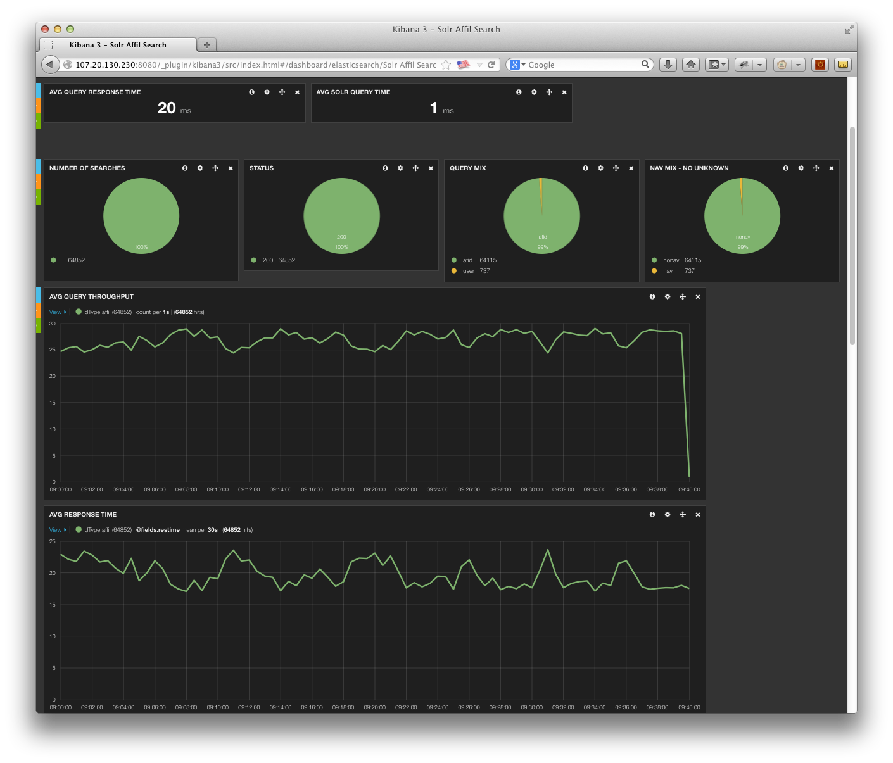

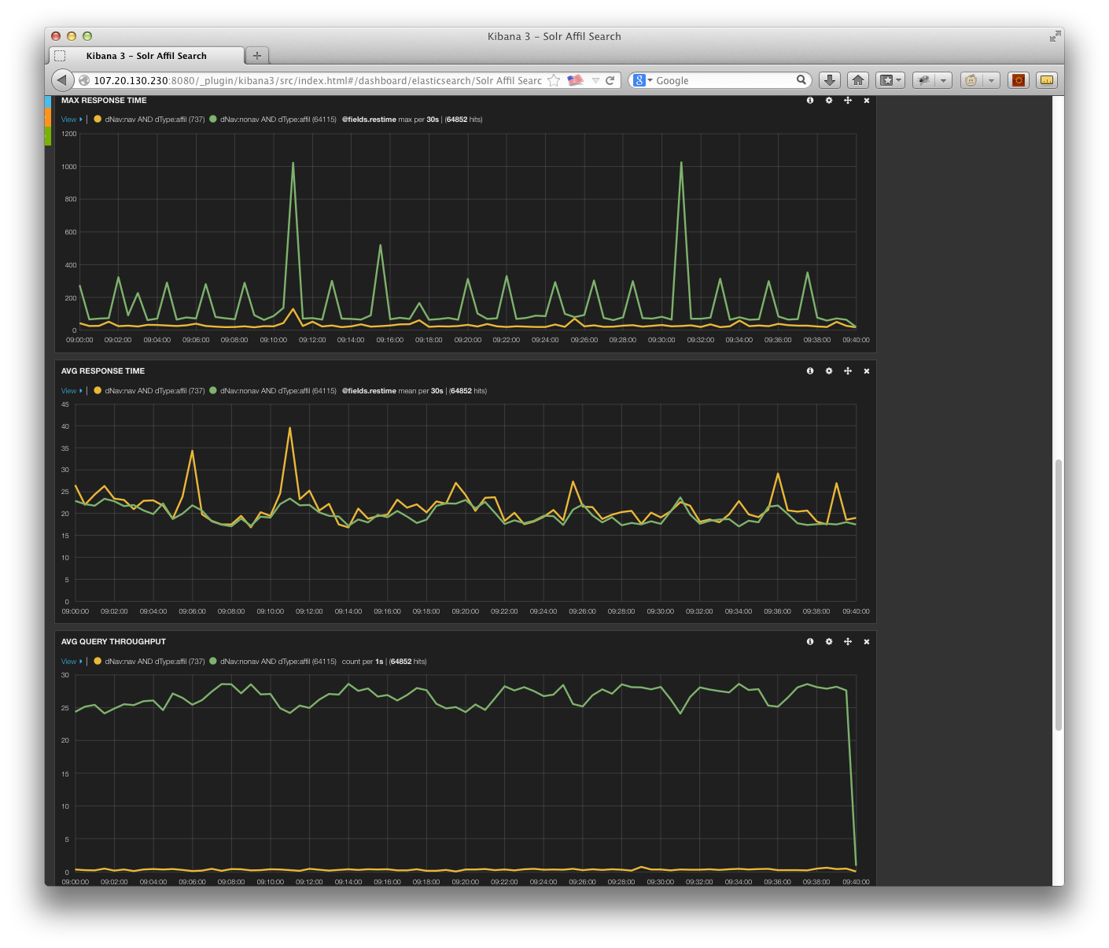

## Author Testing Results

### Author Content Loading

We were able to complete the initial bulk load of 49,705,977 records in approximately 4 hours and 30 minutes. We observed less than 50% CPU utilization during the initial load and update runs. As we ramped up DynamoDB R/W capacities, load performance increased linearly, implying we are not CPU bound on the machine.

While loading, Solr was configured to use a maximum of 8 indexing threads as well as a modified ramBuffer from the default. Specifically, the ramBufferSize was set at 2048MB with a maxBufferedDocs of 100,000. These settings control how much processing Solr will do in memory before committing to disk in the transaction log and represents the amount of work that can be lost if a machine goes down. Finally, the autoCommit maxTime was set to a max time of 10 minutes. This controls how frequently transaction log records are merged into the Solr index segments. Reducing the log size reduces the recovery time needed to replay the log entries against the checkpointed index should a machine go down. Finally, at the end of indexing, we optimize the index to reduce the size and increase the search performance characteristics. We do this as we anticipate flipping indexes at which point the newly optimized index will become read only and only used for query resolution.

Machine/Solr details:

* AWS m3.2xlarge
  + 8 vCPUs
  + 30GB RAM
  + 2 x 80GB Ephemeral SSD Drives
  + High Network performance
  + Note: recommend using some of the newer Amazon r3 family instances in production. They will be a better match for this index. These instances were announced but unavailable during the PoC
* Solr Config
  + -XX:+UseParallelGC
  + –Xms20G
  + –Xmx20G
  + 2 x 80GB drives in raid 0 array.

**Notes:**

* We did not actually compute the corpus wide statistics for the test dataset. Records were loaded with dummy values for the publicationCount field that encompass the corpus wide statistics for authors.

Table 6: Author Bulk Load statistics

|  |  |
| --- | --- |
| Queue Size | 49,705,977 |
| Solr cluster | 1 x m3.2xlarge instance |
| Number of indexer processes | 40 x cc1.4xlarge instances (20 indexer processes/instance) |
| Dynamo DB Read/Write rate | 4096/4096 |
| Processing Time | 4:33 |
| Index Rate | approx. 11,046,000/hr |
| Pre-optimize index size | 28.25 GB |
| Optimize time | 0:22 |
| Post optimize index size | 21.4 GB |
| Total processing time | 4:55 |

Table 7: Author 1x Update Load Statistics

|  |  |
| --- | --- |
| Queue Size | 250,000 |
| Solr cluster | 1 x m3.2xlarge instance |
| Number of indexer processes | 5 x m1. xlarge instances (5 indexer processes/instance) |
| Dynamo DB Read/Write rate | 500/500 |
| Processing Time | 0:37 |
| Index Rate | approx. 649,000/hr |
| Optimize time | 0:28 |
| Total processing time | 1:05 |

Table 8: Author 3x Update Load Statistics

|  |  |
| --- | --- |
| Queue Size | 750,000 |
| Solr cluster | 1 x m3.2xlarge instance |
| Number of indexer processes | 5 x m1. xlarge instances (5 indexer processes/instance) |
| Dynamo DB Read/Write rate | 500/500 |
| Processing Time | 1:52 |
| Index Rate | approx. 600,000/hr |
| Optimize time | 0:30 |
| Total processing time | 2:22 |

### Query Load Testing

For the full query set, we had an overall target of an average rate of 9 qps with no overall average response time. In addition we had specific average response times for the two identified query types (navigator and no navigator). We ran one load test box with one copy of the load test script. The script ran for 15 minutes to warm the cluster before official measurements were taken. We were able to far exceed the target Scopus requirements, reaching 20 QPS on average. In addition, Solr was able to surpass all of the existing specific query type measurements/requirements.

The single Solr server was running on one m3.2xlarge instance. The Server was configured to use at most 20GB of the 30GB available on the instance. The actual instance type we wanted to run on was not yet available from Amazon, so we were unable to leave enough RAM to run a separate update cluster on the same instance. This amount of RAM can easily contain the entire index in memory to get optimal performance from Solr.

The instance itself showed minimal CPU usage during the tests that would seem to indicated significantly more capacity could be extracted from the hardware. We did not push the hardware to its limit as we had already surpassed the targets One other item to note is that we had no replicas configured in the cluster to simulate an HA deployment. Adding a second instance would effectively double the query capacity to at least 40 QPS. It may be possible to investigate combining the author cluster onto the same hardware as the affiliation cluster to save costs (assuming an instance type with adequate RAM and disk drives for both indexes can be identified).

Table : Query Mix for Author Test set – Navigator Based

|  |  |  |
| --- | --- | --- |
| **Query Type** | **Number of queries** | **Percentage of mix** |
| Navigator | 10,627 | 14% |
| No Navigator | 62,997 | 86% |

Table : Author full query mix 1 hour overall averages

|  |  |  |  |  |
| --- | --- | --- | --- | --- |
| **Query Type** | **AVG Request Rate** | **Max**  **Request**  **Rate** | **Avg Response Time** | **Max Response Time** |
|  |  |  |  |  |
| Scopus Targets | 9 qps | 15 qps | N/A | 29,091 ms |
| Solr Observed | 20 qps | 23 qps | 31 ms | 2,100 ms |

|  |  |  |  |  |
| --- | --- | --- | --- | --- |
| **Query Type** | **Mean** | **Median** | **P95th** | **Max** |
|  |  |  |  |  |
| Scopus Target - Navigator | 242 ms | 101 ms | 1,013 ms | 29,091 ms |
| Solr Observed - Navigator | 83 ms | 73 ms | 172 ms | 752 ms |
|  |  |  |  |  |
| Scopus Target - No Navigator | 131 ms | 46 ms | 174 ms | 28,168 ms |
| Solr Observed - No Navigator | 22 ms | 19 ms | 35 ms | 2,100 ms |

Figure : Author Full Query Mix – 1 hour snapshot (4/14/14 10:50 EDT 11:50 EDT)

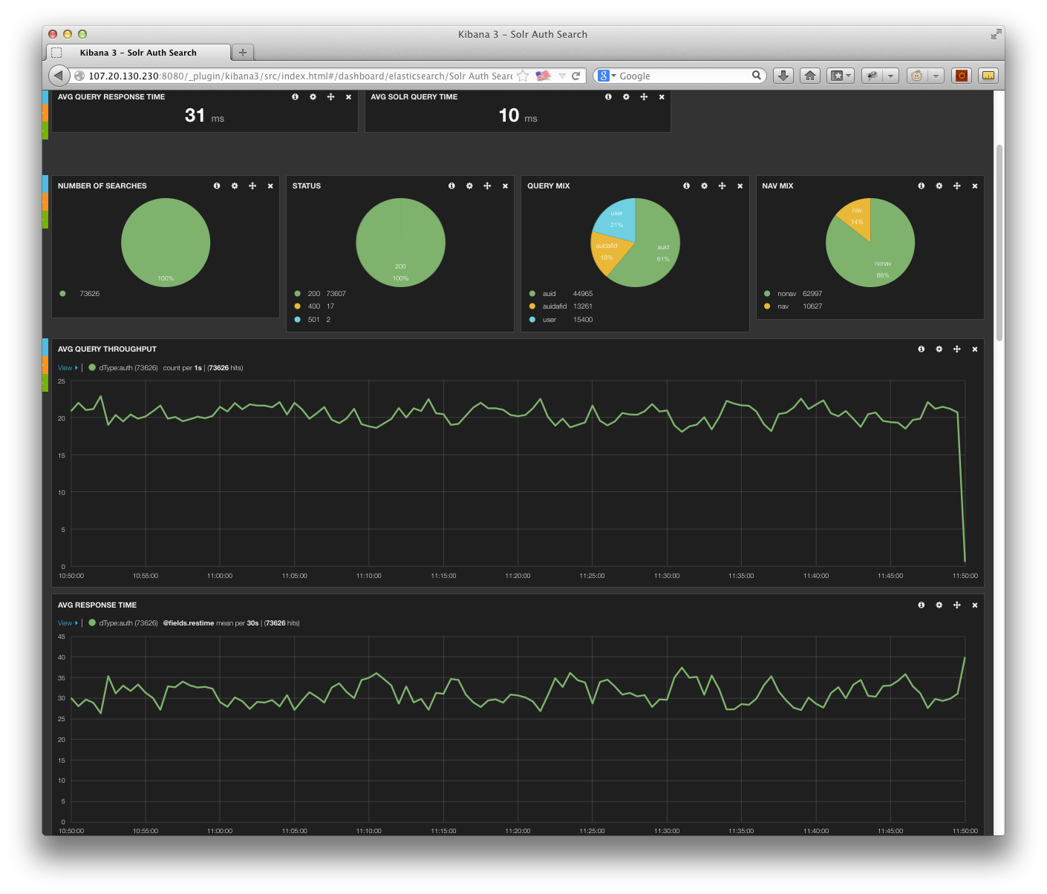

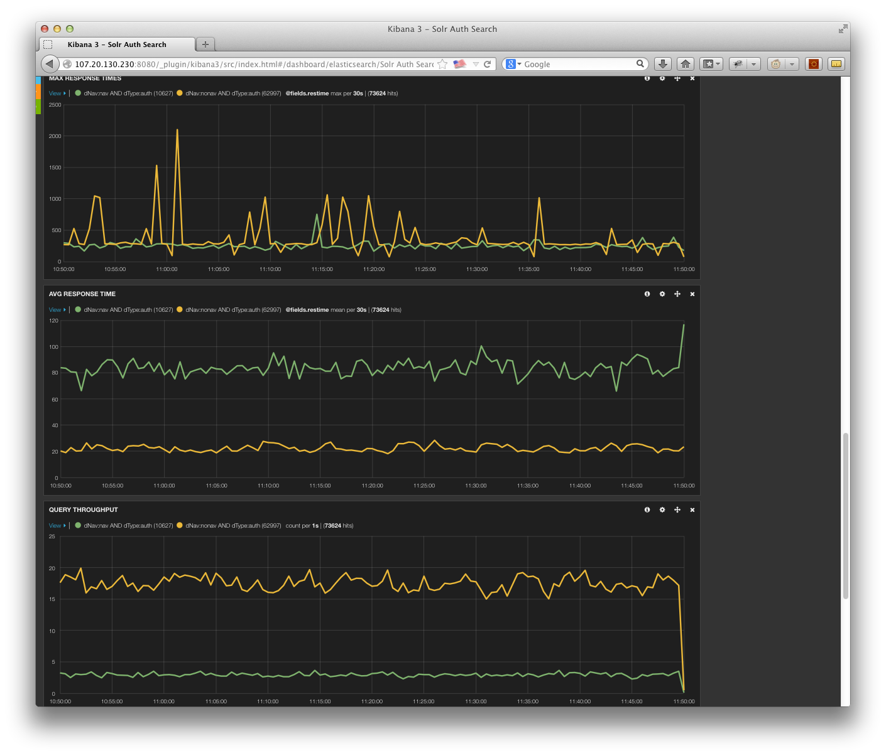

## Core Testing Results

### Core Content Loading

We were able to complete the initial bulk load of 50,773,230 records in approximately 17 hours and 26 minutes (including final optimization). We observed far less than 50% CPU utilization during the initial load and update runs (actual CPU usage during the update runs was 2% for the cluster). One will note that we were not running as many indexers as we had for the author records. As we ramped up DynamoDB R/W capacities, load performance increased linearly, implying we are not CPU bound on the machine and could significantly decrease the load times.

While loading, Solr was configured to use a maximum of 16 indexing threads as well as a modified ramBuffer from the default. Specifically, the ramBufferSize was set at 4096MB with a maxBufferedDocs of 250,000. These settings control how much processing Solr will do in memory before committing to disk in the transaction log and represents the amount of work that can be lost if a machine goes down. Finally, the autoCommit maxTime was set to a max time of 10 minutes. This controls how frequently transaction log records are merged into the Solr index segments. Reducing the log size reduces the recovery time needed to replay the log entries against the checkpointed index should a machine go down. Finally, at the end of indexing, we optimize the index to reduce the size and increase the search performance characteristics. We do this as we anticipate flipping indexes at which point the newly optimized index will become read only and only used for query resolution.

Machine/Solr details:

* AWS 5 x cr1.8xlarge
  + 32 vCPUs / each
  + 244GB RAM / each
  + 2 x 120GB Ephemeral SSD Drives / each
  + 10GBit Network performance
  + Note: recommend using some of the newer Amazon r3 family r3.8xlarge instances in production. This instance type will be a better match for Cores and initial reports list them as being less expensive than the instances we used. These new instances were announced but unavailable during the PoC
* Solr Config
  + -XX:+UseParallelGC
  + –Xms100G
  + –Xmx100G
  + 2 x 120GB drives in raid 0 array.

Additonal notes:

* Flat optimize time based on index shard size. Optimize shards in parallel for fastest throughput.
* 15K errors reported during initial bulk load. Reran these records and they updated successfully. Error logs show they likely encountered timeouts during higher level Solr segment megers. Increasing the connection timeout accordingly in the indexers should enable us to avoid this situation.
* Could have run much harder, plenty of CPU available (decreasing the overall indexing time).
* We did not actually compute the corpus wide statistics for the test dataset. Records were loaded with dummy values for the citedByCount and citref fields that encompass the corpus wide statistics for cores.

Table 11: Core Bulk Load statistics

|  |  |
| --- | --- |
| Queue Size | 50,773,230 |
| Solr cluster | 5 x cr1.8xlarge instance |
| Number of indexer processes | 25 x cc1.4xlarge instances (20 indexer processes/instance) instances were ramped up over 30 minutes |
| Dynamo DB Read/Write rate | 1500/1500 |
| Processing Time | 16:08 |
| Index Rate | approx. 3,173,000/hr |
| Pre-optimize index size | 516.16 GB |
| Optimize time | 1:18 (run in parallel on each shard) |
| Post optimize index size | 465.95 GB |
| Total processing time | 17:26 |

Table 12: Core 1X Update Load Statistics

|  |  |
| --- | --- |
| Queue Size | 400,000 |
| Solr cluster | 5 x cr1.8xlarge instance |
| Number of indexer processes | 5 x m1. xlarge instances (5 indexer processes/instance) |
| Dynamo DB Read/Write rate | 500/500 |
| Processing Time | 1:59 |
| Index Rate | Approx. 200,000/hour |
| Optimize time | 1:20 (run in parallel on each shard) |
| Total processing time | 3:19 |

Table 13: Core 3X Update Load Statistics

|  |  |
| --- | --- |
| Queue Size | 1,200,000 |
| Solr cluster | 5 x cr1.8xlarge instance |
| Number of indexer processes | 5 x m1. xlarge instances (5 indexer processes/instance) |
| Dynamo DB Read/Write rate | 500/500 |
| Processing Time | 6:11 |
| Index Rate | Approx. 200,000/hour |
| Optimize time | 1:19 (run in parallel on each shard) |
| Total processing time | 7:30 |

### Core Query Load Testing

For the full query set, we had an overall target of an average rate of 65 qps with no overall average response time. In addition we had specific average response times for the two identified query types (navigator and no navigator). We ran 2 load test boxes with three copies of the load test script on each. The script ran for 15 minutes to warm the cluster before official measurements were taken. We were able to far exceed the target Scopus requirements, reaching 92 QPS on average. In addition, Solr was able to surpass all of the existing specific query type measurements/requirements.

The Solr cluster was running on 5 cr1.8xlarge instance. Each server was configured to use at most 100GB of the 244GB available on the instance (leaving enough to run a separate update cluster on the same instance without impacting performance). This amount of RAM can easily contain the entire index in memory to get optimal performance from Solr. This amount of RAM can easily contain the entire index in memory to get optimal performance from Solr.

The instance itself showed minimal CPU usage during the tests that would seem to indicate significantly more capacity could be extracted from the hardware. We did not push the hardware to its limit as we had already surpassed the targets. One other item to note is that we had no replicas configured in the cluster to simulate an HA deployment. Adding a second instance would effectively double the query capacity to at least average 184 QPS.

**Notes:**

The timings below reflect leveraging the dummy corpus wide statistic values that were initially inserted into the content when indexed. After the official statistics were gathered, we attempted to leverage the Solr external file capability as an alternative to having to individually update documents with their specific statistics after the Redshift job had run. Using this approach, we saw approximately the same general performance pattern leading us to believe we can leverage that capability to significantly reduce our ongoing update load with little performance impact. More information about our proposed use of the external file capability can be found in the “Corpus Wide Statistics” section later in this paper.

Table : Query Mix for Core Test set – Navigator Based

|  |  |  |
| --- | --- | --- |
| **Query Type** | **Number of queries** | **Percentage of mix** |
| Navigator | 38,728 | 12% |
| No Navigator | 286,255 | 88% |

Table : Full query mix 1 hour overall averages

|  |  |  |  |  |
| --- | --- | --- | --- | --- |
| **Query Type** | **AVG Request Rate** | **Max**  **Request**  **Rate** | **Avg Response Time** | **Max Response Time** |
|  |  |  |  |  |
| Scopus Targets | 65 qps | 91 qps | N/A | 179,189 ms |
| Solr Observed | 92 qps | 98 qps | 47 ms | 14,196 ms |

|  |  |  |  |  |
| --- | --- | --- | --- | --- |
| **Query Type** | **Mean** | **Median** | **P95th** | **Max** |
|  |  |  |  |  |
| Scopus Target - Navigator | 452 ms | 259 ms | 1,022 ms | 65,058 ms |
| Solr Observed - Navigator | 117 ms | 88 ms | 326 ms | 12,707 ms |
|  |  |  |  |  |
| Scopus Target - No Navigator | 379 ms | 171 ms | 633 ms | 179,189 ms |
| Solr Observed - No Navigator | 38 ms | 25 ms | 81 ms | 14,196 ms |

Figure Cores Full Query Mix – 1 hour snapshot (4/15/14 12:00 EDT – 13:00 EDT)

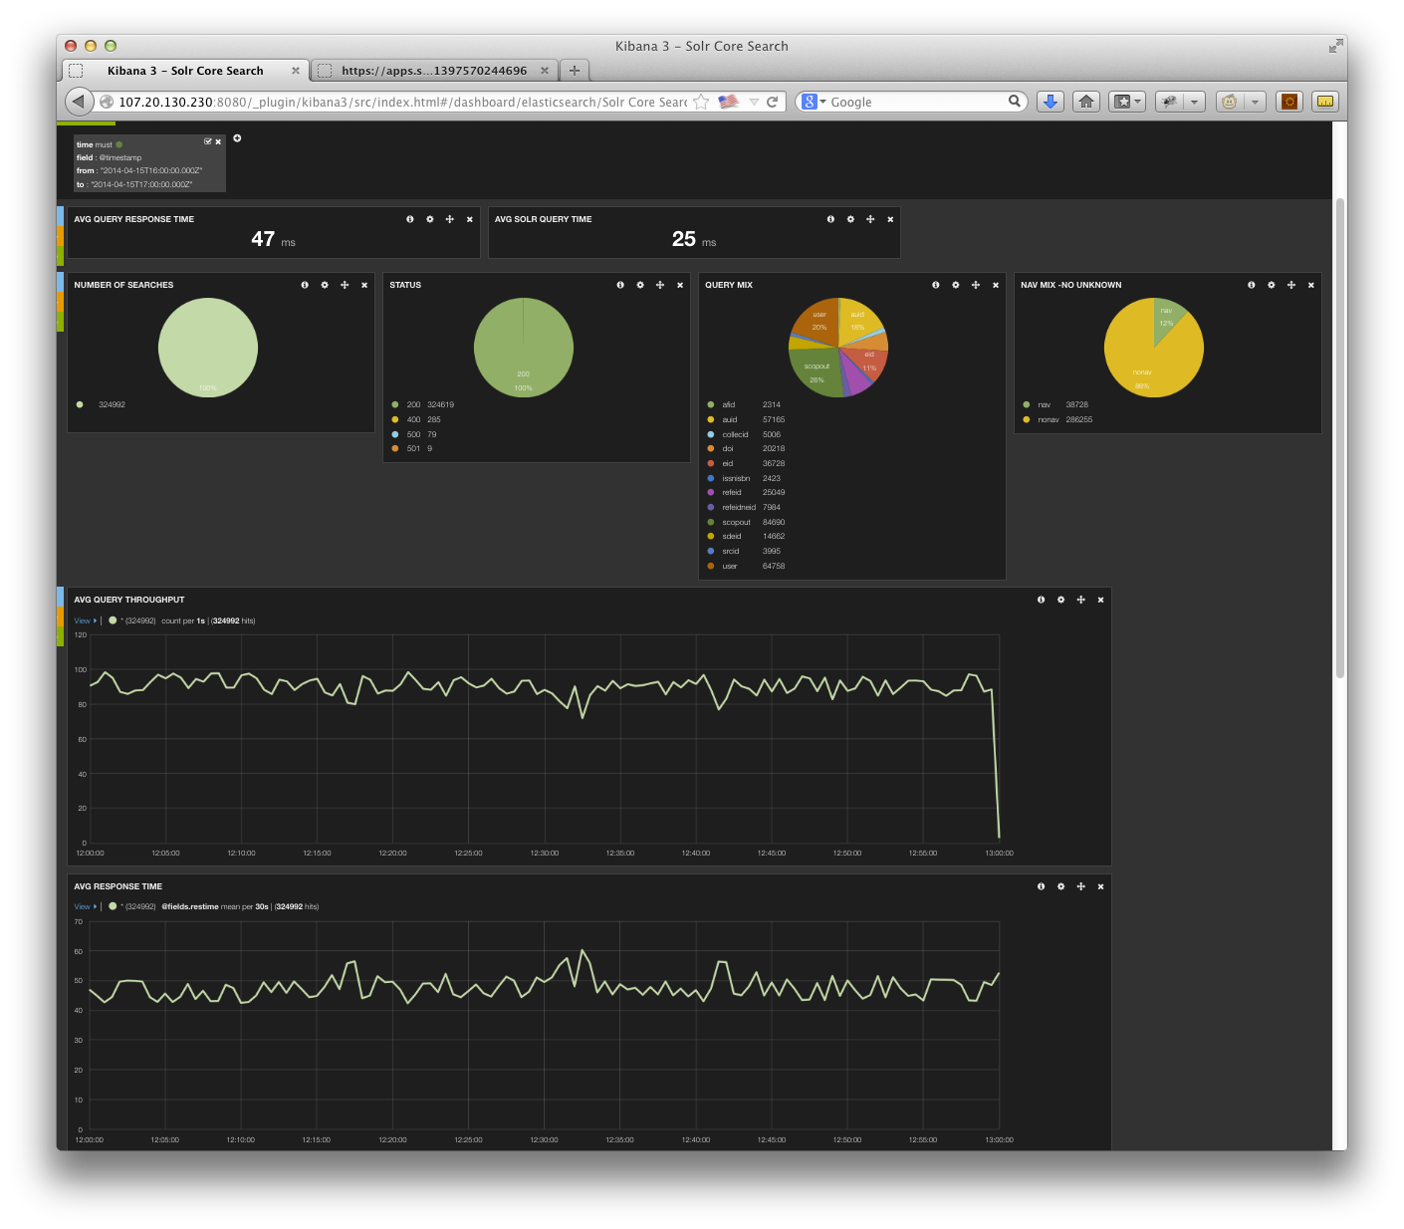

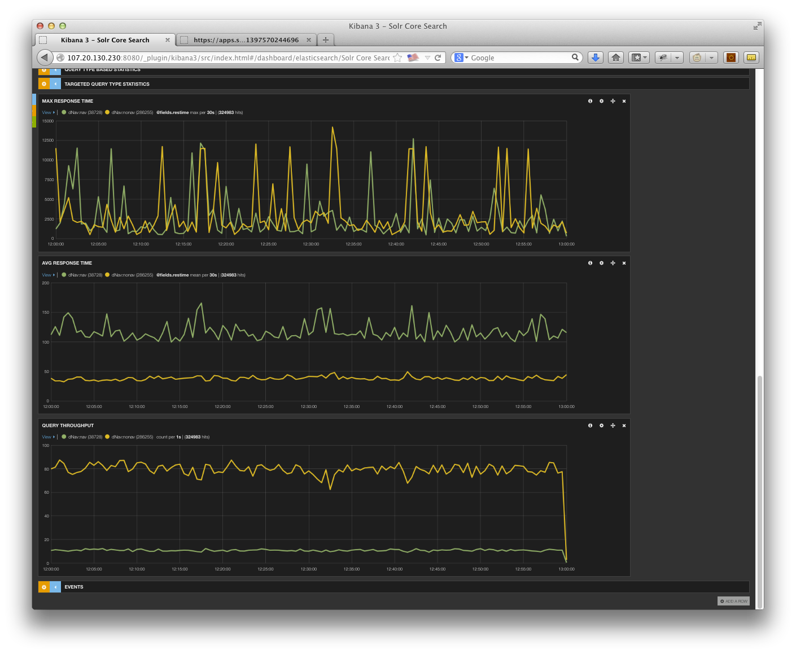

## Potential Problematic/High Cost Features

* **Tombstone queries**: This is not necessarily problematic but something that would require development (along with the associated cost). This functionality is currently provided by the Fast Unity layer and was out of scope for the PoC. Since Tombstone queries are a 2-step process, some of the scripting capabilities provided by Search Technologies QPL could potentially facilitate a faster and less expensive implementation. Another alternative would be to create a separate search endpoint that performs this 2-step query or implement the functionality in the new Solr SearchService layer.
* **Storing XML markup**: Solr does not handle XML formatting natively. We would need to author an XML-aware tokenizer for the system that would ignore markup when creating the search index but allow us to store the data for retrieval. Search Technologies (possibly QPL) might have an XML aware tokenizer that we could potentially license. Presumably, the ScienceDirect Solr implementation has already addressed this and the tokenizer developed for that project could be used.
* **Storing/Retrieving Many Fields**: Having pre-defined views that have blanket sets of fields to return results in lower performance as unused/unwanted data has to be retrieved, formatted, and transmitted to the client. All calls should explicitly list the fields that are actually needed.
* **Scoped Searching:** Scopus needs to ability to search within authors, affiliations, and references. The scope search is a bit more complex than the ScienceDirect scope requirements. Specifically, there are multiple levels of scoping (instead of the single level needed for ScienceDirect. It’s possible the custom development solution created for ScienceDirect could be used (or extended). Another option would be to leverage QPL as this feature is already supported.
* **Wildcard and stemming:** Solr will not analyze a term that contains wildcard characters. This has the net effect of not applying any stemmers during the query execution for that term. Many search engines have this limitation. If this is needed, custom development would be required. However, there could be a significant performance penalty.
* **Limiting Wildcard expansion:** Currently FAST only allows a wildcard to expand to the first 2000 terms (presumably to prevent performance problems). If this is needed (and necessary for performance), custom development would be required.

## Answer Features/Count Results

In general the numbers from Solr will be slightly lower due to the changes in the document set since the snapshot for HotHouse was taken. Other minor variations may exist due to the transformation of content not being exactly right, stemming variations, or configuration/mapping issues within Solr. For example, we did notice a CIP mapping issue with author first name. The scope feature is not implemented out of the box in Solr and would require custom development or a third-party plug-in such as QPL.

|  |  |  |  |
| --- | --- | --- | --- |
| **#** | **Scopus Count** | **SOLR Count** | **Query/Notes** |
| CORE1 | 1 | 1 | doi(10.1109/lawp.2005.850798) |
| CORE2 | 2 | 2 | eid(2-s2.0-84861409323 OR 2-s2.0-0032977045 OR 2-s2.0-84871047622) |
| CORE3 | 1334 | 1315 | refeid(2-s2.0-0034824859) |
| CORE4 | 14 | 15 | au-id(55177469200) |
| CORE5 | 122599 | 121545 | af-id(60026851) |
| CORE6 | 2 | 0 | scopus-id(33749522827 OR 33750354968) |
| CORE7 | 1927 | 1927 | issn(2090-4649 OR 0301-0538 OR 004-2675-X) |
| CORE8 |  | 0 | fulltext-eid(1-s2.0-S0169409X13002275) |
| CORE9 | 15 | 15 | srcid(24527) AND PUBYEAR = 2012 |
| CORE10 | 4920871 | 4779881 | all(blood) |
| CORE11 | 3524700 | 3499039 | title-abs-key-auth(blood) |
| CORE12 | 3523591 | 3498027 | title-abs-key(blood) |
| CORE13 | 1383826 | 1383796 | abs(blood) |
| CORE14 | 209717 | 207911 | affil(oxford). |
| CORE15 | 863 | 846 | chemname(rhamnose) AND indexterms (polysaccharide). |
| CORE16 | 1021 | 1002 | key(rhamnose AND polysaccharide). |
| CORE17 | 4145698 | 2388514 | ref(engineering). ML had similar results. Since we used the ‘storage’ format and not the ‘syndication’ formation for the XML, it’s possible that additional information was included in the ‘syndication’ format. |
| CORE18 | 60734 | 60580 | abs(blood) AND abs(cancer) |
| CORE19 | 664325 | 656006 | (abs(brain) AND NOT abs(cancer)) |
| CORE20 | 1611025 | 1597394 | (abs(brain) OR abs(cancer)) |
| CORE21 | 3308 | 2960 | abs(brain PRE/5 cancer). SOLR Surround Query Parser will not stem tokens. QPL could address this limitation. |
| CORE22 | 5045 | 4499 | abs(brain W/5 cancer). SOLR Surround Query Parser will not stem tokens. QPL could address this limitation. |
| CORE23 | 486 | 141 | title (practice W/5 "letter"). SOLR Surround Query Parser will not stem tokens. QPL could address this limitation. |
| CORE24 | 600 | Error | title(neuro* W/3 letter). SOLR errored on too many terms. . Would require custom development or QPL. |
| CORE25 | 24767 | Error | title(neurological) AND NOT title(neurological W/5 letter). Could not construct query in SOLR (parse error). Would require custom development or QPL. |
| CORE26 | 754 | 141 | title((neurological OR letter) w/5 practice). SOLR Surround Query Parser will not stem tokens. . Would require custom development or QPL. |
| CORE27 | 3 | 3 | auth(Rumiá Arboix J). |
| CORE28 | 103987 | 103320 | title(blood) AND pubyear AFT 2003 |
| CORE29 | 23933106 | 23650409 | pubyear AFT 2000 AND pubyear BEF 2014 |
| CORE30 | 3727 | 3696 | abs("heart attack") |
| CORE31 | 21 | 13 | abs({heart-attack}) |
| CORE32 | 43462156 | 43082537 | all("the") |
| CORE33 | 16330 | 16268 | title ("the end" ) |
| CORE34 | 96730 | 95800 | abs(thio*e) |
| CORE35 | 5325 | 3052 | abs(thio?e). Unclear why Solr has is 2K less than Scopus. |
| CORE36 | 2924 | 2787 | title("*snake venom") |
| CORE37 | 2924 | Not Implemented | title (*snake pre/0 venom). Solr has a praser error. Would require custom development or QPL. |
| CORE38 | 65626 | Not Implemented | author-name(smith,j). Not implemented. Would require custom development or QPL. |
| CORE39 | 276 | Not Implemented | author-name(smith,john). Not implemented. Would require custom development or QPL. |
| CORE40 | 81374 | Not Implemented | affil(affilorg (university california) AND affilcity(san diego)). Not implemented. Would require custom development or QPL. |
| CORE41 | 22488 | Not Implemented | ref(sanger nicklen DNA). Not implemented. Would require custom development or QPL. |
| CORE42 | 6178 | Not Implemented | ref(refauth(darwin) AND refsrctitle(species) AND refpubyear IS 1859). Not implemented. Would require custom development or QPL. |

|  |  |  |  |
| --- | --- | --- | --- |
| **#** | **Scopus Count** | **SOLR Count** | **Query/Notes** |
| AUTH1 | 1 | 1 | au-id(10038760900) |
| AUTH2 | 11686 | 11479 | auth-last-name(smith) AND auth-first(j*). |
| AUTH3 | 7021 | 4599 | auth-last-name (EQUALS(smith)) AND auth-first (STARTS-WITH(j)). Mapping issue for Solr in the CIP. |

|  |  |  |  |
| --- | --- | --- | --- |
| **#** | **Scopus Count** | **SOLR Count** | **Query/Notes** |
| AFFIL1 | 1 | 1 | af-id(60030162) |
| AFFIL2 | 348 | 17835 | affilcity(london). Likely attributed to differences in publication counts as well as identification of root nodes. MarkLogic and SOLR had same count (25,847) when all filtering was removed. |
| AFFIL3 | 1 | 4 | affil("university of york"). Likely attributed to differences in publication counts as well as identification of root nodes. MarkLogic and SOLR had similar counts (9/6) without filters with the difference being stemming of ‘universities’ in MarkLogic. |
| AFFIL4 | 86 | 666 | affil (university of york). Likely attributed to differences in publication counts as well as identification of root nodes. MarkLogic and SOLR had similar counts (1087/1075) without the filter with the difference being stemming of ‘universities’ in MarkLogic. |

## Scopus Specific Challenges Investigated in PoC

### Introduction

The following diagram presents a more detailed representation of the proposed deployment architecture as it relates to managing the update of content and management of the various shards and Solr Collections. It will be used as a reference in the discussions of a number of the Scopus specific challenges discussed in this section. The diagram specifically depicts the deployment in support of the Cores datatype, as it is the most complex of the three that were investigated. All three Solr deployments will be running at the same time to provide a complete search solution for Scopus. The Authors and Affiliations diagram appear similar to Cores (lacking the AWS Kinesis/Redshift Components and encompassing only 1 AWS instance each).

Figure - Detailed Scopus Cores Deployment proposal

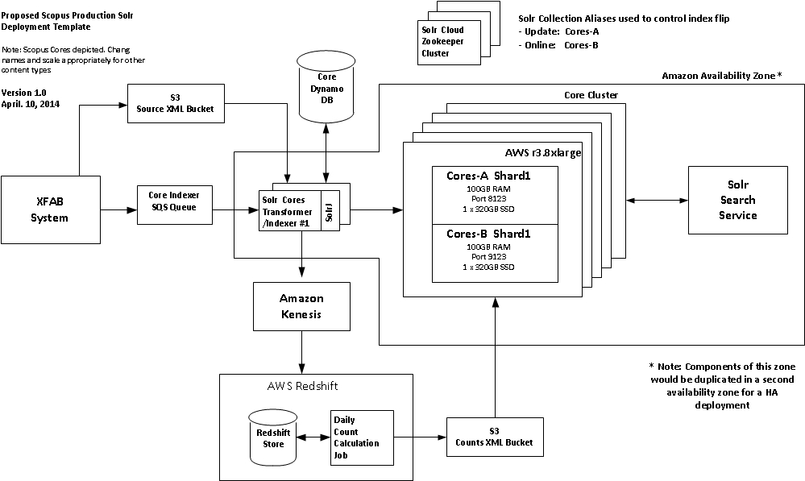

### Large, Accurate Navigators/Facets

As previously mentioned in this paper, Scopus presents the user with a number of navigators that can have millions of distinct values in them. This was one of the areas of concern that was noted in the ScienceDirect Hothouse, as performance appeared to degrade linearly as the number of items to count for the navigator increased. After discussions with consultants from Search Technologies, we investigated the use of the Solr “Doc Values” feature that was added in Solr 4.2 as a potential solution for this problem. “Doc Values” leverages a different way of building the index for those fields where it is applied. Instead of inverting those field’s data into the index to make them quickly searchable, it builds a column-oriented field with a doc:value mapping that greatly increases speed for things like faceting, sorting, grouping, etc. When applying this approach to the Scopus content, we saw a drastic increase in search performance for those queries with large answer sets and high cardinality navigators.

There was also the concern for whether the facet values/counts are consistent (specifically in a Solr sharded environment). We developed a Node.js testing tool that allowed us to request all of the core facets and their associated counts for each Solr query specified in a file. The tool was run four times requesting the top 3, 10, 20, and 200 facet values/counts for the 50 queries specified in the file. In between each run, the Solr cluster was restarted to flush the cache. We then compared the results for each facet and verified that the top 3 values matched the first 3 values in the top 10, top 20, and top 200. We did the same for the top 10 and top 20. In the end, we saw no difference in the top values/counts across all of the facets.

We then wanted to verify that the counts for the facet values were accurate. We developed another Node.js testing tool (similar to the first one) that executed the queries from a file. However, this time in addition to requesting the top n values for each of the facets for the query, we then submitted a search request (appending the facet value to the original search request) and compared this result with the count returned for the facet. We ran this test for the same 50 queries specified in the file (requesting the top 20 values for each facet) and saw no differences between the count returned for the facet value and the count returned from the value appended to the original search query.

### High Update Volumes

Based on the statistics we collected over a 3 month period, the Scopus product exhibits a much higher update (and erratic) rate than ScienceDirect. The team had serious concerns about the ability to guarantee search performance using the “update in place” on the live index strategy proposed by the ScienceDirect Hothouse. As a result, we are proposing a dual copy solution, where there is an online copy of index that is actively queried by the product and an offline copy that processes updates in real time. Periodically, these two indexes are flipped to make the latest set of changes visible in the product and the old “online” index starts getting used for updates.

This approach and how we have chosen to implement it has some impacts on our hardware configuration as well as management of each Solr Collection’s shards. In order to get the best query performance from Solr, you want to keep as much of the index resident in RAM as possible and for indexing you want as much RAM as possible as well as fast disk drives (SSD if possible) to decrease the latency of writing Solr segments and merges. Furthermore, you must also take the latency needed to sync up the “new” version of the index to the outdated version after the index “flip” occurs.

Taking these three goals into account, we decided it would be best to run the two indexes in parallel on a machine(s) as two distinct Solr deployments. This implies that each machine will need at least 2x shard size + 5 GB (for OS) RAM as well as 4x shard size SSD drive space. Preferably, we’d like the SSD drives to be on at least 2 drives with 2 controllers so there is limited interference between Solr deployments. In the PoC tests run so far, CPU utilization has been far below 50% when running indexing tests as well as query tests implying that the hardware should be able to support both activities simultaneously on the instance.

Finally, we will need to manage the Solr Cloud deployment configurations to make sure that the shards for each deployment ends up with their matching shard from the other deployment on the same machine. By having them on the same AWS instances, we can do SSD to SSD copies of the index data during the flip instead of slower network transfers. Finally, all of this implies that AWS instance RAM size availability will drive the sharding strategy for those datatypes that have large index sizes.

### Corpus Wide Statistics

One of the key product features of Scopus is the availability of corpus wide statistics that assist the researcher in validating the merit of a paper, author, or institution. This is presented via a “count” of the number of times a paper is cited, or number of papers an author or institution has published. The data that drives these “counts” is derived from Scopus Core records that have been augmented with ids for the various entities in the Scopus corpus. A new core record or changes to an existing record can have rippling effects across the entire set of Scopus content and drive an exponential number of updates. As the product has requirements for providing “accurate” statistics at all times, it poses a problem in that individual updates to impacted documents do not occur within a single transaction and the counts can “drift” for a period of time until all the associated updates complete. This “drift” has been an issue with the existing Fast search implementation from the beginning.

In order to avoid this drift, the Solr solution has approached the problem with a “snapshot” based solution. Specifically, The Solr index will only be updated and made visible to the end user at specific intervals. On an ongoing basis, XFAB puts Core changes onto the appropriate SQS queue for processing. As each core is merged into the Solr index, the key information that drive the counts is extracted and sent to our AWS Redshift cluster via AWS Kinesis queuing (Kinesis is being leveraged as Redshift is unable to handle the direct update load without significantly degrading indexing speed). At the pre-defined index promotion intervals, ongoing updates from the XFAB system into the Solr SQS queues will be paused and the queues allowed to drain of records. When the queues have drained, XFAB will kick off a set of Redshift jobs (one for each corpus-wide statistic) against the data stored there to generate the record level statistics for each content type. At the end of the Redshift job, the resulting statistics will be flattened into a record id:value file and exported to S3. Once the export has completed, a copy of the appropriate file(s) will be posted to each shard of the update Solr Collection in preparation for the promotion of the new index as part of the “Flip”.

Within Solr, we are leveraging the “external file” feature that allows you to store information for a record outside of the index without needing to update it into the index itself. In the Scopus use case, these statistics values’ are typically used for sorting, returned in search results, or used as part of range queries. The Solr “external file” feature supports these use cases and allows us to avoid having to update all of the impacted documents with new count values, significantly reducing the update load on the index. The one drawback to this approach is the lack of direct querying against fields stored in these external files (a requirement Scopus does not present). Should this become necessary, it would be possible to migrate back to updating the values into the index itself at the drawback of longer cycle times to update and promote an index to the end user.

### Index Flipping

The key to the proposed Solr solution rests in our ability to manage our updates (content and corpus wide statistics) as snapshots and to be able to easily promote new versions of the index into production easily. We are referring to this promotion as the “Flip”. In this section we will lay out how we envision the Flip actually occurring in production.

To implement the Flip we are relying on Solr’s alias capability. Aliases allow you to point a logical name to a physical set of nodes/shards that encompass a set of content. In our case, we would have two aliases per content type: “online” and “update”. Each of them would point at one of the two copies of our index for that content type. In the diagram depiction above for Scopus Cores, we have A and B copies for each shard, one pair per box. In the case of Affiliation and Authors, there is only one shard and one box in play.

SolrCloud leverages Zookeeper to keep track on shard copies for a Solr Collection within a cluster. It also manages the definition of aliases based on the contents of a collection. Zookeeper keeps track of the current state of the cluster as machine join/depart the cluster and makes that information visible to all of the participants. In this way, it behaves as a smart load balancer for those processes that leverage it to manage the list of active nodes.

Clients would leverage the SolrJ CloudSolrServer class (or equivalent class in other languages) to manage their connections to the Solr cluster. In our Scopus deployment the “online” alias would point to either the A or B index, and update to the other. The Transform/Indexers would use the “update” alias while the SolrSearch Service and other search clients would use the “online” alias. At the predefined promotion times, the flow of updates from XFab would be paused, the Corpus Wide Statistic Updates performed, and the index is prepared for the flip. Once the Statistic Updates are copied to each shard in the cluster, a Solr optimize is kicked off on each shard to compress it down as much as possible. At the completion of the compress, a snapshot and backup is made and stored off to S3. Finally, the alias update is initiated. The “online” alias is changed to point to the copy of the index that was just optimized. A side effect of this command will have the side effect of updating all the clients’ local routing tables with the new endpoints and search traffic will migrate to the new index. Once traffic has migrated, the previous index will be restored from the snapshot of the new index that is on the same AWS instance. Once complete, we will refresh the ‘update’ alias to point at the newly restored index and update flow from XFab will be resumed.

## Operational Challenges

Describe predicted challenges that will/may be experienced if this solution were chosen to go forward.

### Integration with Existing XFAB Job Control System

The Scopus Solr workflow is much more complex than the one proposed last year in the ScienceDirect Hothouse. Beyond posting all changes to the appropriate SQS queue, we need to be able to pause that posting, monitor queue depth to make sure queues have drained, initiate Kinesis and Redshift jobs, push the results to multiple boxes, and manage the index “Flip”. Scopus will obviously need some sort of job control management layer to orchestrate all of these tasks in the proper sequence. At one point we considered looking at AWS Simple Work Flow, but decided that it probably makes more sense to try and drive all of this processing by extending the existing XFAB job control system to provide end-to-end management of the process. Since all of the Solr and AWS components expose administration APIs via HTTP, we assume this integration should be possible with some additional internal development on the XFAB system.

### Limited PoC interaction with AWS Kinesis

Time limitations as well as Java version restrictions prevented the team from doing any significant development prototyping of the Kinesis data stream population or the periodic feed to Redshift.

### Management of the Flip

Put stuff Here: Haven’t actually tested, but appears on paper that it would work. Amount of RAM needed, etc.

### Resource Availability

There is currently a limited pool of development resources with Solr experience within Elsevier. They are currently engaged in implementing the ScienceDirect migration to Solr. It is possible that there will be availability conflicts depending on the timing of the Scopus project initiation. In addition, the Solr PoC team is recommending using SolrCloud. We do not believe that the current Solr development team has extensive experience with SolrCloud. It is unclear how big an impediment that will be to the project.

## Deployment Architecture/Cost

Put stuff Here:

### Proposed Architecture

Put stuff Here:

### Proposed Costs

#### Scopus Affiliations

Include the various AWS costs (both ongoing and complete reload)

* DynamoDB
* SQS
* SNS
* EC2
* S3 and/or EBS
* Static IP Addresses

#### Scopus Authors

Include the various AWS costs (both ongoing and complete reload)

* DynamoDB
* SQS
* SNS
* EC2
* S3 and/or EBS
* Static IP Addresses

#### Scopus Core Abstracts

Include the various AWS costs (both ongoing and complete reload)

* DynamoDB
* SQS
* SNS
* EC2
* S3 and/or EBS
* Static IP Addresses
* Kinesis
* RedShift

## Pros of Solr

What would be the advantages?

* Mature offering
* Solr experience within Elsevier
* Open Source (cost savings?)
* Extensible/Flexible
  + Add handlers, parsers, etc.
  + Target specific content types to appropriately sized AWS EC2 instance types
  + Availability of 3rd party plugins (e.g. QPL)
* Scalable
* Cloud friendly
* What else?

## Cons of Solr

What would be the disadvantages?

* No internal experience with SolrCloud
* Record length limitations with Kinesis
* What else?

# Evaluation Matrix

**Total Possible Score Categories:**

**3 = for items of low importance**

**5 = for items of medium importance**

**7 = for items of medium-high importance**

**10 = for items of high importance**

| **Criteria** | **Total Possible Score** | **SOLr** |
| --- | --- | --- |
| Meets or Exceeds Performance Requirements | **10** |  |
| Meets or Exceeds Functional Requirements | **10** |  |
| Meets or Exceeds Answer Count Requirements | **7** |  |
| Provides Quality Relevance Results | **7** |  |
| Costs (of final solution) | **10** |  |
| Time to Market | **7** |  |
| Operational Challenges | **5** |  |
| Total Score | **56** |  |